PROPOSED METHODOLOGY
Provision of Artificial Intelligence Training Services for AFC Holdings Limited
Submitted by AI Institute Africa in partnership with Rubiem Intelligence and the University of Zimbabwe
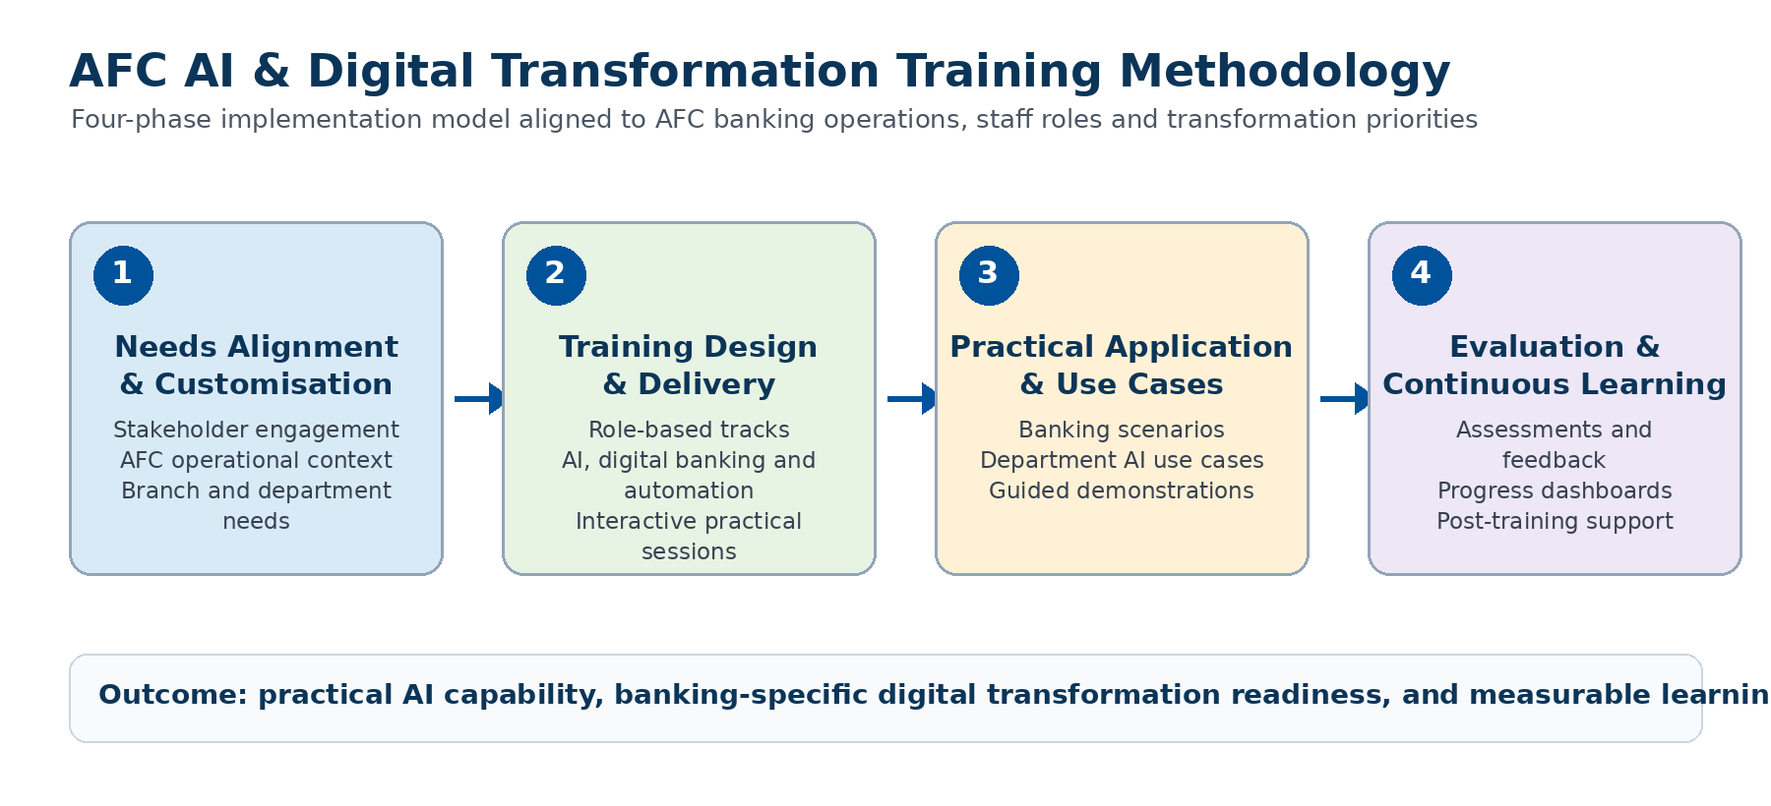
Figure 1: Four-phase methodology for AFC AI and Digital Banking Transformation training.

1. Approach Overview
AI Institute Africa, in partnership with Rubiem Intelligence and the University of Zimbabwe, will adopt a practical, banking-focused and impact-driven training methodology designed to ensure immediate applicability within AFC’s operational environment. The methodology supports AFC’s objective to build Artificial Intelligence capability, strengthen digital banking transformation readiness, and establish a continuous learning environment for staff across head office and branch locations.
Our methodology is structured around four implementation phases:
• Needs Alignment and Customisation
• Training Design and Delivery
• Practical Application and Demonstrations
• Evaluation and Post-Training Support

2. Phase 1: Needs Alignment and Customisation
Prior to training rollout, we will engage AFC stakeholders to align the programme with AFC’s strategic priorities, banking operations, staff roles and digital transformation objectives.
• Align training content with AFC’s digital transformation and AI adoption priorities.
• Identify key executive, management, technical, operational and general staff learning needs.
• Map training content to AFC’s banking processes, governance structures, operational workflows and customer service environment.
• Customise case studies for banking operations, process automation, customer service, compliance, risk management, data analytics and AI-enabled decision support.
• Review existing AFC training materials, facilities and schedules to support smooth implementation across head office and branches.

Phase 1 Outputs
Output | Description
Tailored training agenda | Programme agenda aligned to AFC priorities, roles and staff availability.
Banking-specific case studies | Use cases relevant to AFC operations, branch banking, compliance, customer service and digital workflows.
Readiness assessment inputs | Initial view of staff groups, platform needs, delivery constraints and training support requirements.

3. Phase 2: Training Design and Delivery
We will deliver a structured training programme organised into role-based learning tracks. The programme will balance executive-level strategic content with practical operational examples and hands-on demonstrations for staff who require applied exposure to AI tools.
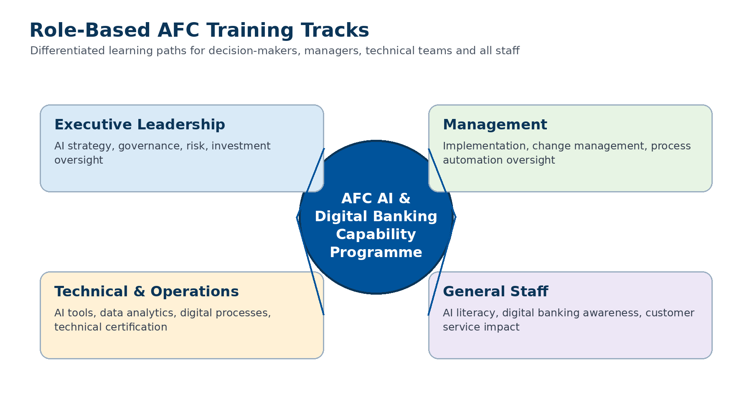
Figure 2: Role-based training tracks for AFC staff groups.

Core Training Sessions
Session | Focus Area | AFC Application
Session 1 | AI Fundamentals for Banking Professionals | AI, machine learning, generative AI, agentic AI and the business value of AI in financial institutions.
Session 2 | AI for Productivity and Decision-Making | Report writing, document summarisation, customer communication, analysis support and executive decision support.
Session 3 | Microsoft 365 Copilot and AI Tool Demonstrations | Practical demonstrations in Word, Excel, PowerPoint, Outlook and Teams for banking productivity.
Session 4 | AI Strategy, Governance and Leadership | AI governance, responsible AI, ethics, risk, compliance and roadmap development for AFC.
Session 5 | Digital Transformation and Process Automation | Digital banking processes, workflow automation, robotic process automation and AI-enabled operational processes.

4. Phase 3: Practical Application and Interactive Learning
To ensure maximum impact, the training will move beyond theory into practical application. Participants will work through AFC-relevant examples and guided demonstrations that show how AI can improve banking productivity, process efficiency and decision-making.
• Live demonstrations of AI tools, including Microsoft 365 Copilot and relevant generative AI applications.
• Banking-sector case studies covering customer service, risk, compliance, operations, HR, finance and executive reporting.
• Group discussions and scenario-based exercises aligned to AFC departmental responsibilities.
• AI use case development workshops to help departments identify, prioritise and document practical AI opportunities.
• Hands-on guided exercises for selected staff, including prompt engineering, data interpretation and workflow automation examples.

5. Blended Delivery and Digital Learning Platform
The delivery model will combine facilitator-led training, online learning, self-paced modules and interactive workshops. This approach supports participation by AFC staff across head office and branch locations while enabling continuous learning and monitoring of progress.
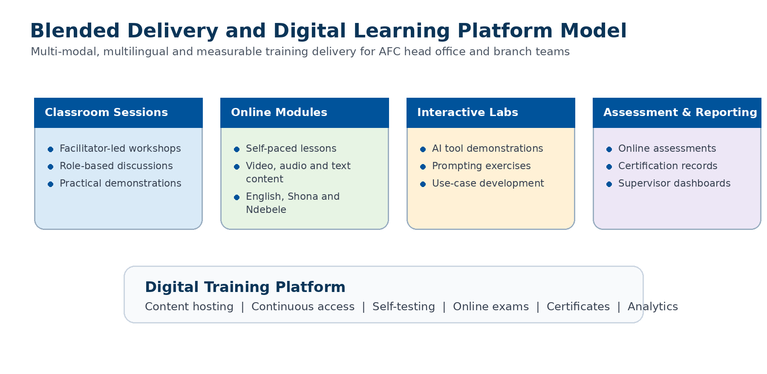
Figure 3: Blended training delivery and digital platform model.
• Classroom-based and facilitator-led sessions for strategic and operational engagement.
• Online and self-paced modules for flexible access by staff in different locations.
• Multi-modal content including text, video, audio, practical guides and live demonstrations.
• Multilingual support where required, including English, Shona and Ndebele learning support.
• Learning analytics, online assessments, supervisor monitoring and certificate generation.

6. Phase 4: Evaluation and Post-Training Support
We will measure learning effectiveness and support programme sustainability through structured evaluation and post-training reporting. The evaluation process will help AFC understand training uptake, learning outcomes and areas requiring additional support.
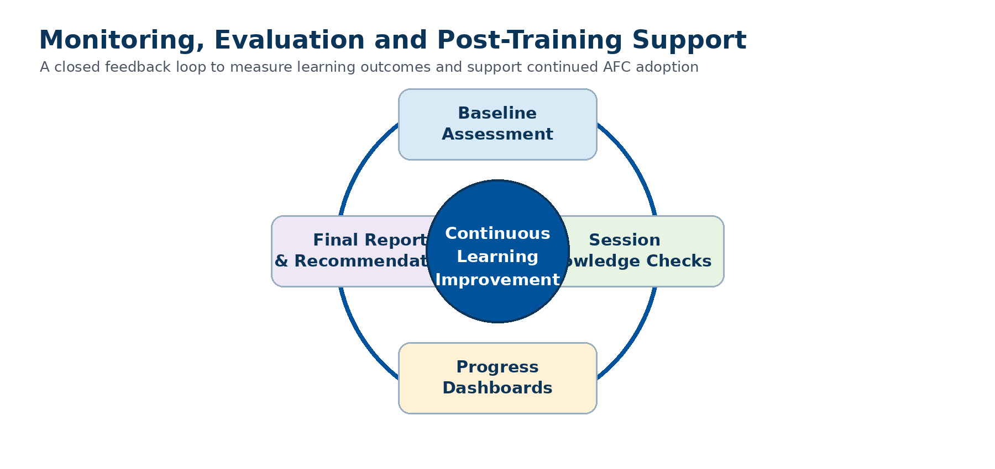
Figure 4: Monitoring, evaluation and continuous improvement loop.
• Participant feedback and evaluation forms.
• Knowledge checks and assessments during training sessions.
• Training progress reporting and platform analytics.
• Post-training report with key insights, attendance summaries, performance observations and recommendations for AI adoption at AFC.
• Optional follow-up advisory sessions to support implementation and internal adoption.

7. Training Materials and Resources
Participants will receive practical, AFC-relevant training resources that can be used during and after the programme.
• Executive-level slide decks and facilitator notes.
• Practical AI use-case guides for banking and financial services.
• Prompt engineering guides and AI productivity toolkits.
• Reference materials covering AI governance, ethics, risk and compliance.
• Digital learning resources hosted on the training platform.
• Certificates of completion and, where applicable, AI technical certification support.

8. Implementation Work Plan
Phase | Key Activities | Outputs | Indicative Timing
1. Needs Alignment | Stakeholder engagement, readiness review, staff segmentation, content alignment. | Tailored agenda, case study themes, readiness notes. | Weeks 1-2
2. Design and Preparation | Curriculum finalisation, platform setup, materials development, schedule confirmation. | Training materials, platform content, implementation schedule. | Weeks 3-6
3. Delivery and Application | Training sessions, workshops, demonstrations, AI use case development. | Trained staff, use case outputs, assessment records. | Weeks 7-20
4. Evaluation and Support | Feedback analysis, reporting, certification support, recommendations. | Progress reports, final report, post-training recommendations. | Weeks 21-24

9. Value Addition
Our partnership brings a balanced combination of academic quality assurance, industry implementation experience and specialised AI training capability.
• Academic rigor and quality assurance through the University of Zimbabwe.
• Industry expertise and digital transformation implementation insight through Rubiem Intelligence.
• Specialised AI training capability and certification support through AI Institute Africa.
• AFC-specific customisation that links AI concepts to banking operations, governance, customer service and process automation.

10. Expected Outcomes for AFC
Outcome | Benefit to AFC
Improved AI literacy | Staff understand AI concepts, opportunities, risks and practical use cases in banking.
Digital transformation readiness | Teams are better prepared for process automation and digital banking workflows.
Departmental AI use cases | AFC receives practical AI opportunities that can inform future strategy and implementation.
Continuous learning capability | Staff can continue learning through digital modules, assessments and progress tracking.
Governance and adoption support | Leadership and management gain insight into responsible AI governance and adoption planning.

