REQUEST FOR PROPOSALS – PROVISION OF ARTIFICIAL INTELLIGENCE TRAINING SERVICES
PROCUREMENT REFERENCE NO: AFC10/2026
TECHNICAL PROPOSAL SUBMISSION SHEET
Note to Consultants: Complete this form with all requested details and submit it as the first page of the technical proposal. A signature and authorisation on this form confirms that the terms and conditions of the RFP prevail over any attachments.
Procurement Reference Number: | AFC10/2026
Subject of Procurement: | Provision of Artificial Intelligence Training Services
Name of Consultant: | Artificial Intelligence Institute Africa
Consultant’s Reference Number: | AIIA/AFC10/2026/TECH
Date of Technical Proposal: | 18 May 2026
We offer to provide the services described in the Statement of Requirements, in accordance with the terms and conditions stated in the Request for Proposals referenced above.
We confirm that we are eligible to participate in public procurement and meet the eligibility criteria specified in Part 1: Proposal Procedures of the Request for Proposals.
The validity period of our proposal is 90 days from the date of submission.
We submit on the attached Appendices the evidence to demonstrate our suitability to perform the required services:
- Appendix A: Methodology and Work Plan
- Appendix B: Experience, Qualifications and Learning Pathways
We understand that the proposals in these Appendices, if approved or as amended, will be included in the Contract Appendices and shall form a contractual commitment.
We enclose a separately sealed financial proposal.
We declare that we are not debarred from bidding and that the documents we submit are true and correct.
Authorised signatory:
Name:
Designation:
Date and stamp:

TECHNICAL PROPOSAL
Provision of Artificial Intelligence Training Services for AFC
Prepared by Artificial Intelligence Institute Africa in partnership with Rubiem Intelligence and the University of Zimbabwe

Table of Contents
1. Executive Summary
2. Understanding of AFC Requirements
3. Appendix A: Methodology and Work Plan
3.1 One-Month Blended Methodology
3.2 Four-Phase Delivery Model
3.3 Detailed Cohort Work Plan
3.4 Deliverables and Outputs
4. Appendix B: Experience, Qualifications and Learning Pathways
4.1 Institutional Capability
4.2 Accredited Certificates and Qualifications
4.3 AFC Learning Pathway
5. Commercial Compliance Note

1. Executive Summary
Artificial Intelligence Institute Africa proposes a practical, blended and implementation-focused AI training programme for AFC. The programme is designed to help AFC leadership, management, support functions, branches and technical teams build immediate AI productivity capability while establishing a structured pathway toward formal certification and long-term organisational adoption.
The proposed solution combines classroom training, online lessons, practical exercises and post-implementation support. This ensures that participants do not only understand AI concepts, but also apply AI tools to AFC-relevant documents, reporting, communication, decision-support and operational scenarios.
- AFC-specific methodology with examples aligned to productivity, governance, reporting and operational efficiency.
- Four-phase delivery model: classroom training, online lessons, practical exercise and post-implementation support.
- Cohort-based work plan covering EXCO, management, support functions, branches and technical participants.
- Learning pathway from short courses to national qualifications, professional competence certificates and advanced progression.
- Certification coverage supported by University of Zimbabwe and HEXCO-aligned programmes.

2. Understanding of AFC Requirements
AFC requires artificial intelligence training services that are practical, credible, measurable and aligned to organisational adoption. The technical response therefore prioritises hands-on learning, role-specific application, responsible AI use and implementation support.
The programme recognises that different AFC groups require different levels of exposure and depth. Executives require strategic, governance and decision-support use cases; management teams require productivity and reporting use cases; support functions require function-specific tools; branches require practical customer and operational application; and technical teams require deeper workflow and implementation capability.

3. Appendix A: Methodology and Work Plan

3.1 One-Month Blended Methodology
The proposed methodology is structured as a one-month learning and implementation cycle per cohort. It moves participants from foundational classroom learning to online reinforcement, hands-on practical application and post-implementation support.
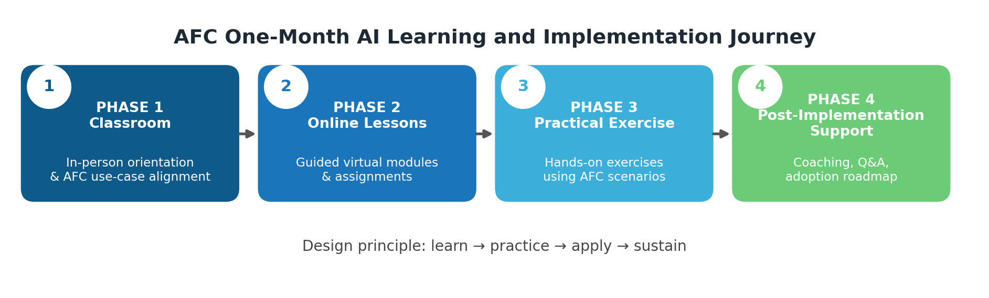

3.2 Four-Phase Delivery Model
Phase | Delivery Focus | Key Activities | Outputs
Phase 1: Classroom | In-person training and AFC needs alignment | AI foundations; responsible AI; Microsoft 365 Copilot demonstrations; AFC use-case identification | Aligned agenda, use-case priorities and classroom materials
Phase 2: Online Lessons | Guided reinforcement through virtual learning | Short online lessons; assignments; knowledge checks; prompt and productivity templates | Online completion record, assignments and refined templates
Phase 3: Practical Exercise | Applied AFC scenarios and demonstrations | Group exercises; summarisation; drafting; presentation generation; workflow prototype prompts | Completed exercises, reusable workflows and feasibility feedback
Phase 4: Support | Post-implementation support and close-out | Office hours; implementation Q&A; governance guidance; adoption roadmap | Post-training report, recommendations and support plan
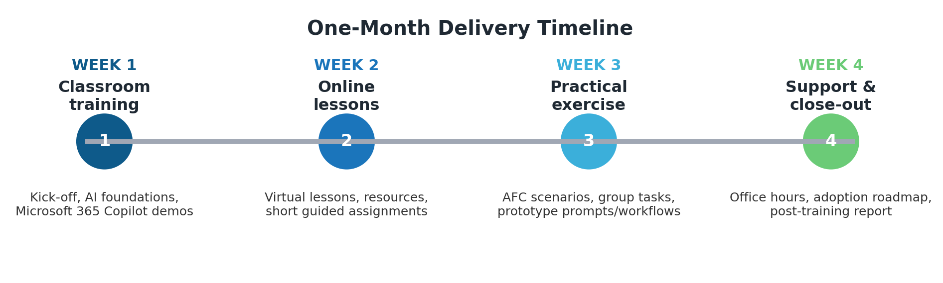

3.3 Detailed Cohort Work Plan
The draft work plan is consolidated into a cohort schedule covering key AFC participant groups. Each group follows the same blended journey, with sessions scheduled to manage business continuity and maximise attendance.
Participant Group | Training Readiness Assessment | Physical Session 1 | Online Lesson | Physical Session 2 | Assessment Test (Online)
Exco | 1st July | 6th July | 24th July | 3rd Aug | 11th Aug
Management | 2nd July | 8th July | 17th July | 6th Aug | 11th Aug
Support Functions (HR, Risk, Audit) | 7th July | 15th July | 22nd July | 10th Aug | 11th Aug
Branches (Southern) | 9th July | 20th July | 30th July | 17th Aug | 25th Aug
Branches (Northern) | 10th July | 23rd July | 31st July | 19th Aug | 25th Aug
Technical | 13th July | 27th July | 5th Aug | 24th Aug | 28th Aug
Note: The calendar above schedules multiple AFC cohorts across July and August while preserving the one-month blended learning cycle for each participant group as far as operationally practical.

3.4 Deliverables and Outputs
- Training readiness assessment and AFC use-case alignment inputs.
- Executive-level slide decks, facilitator-led sessions and online lesson resources.
- AI productivity guides, prompt templates, workflow checklists and practical toolkits.
- Practical exercises and AFC-relevant AI workflow examples.
- Participant knowledge checks and assessment outputs where applicable.
- Post-training report, implementation recommendations and one-page adoption roadmap.
- Certificates of completion and/or qualification pathways aligned to the selected programme.

4. Appendix B: Experience, Qualifications and Learning Pathways

4.1 Institutional Capability
AI Institute Africa brings specialised AI training capability supported by academic and industry partnerships. The delivery model is strengthened by University of Zimbabwe academic rigour, Rubiem Intelligence industry expertise and the Institute’s practical AI training experience.
- Specialised artificial intelligence training capability for executives, professionals and technical teams.
- Experience translating AI concepts into practical business applications and governance practices.
- Ability to provide both short-course training and longer-term learning progression pathways.
- Capacity to support blended delivery through classroom, online, practical and advisory formats.

4.2 Accredited Certificates and Qualifications
The proposed training pathway is supported by a suite of certificates, professional competence certificates and national qualifications. These include short University of Zimbabwe courses, HEXCO qualifications and sector-specific Professional Competence Certificates.
No. | Programme Type | Certificate / Qualification | Accreditation Body | Certificate Issued
1 | 3 day course | Mastering AI for Professionals | UZ | Certificate of completion
2 | 3 day course | Mastering AI for Executives | UZ | Certificate of completion
3 | 3 day course | Mastering AI for Directors | UZ | Certificate of completion
4 | examinable | National Foundations Certificate in Artificial Intelligence | Hexco | Qualification
5 | examinable | National Certificate in Artificial Intelligence | Hexco | Qualification
6 | examinable | National Diploma in Artificial Intelligence | Hexco | Qualification
7 | examinable | Technical Certification | Hexco | Qualification
8 | examinable | Tourism and Hospitality PCC | Hexco | Professional competence certificate
9 | examinable | Procurement PCC | Hexco | Professional competence certificate
10 | examinable | Agriculture PCC | Hexco | Professional competence certificate
Certificates and qualifications schedule continued on the next page.

No. | Programme Type | Certificate / Qualification | Accreditation Body | Certificate Issued
11 | examinable | Banking & Insurance PCC | Hexco | Professional competence certificate
12 | examinable | Cybersecurity PCC | Hexco | Professional competence certificate
13 | examinable | Education PCC | Hexco | Professional competence certificate
14 | examinable | Financial Accounting PCC | Hexco | Professional competence certificate
15 | examinable | Human Resources PCC | Hexco | Professional competence certificate
16 | examinable | Law PCC | Hexco | Professional competence certificate
17 | examinable | Marketing PCC | Hexco | Professional competence certificate
18 | examinable | Policy, Defence, and Security Operations PCC | Hexco | Professional competence certificate
19 | examinable | Technical Certification | Hexco | Professional competence certificate
20 | examinable | Mining PCC | Hexco | Professional competence certificate

4.3 AFC Learning Pathway
The AFC learning pathway enables participants to move from role-based AI awareness into national qualifications, professional competence certificates, technical certification and advanced AI degree progression.
Level | Programme / Award | AFC Application | Credential
Entry / Awareness | 3-Day UZ Courses | Mastering AI for Professionals, Executives and Directors | Certificate of Completion
Foundation | NFC in Artificial Intelligence | Baseline AI literacy, responsible use, productivity tools and introductory problem solving | HEXCO Qualification
Core Practitioner | NC in Artificial Intelligence | Applied AI, data use, workflow automation and organisational implementation | HEXCO Qualification
Advanced Practitioner | ND in Artificial Intelligence | Advanced AI applications, implementation projects and technical leadership | HEXCO Qualification
Specialisation | Professional Competence Certificates (PCCs) | Sector-specific AI competence for areas such as procurement, finance, cybersecurity, HR, law, marketing, agriculture, mining and operations | HEXCO Professional Competence Certificate
Technical Skills | Technical Certification | Skills-based technical validation for practical AI implementation roles | HEXCO Qualification / PCC
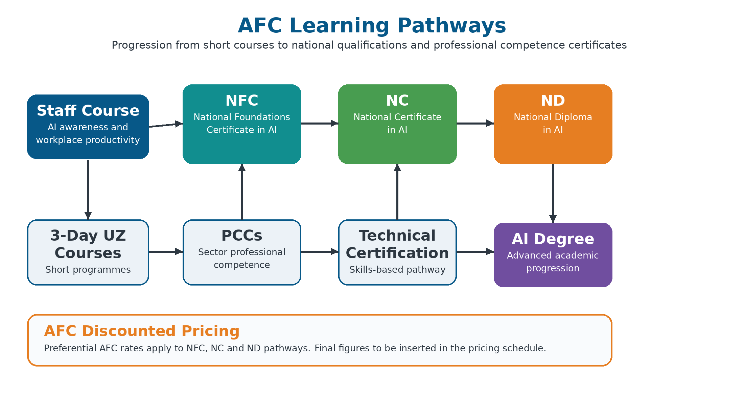

5. Commercial Compliance Note
In compliance with the RFP instruction, commercial pricing is provided in a separately sealed financial proposal. Preferential AFC discounted rates apply to the selected learning pathways, with final figures to be inserted in the financial proposal/pricing schedule.
This technical proposal therefore focuses on methodology, work plan, qualifications, learning pathways and delivery capability.

