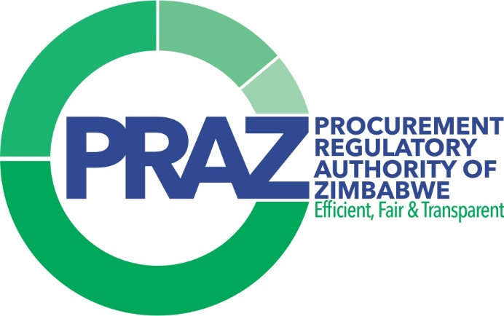
Welcome to the electronic Government Procurement (eGP) System, supplier registration steps (manual).

In this manual, we will take you through the following steps…

CONTENTS
Q1: How to register with eGP System? 1
Q2. How to Login as a Supplier and Complete your Supplier Profile 1
Q3: Dashboard, check notification and view pending tasks 2
Q4: Apply for categories, make payments and Submit an application. 3
Q5: How to provide clarification to PRAZ? 4
Q6: How to download certificate? 4

Q1: HOW TO REGISTER WITH EGP SYSTEM?

On your internet browser, please open https://egp.praz.org.zw The site will open the Landing Page of eGP System. Click on “Signup” at the top right of the eGP System landing page, the system will open the Supplier Registration Form. Please fill the forms with required details which includes Email Address, password and then confirm password for logins and other details of Primary contact person of the organization.

**Please note that the provided email address should be unique and should not be used as a part of any registration in eGP System.

**It is important to note that you have to choose the security question as desired and answer the question of choice carefully as it will be asked during the reset of your password.
After completing the form, the system will send an OTP on your email address to verify that the email provided is valid. Open your inbox and check for the OTP. If your inbox has not received the OTP email kindly check in your SPAM folder and mark the eGP System email not a SPAM. Insert the OTP on the signup form. Please note that OTP is valid for 5 minutes only.
eGP System will prompt a message “OTP Verified successfully”. You (The supplier) will now be taken to the Login Page.
-----------------------------------------------------------------------------------------------------

Q2. HOW TO LOGIN AS A SUPPLIER AND COMPLETE YOUR SUPPLIER PROFILE

Please Open https:// egp.praz.org.zw. This will open the Landing Page. Click on “Login” at the top right of the eGP System landing page.
On the login page, click Select Login as Supplier in the first box of drop-down field, type your email address that you used during registration (e.g. userid@emaildomain.com) in the second box and in the third box, type the password that you used when you registered. Then click on the Log In button. After a successful login, the system will route to Supplier Organization Profile where you have to fill in the required details

Step 1: Select the option either local organization or foreign registered organization.
Step 2: Select the Organization Type
Step 3: Fill in the Organization Name: if you are previously registered with PRAZ, then you have to fill the exact company name as per your 2023 PRAZ Certificate.
Step 4: Fill in the Organization Registration Number: as per your Certificate of Incorporation, say from deeds and companies, e.g. 2564/2014 or Partnership number or PBC registration number.
Step 5: If you were previously registered with PRAZ, then enter the exact PRAZ registration number without space or without special characters. PRAZ registration number generally starts with PR.
Step 6: Select the Company/Business Owned By: It is mandatory to Upload Supporting Document: other than the “Other” selection option.
Step 7: Fill in the organization address details.
Step 8: on the Primary contact section, there is no need to fill in as the system will fill in automatically the form from previously filled in information.
Step 9: Organization Bank Account Details: At least one bank account is mandatory. Please note that the bank account details will be used for any future refunds from PRAZ.
Step 10: Click on the Update and Continue, and this will take you to Step two of Organization Profile.
Step 11: Fill in the Director's Details by clicking on the Add Director button. It is mandatory to fill the exact number of all director details as per company registration form CR 14 old companies or CR 6 for new companies.
Step 12: Fill in the Shareholders Details by clicking on the Add Shareholding Information button. It is important to fill in the exact Shareholders information per company registration form. And proceed for clicking on Continue to Next Step.
Step 13: The system will ask for uploading of supporting documents. It is mandatory to upload the exact required supported documents in pdf format. In case of inaccurate or wrong information, your application will be rejected.
Step 14: Check the declaration and click on Save and Complete. The eGP System will redirect you on the category selection page.

From here, the system will allow you to update company profile by clicking on Menu > Organization > Update Organization Profile. Please note that some of the information is filled in once.
------------------------------------------------------------------------------------------------------

Q3: DASHBOARD, CHECK NOTIFICATION AND VIEW PENDING TASKS

Dashboard> Pending Task
Once you are logged in, the system will show you a dashboard having the listed pending tasks. Pending tasks will highlight the task you have to perform. By clicking on Count, the system will take you to the list of applications where you need to perform the task. E.g. Give clarification on your application.

Dashboard> Menu
By clicking on Menu, the system will show you the following menu item:

- Organization: This menu allows you to view, update or download the organization registration certificates.
- Category Application: Apply Category, Pending Category, Approved Category and Approved Application
- Bulletin Board: Allows you to view Latest Tenders, Past Tenders and Annual Procurement Plan
- Manage Key Pair: the system allows you to apply and manage Key Pairs secure and encrypt your data.
- Event Management: the system allows you to view and work on Invitation to Bid, My Opportunities and My Award Notices.
- Challenge/ Review: Allow to raise or respond to challenges of the tendering process.
- Useful Downloads: Uploaded help manuals and documents released by PRAZ will be listed for downloading.
- Audit: You can view the audit trail of your organization.
- Notifications: There is the bell icon at the top of the menu bar. This option will allow you to view the various notifications or tasks to be performed, e.g. the system will send a notification where PRAZ seeks clarification on your category application or when you are being invited for tender.
- Update primary contact profile
- By clicking the name and on profile system, the system will allow you to update your profile.
------------------------------------------------------------------------------------------------------

Q4: APPLY FOR CATEGORIES, MAKE PAYMENTS AND SUBMIT AN APPLICATION.

Once your organization profile update task is completed, please click on the Category application menu from main menu.
- Click on Apply category sub-menu.
- Then click on Select Category button on the top right corner of the category list page. A pop-up window with the list of categories will be displayed.
- Click on the check box available under action column and then save. Confirm the selection by clicking Yes and then click on OK to close the dialog box.
- Now, you will be able to view the select payment mode option against the category you have selected. Click on the select payment method button and select the payment option as required and then save. Confirm the selection by clicking Yes and click on OK to close the dialog box.
- Now click on Proceed to Checkout button available on the page. Click on Yes to confirm. The system will take you to the payment page where details of the category selected and amount required to pay will be displayed. Select the currency type that you want to pay in from the dropdown.
- Accept the disclaimer by clicking on the checkbox and then click on proceed to payment button. The system will ask for confirmation and by clicking Yes confirm the same.
- Once confirmed, the system will display the invoice generated which needs to be settled to complete the process. Click on proceed to payment for which the system will ask for confirmation. By clicking Yes to confirm the same, the system will show your wallet balance notification.
- Now you can settle the invoice by making an online payment utilising your wallet balance or by making a bank transaction.
- To settle the invoice, if your wallet balance is not sufficient you can top up your wallet balance by clicking Proceed with online payment button. The system allows to top up your wallet balance by using the Paynow option. Top-up using that option and settle the invoice.
- Or to settle the invoice by making a Bank Transaction, click on procced with Bank Transaction. The system will allow you to settle the invoice by bank transaction reference number, bank name, transaction date and uploading the proof of payment document. Once completed click on upload document and send for payment approval.
NB: after sending for payment approval, it may take up to seventy-two (72) working hours to get the payment and documents approval.

------------------------------------------------------------------------------------------------------

Q5: HOW TO PROVIDE CLARIFICATION TO PRAZ?
If there is clarification required by PRAZ, there will be a notification which will also be available under pending task of actions. By clicking on the count or proceed button, the system will take you to the category pending for approval. Click on the action column to view the comment. Read the comment and amend or update accordingly. Put your comment and click on submit.

------------------------------------------------------------------------------------------------------

Q6: HOW TO DOWNLOAD CERTIFICATE?
- Once your application is approved, you are then able to download the supplier registration certificate for your category.
- Login to the system and click on Menu
- click on Download Certificate and eGP system will redirect you to the approved category list.
- Refer to the last column named Action and then Click on Select > View and Download Certificate.
- The system will show the preview of the certificate.
- To download Certificate, click on Download Certificate button. System will download your PRAZ registration Certificate in the PDF format.

Thank you for registering on the electronic Government Procurement (eGP) System
#InclusivityInPublicProcurement

