ZMC Registration and Accreditation System Review 1
- Home page
- Work on the aesthetics of the home page and ensure the green colour blends with a diminished opacity and the ZMC building is a bit more visible.
- Include system timeout to avoid idleness in the system.
- Upon login roles should be automatically selected and not request a user to select a role, since the login credentials are already in the system.
- Sign In page
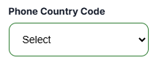
- Add all countries in the ‘Phone Country Code” & change the phrasing to “Country Code” only
- Media Practitioner Accreditation Dashboard
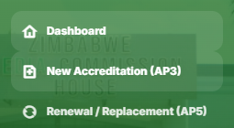
- Separate the renewal and replacement link and ensure that it is also separated as well for the staff members’ portal.
- Notices & Events - should appear direct from the website in an aesthetic way.
- Downloads - should also appear as they are from the website (this means, create a design that is almost beautiful as the design in the website).
- Requirements - should also appear as they are from the website (this means, create a design that is almost beautiful as the design in the website).
- How it works – Remove the section of Expected Timelines.

Just write applicant
- New Accreditation (AP3) – Link
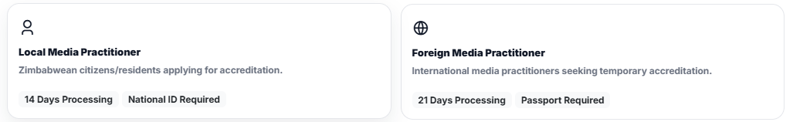
- Remove the processing days
- Remove. “Zimbabwe Media Commission Act (2020) and leave the statutory instrument.
- Let people type as it is in the box and reject those that did not insert properly;
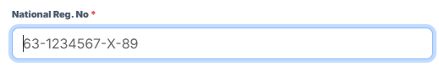
- Add all countries and their 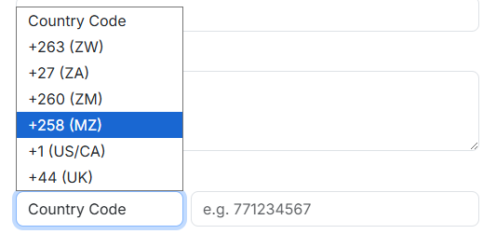
- Add a drafts tab for easy tracking of the application in progress; 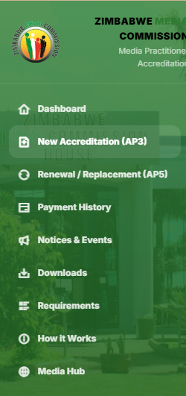
- Let it automatically pick the date and time for when the declaration is being submitted;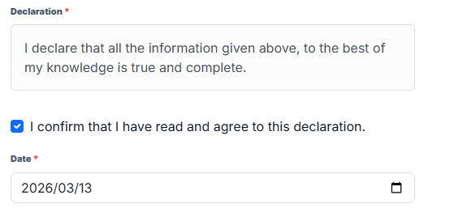
- Put sample of the past work tab where people would upload their samples.
- Add info boxes with option to add another row for people to add web links to their work which are online as well and make it optional for those who would want to add links.
- There is need to change the appearance and text arrange on this review application section,
- The submission part is taking time, not submitting and it needs to be fixed; 
- Renew/Replacement – Link
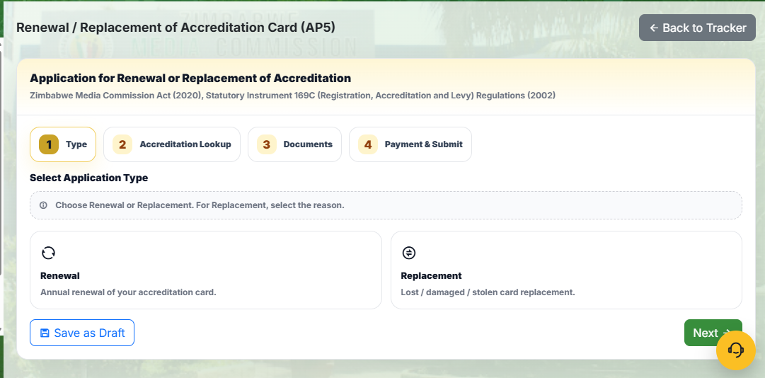
Separate the renew and replace links, ensure that the renewals and replacements are separated and it also reflect in the database.
- Add the accreditation number and the national ID number for locals & accreditation number and Passport number for foreigners. 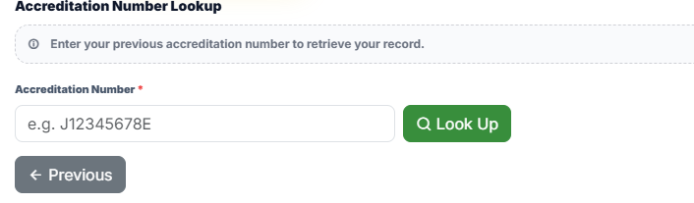
- NB: Ensure that the payment will be done automatically via Pay in the applicant’s portal as they submit.
- Media House Registration Dashboard.
- This dashboard is almost similar to that of Accreditation.
- Accreditation Officer – Dashboard
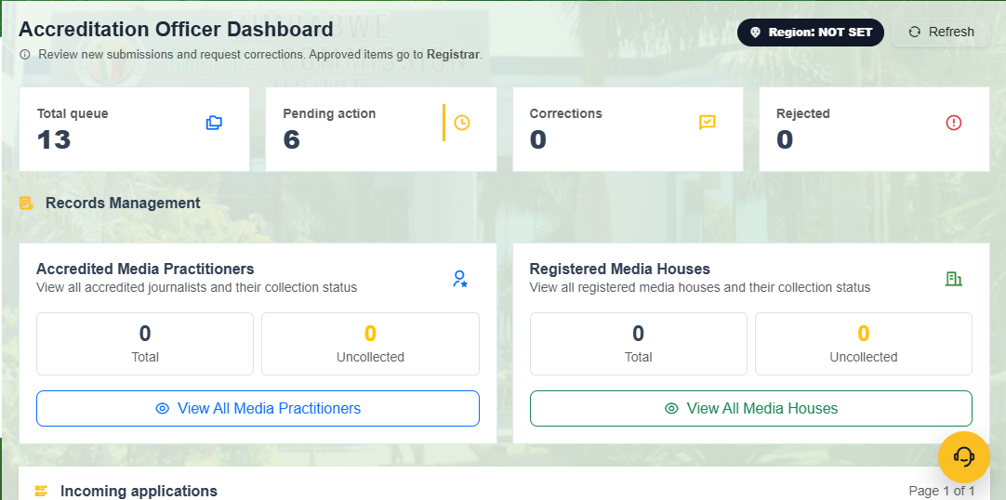
- Remove the rejected link on the dashboard, on the Accredited Media Practitioners and Registered Media House, indicate the total application and processed for the year.
- On the applications, remove the rejected and leave returned for correction.
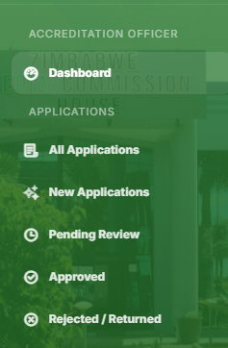
- All applications will be those that have been send by applicants.
- Change the New Application to Recent Application (since these will be the incoming once).
- Pending review will show all applications that have not been attended to by the Officer.
- Approved, will show all application that have been pushed for production
- All Applications
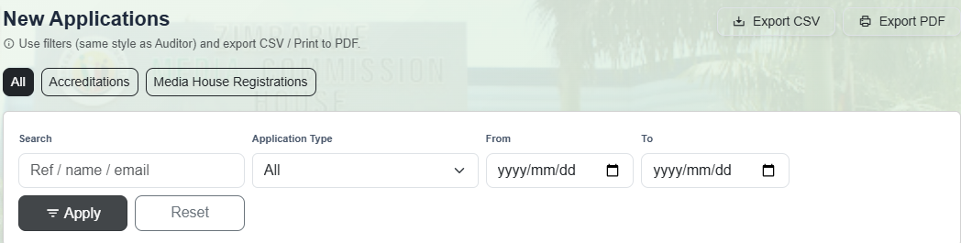
- Incoming application must not be exported.
- They can be filtered by name, application type (for Accreditation -new, renewal and replacements & for Registration – new, renewal and replacement, this should also separate local and foreign) email address, application reference number, date, month and year.
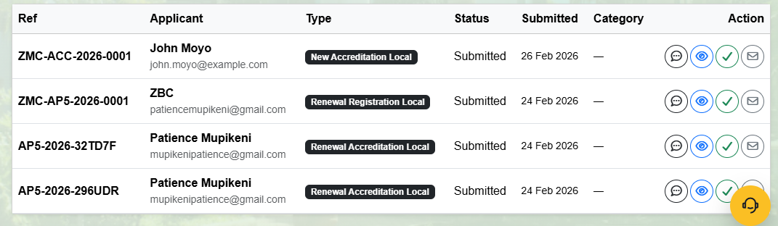
- Fields of application’s data to show here must be, application’s reference number, Applicant’s Name and email address below the name, Type, Submission date and add time (Remove the status – its repetition because the application is already submitted & remove the category because it is yet be assigned in the stage) and Action.
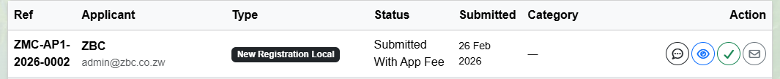
- NB: On the action, on the message Icon change all other functionality and push the functionally of seeking guidance from the Registrar in the event that the application is a bit complicated and it needs the supervisor’s perusal and approval.
- News Applications to be changed to Recent Application
- Filters will be the same as those suggested for All Applications.
- Pending Review
- Filters will be the same as those suggested for All Applications.
- Approved
- Filters will be the same as those suggested for All Applications.
- Returned
- Filters will be the same as those suggested for All Applications.
NB: Data for the above links from All Application going to Returned must not be exported, Only the records data should be exported since it is the actual database link.
- Production Queue
- On this link seems to be a repetition with the approved link. However, this production queue needs to show actually in the production dashboard where the processing and printing activities are done.
- Filters should be the same as in All Applications
- Physical Intake
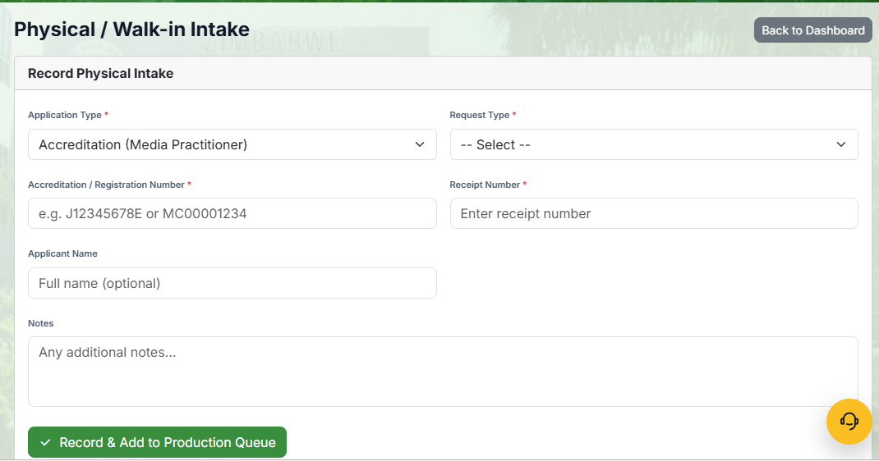
- I believe the accreditation number to be uploaded here will automatically push the added application to the right database. The appearance of the above fields seem to work for renewals better, there is need to clearly ensure how will a new application be processed outside the normal way as well as making it easier to collate the data recorded from this end to the one which is coming from applications.
- Record (This is the sections that links us to our database)
- Data analytics should be here for the officer to ensure generation of graphical reports.
- All of the data in this section must be exported in various formats.
- The following are the fields that should appear for each tab;
Accredited Media Practitioners
- Media / Accreditation number (Primary Key)
- Applicant’s name
- Organization
- Category
- Valid from
- Valid to
- Month
- Year (Very important for historical data)
- ID number (Primary Key number 2)
- Photofield
- Marital status
- Sex
- Date of birth
- Birth place
- Nationality
- Home address
- Town
- Province
- Phone number
- Cell number
- Telephone
- Medium
- Designation
- Email address
NB: The fields must be presented for each year’s accreditation record, which is something the current offline system is not doing rather it is wiping data each time a person has updated his/her accreditation each year in the system.
Registered Media Houses
- The data must be exported here, and the data must be presented in fields as indicated below;
- Registration number (Primary key)
- Organization / Media company
- Directors (Indicate their sex)
- Shareholding structure
- Office address
- Telephone(s)
- Phone
- Email
- Webiste
- Category
- Registration status
- Registration date
- Registration year
- Publication / Service (This should have a drop-down menu for those with many services or publications and when one clicks; they must be able to see the following fields for each service or publication;
- Type (Digital platform, Magazine, Newspaper, Newsletter, News Agency, Production House, Advertising)
- Print/online (Yes/No, or Both)
- Frequency (whether daily, weekly, bi-weekly / fortnight, monthly, bi-monthly, quarterly, annually e.t.c)
- Language
- Focus (Type of content)
- Scope (National, Community, Foreign, Regional, Advertising, Online, Print, In-house, Production)
- Reach (The cities or towns)
- Provincial reach (All 10 provinces)
- Editor/ Manager / Head
- Web address
- Email
- Telephone
- Phone
- Operational status (Yes/No)
- Previous renewal year
- License status
- License expiry date
- License expiry year
- Operational status
NB: Data in the database should be editable upon request and approval by the registrar in the Accreditation Officer’s Dashboard.
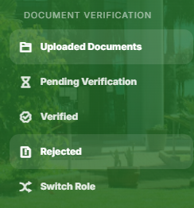
- This section must also be a database section, where we are able to get the uploaded documents of all applications;
- We must also be able to download by searching a particular applicant using their registration / accreditation number, therefore, this means the above suggested fields should be used in the tab of the Verified to be change Approved.
- Change rejected to returned.

NB: Add 2 switches that is witch to Production (This where the officer will then go the create and print all the approved cards/certificates) and Designer (This is where the Officer will do the designing of the media card and the certificate, either by restructuring their appearance and uploading the designs for each year).

