ZMC Registration and Accreditation System Review 2
NB: In Media House profile, add functionality for batch processing where they have restricted access to Media Practitioners in our database and they can select the media practitioners they want to push for batch processing and proceed to pay by uploading POP or via pay now or cash Payment.
NB: Media Services should be able to view a list of Media Practitioners within their domain on the portal, as well as notify the Commission on those that are no longer part of them. Once batch payment is done individual notifications to the batch accounts should be sent highlighting that the journalist should proceed to renew as payment has been done.
NB: The Accountant and Accreditation Officer should also be able to see applications that have been processed as batch from the Media House Profile.
NB: Create profiles for;
- PR
- Public Information Compliance
- Research, Training and Standards Development
ACCOUNTANT PROFILE
- Overview – Accounts / Payments Dashboard
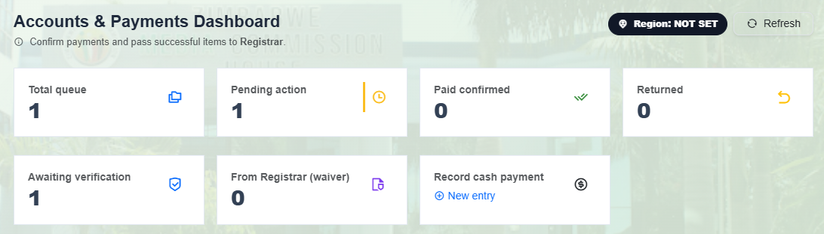
- Change Total Queue to Total Applications (These fields must align with those of the Accreditation Officer).
- Add Paid via Pay Now Link (For all applications that have payments that are automatically processed by Pay Now).
- NB: The Accountant should receipt the payment notification and references automatically from Pay Now after every transaction.
- Add Paid via Uploads Link (This link shows all approved applications paid by uploads, cash payments, waivers or exemptions).
- Pending action (Must only show applications that have uploaded payment proof such as POP, Receipt, Waiver or Exemptions that are yet to be confirmed and approved by the accountant after being pushed by the Accreditation officer – after being approved they must go directly to the production dashboard as well as appearing on the Accreditation Officer’s dashboard).
- Paid Confirmed Link – Must be changed to Approved (Paid – must be in brackets). This link will show all the cards approved for printing and the Pay Now reference number should show as well.
- Awaiting Verification – Kindly remove this link since it is a repetition of the Pending Action Link.
- 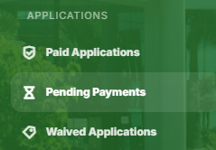 NB: Clarify on what will be happening on pending payments.

- Remove audit reports

- Remove User Action Logs (This is the responsibility of IT, hence move this function to the IT role)
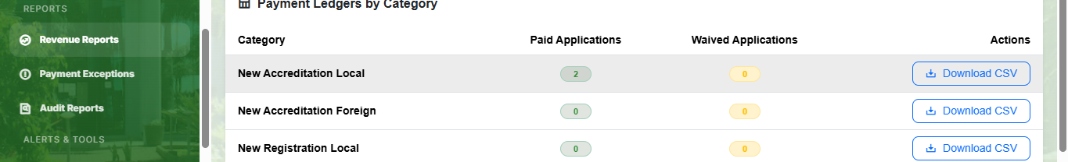
- For each and every category the option to download should be present as well as the option to view a dashboard with analytics in the form of graphs and trends for each and every category.
- NB: Incorporate a digital receipt functionality where finance will send a copy of receipt of payment to all applicants that have paid.
REGISTRAR PROFILE
NB: The Commission agreed that the Accreditation Officer approves application for printing. However, the Officer can request guidance on complex applications from the Registrar before approving.
NB: The Registrar now supervises the actions conducted by the Accreditation Officer.
Overview
- Registrar Dashboard
NB: The Registrar should able to review all approved applications and indicate by ticking check boxes that an application is reviewed and if there is an anomaly, he/she should be able to flag it. The Accreditation officer must also be able to see all reviewed application and those which are not yet reviewed by the Registrar.
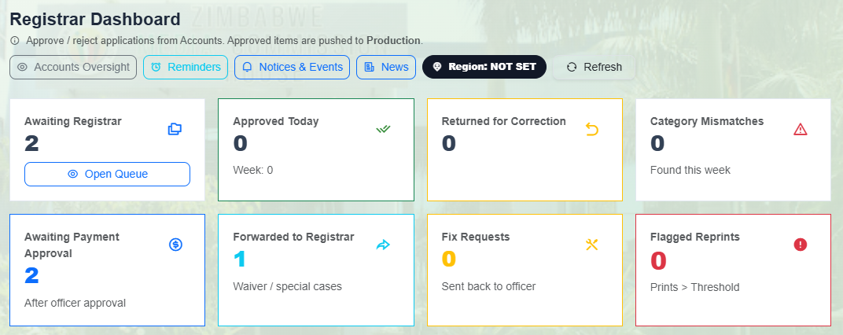
- Awaiting Registrar should be changed to All applications.
- Returned for correction should show all applications returned by the officer.
- Forwarded to Registrar, that’s where complex applications are and the registrar has to be responded by sending a noted to the Officer.
- Category Mismatch should be removed.
- Fix requests should be removed.
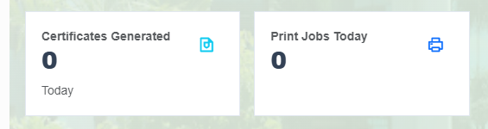
- Print Jobs Today should be changed to cards generated.
- Activity Feed should show the activity between the Accreditation Officer and Accountant since the Registrar’s job is supervisory.
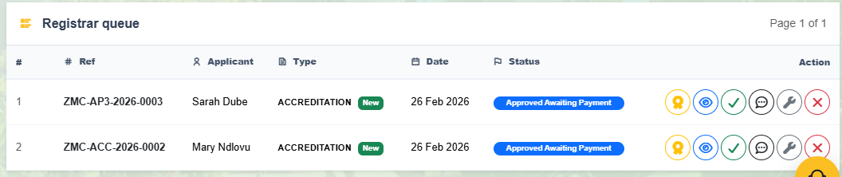
- On the Registrar’s queue, the reassign option should to the Accreditation Officer since she/he has the responsibility as the applications are being processed.
- All the other options should be removed and then keep 2 options which are view application and send message to the Accreditation Officer.
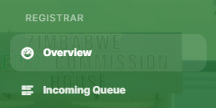
- On the incoming queue, the Registrar should be able to view all applications and their status. There must also be filtering options in accordance to the fields of the Accreditation Officer.
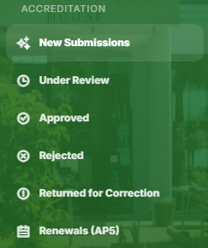
- New Submissions should be to change to All applications and the Registrar must be able to filter those approved, those awaiting approval and new applications.
- Approved tab should categorize, renewals, new applications and replacements.
- Rejected should be removed
- Returned for correction should show all applications returned by the Officer and the reason.
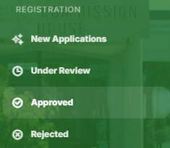
- New Submissions should be to change to All applications and the Registrar must be able to filter those approved, those awaiting approval and new applications.
- Approved tab should categorize, renewals, new applications and replacements.
- Rejected should be removed
- Returned for correction should show all applications returned by the Officer and the reason.
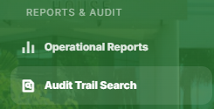
- Operational reports should show the activities of the Accreditation Officer regarding the Accreditation and Registration applications.
- Audit Trail Search should be removed since there is an activity feed already.
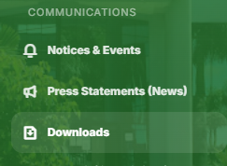
- On Downloads, the Registrar must download content related to registration and accreditation only.
- NB: All profiles should be able to see notices, events and news but without rights to perform any action.
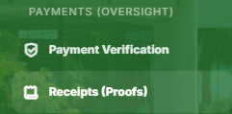
- Registrar does not have payments oversight, it’s the responsibility of the chief accountant, however the registrar and the accreditation officer should be able to see payment statuses for all applications
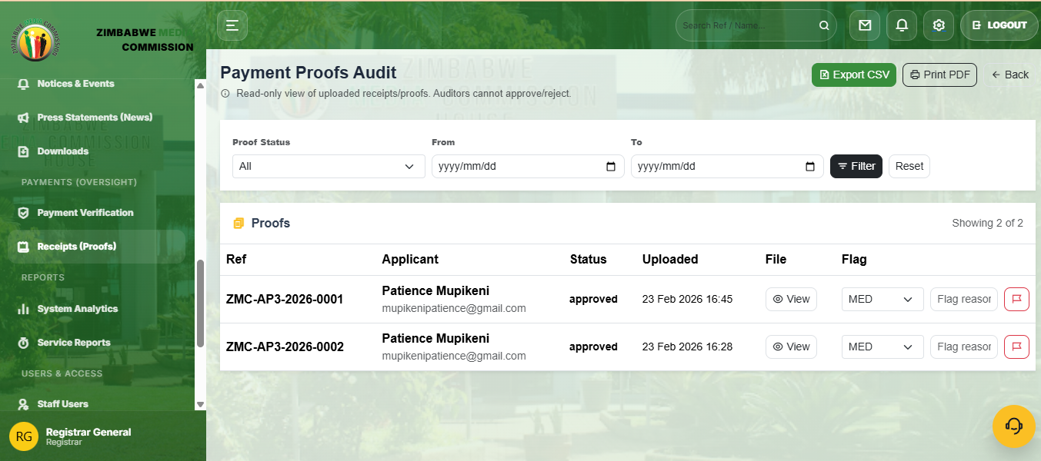
- The Chief Accountant, Auditor and the Super User are responsible for viewing payment proofs.
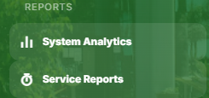
- NB: The records tab on the Accreditation Officer’s Dashboard should also be seen here.
- The Registrar must be able to download and print reports.
- Analytics must be related to the accreditation and registration only, system analytics are for IT, Auditor and Super User (Analytics must be downloadable).
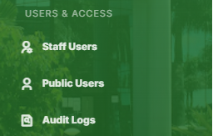
- Users and Access Tabs should be removed since it is the responsibility of IT and the Super User.
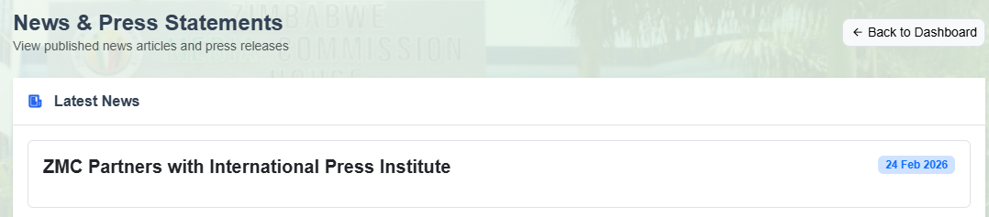
- News and Press Statements should be clickable to read more.

AUDITOR DASHBOARD
NB: Change rejected to returned for all tabs.
NB: Apply the design for analytics in this Dashboard on the Dashboards, for instance, IT, Registrar, Accreditation Officer.
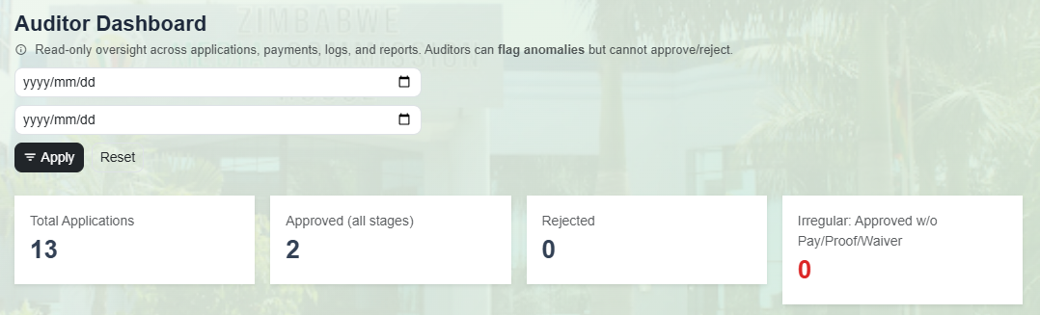
- Remove the irregular tab and change rejected to returned for correction.

NB: Add security oversight on IT Dashboard and Super User
Super User
NB: The Super User has all the rights to perform any action.

IT ADMINISTRATOR PROFILE
- IT Dashboard
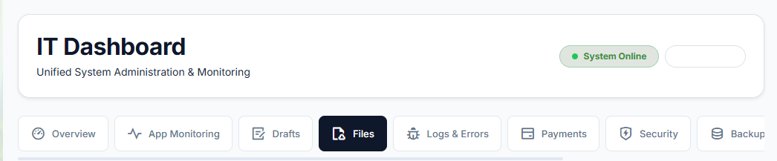
- On the Draft Section, IT, Accreditation Officer, Registrar and Accountant should be able to see the drafts. However, the system must give a disclaimer to the applicant that an application will be in the drafts for a certain period and once the period lapses, they will have to restart the application process and the draft is deleted. This ensure that the system does not keep idle data for long. (A period of 2 weeks). Kindly remove the recover option and place review (IT, Accreditation Officer, Registrar can only review the application).
- On the files section, IT Must not download any file – They can only see documents or files uploaded in the system but not given the authority to download since the documentation is not their responsibility (This function should go to the Registrar and the Accreditation Officer).
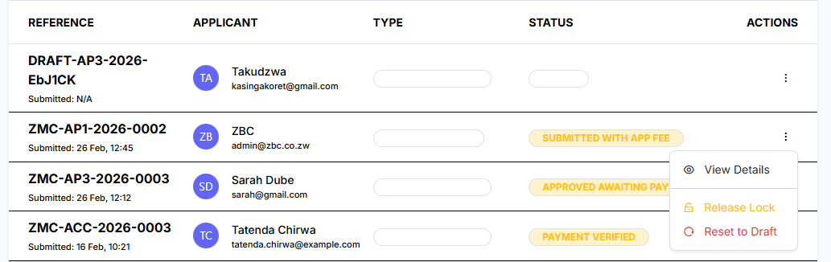
- NB: What does release lock and release to draft functionality do to the application?
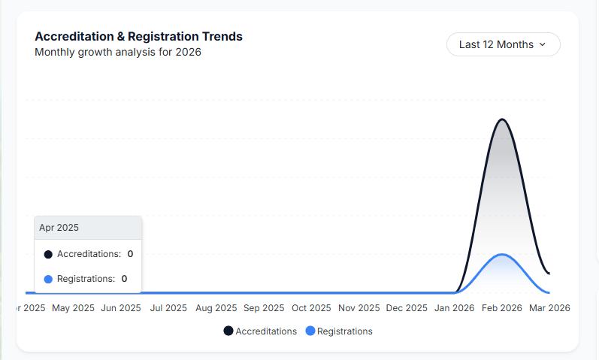
- Accreditation and Registration trends should be removed from IT and pushed to Accreditation Officer, Registrar, Super Admin, Director Media Development and Governance, Auditor, Chief Accountant. IT must not review these trends because it is not its responsibility to monitor these trends.
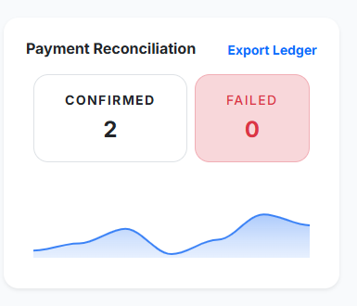
- This section should be removed from IT (it is not its responsibility to track payments and reconciliations) and pushed to Finance (Chief Accountant and Accountant, Audit and Super User).
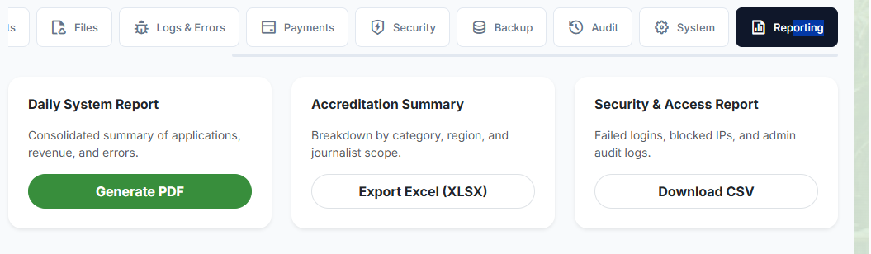
- The Accreditation summary should be removed from IT and pushed to the Accreditation Officer, Finance (Chief Accountant and Accountant), Auditor, Registrar, Director Media Development and Governance and Super Admin.
- On the Daily System Report, IT should not monitor revenue, this is the responsibility of Finance (Chief Accountant and Accountant), Auditor and Super User.
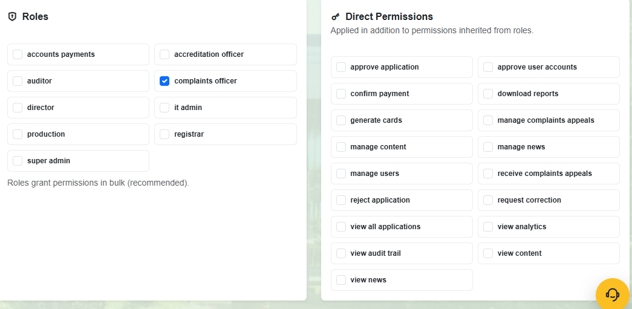
- All Actions in the system for each and every role or profile should be listed on the Direct Permissions. However, the Auditor and Super Admin should be able to see actions taken by IT in the system particularly when some has been assigned a role or a function (There must be an audit trail showing, date, time e.t.c.).
- When IT assigns another role for an already existing profile, it must be able to assist the person to have temporary credentials.
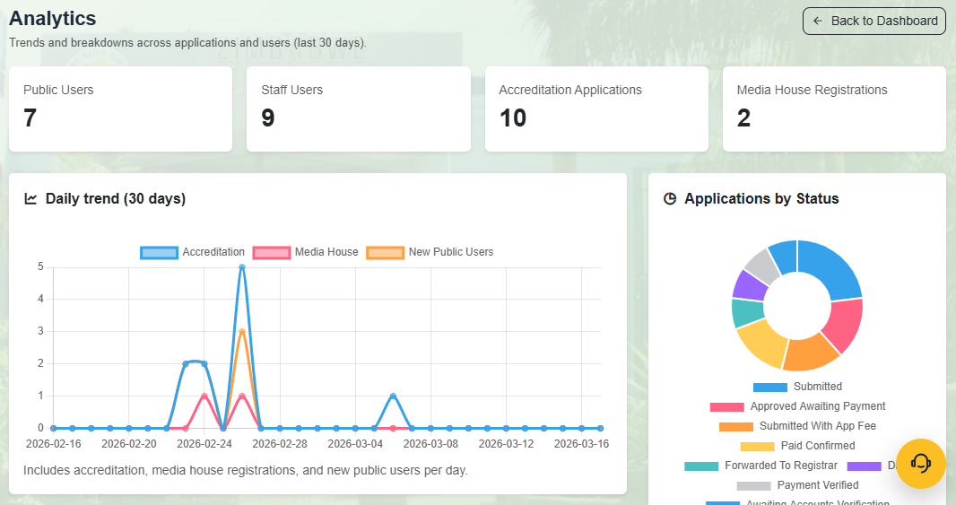
- These analytics on this dashboard should show on the following profile; Accreditation Officer, Audit, Finance and Registrar, Director Media Development and Governance, Super User (But more detailed).
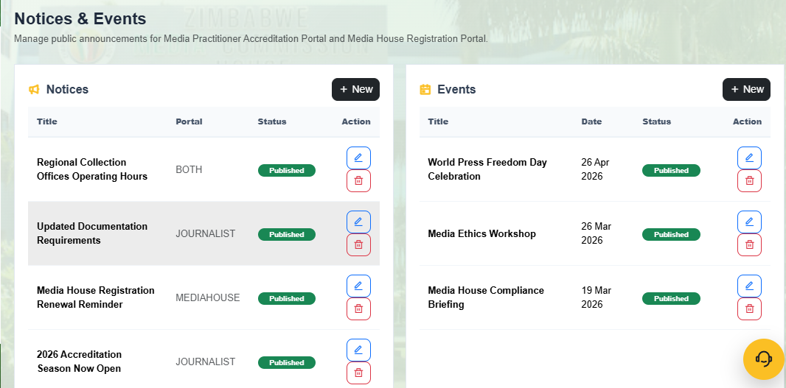
- Uploading Notices and Events should be removed from IT and pushed to Public Relation Officer, since it is the responsibility of PR.
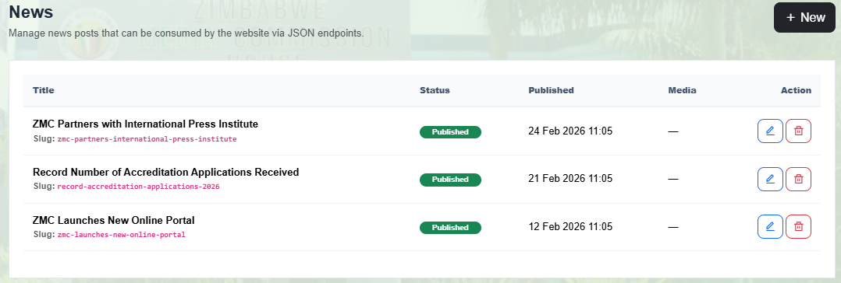
- Uploading News should be removed from IT and pushed to Public Relation Officer, since it is the responsibility of PR.
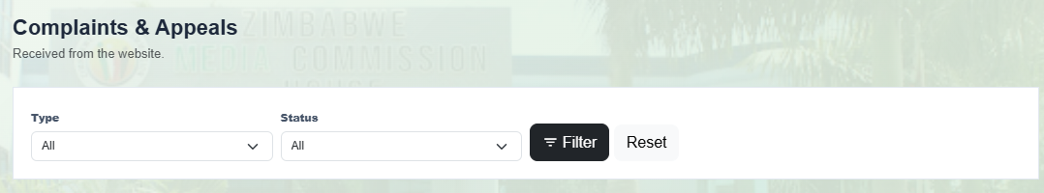
- Complaints and Appeals should be removed from IT and pushed to Public Information Compliance Manager, since it is their responsibility.
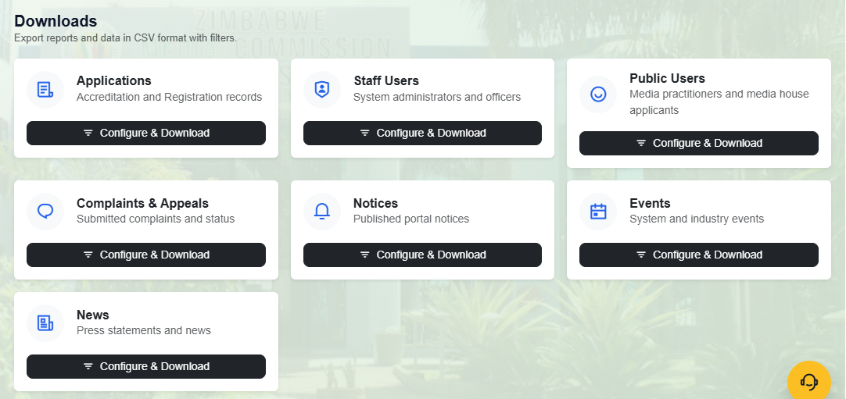
- Remove Applications (its for Accreditation Officer, Registrar, Director Media Development and Governance) and Complaints and Appeals (Complaints for Research, Training and Development, Director Media Development and Governance & Appeals for Public Information Compliance) from IT. Audit and Super User can see everything.
- NB: On analysis may you kindly add in more visualizations like doughnut chats and other types of visualizations.
NB: Notice, Events and News tabs should appear on every profile but without the option to download. The option to download should remain with PR.
NB: Access to CPANEL and access to admin porta for the website to be able to upload content.
DIRECTOR DASHBOARD to be changed to DIRECTOR MEDIA DEVELOPMENT AND GOVERNANCE DASHBOARD
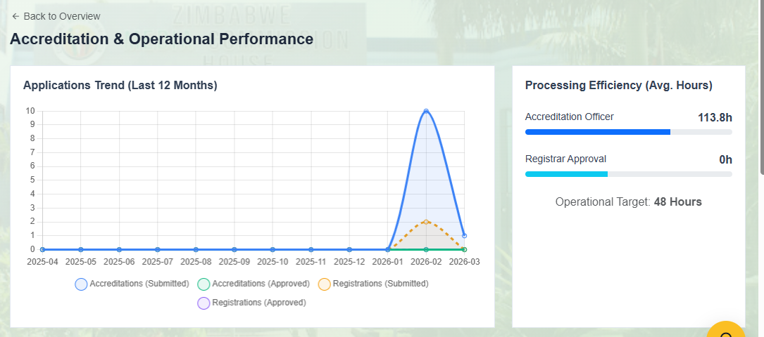
- Change Registrar Approval to Registrar Reviews.
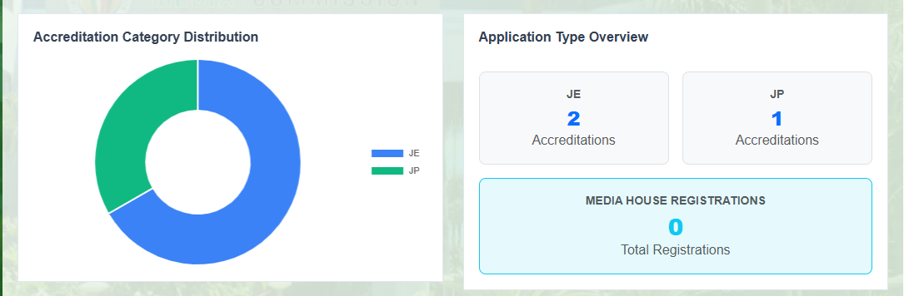
NB: The Registrar should be able to see the accreditation performance as is above.
NB: Add some of the function on the Director’s Dashboard to the Auditor.
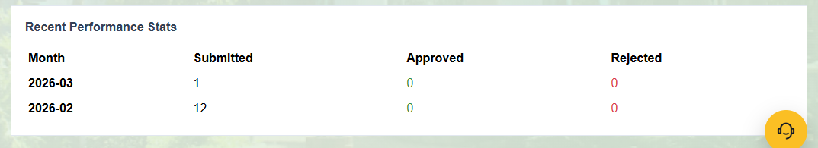
- Change rejected to returned for correction.
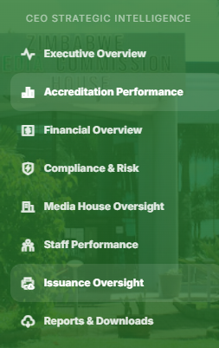
- Change CEO Strategic Intelligence to Director MDG’s Strategic Oversight
- Change Executive Overview to Overview.
- NB: Add Financial Overview and Compliance and Risk to the Auditor’s Dashboard.
- Remove staff performance, it is the responsibility of the Super User.
Super Admin Dashboard
- Make sure all the functions and actions in the system are under his/her supervision with the help of IT.
NB: PROFILES TO BE CREATED AND THEIR ROLES
- Public Relations - The PR is the one responsible for uploading news, events and notices as well as updating the gallery on the website.
- PR should be able to view analytics on website traffic as well as trends.
- The PR department shall be responsible for posting and uploading notices, vacancies, tenders and all available openings.
- Public Information and Compliance – He/she must be able to receive uploaded appeal documents and the payment status. He/She must have analytics and be able to download documents and reports.
- NB: The Auditor and Finance should also view their payment records.
- NB: The accountant should also view and process FOIA payments.
- Chief Accountant – should supervise the activities of the accountant in relation to accreditation, registration and FOIA appeals.
- Research, Training and Standards Development – He/She should receive the complaint documents, enquiries or emails. There must be analytics in this profile.

