SIMATS ENGINEERING
ASSESSMENT TOOL 2

COURSE NAME: CSA0709
COURSE CODE: Computer Networks

COURSE OUTCOME COVERED
CO1: Apply the functions of OSI layer in enabling reliable data transmission across
networks. (BL2, BL3)
Assessment Tool Weightage: 30%

Annexure A
CONCEPT MAPPING

Dr.V.PARTHIPAN

Code of Conduct:
I RUCHITA.S(192572081) certify that this submission is my original work
and that I have adhered to the guidelines specified for this assessment.
I understand that any violation of academic integrity rules will result in disciplinary action.
Signature of the student:
RUCHITA.S (192572081)

CSA0706 COMPUTER NETWORKS SLOT C

Annexure A – Concept Mapping (With Questions )

1. A partially completed concept map is given below:
Question:
Application → Presentation → ______ → Transport → Network → ______ → Physical
Analyse the missing layers and explain how their functions are essential for reliable communication.
Answer:
Same missing layers as before (Session and Data Link), but here's a different way to think about why each one exists, using how a courier company operates.
Session is like a courier keeping track of an ongoing back-and-forth exchange with a customer — remembering that this delivery and the previous one belong to the same conversation, and being able to pause and resume if something interrupts it, rather than treating every letter as a brand new, unrelated interaction.
Data Link is the local courier van itself: it doesn't care about the letter's final city, only about getting the sealed package to the correct house on its route, checking that the package wasn't damaged during the short hop from the sorting hub to the doorstep. Without this layer, the sorting hub could decide which city a package should go to, but there'd be no mechanism to actually get it the last few kilometers to the right address.

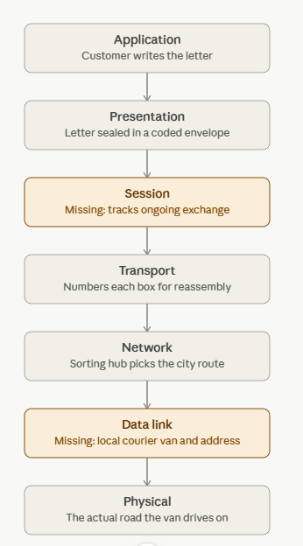
2. Construct a concept map linking data units (Segment, Packet, Frame, Bits) with their respective OSI layers and analyse how transformation of data units supports transmission.
Answer: 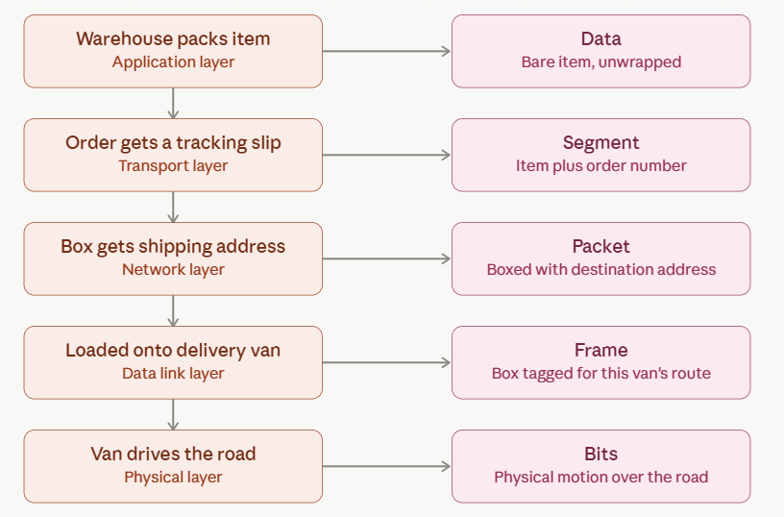
Instead of encapsulation as a generic table, here it is as a package physically getting more layers of wrapping as it moves through a shipping company.
The core idea is the same as encapsulation in networking: nothing is ever removed, only added, as the item moves down the chain. The bare item never changes; it just accumulates more wrapping and labeling at each stage, and every added layer exists to solve one specific problem for the stage that added it — tracking, addressing, or routing. On arrival, the receiving side peels these back off in reverse order, one wrapping at a time, until the original item is what's left.
3. Given the concept map:
Data Link → MAC Address → Local Delivery
Network → IP Address → Global Delivery
Explain how these relationships ensure complete data delivery across networks.
Answer:
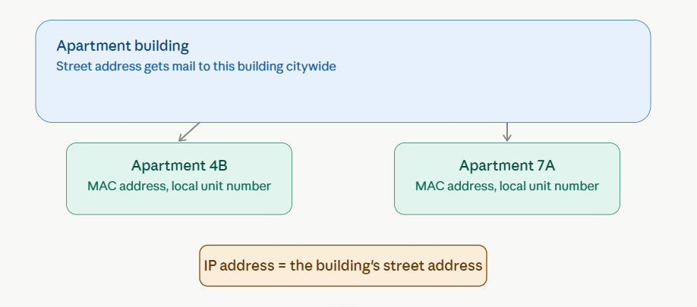
A different everyday scenario for the same local-vs-global delivery idea: getting mail delivered to a specific apartment inside a large building.
The street address (IP address) is what postal workers use across the whole city to get a letter to the correct building — it's meaningful to anyone anywhere, and it's what routing decisions are based on the entire way there. But once the letter physically arrives at the building, the street address has done its job and is no longer useful; someone inside now needs the apartment number (MAC address) to hand it to the right resident. That apartment number means nothing outside the building, but it's exactly what's needed for the last, local step of delivery.
This maps directly onto how a packet crosses the internet: the IP address gets it to the correct network everywhere along the route, and the MAC address handles the final, local handoff to the specific device once it's arrived on that segment.

4. A concept map shows:
Error Control
↓
Data Link Layer → Error Detection
↓
Transport Layer → Error Correction
Analyse how the interaction between these layers improves reliability in data transmission.
Answer:
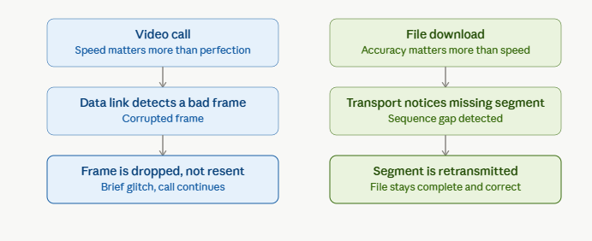
A more advanced angle than the original: instead of just describing what each layer does, this contrasts two applications that use error control very differently.
This contrast shows that "error control" isn't a single fixed behavior — it depends on what the application actually needs.
A video call typically runs over UDP, where the Transport layer does not guarantee delivery or retransmission at all. If the Data Link layer detects a corrupted frame, the best it can do is discard it; there's no time to request a resend, since by the time a replacement frame arrived it would already be too late to display. The result is a brief visual or audio glitch, which is an acceptable trade-off for keeping the call flowing in real time.
A file download typically runs over TCP, where the Transport layer actively tracks every segment. If one goes missing or arrives corrupted, Transport requests retransmission and holds the rest of the data until it arrives — because an incomplete or corrupted file isn't acceptable, even if it means waiting a little longer.
This is a good thing to understand beyond just "Data Link detects, Transport corrects": the Transport layer's error correction is a choice the protocol makes based on the application's tolerance for delay versus tolerance for imperfection.

5. Develop a concept map for web browsing using OSI layers and analyze how failure in one layer affects the entire communication process.
Answer:
Concept Map:
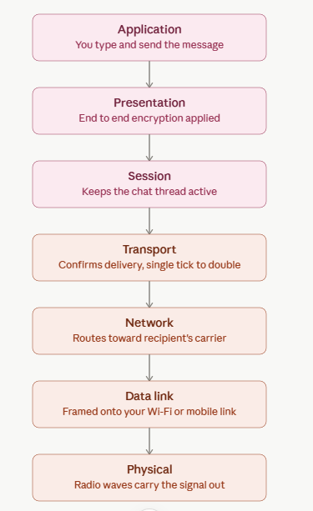
Instead of web browsing, this walks through the same OSI concept using a chat message.
The layer-by-layer logic is identical to the web browsing example, but the visible symptoms of a failure look different here:
- If Physical fails (phone in airplane mode, no signal bars), the message won't even attempt to leave the device — it stays queued with a clock icon.
- If Network fails (no mobile data route, carrier outage), the message sits stuck on a single gray tick, meaning it left the device but never reached the server.
- If Transport fails (connection drops mid-send), you might see the message fail entirely with a retry option, since the app couldn't confirm it was received.
- If Presentation fails (an encryption handshake issue), the app may show a "waiting for this message" placeholder, since it can't decrypt content it received.
Same underlying layer dependencies as web browsing, just a different, more immediately recognizable set of everyday symptoms (ticks, clocks, "waiting for message") to tie back to a specific layer.
6. A network issue is represented in the concept map:
Physical ✔ → Data Link ✔ → Network ✖ → Transport ✖ → Application ✖
Analyse the problem and explain how the concept map helps in troubleshooting.
Answer:
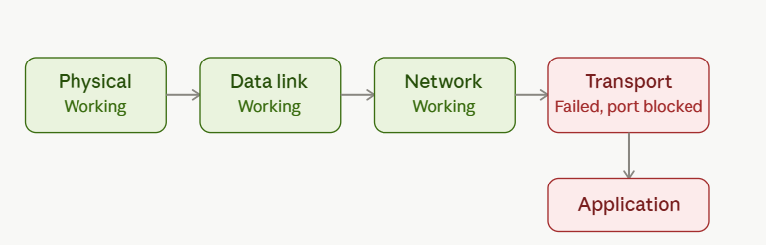
Instead of a Network-layer routing fault, here's a different, equally common real-world pattern: everything up through Network works, but Transport and Application fail.
This is a meaningfully different diagnosis from the previous scenario, and it's worth understanding why the fault sits one layer higher here.
Because Physical, Data Link, and Network are all working, the device has a live connection and can successfully route packets to the destination's IP address — so this rules out cabling, local link issues, and routing problems entirely, unlike the earlier case. The packets are arriving at the right machine.
The break happens specifically once a connection needs to be established on a particular port. This pattern is classic for a firewall or security group blocking a specific port (for example, port 443 for HTTPS, or a custom application port), or a service that has crashed and is no longer listening on that port at all. The Network layer successfully gets packets to the server's doorstep, but Transport can't complete the three-way handshake or gets rejected outright, so no session is ever established — and Application naturally fails as a result, since it never receives any usable data.
The teaching point: two failures that look identical from the user's side ("the site won't load") can trace back to completely different layers — a routing problem (Network) versus a blocked port or dead service (Transport) — and the concept map is what lets you tell them apart instead of guessing.

