Constraint-Based Problem Solving
University Exam Timetabling as a Constraint Satisfaction Problem (CSP)

PROBLEM SET-UP
Five courses, Artificial Intelligence (A), Database Systems (B), Computer Networks (C), Operating Systems (D) and Software Engineering (E), must be scheduled into 3 exam slots (Slot1, Slot2, Slot3). Courses with shared students cannot share a slot. The conflicting pairs are A–B, A–C, B–C, B–D, C–D, C–E and D–E.
- Search uses the static variable order A → B → C → D → E and the value order Slot1 → Slot2 → Slot3, as required.
- An assignment attempt is one try of a value for a variable. A rejected attempt violates a constraint. A backtrack is the undoing of an earlier accepted assignment.

(A): PEAS DESCRIPTION
PEAS | Description for the exam-scheduling agent
Performance measure | Every course gets exactly one slot.  No two conflicting courses share a slot (zero student clashes).  Only the 3 available slots are used.  Low computation effort (few assignment attempts and backtracks).
Environment | 5 courses, 3 slots (one exam per day over three days), 7 conflict pairs from student enrolment overlaps.  Fully observable, deterministic, static, discrete, single-agent, sequential (a CSP).
Actuators | Assigns or changes a slot for a course, and outputs or publishes the timetable (notice, database update, notification to students and staff).
Sensors | Reads the course list, the slot list, the enrolment data or conflict list, and the current partial timetable (which course holds which slot).

(B): AGENT TYPE
Best choice: a goal-based agent.
Agent type | Suitable? | Reasoning
Simple reflex | No | Reacts only to the current percept. Choosing a slot depends on the other courses already scheduled, so a fixed condition-action rule cannot guarantee a conflict-free timetable.
Model-based reflex | Partly | Remembers the partial timetable but has no goal to plan towards.
Goal-based | Yes | The goal is explicit: a complete assignment that satisfies all 7 constraints. The agent searches (backtracking, forward checking) for a sequence of assignments that reaches this goal state.
Utility-based | Not needed | Any conflict-free timetable is equally acceptable. There are no preferences (e.g. minimise gaps) to trade off, so a utility function adds nothing.

(C): CSP FORMULATION AND CONSTRAINT GRAPH
Component | Definition
Variables | X = {A, B, C, D, E}
Domains | D(A) = D(B) = D(C) = D(D) = D(E) = {Slot1, Slot2, Slot3}
Constraints | Binary inequality constraints:  A ≠ B, A ≠ C, B ≠ C, B ≠ D, C ≠ D, C ≠ E, D ≠ E  (7 constraints; each means "different slots".)

Constraint graph: vertices V = {A, B, C, D, E}; edges E = {A–B, A–C, B–C, B–D, C–D, C–E, D–E} (7 edges).
Vertex | Neighbours | Degree
A | B, C | 2
B | A, C, D | 3
C | A, B, D, E | 4
D | B, C, E | 3
E | C, D | 2

The graph contains three triangles (A-B-C, B-C-D, C-D-E), so at least 3 slots are needed. With 3 slots a solution can exist, and C is the most constrained variable (degree 4). The graph is drawn below:
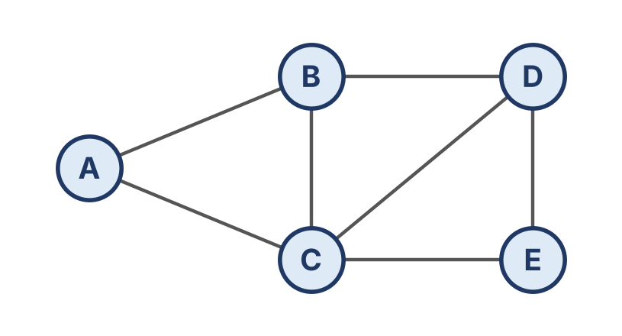
Edges in the drawing: A–B, A–C, B–C, B–D, C–D, C–E, D–E.

(D): PLAIN BACKTRACKING SEARCH
Variables are assigned in the order A, B, C, D, E and values are tried as Slot1, Slot2, Slot3. A value is checked against the already-assigned neighbours only.
Step | Attempt | Result | Reason
1 | A = Slot1 | Accept | No neighbour assigned yet
2 | B = Slot1 | Reject | Conflict with A = Slot1 (A–B)
3 | B = Slot2 | Accept | A = Slot1 ≠ Slot2
4 | C = Slot1 | Reject | Conflict with A = Slot1 (A–C)
5 | C = Slot2 | Reject | Conflict with B = Slot2 (B–C)
6 | C = Slot3 | Accept | A = Slot1, B = Slot2, both different
7 | D = Slot1 | Accept | B = Slot2 and C = Slot3, both different (D is not linked to A)
8 | E = Slot1 | Reject | Conflict with D = Slot1 (D–E)
9 | E = Slot2 | Accept | C = Slot3 and D = Slot1, both different. All 5 courses assigned.

Final timetable: A = Slot1, B = Slot2, C = Slot3, D = Slot1, E = Slot2.
Slot | Courses
Slot1 | Artificial Intelligence (A), Operating Systems (D)
Slot2 | Database Systems (B), Software Engineering (E)
Slot3 | Computer Networks (C)

Counts: 9 assignment attempts (5 accepted, 4 rejected) and 0 backtracks. With this ordering every dead end was resolved by trying the next value of the same variable, so no earlier assignment had to be undone. The result is verified: all 7 pairs have different slots.

(E): BACKTRACKING WITH FORWARD CHECKING
After each assignment, the assigned value is removed from the domains of its unassigned neighbours. If any domain becomes empty, the assignment fails at once. Domains are written as sets of slot numbers (1 = Slot1, and so on). The starting domains are A,B,C,D,E: {1,2,3} each.
Step | Assignment | Pruning done | Domains after (A, B, C, D, E)
1 | A = Slot1 | Remove 1 from B and C | A{1} B{2,3} C{2,3} D{1,2,3} E{1,2,3}
2 | B = Slot2 | Remove 2 from C and D | A{1} B{2} C{3} D{1,3} E{1,2,3}
3 | C = Slot3 | Remove 3 from D and E | A{1} B{2} C{3} D{1} E{1,2}
4 | D = Slot1 | Remove 1 from E | A{1} B{2} C{3} D{1} E{2}
5 | E = Slot2 | No unassigned neighbours left | All variables assigned

Notes: in step 1, B and C are pruned because they neighbour A, but D and E are untouched. In step 2, B = Slot2 reduces C to a single value {3} immediately. In step 3, the domain of D is forced to {1} and E is cut to {1,2}. In step 4, E is forced to {2}, so its value is known before it is even tried.
Final timetable: A = Slot1, B = Slot2, C = Slot3, D = Slot1, E = Slot2 (the same as plain backtracking).
Counts: 5 assignment attempts, 0 rejected attempts and 0 backtracks.

(F): COMPARISON
Criterion | Plain Backtracking | Backtracking + Forward Checking
Assignment attempts | 9 | 5 (one per variable)
Rejected (failed) attempts | 4 (B=Slot1, C=Slot1, C=Slot2, E=Slot1) | 0
Backtracks (undone assignments) | 0 | 0
Final timetable | A1, B2, C3, D1, E2 | A1, B2, C3, D1, E2 (identical)
Work per assignment | Checks only against assigned neighbours, when the value is tried | Prunes neighbours' domains after each assignment (extra bookkeeping)
Detects dead ends | Only after trying the bad value | Early, as soon as a domain becomes empty

Forward checking reduces the search effort:
- It removes inconsistent values from neighbours' domains in advance, so bad values such as B = Slot1, C = Slot1, C = Slot2 and E = Slot1 are never tried. This is why the failed attempts drop from 4 to 0.
- It exposes forced moves: C's domain becomes {3} and E's becomes {2}, so each of these variables has exactly one candidate left.
- It detects failure early. If a domain became empty, the algorithm would abandon that branch immediately, instead of discovering the dead end several levels deeper. On harder instances, this prevents large amounts of wasted work and many backtracks.
Overall efficiency: both methods return the same valid timetable and neither needed a backtrack on this small instance, because the static order happened to lead straight to a solution. Forward checking is nevertheless more efficient: 5 attempts against 9 (about 44% fewer) and no rejected tries. The price is a small amount of pruning work per assignment, which is worthwhile because it reduces the number of search nodes. On larger or tighter CSPs, the advantage grows, and it can be improved further with MRV/degree ordering or arc consistency (AC-3).

APPENDIX: PYTHON CODE AND OUTPUT

PYTHON CODE:
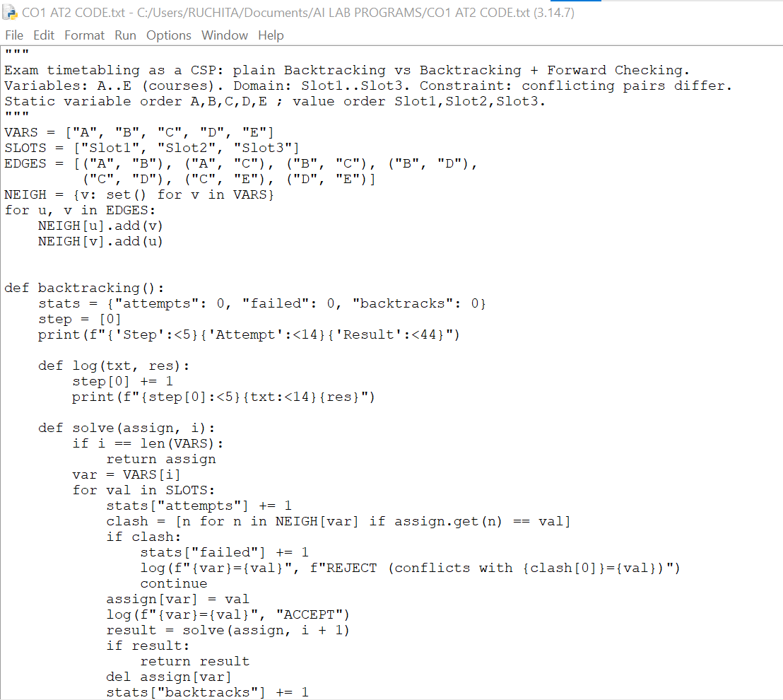
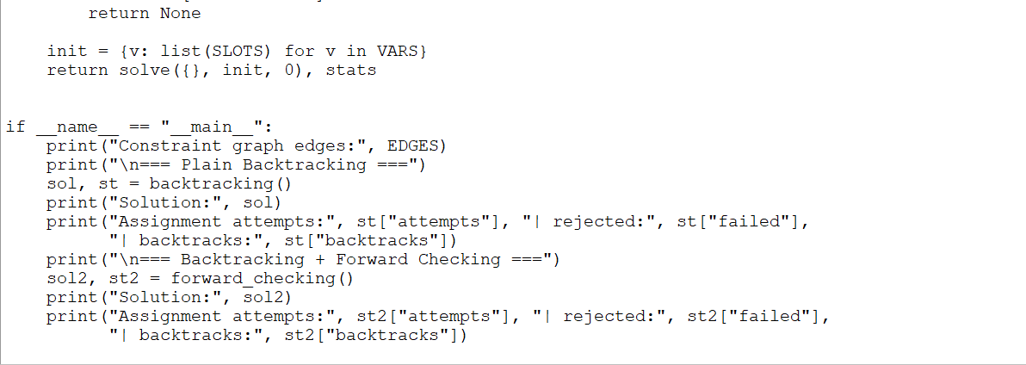

PROGRAM OUTPUT:

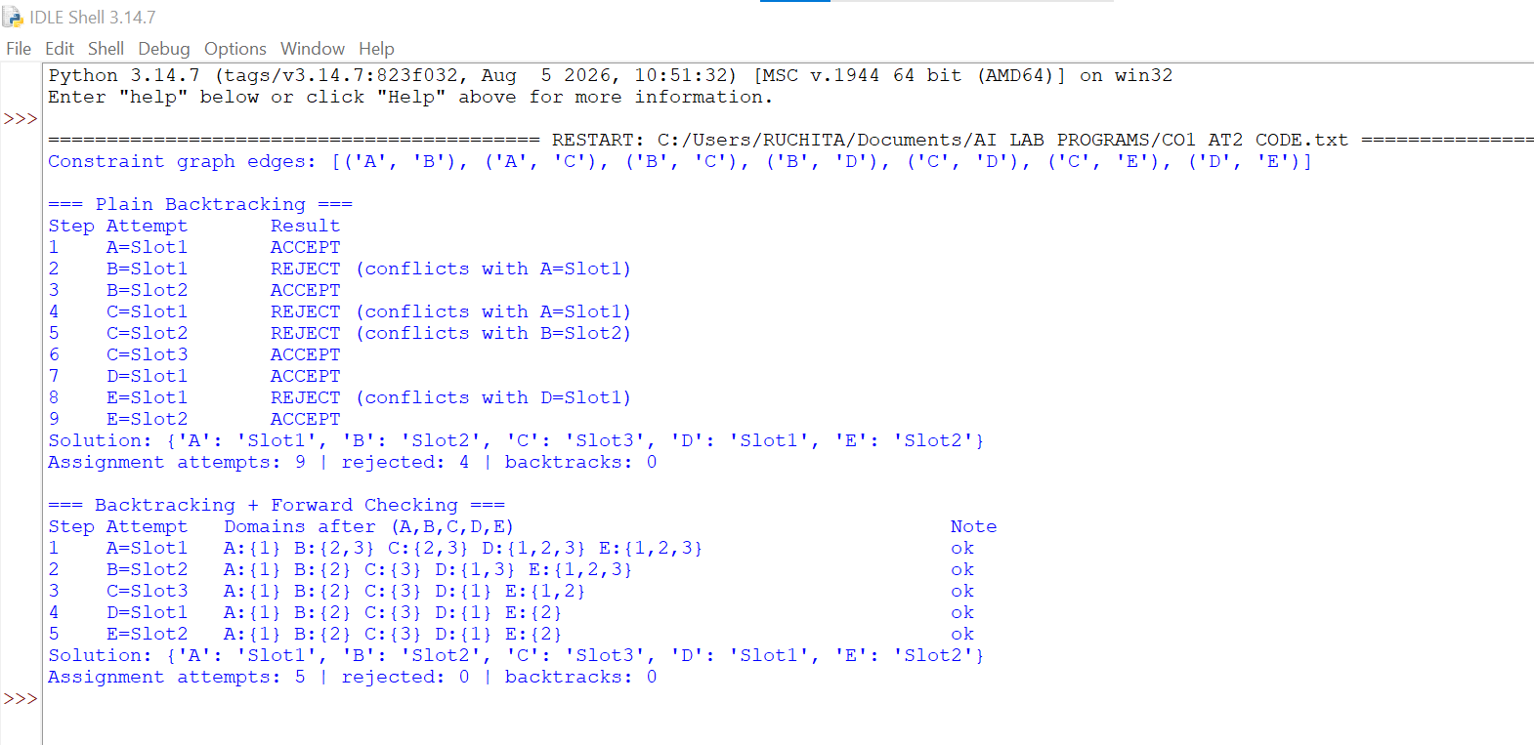

CONCLUSION:
The exam timetabling task was modelled as a CSP with five variables, three-slot domains and seven inequality constraints, and solved by a goal-based scheduling agent. Both plain backtracking and backtracking with forward checking produced the same conflict-free timetable: Slot1: A and D; Slot2: B and E; Slot3: C. Forward checking needed only 5 assignment attempts compared with 9, and avoided all 4 rejected attempts by pruning domains in advance. It is therefore the better method for this problem and the more scalable choice for larger timetabling problems.

