**Patel Rudra Dineshbhai**

**Registration E - Mail ID**

**(** [p4patelrudra@gmail.com](mailto:p4patelrudra@gmail.com) **)**

**Enrollment No.**

**(** 220170116044 **)**

**Vishwakarma Government Engineering College,**

**Chandkheda, Ahmedabad.**

**4th Year**

**(7th Semester)**

**Information Technology**

**1. Project Title**

“ Healthcare Performance & Patient Insights Dashboard ”

**2. Introduction To The Project**

This project focuses on analyzing healthcare performance through a data – driven dashboard titled **“ Healthcare Performance & Patient Insights Dashboard ”**. The dashboard visualizes key metrics such as total patients, revenue, profit, treatment cost, departmental performance, regional distribution & payment method usage.

Data Analytics plays a critical role in transforming raw healthcare data into meaningful visual insights. By aggregating & analyzing patient volumes, treatment profits, average costs & regional trends.

The project contributes to the United Nations Sustainable Development Goal (SDG) 3 : Good Health & Well – Being by :

* Promoting efficient & equitable healthcare management.
* Enhancing the quality of care through informed decision – making
* Supporting universal health coverage by optimizing cost and access across regions.

Tableau Public was used to create interactive visualization, allowing stakeholders to explore trends, detect inefficiencies & support data – driven planning.

**3. Problem Statement**

The healthcare industry generates vast amounts of data, but much of if remains underutilized. Hospitals often face challenges such as :

* Lack of visibility into department – wise performance.
* Unclear understanding of cost – effectiveness of treatment types.
* Difficulty in identifying regional disparities in patient load or profit.
* Poor insight into monthly patient trends & payment method preferences.

The gap leads to inefficient resource allocation, rising costs & missed opportunities for improving patient care and operational effectiveness.

Efficient healthcare delivery requires :

* Understanding which departments drive the most revenue & patient traffic.
* Identifying treatments with the highest profit margins and average costs.
* Recording regional and seasonal trends to manage resources.
* Making informed financial & administrative decisions.

Without clear insights, hospitals risk overspending, under serving certain areas & delivering uneven care quality.

Data Analytics bridges the gap by :

* Turning raw healthcare data into actionable insights through visualizations.
* Highlighting underperforming areas or high cost treatments.
* Revealing patient behaviour patterns across time, region and treatments type.
* Supporting evidence – based decisions that improve financial & clinical outcomes .

Through this analysis, hospital administrators can make data informed decisions that lead to better patient outcomes and more sustainable healthcare systems.

**4. Objective of The Project**

Here’s a clear & focused list of project objectives tailored to your healthcare dashboard project.

* Analyze total patients, revenue, profit & expenses across departments.
* Identify top – performing department based on revenue generation.
* Compare treatment types by profit and average cost.
* Visualize regional disparities in patient count & departmental reach.
* Track monthly trends in patient visits to identify peak & low periods.
* Understand patient payment preferences (Online Payment, Cash, Insurance).
* Provide data – driven insights for hospital management and policy planning.
* Support cost optimization and efficient resource allocation.

**5. Hypothesis**

* Hospitals can improve overall profitability & patient satisfaction by identifying high – performing departments & optimizing treatment costs based on regional & seasonal patient trends.
* Treatment types with higher average costs do not always correlate with higher profits, indicating a need for cost – efficiency improvements.
* Departments receiving higher patient volumes in certain regions contribute disproportionately to overall hospital revenue & should be prioritized for resource allocation.

**6. Analysis & Visualization (Tableau Dashboard Summary)**

The **“ Healthcare Performance & Patient Insights Dashboard ”** presents an interactive visual analysis of hospital operations using a variety of filters & visualizations to reveal key trends & comparisons.

**Filters & Parameters Used :**

* **Region :** To explore patient volume & departmental performance by geographic location.
* **Department :** To focus on specific medical units like Cardiology, Orthopedics, etc.
* **Year / Month :** To analyze trends over time (seasonality or monthly fluctuations ).
* **Treatment Type :** To compare costs & profits among different services.
* **Payment Method :** To assess patient preferences & financial behavior.

**Type of Visualizations :**

* **Bar Charts :** Showing revenue, profit & expenses by department & region.
* **Pie Chart :** Depicting distribution of payment methods.
* **Trend Line** **:** Illustrating monthly patient visit patterns.
* **Heatmap :** Highlighting regional variations in patient count & performance.
* **KPI Cards :** Displaying total revenue, total patients & overall profit at a glance.

**Interactivity & User Navigation :**

* Users can interact with filters to dynamically update charts.
* Hover features reveal specific values (tooltips) for deeper insights.
* Clickable visual allows drilling down into departments or time periods.
* The layout is designed for intuitive navigation between insights.

**Patterns & Comparisons Enabled :**

* Compare department-wise performance across regions.
* Identify the most and least profitable treatment types.
* Observe seasonal trends in patient inflow.
* Understand regional disparities in healthcare service delivery.
* 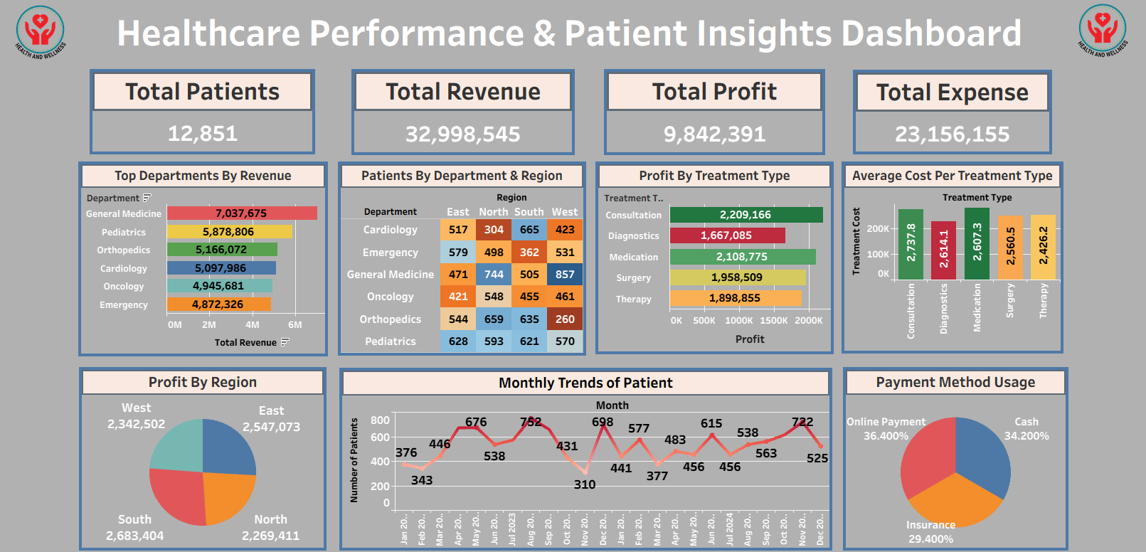Analyze how payment methods influence financial outcomes.

**7. Key Insights & Findings**

1. High patient volume doesn’t always mean high profit : Some departments treat more patients but earns less profit.
2. Regional gaps exist : Certain areas have fewer patients and lower revenue, showing unequal access.
3. Low – cost treatments can be more profitable : Not all expensive treatments bring high returns.
4. Patient visits vary by season : Monthly trends help plan staffing and resources better.
5. Online payments are rising : More patients prefer digital modes over cash.

**8. Proposed Solutions & Recommendations**

* Allocate more staff, equipment & budget to departments with high profit & patient demand to maximize impact & efficiency.
* Deploy mobile clinic or targeted awareness campaigns in regions with low patient counts to improve healthcare access & service utilization.
* Invest in digital payment infrastructure & educate patients on using online methods to streamline billing & improve financial tracking.

**9. Probable Outcomes & SDG Contribution**

* This project supports SDG 3 : Good Health & Well – Being by identifying gaps in healthcare access, optimizing treatment costs & improving departmental efficiency.
* It can help hospitals allocate resource better, reach underserved regions & enhance patient care. Promoting digital payments also supports faster, transparent healthcare services.

**10. Tools & Technologies Used**

I used Microsoft Excel for data cleaning, processing and organization. After that used Tableau Public Edition for creating interactive dashboards & visualizations and also used for publishing the dashboards on Tableau Public. And used Microsoft Word for making reports.

**11. References**

I used Google Search for understanding chart types in deep, aggregation formulas & Tableau Public functionalities.