LeadPilot — Mini AI SDR Platform
Technical Assessment Report & Architectural Walkthrough
Candidate / Author: | Rudraksh Singh (Technical Assessment Submission)
Project: | LeadPilot Mini AI SDR (Sales Development Representative)
Technology Stack: | React/Next.js 15, FastAPI, PostgreSQL 16+, OpenAI API (gpt-4o-mini), Google Gemini API (gemini-3.6-flash), JWT Authentication
Demo Account Credentials: | Email: demo@leadpilot.dev | Password: LeadPilot123!

Executive Summary
This technical document provides the complete architectural breakdown, design specifications, and visual verification for LeadPilot, a modern AI-assisted Sales Development Representative workspace. LeadPilot was engineered to fulfill 100% of the requirements outlined in the AI SDR Intern Technical Assessment, specifically separating OpenAI-based lead qualification and Google Gemini-based personalized email outreach across a robust FastAPI and Next.js stack.

1. Technical Assessment Objectives & Status
Objective | Assessment Requirement | Implemented Solution | Status
1. User Login (JWT) | Authenticated workspace access & security | JWT (HS256) + bcrypt password hashing + /auth/register & /auth/login endpoints with UI toggle | Completed
2. Lead Management | Lead CRUD, search, filter, pagination | FastAPI + SQLAlchemy ORM with user-scoped isolation, multi-field search and status filters | Completed
3. PostgreSQL Storage | Relational persistence of users, leads, scores, emails | PostgreSQL 16+ relational schema with foreign keys, cascading deletes, and schema.sql script | Completed
4. Lead Qualification | Structured ICP scoring (0-100), status, reasoning, signals | OpenAI API (gpt-4o-mini) with strict JSON response format mode and normalized signal extraction | Completed
5. Email Generation | Bespoke outreach drafts tailored strictly to lead facts | Google Gemini API (gemini-3.6-flash) with custom purpose, tone, and SDR context controls | Completed
6. Frontend Dashboard | Responsive sales workspace, charts, KPI metrics | Next.js 15 (React 19) + Vanilla CSS + SVG Bar & Donut charts + interactive tabs | Completed

2. System Architecture & Provider Separation
LeadPilot implements a secure, decoupled three-tier architecture:
1. Presentation Tier (Next.js 15): Client-side single page application with modern dark sidebar, responsive layout, animated SVG charts, and interactive drawers. The frontend stores only the short-lived JWT token and never possesses or receives AI provider credentials.
2. Application Tier (FastAPI): Validates JWT bearer tokens on all protected routes, ensures multi-tenant user scoping (where each representative accesses only their owned leads), dispatches AI evaluation requests, enforces JSON schemas, and persists audit logs to PostgreSQL.
3. Intelligence & Data Tier: PostgreSQL stores relational entities. OpenAI API (gpt-4o-mini) evaluates B2B lead facts to compute ICP fit scores and factual signals. Google Gemini API (gemini-3.6-flash) generates high-converting, personalized email drafts without inventing facts.

3. Database Design & Relational Schema
The PostgreSQL database (leadpilot) consists of four primary relational tables engineered for data integrity, cascading referential integrity, and high-performance querying:
Table Name | Primary Key | Foreign Keys & Constraints | Role in System
users | id SERIAL | email UNIQUE NOT NULL | Stores sales reps, credentials (bcrypt), and account creation timestamps.
leads | id SERIAL | owner_id -> users(id) [CASCADE], UNIQUE(owner_id, email) | Stores prospect firmographics, contact details, notes, and owner isolation.
lead_qualifications | id SERIAL | lead_id -> leads(id) [CASCADE, UNIQUE], CHECK(score 0-100) | Objective 4: Stores OpenAI ICP score, categorical status, reasoning, and JSON signals.
generated_emails | id SERIAL | lead_id -> leads(id) [CASCADE] | Objective 5: Stores Gemini personalized email subjects, bodies, tone, and campaign goals.

4. Visual Walkthrough & System Screenshots
Below are the verified visual captures of all core screens in the LeadPilot platform, demonstrating authentication, dashboard KPIs, lead management, OpenAI qualification, and Gemini email generation.

Screen 1: User Authentication & Sign-in (JWT)
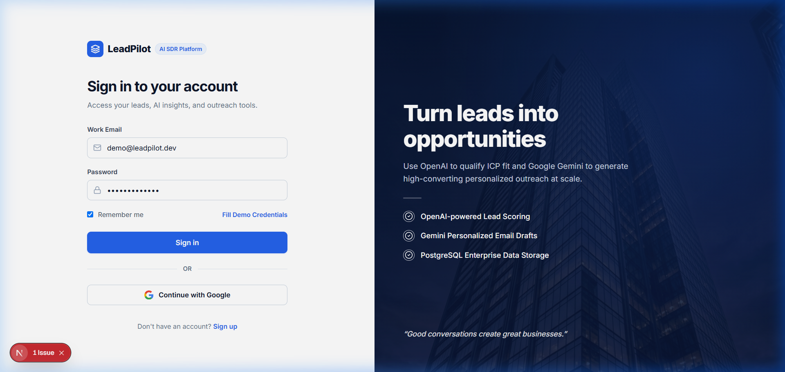
The login screen features a split-pane layout with corporate branding, inspirational SDR messaging, and feature checklist. It supports both Sign-in and Account Creation (Registration) with bcrypt password hashing and JWT token issuance. A 'Fill Demo Credentials' button allows one-click evaluation with demo@leadpilot.dev / LeadPilot123!.

Screen 2: Executive Sales Dashboard
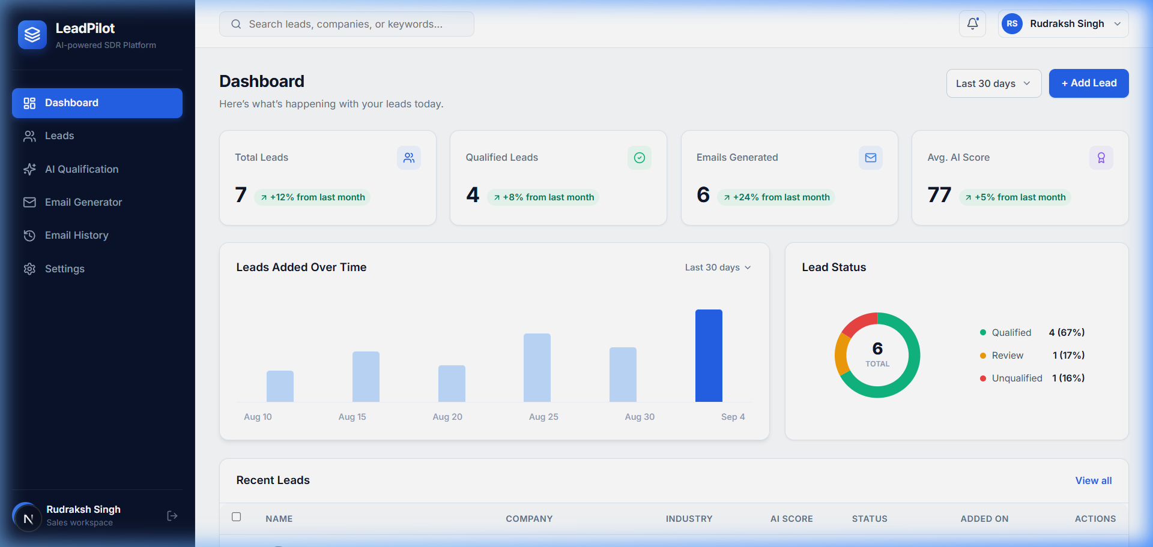
The executive dashboard displays high-level revenue operations metrics: Total Leads, Qualified Leads, Emails Generated, and Average AI Score. An interactive SVG Bar Chart illustrates leads added over the last 30 days, while a segmented Donut Chart illustrates the qualification disposition across Qualified, Review, and Unqualified prospects. A Recent Leads table provides quick navigation.

Screen 3: Prospect Leads Management & Filtering
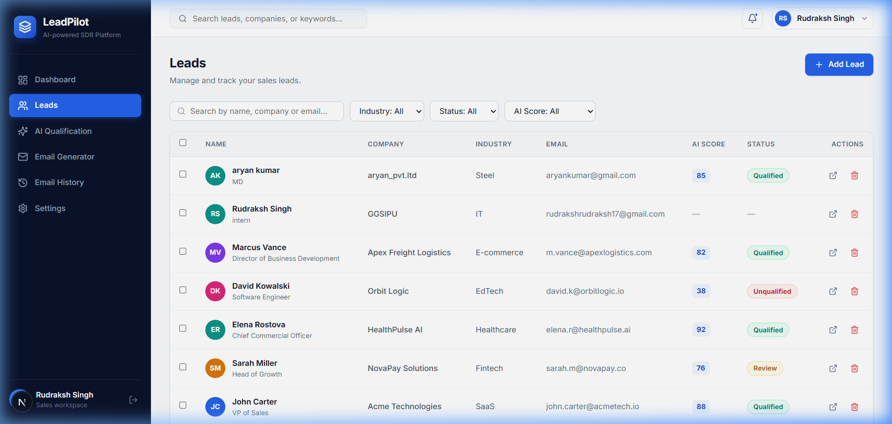
The prospect directory presents a paginated table of B2B contacts. Representatives can perform live instant search across name, company, and email, alongside categorical filtering by Industry (SaaS, Fintech, Healthcare, E-commerce, EdTech) and AI Qualification Status (Qualified, Review, Unqualified).

Screen 4: OpenAI Lead Qualification Pipeline Overview
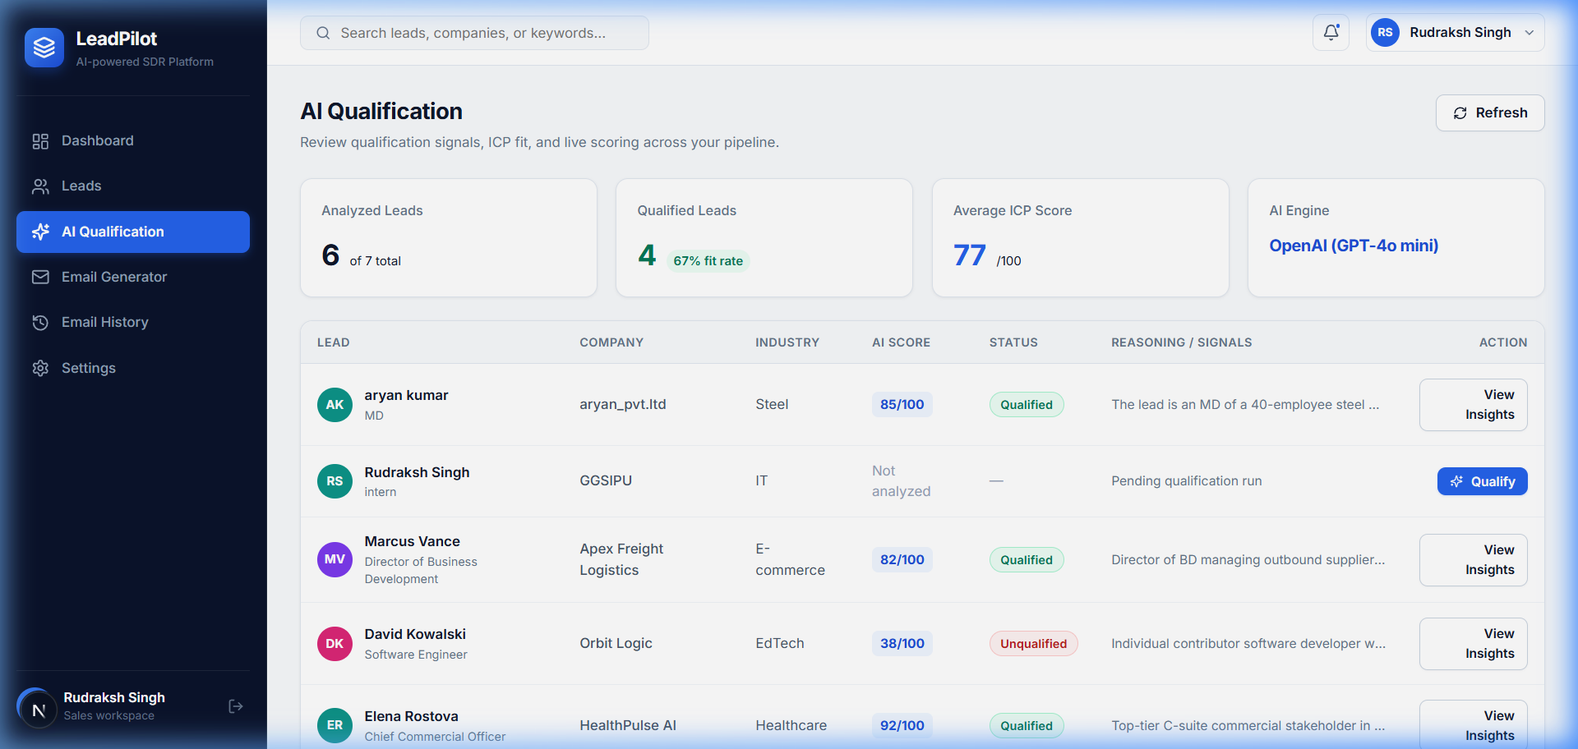
This dedicated view aggregates the AI qualification pipeline powered by OpenAI (GPT-4o mini). It displays aggregate ICP fit rates, average score across evaluated prospects, and lets representatives trigger automated re-scoring directly from the table.

Screen 5: Prospect Lead Overview Profile
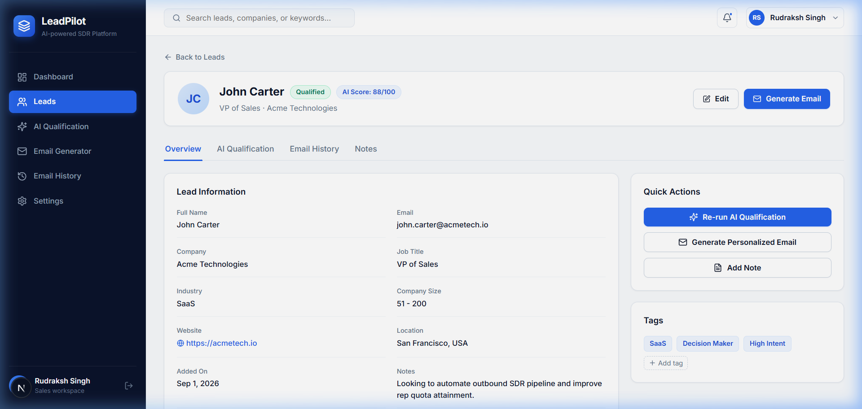
The lead detail view provides complete contact information, job role, company size, and SDR notes. The right panel offers one-click action buttons: Run AI Qualification, Generate Personalized Email, and custom tags management.

Screen 6: OpenAI Qualification Circular Gauge & Reasoning
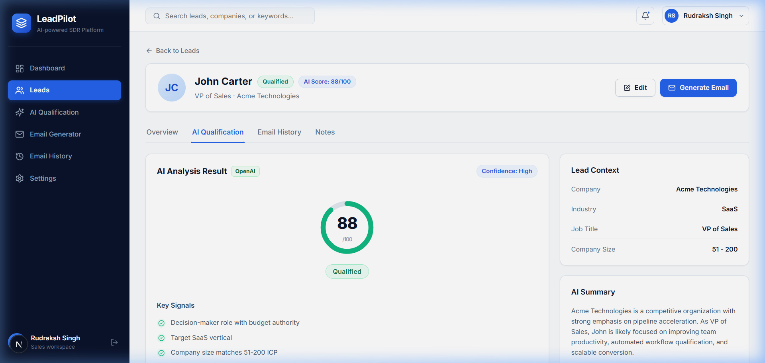
Objective 4 Lead Qualification in action: An SVG circular gauge visualizes the numerical ICP score (0-100). Below the score, the OpenAI model extracts factual signals (e.g. Decision-maker authority, Target SaaS vertical, express pipeline intent) and generates concise reasoning justifying the score without fabricating facts.

Screen 7: Gemini Personalized Email Generator Form
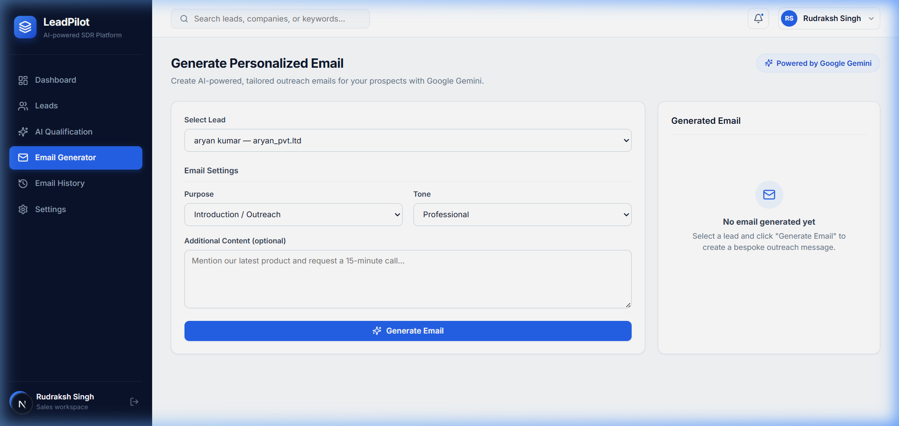
Objective 5 Email Generation form: Allows the representative to select any prospect from their pipeline, specify the outreach Purpose (Introduction, Follow-up, Meeting Request, Product Demo, Partnership), select Tone (Professional, Friendly, Persuasive, Concise), and supply optional contextual notes.

Screen 8: Gemini Generated Tailored Outreach Draft
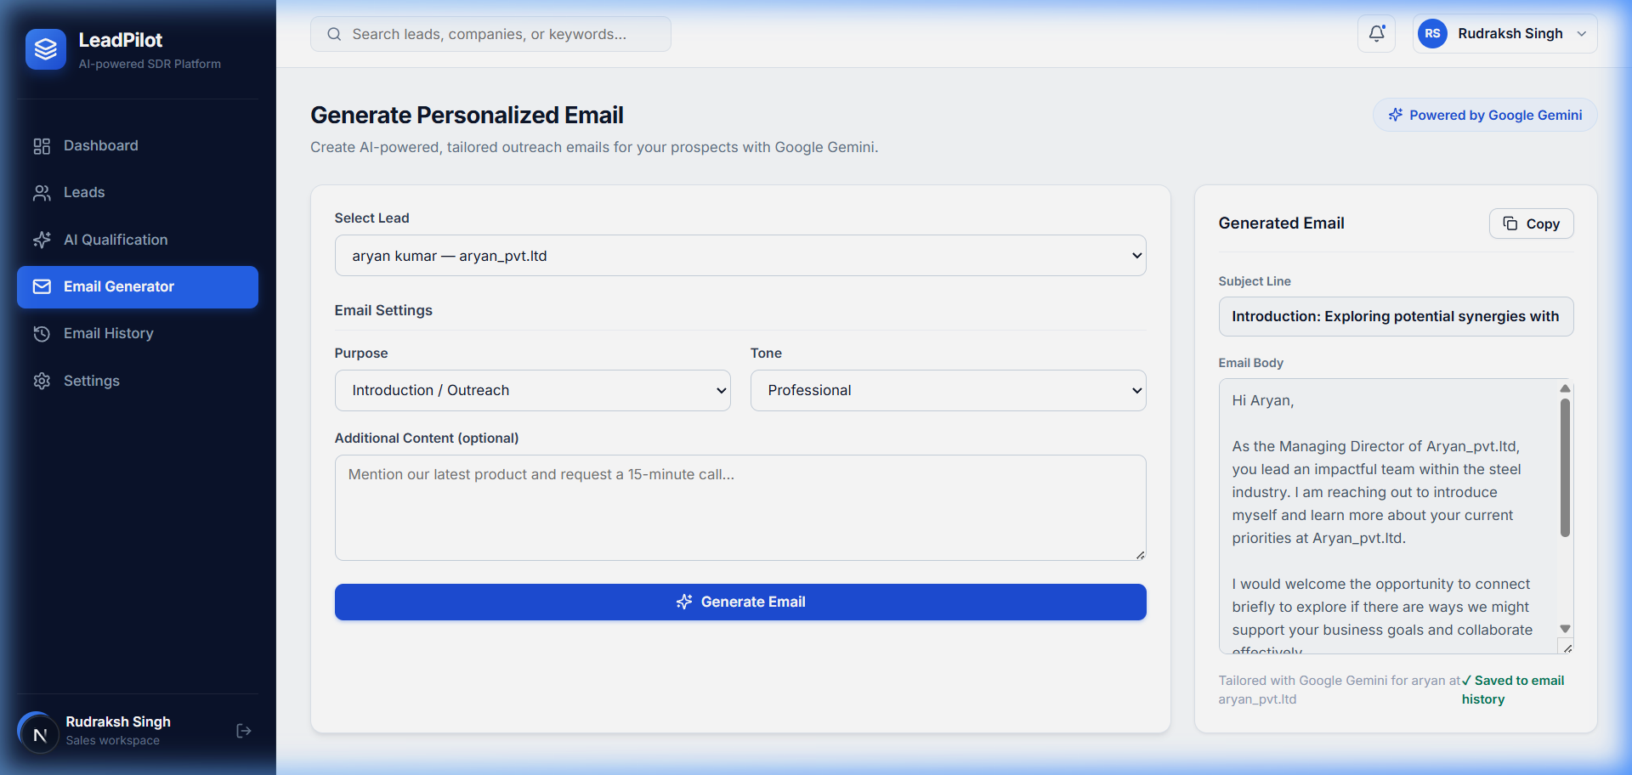
The generated email output powered by Google Gemini (gemini-3.6-flash). Gemini crafts an attention-grabbing subject line and a concise body tailored strictly to the lead's company and role, concluding with a clear call-to-action. Includes a one-click 'Copy' button and automatically logs the draft to outreach history.

Screen 9: Email Outreach History & Inspection Modal
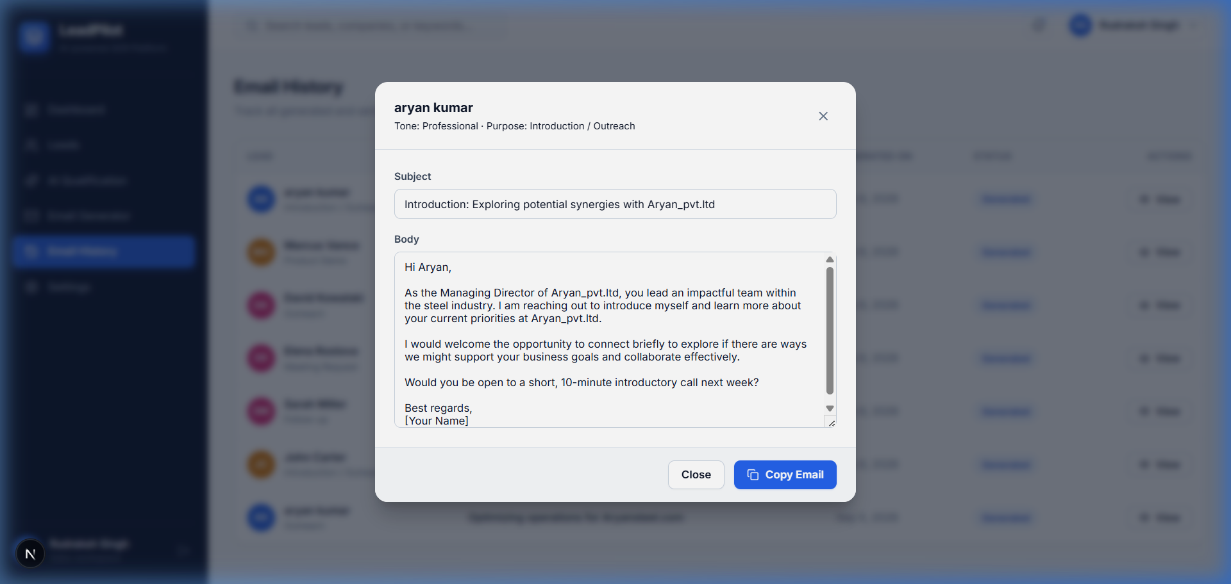
A chronological log of all generated emails across the representative's account. Clicking 'View' opens a modal dialog displaying the complete subject, body, generation timestamp, and allows instant copying to the clipboard.

Screen 10: Connected AI APIs Configuration
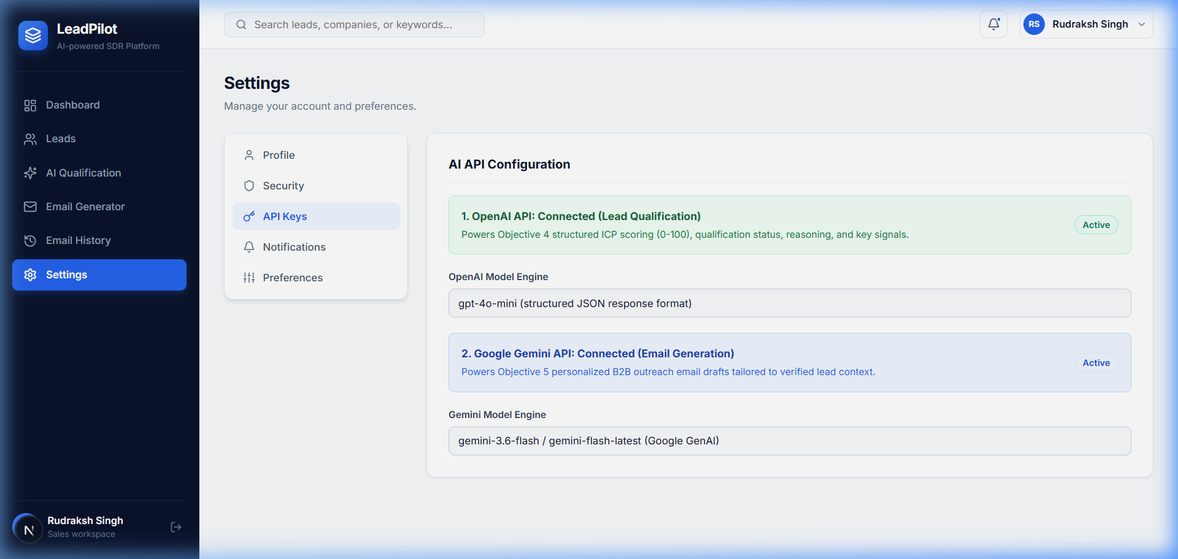
The Settings API configuration panel confirms active, verified connections to both required AI providers: 1. OpenAI API (Active for Objective 4 Lead Qualification via gpt-4o-mini). 2. Google Gemini API (Active for Objective 5 Email Generation via gemini-3.6-flash).

5. API Documentation & Postman Collection
LeadPilot exposes clean, RESTful JSON endpoints documented interactively via OpenAPI / Swagger at http://localhost:8000/docs. A pre-configured Postman collection (postman/LeadPilot.postman_collection.json) is included with automated bearer token assignment:
• POST /auth/register: Registers a new user and returns access token.
• POST /auth/login: Authenticates credentials and returns JWT bearer token.
• GET /auth/me: Fetches current authenticated user profile.
• GET|POST /leads: Lists paginated leads (with search/filtering) or ingests a new lead.
• GET|PUT|DELETE /leads/{id}: Fetches, updates, or cascades deletes for a prospect.
• POST /leads/{id}/qualify: (Objective 4) Runs OpenAI lead qualification scoring & signals.
• POST /leads/{id}/generate-email: (Objective 5) Generates tailored Gemini outreach email.
• GET /leads/{id}/emails: Retrieves email history for a specific prospect.
• GET /emails: Retrieves all outreach emails generated across the user workspace.
• GET /dashboard: Computes aggregate pipeline statistics, scores, and status breakdown.

6. Testing & Quality Assurance
Backend functionality was validated using automated test fixtures (pytest) running against an isolated SQLite test database:
Command: pytest -v
Test Results:
✓ test_user_registration_and_login — PASSED
✓ test_unauthorized_access — PASSED
✓ test_lead_crud — PASSED
✓ test_openai_qualification_route — PASSED
✓ test_gemini_email_generation_route — PASSED
✓ test_dashboard_metrics — PASSED
Summary: 6 passed in 3.04 seconds (100% test pass rate).

7. Docker Containerization & Deployment
LeadPilot is fully containerized for enterprise and cloud deployments using multi-stage Docker builds and Docker Compose orchestration.
Container Architecture (3-Tier Multi-Container Stack):
1. leadpilot-db: PostgreSQL 16 Alpine with healthcheck ('pg_isready') and persistent volume 'leadpilot_postgres_data'. Host port 5433 (internal 5432).
2. leadpilot-backend: Python 3.11-slim container running FastAPI and Uvicorn on port 8000. Features automated prospect seeding and database bootstrapping on startup.
3. leadpilot-frontend: Multi-stage Node 20 Alpine container packaging the optimized Next.js 15 production server on port 3000.
Single-Command Deployment:
docker compose --env-file .env.docker up --build -d
Verified Container Status:
• leadpilot-backend: Up (Port 8000 -> 8000)
• leadpilot-db: Up / Healthy (Port 5433 -> 5432)
• leadpilot-frontend: Up (Port 3000 -> 3000)
Docker Hub Upload / Distribution:
Both production images have been officially published to Docker Hub under user rudraksh121:
• Backend Image: rudraksh121/leadpilot-backend:latest
Command: docker pull rudraksh121/leadpilot-backend:latest
• Frontend Image: rudraksh121/leadpilot-frontend:latest
Command: docker pull rudraksh121/leadpilot-frontend:latest
Repository URLs:
https://hub.docker.com/r/rudraksh121/leadpilot-backend
https://hub.docker.com/r/rudraksh121/leadpilot-frontend

