S3 Terraform Module
User Work Instructions
Reusable Amazon S3 bucket provisioning through Terraform Enterprise

Document item | Details
Document purpose | Provide a standard, reusable method for consuming the published S3 Terraform module from the Terraform Enterprise private module registry.
Audience | Application teams, infrastructure teams, Terraform users and other approved consumers.
Module | Novartis/s3-poc/aws
Example version | 1.0.1
Provider | AWS
Module source | tfe-dev.aws.novartis.net/Novartis/s3-poc/aws

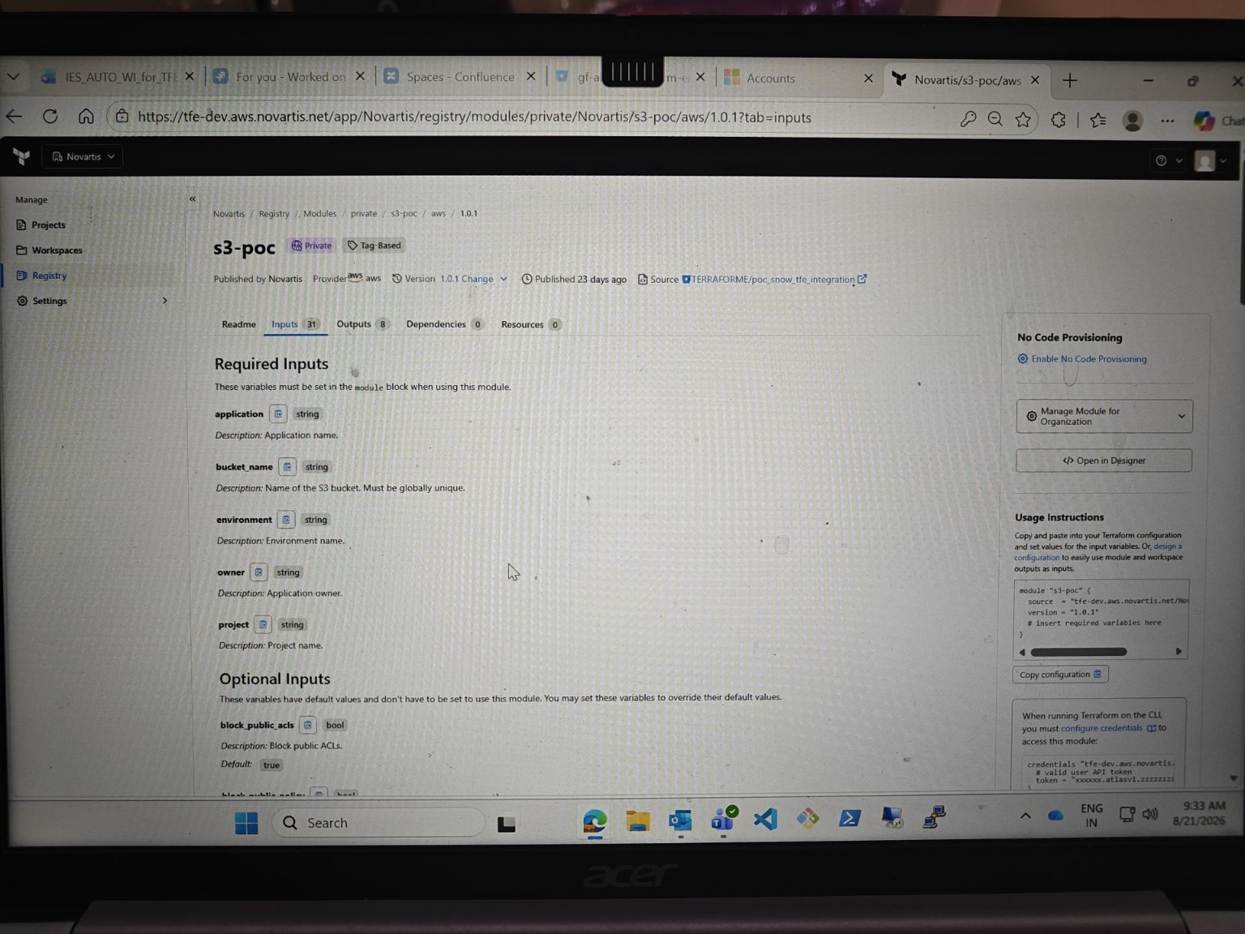
Figure 1. Terraform Enterprise private registry page showing the published S3 module, version and inputs.
Document status: User work instruction – draft for review. Validate organization-specific access, approval and execution requirements before publication.

Table of Contents
1 Purpose and Scope
2 Solution Overview
3 Prerequisites
4 Consumer Repository Setup
5 Configure the AWS Provider
6 Consume the Published S3 Module
7 Configure Required Inputs
8 Use Variables Instead of Hard-Coded Values
9 Provision Multiple Buckets with for_each
10 Module Input Reference
11 Feature Configuration Guide
11.1 Encryption and KMS
11.2 Versioning, Ownership and Public Access
11.3 Tags
11.4 Object Lock
11.5 S3 Event Notifications
11.6 EventBridge Notifications
11.7 Static Website and Redirect Hosting
11.8 Transfer Acceleration and Requester Pays
12 Terraform Execution and Validation
13 End-to-End Consumer Example
14 Troubleshooting and Validation
15 Roles and Responsibilities
16 Recommended Practices
17 Quick Reference
18 Source and Implementation Notes

Navigation note: This Table of Contents is intentionally maintained as visible text so it remains available when the document is viewed outside Word or when fields are not updated.

1. Purpose and Scope
This document explains how an approved consumer can create and configure Amazon S3 buckets by reusing the S3 Terraform module published in the Terraform Enterprise (TFE) private module registry. The consumer repository contains only the configuration required to call the module and provide its inputs; the consumer does not need to recreate the module implementation.

1.1 Intended outcome
- Create a standardized S3 bucket using the published module.
- Reuse the same module for different applications and environments.
- Keep environment-specific values in variables rather than hard-coding them.
- Use for_each when multiple similar buckets are required.
- Use optional module features only when the workload requires them.
Scope: This guide is based on the supplied TFE registry screenshot and the supplied Terraform variables.tf and main.tf files. Organization-specific access, approval and authentication procedures should be added by the owning team.

2. Solution Overview
The intended model separates the reusable module implementation from the consumer configuration:
Layer | Purpose
Module source repository | Stores the S3 module implementation. The supplied setup uses Bitbucket as the source repository.
Terraform Enterprise registry | Publishes the module as a private reusable module for approved consumers.
Consumer repository | Contains provider.tf, main.tf, variables.tf and optional locals/tfvars files.
AWS account/region | Receives the S3 bucket and enabled supporting configurations when Terraform is applied.

2.1 Consumer workflow
Step | Stage | Expected action
1 | Prepare consumer repository | Create the Terraform files required by the workload.
2 | Select module | Reference the published TFE module and a tested version.
3 | Provide inputs | Pass required values and optional feature settings through variables.
4 | Validate | Run formatting, validation and plan; review proposed changes.
5 | Apply | Execute through the approved Terraform/TFE workflow.
6 | Verify | Confirm the S3 bucket and enabled features in AWS.

2.2 What the consumer reuses
The supplied module implementation covers the S3 bucket and several optional configurations, including server-side encryption, versioning, ownership controls, public access blocking, website configuration, event notifications, EventBridge, transfer acceleration, requester pays and Object Lock. The module also contains notification permission handling. fileciteturn1file0L237-L239

3. Prerequisites
- Access to the approved Terraform Enterprise organization/registry and the published private module.
- A consumer repository where the Terraform configuration will be maintained.
- An AWS provider configuration for the target account and region.
- Permissions required to provision the requested S3 and related AWS resources.
- Existing SNS, SQS or Lambda destination resources when S3 event notifications are required.
- Required permissions for notification destinations. The supplied source expects destination resources and permissions to be available.
- Where notification permission management is enabled, a supported execution environment for the configured Python helper command.
Do not assume: The supplied module files do not define your organization's repository-creation, TFE workspace creation, authentication, approval or change-management process. Those steps should be documented separately by the platform team.

4. Consumer Repository Setup
A recommended consumer repository structure is:
s3-consumer/
├── provider.tf
├── main.tf
├── variables.tf
├── locals.tf # optional – useful for multiple buckets
├── terraform.tfvars # optional – non-sensitive environment values
└── README.md # optional – application-specific notes

4.1 File responsibilities
File | Recommended responsibility
provider.tf | Terraform/provider configuration and the target AWS region.
main.tf | Calls the published S3 module and passes inputs.
variables.tf | Defines consumer-side variables used by main.tf.
locals.tf | Optional data structure for multiple buckets or derived configuration.
terraform.tfvars | Optional environment-specific values; use approved secure mechanisms for sensitive data.
README.md | Optional repository-specific usage and operational notes.

5. Configure the AWS Provider
The consumer repository should configure the AWS provider according to the organization's approved Terraform standard.
# provider.tf
terraform {
required_providers {
aws = {
source = "hashicorp/aws"
# Use the organization-approved provider version.
}
}
}
provider "aws" {
region = var.aws_region
}
Important: The supplied S3 module source does not establish an organization-wide AWS provider version or authentication pattern. Do not treat an example provider version as a mandatory standard; use the version and authentication method approved for your environment.

6. Consume the Published S3 Module
From the TFE registry page, the consumer-facing module reference is:
module "s3" {
source = "tfe-dev.aws.novartis.net/Novartis/s3-poc/aws"
version = "1.0.1"
# required and optional inputs
}
The registry screenshot shows the module under the private registry and provides a Usage Instructions section with the source and version. The consumer should use the registry source rather than copying the module implementation.

6.1 Why this approach is preferred
- One reusable implementation can be consumed by multiple application teams.
- Module changes can be versioned and released centrally through the registry.
- Consumers provide configuration rather than maintaining duplicate S3 resource code.
- Security and standard configuration can be applied consistently through module defaults and validations.

7. Configure Required Inputs
The TFE registry screenshot identifies five required inputs for the published version:
Input | Description
application | Application name.
bucket_name | Bucket name prefix. The module generates the final bucket name.
environment | Environment name.
owner | Application owner.
project | Project name.

The supplied variables file also defines cost_center without a default, so it should be treated as a required consumer input for this module configuration. The module applies these values as tags. fileciteturn1file0L269-L299
module "s3" {
source = "tfe-dev.aws.novartis.net/Novartis/s3-poc/aws"
version = "1.0.1"
bucket_name = var.bucket_name
environment = var.environment
project = var.project
application = var.application
owner = var.owner
cost_center = var.cost_center
}

8. Use Variables Instead of Hard-Coded Values
Keep the module block reusable by defining consumer-side variables and passing those variables into the module.
# variables.tf
variable "bucket_name" {
type = string
description = "Bucket name prefix."
}
variable "environment" {
type = string
}
variable "project" {
type = string
}
variable "application" {
type = string
}
variable "owner" {
type = string
}
variable "cost_center" {
type = string
}
variable "aws_region" {
type = string
}
# terraform.tfvars – example only
bucket_name = "customer-data"
environment = "dev"
project = "analytics"
application = "reporting"
owner = "data-team"
cost_center = "12345"
aws_region = "ap-south-1"
Security: Do not place credentials, passwords, access keys or other secrets directly in Terraform configuration. Use the approved TFE/workspace or AWS authentication mechanism.

9. Provision Multiple Buckets with for_each
For multiple buckets, represent the bucket-specific values as a map and use for_each on the module block. This keeps the implementation DRY and makes additional buckets data changes rather than repeated module code.
# locals.tf
locals {
s3_buckets = {
raw = {
bucket_name = "raw-data"
project = "data-platform"
application = "ingestion"
owner = "data-team"
environment = "dev"
cost_center = "12345"
}
processed = {
bucket_name = "processed-data"
project = "data-platform"
application = "processing"
owner = "data-team"
environment = "dev"
cost_center = "12345"
}
}
}
# main.tf
module "s3" {
for_each = local.s3_buckets
source = "tfe-dev.aws.novartis.net/Novartis/s3-poc/aws"
version = "1.0.1"
bucket_name = each.value.bucket_name
project = each.value.project
application = each.value.application
owner = each.value.owner
environment = each.value.environment
cost_center = each.value.cost_center
}
Design principle: Keep bucket-specific data in locals/variables and keep the module block generic. Add optional inputs to the data structure when individual buckets need additional features.

10. Module Input Reference
The supplied variables.tf contains the active module inputs listed below. Descriptions, defaults and validation rules are summarized from the supplied source. fileciteturn1file0L5-L19
Variable | Req. | Type | Purpose | Default
bucket_name | Required | string | Bucket name prefix; 3–30 chars, lowercase letters/numbers/hyphens; start with lowercase letter; cannot end with hyphen; reserved names/prefixes are rejected. | —
force_destroy | Optional | bool | Allow Terraform to delete all objects when destroying the bucket. | false
encryption_type | Optional | string | AES256, aws:kms or aws:kms:dsse. | AES256
kms_key_type | Optional | string | AWS_MANAGED or CUSTOMER_MANAGED. | AWS_MANAGED
kms_key_alias | Optional | string/null | Customer-managed KMS key alias; used for KMS/DSSE-KMS with CUSTOMER_MANAGED. | null
bucket_key_enabled | Optional | bool | S3 Bucket Keys; applicable to aws:kms. | true
enable_versioning | Optional | bool | Enable S3 versioning. | true
block_public_acls | Optional | bool | Block public ACLs. | true
ignore_public_acls | Optional | bool | Ignore public ACLs. | true
block_public_policy | Optional | bool | Block public bucket policies. | true
restrict_public_buckets | Optional | bool | Restrict public buckets. | true
object_ownership | Optional | string | BucketOwnerEnforced, BucketOwnerPreferred or ObjectWriter. | BucketOwnerEnforced
environment | Required | string | Environment name; used in tags. | —
project | Required | string | Project name; used in tags. | —
application | Required | string | Application name; used in tags. | —
owner | Required | string | Application owner; used in tags. | —
cost_center | Required | string | Cost center; used in tags. | —
additional_tags | Optional | map(string) | Additional tags merged with module tags. | {}
enable_object_lock | Optional | bool | Enable Object Lock. | false
object_lock_mode | Optional | string | GOVERNANCE or COMPLIANCE. | GOVERNANCE
object_lock_days | Optional | number/null | Retention period in days; must be > 0 when supplied/enabled. | null
enable_event_notifications | Optional | bool | Enable S3 event notifications. | false
event_notifications | Optional | list(object) | SNS/SQS/Lambda destination, ARN, events, optional prefix/suffix filters and manage_permission. | []
python_command | Optional | string | Python executable used by notification helper scripts. | python3
enable_eventbridge_notifications | Optional | bool | Enable S3 EventBridge notifications; rules/targets are separate. | false
static_website_type | Optional | string/null | null, website or redirect. | null
website_index_document | Optional | string/null | Index document for website hosting. | null
website_error_document | Optional | string/null | Error document for website hosting. | null
redirect_host_name | Optional | string/null | Host name used for redirect hosting. | null
redirect_protocol | Optional | string/null | http or https. | null
enable_transfer_acceleration | Optional | bool | Enable S3 Transfer Acceleration. | false
enable_requester_pays | Optional | bool | Enable Requester Pays. | false

11. Feature Configuration Guide
Use the following sections when a workload needs more than the standard/default S3 configuration.

11.1 Encryption and KMS
The module supports AES256, aws:kms and aws:kms:dsse. For customer-managed KMS encryption, the supplied variables definition requires a KMS alias when the applicable KMS encryption mode and CUSTOMER_MANAGED key type are selected. fileciteturn1file0L59-L90
encryption_type = "aws:kms"
kms_key_type = "CUSTOMER_MANAGED"
kms_key_alias = "alias/application-key"
bucket_key_enabled = true
The module implementation also contains preconditions to validate customer-managed KMS configuration and prevent unnecessary KMS options when AES256 is selected. fileciteturn1file0L5-L19

11.2 Versioning, Ownership and Public Access
The supplied defaults enable versioning, all four public-access-block controls and BucketOwnerEnforced ownership. The module passes these values into the corresponding AWS S3 resources. fileciteturn1file0L212-L260
enable_versioning = true
block_public_acls = true
ignore_public_acls = true
block_public_policy = true
restrict_public_buckets = true
object_ownership = "BucketOwnerEnforced"

11.3 Tags
The module applies Environment, Project, Application, Owner and CostCenter values and merges additional_tags. The implementation also adds Name, ManagedBy and Terraform metadata. fileciteturn1file0L269-L299
additional_tags = {
DataClassification = "Internal"
BusinessUnit = "Finance"
}

11.4 Object Lock
Object Lock is disabled by default. When enabled, the implementation requires object_lock_days to be greater than zero. The supported retention modes are GOVERNANCE and COMPLIANCE. fileciteturn1file0L303-L345
enable_object_lock = true
object_lock_mode = "GOVERNANCE"
object_lock_days = 30

11.5 S3 Event Notifications
The active event_notifications input supports SNS, SQS and Lambda destinations. Each entry contains destination_type, destination_arn and events, with optional filter_prefix, filter_suffix and manage_permission. The source validates destination types, ARNs and event names. fileciteturn1file0L557-L702
enable_event_notifications = true
event_notifications = [
{
destination_type = "lambda"
destination_arn = "arn:aws:lambda:ap-south-1:123456789012:function:image"
events = ["s3:ObjectCreated:*"]
filter_prefix = "images/"
filter_suffix = ".jpg"
manage_permission = true
}
]
The module implementation creates the S3 notification configuration and can create Lambda permission and invoke helper scripts for SQS/SNS permission updates when manage_permission is enabled. fileciteturn1file0L445-L689
Prerequisite: The destination resource must exist and the required permissions must be available. Notification filters must also be designed so they do not create overlapping/conflicting configurations.

11.6 EventBridge Notifications
Set enable_eventbridge_notifications = true to enable EventBridge notifications for the bucket. The supplied source states that EventBridge rules and targets are configured separately. fileciteturn1file0L715-L750
enable_eventbridge_notifications = true

11.7 Static Website and Redirect Hosting
static_website_type supports null, website or redirect. Website mode requires an index document. Redirect mode requires a redirect host name; the protocol can be http or https. The module contains preconditions to prevent incompatible website and redirect settings. fileciteturn1file0L753-L889
# Website
static_website_type = "website"
website_index_document = "index.html"
website_error_document = "error.html"
# OR redirect
static_website_type = "redirect"
redirect_host_name = "example.com"
redirect_protocol = "https"

11.8 Transfer Acceleration and Requester Pays
enable_transfer_acceleration = true
enable_requester_pays = true
Both options are disabled by default. The module creates the corresponding S3 configuration only when enabled. fileciteturn1file0L896-L913

12. Terraform Execution and Validation
Use the organization's approved TFE execution process. The following sequence is a general consumer workflow:
- Confirm the module source and version.
- Confirm all required inputs are populated.
- Check optional feature inputs and their prerequisites.
- Run terraform init.
- Run terraform fmt and terraform validate.
- Run terraform plan and review the planned S3 and supporting resources.
- Complete the required approval/change process.
- Run terraform apply through the approved workflow.
- Verify the resulting bucket and enabled features.
terraform init
terraform fmt -check
terraform validate
terraform plan
terraform apply
Plan review checklist: Confirm bucket naming, account/region, encryption/KMS, versioning, public access settings, tags, optional features and any notification destinations before approving the plan.

13. End-to-End Consumer Example
The following example shows a basic consumer configuration. It intentionally uses variables for workload-specific values and leaves the module's security-oriented defaults in place.
# main.tf
module "s3" {
source = "tfe-dev.aws.novartis.net/Novartis/s3-poc/aws"
version = "1.0.1"
bucket_name = var.bucket_name
environment = var.environment
project = var.project
application = var.application
owner = var.owner
cost_center = var.cost_center
encryption_type = var.encryption_type
enable_versioning = var.enable_versioning
additional_tags = var.additional_tags
}
# variables.tf
variable "bucket_name" {
type = string
}
variable "environment" {
type = string
}
variable "project" {
type = string
}
variable "application" {
type = string
}
variable "owner" {
type = string
}
variable "cost_center" {
type = string
}
variable "encryption_type" {
type = string
default = "AES256"
}
variable "enable_versioning" {
type = bool
default = true
}
variable "additional_tags" {
type = map(string)
default = {}
}
Result: The consumer supplies configuration values while the published module remains responsible for the S3 resource implementation.

14. Troubleshooting and Validation
Symptom | Recommended check
Module cannot be initialized | Confirm the TFE hostname, organization/module path, version and registry access.
Required input missing | Review the registry Inputs tab and provide the required values.
Invalid bucket_name | Use the module's allowed naming pattern and avoid the reserved names/prefixes defined in variables.tf.
KMS validation failure | Check encryption_type, kms_key_type and kms_key_alias combination.
Event notification validation failure | Confirm event notifications are enabled, at least one entry exists, destination type is sns/sqs/lambda, ARN is valid and every event begins with s3:.
Website validation failure | Website mode requires website_index_document; redirect mode requires redirect_host_name. Do not mix website and redirect configuration.
Object Lock validation failure | Set object_lock_days to a value greater than zero when Object Lock is enabled.
Notification permission failure | Confirm the destination resource and required permissions. If automatic permission handling is enabled, confirm the configured Python command and execution environment.
Unexpected changes after module upgrade | Review the module version change and terraform plan before applying. Pin a tested version.

15. Roles and Responsibilities
Role | Responsibility
Consumer / application team | Maintain the consumer repository and input values; select a tested module version; review plans; provide destination resources and required permissions; follow approval/change procedures.
Module owner | Maintain the reusable S3 module, validations, supported inputs and published versions.
Terraform Enterprise | Host/publish the private module registry entry and make approved versions available to consumers.
AWS | Provision and operate the resulting S3 and related AWS resources.

16. Recommended Practices
- Pin a tested module version in consumer configurations.
- Do not copy the module implementation into each application repository.
- Use variables or structured input data for environment-specific values.
- Use for_each for multiple buckets with a common configuration pattern.
- Keep public access blocking enabled unless a documented requirement says otherwise.
- Use KMS settings deliberately and verify the selected key type and alias.
- Enable optional features only when required by the application.
- Review terraform plan before every apply.
- Document non-default security, retention, website and notification settings.
- Keep module changes and consumer changes independently reviewable.

17. Quick Reference
Item | Reference
Published module | Novartis/s3-poc/aws
Consumer source | tfe-dev.aws.novartis.net/Novartis/s3-poc/aws
Example version | 1.0.1
Required registry inputs | application, bucket_name, environment, owner, project
Additional required input in supplied variables.tf | cost_center
Default encryption | AES256
Default versioning | Enabled
Default public access block | All four controls enabled
Default object ownership | BucketOwnerEnforced
Object Lock | Disabled
Event notifications | Disabled; SNS/SQS/Lambda supported when enabled
EventBridge notifications | Disabled
Static website | Disabled
Transfer Acceleration | Disabled
Requester Pays | Disabled

18. Source and Implementation Notes
This work instruction was reviewed against the supplied materials:
- Terraform Enterprise registry screenshot showing the private module, module source, version, required/optional inputs and usage instructions.
- variables.tf supplied by the module owner.
- module main.tf supplied by the module owner.
- root/consumer main.tf supplied for reference.
The supplied module implementation shows the S3 bucket resource, encryption configuration, versioning, ownership controls, public access block, website configuration, event notification configuration, Lambda/SQS/SNS permission handling, transfer acceleration, requester pays and Object Lock. fileciteturn1file0L5-L25 fileciteturn1file0L445-L790
Review item before publication: Confirm the final organizational terminology, approved Terraform provider/version standard, TFE workspace workflow, authentication method, change/approval process and support contacts before releasing this document to end users.

