TFE SEARCH AND IMPORT
Work Instructions
Discover existing AWS resources, generate Terraform configuration, import resources into state, and validate the resulting plan.

Document Type | Work Instruction
Technology | Terraform Enterprise (TFE) / Terraform
Cloud Platform | AWS
Primary Use Case | Search and import existing AWS resources into Terraform management

Important
This document follows the implementation approach shown in the supplied screenshots. Resource types and import IDs are examples; replace them with the actual resources being onboarded.

TABLE OF CONTENTS
1. Document Overview
1.1 Objective
1.2 High-Level Process
1.3 Process Flow
2. Repository and Workspace Preparation
2.1 Repository Requirements
2.2 TFE Workspace
3. Initial Terraform Files
3.1 search.tfquery.hcl
3.2 Provider Configuration
4. Define the Terraform Import Blocks
4.1 EC2 Example
4.2 RDS Cluster Example
4.3 RDS Cluster Instance Example
4.4 Multiple S3 Bucket Examples
5. Publish Repository and Run Search/Import
5.1 Repository and Branch
5.2 Review Search Results
6. Convert Generated Configuration into Maintainable Terraform
6.1 Recommended File Responsibilities
6.2 Use Variables Instead of Hard-Coded Values
6.3 Use Data Sources for Existing Dependencies
7. Push Changes and Validate the TFE Plan
7.1 Expected Plan Review
7.2 Plan Outcome Interpretation
8. Apply and Post-Import Verification
8.1 Post-Import Checks
9. Troubleshooting and Common Checks
10. Execution Checklist
11. Screenshot Placement Guide
12. Document Control
This contents list is intentionally static so it remains visible and readable when the document is opened.

1. Document Overview
The TFE Search and Import process is used to bring existing AWS resources under Terraform management without recreating those resources. The process starts by maintaining the infrastructure-as-code (IaC) code in a dedicated source-control repository, defining the resources that need to be discovered/imported, running the TFE search operation, converting the discovered configuration into maintainable Terraform code, and finally validating the Terraform plan before applying it.

1.1 Objective
- Identify existing AWS resources that are currently unmanaged by Terraform.
- Use TFE Search and Import to discover the existing resource configuration.
- Generate/import Terraform configuration for the selected resources.
- Organize generated configuration into maintainable Terraform files.
- Validate the Terraform plan so that existing resources are imported rather than unintentionally changed or destroyed.
- Create a repeatable process that can be used for resources such as EC2, S3, RDS, and other supported AWS resources.

1.2 High-Level Process
- Create or select a dedicated repository for the application's IaC code.
- Create a TFE workspace for the application and connect it to the repository.
- Create the required Search Query, provider configuration, and import configuration files.
- Identify the AWS resource types and individual resources to be imported.
- Publish the repository and configure the workspace to use the required branch.
- Run Terraform/Search and Import from TFE.
- Review the generated resource configuration, arguments, and values.
- Copy the required configuration into main.tf and refactor it into variables, locals, and data sources as appropriate.
- Push the refactored Terraform code back to the repository.
- Run a new TFE plan and confirm that the plan shows the expected import actions and no unintended changes or destroys.
- Apply only after the plan has been reviewed and approved.

1.3 Process Flow
Repository | TFE Workspace | Search Query | Search | Generate Config | Refactor Code | Plan / Apply

2. Repository and Workspace Preparation
Before starting the import, maintain a clear separation between application IaC code and unrelated repositories. The recommended approach is to keep the Terraform code in a dedicated repository and maintain a dedicated TFE workspace for the application or infrastructure component.

2.1 Repository Requirements
- Create a dedicated repository for the Terraform/IaC code.
- Use a controlled branch strategy; the branch connected to TFE should be clearly identified.
- Keep Terraform configuration, variables, provider configuration, and import/search files organized.
- Do not commit credentials, access keys, passwords, or other sensitive values.
- Use variables, data sources, and approved secret-management mechanisms instead of hard-coding sensitive information.

2.2 TFE Workspace
- Create a workspace for the application or infrastructure component.
- Connect the workspace to the appropriate VCS repository.
- Select the repository and configure the branch that should be used by the workspace.
- Confirm that the workspace can read the repository and initialize Terraform successfully.
- Use the workspace as the central location for search/import execution and subsequent plan/apply operations.
Screenshot placement – Figure 1
Insert the TFE workspace/repository configuration screenshot here. This screenshot should show the workspace and the repository/branch association. Place it immediately after Section 2.2 so the reader can compare the written steps with the TFE screen.

3. Initial Terraform Files
The initial repository should contain the files required to define the provider, identify the resources to be searched/imported, and define the Terraform import blocks. A simple starting structure is shown below.
.
├── provider.tf
├── search.tfquery.hcl
├── import.tf
├── variables.tf
├── main.tf
├── locals.tf
└── data.tf

3.1 search.tfquery.hcl
The search query file identifies the AWS resource types that should be discovered. Each resource type is kept in a separate search definition. This makes the search/import configuration easier to understand and maintain.
list "aws_instance" "unmanaged" {
provider = aws
config {
region = var.region
}
}
list "aws_rds_cluster" "unmanaged" {
provider = aws
config {
region = var.region
}
}
list "aws_s3_bucket" "unmanaged" {
provider = aws
config {
region = var.region
}
}

Multiple resource types
If EC2, RDS, and S3 resources are being imported, maintain separate list definitions for each resource type. If multiple resources of the same type are required, maintain separate list entries with unique names, as shown in the supplied example.

3.2 Provider Configuration
The provider configuration should define the AWS provider and the required region. Keep the region configurable through a variable rather than hard-coding it when the same code may be reused across environments.
variable "region" {
type = string
}
provider "aws" {
region = var.region
}

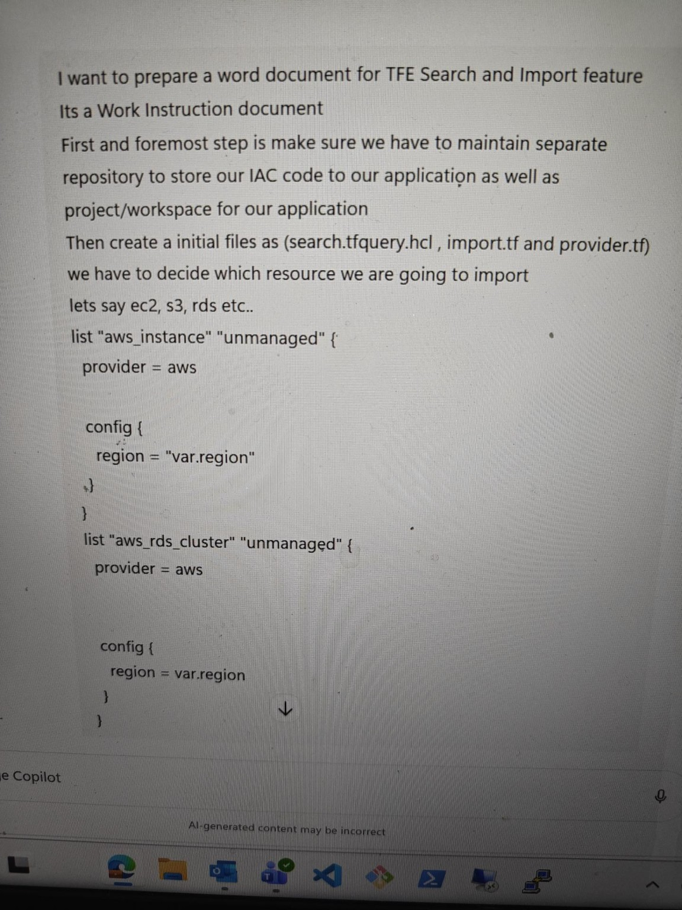
Figure 1 – Example search definitions for EC2 and RDS. Use this screenshot immediately after Section 3.1.

4. Define the Terraform Import Blocks
After identifying the resources to import, define an import block for each resource. The import block maps the existing AWS resource identifier to the Terraform resource address that will represent it in the configuration.

4.1 EC2 Example
import {
to = aws_instance.unmanaged
id = "i-0193268584047e2f3"
}

4.2 RDS Cluster Example
import {
to = aws_rds_cluster.unmanaged
id = "tfefdo-aurorapgsql-dr-testing"
}

4.3 RDS Cluster Instance Example
import {
to = aws_rds_cluster_instance.writer
id = "tfefdo-aurorapgsql-dr-testing-0"
}

4.4 Multiple S3 Bucket Examples
import {
to = aws_s3_bucket.unmanaged1
id = "tfe-search-import"
}
import {
to = aws_s3_bucket.unmanaged2
id = "tfe-search-import-2-poc"
}

The Terraform address in the 'to' argument must match the resource definition/list naming used in the repository. The 'id' value must be the identifier expected by the corresponding AWS Terraform resource.
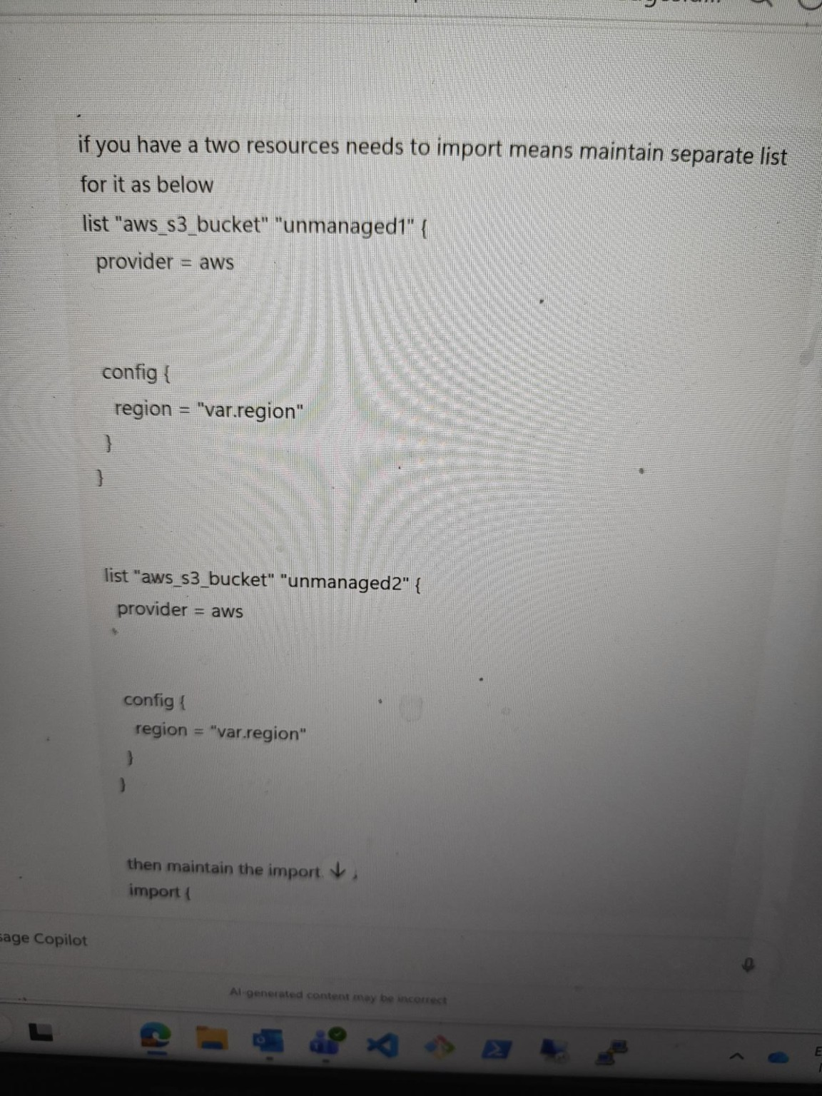
Figure 2 – Example import.tf blocks for EC2, RDS cluster, RDS instance, and S3. Place this screenshot after Section 4.4.

5. Publish Repository and Run Search/Import
Once the initial files are committed, publish the repository and connect the selected branch to the TFE workspace. The workspace should then be used to execute the search/import workflow.

5.1 Repository and Branch
- Commit search.tfquery.hcl, import.tf, provider.tf, and any required variables/configuration files.
- Push the changes to the repository.
- Confirm that the TFE workspace is connected to the correct repository.
- Select the intended branch as the workspace's working branch/default branch as applicable.
- Trigger the Terraform/Search operation from TFE.

5.2 Review Search Results
The search/import operation should return the existing resource information and configuration that Terraform can use to represent the resource. Review the generated arguments and values carefully before copying them into the main Terraform configuration.
Review before copying
Do not blindly copy generated configuration into production code. Review provider-specific arguments, references, defaults, tags, networking settings, encryption settings, and any sensitive values before committing the final configuration.

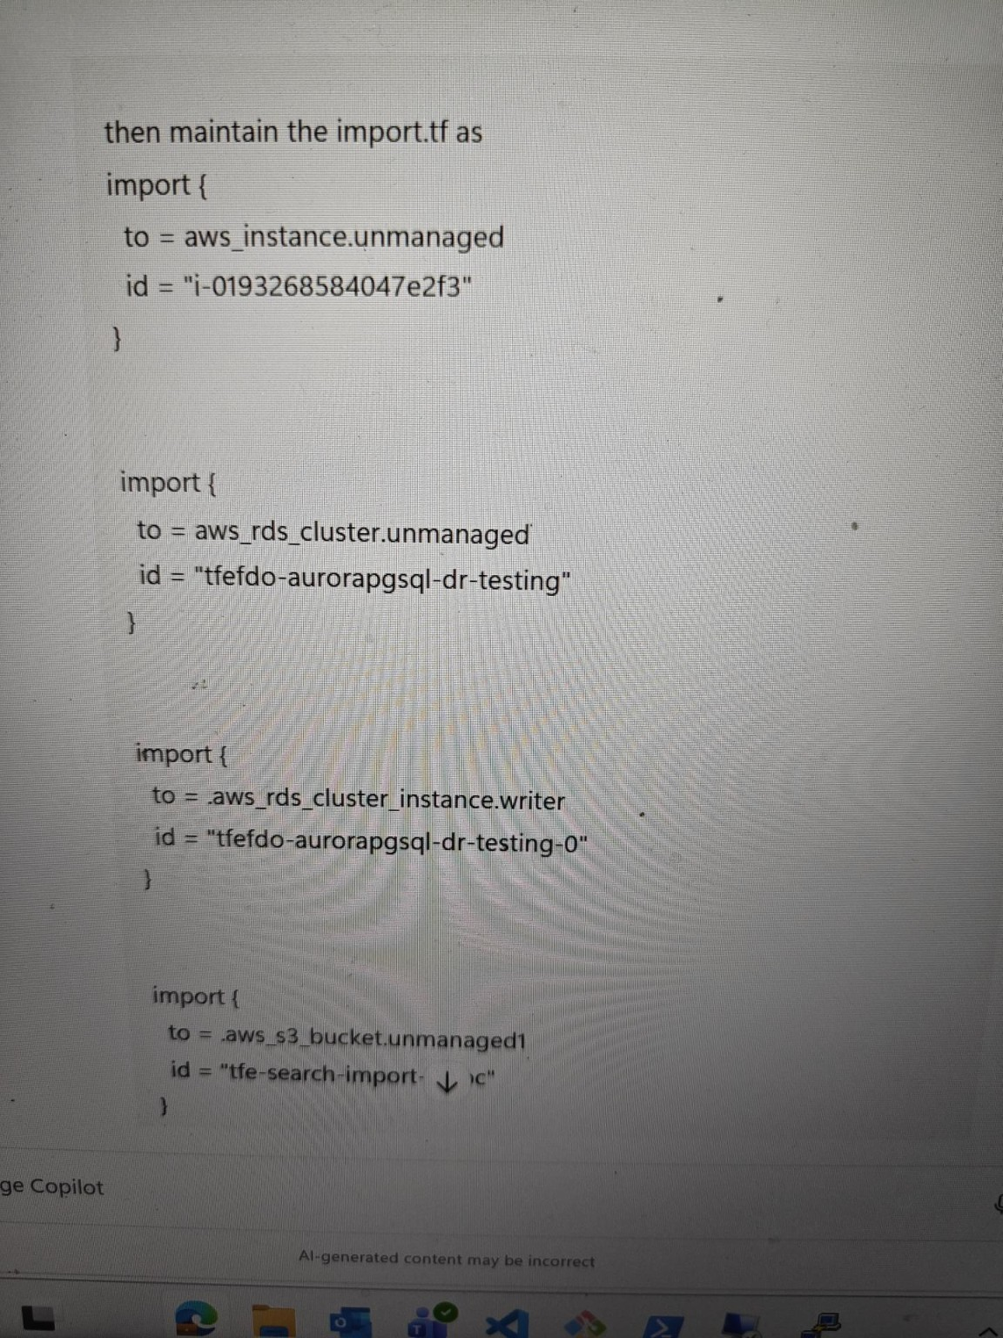
Figure 3 – Example TFE Search and Import workflow/result screen. Place this screenshot after Section 5.2 and refer to it while describing the generated configuration.

6. Convert Generated Configuration into Maintainable Terraform
The generated configuration is a starting point. After reviewing the generated output, copy the required resource configuration into main.tf and refactor it into the standard Terraform structure used by the team.

6.1 Recommended File Responsibilities
File | Purpose | Examples
main.tf | Primary resource definitions | aws_instance, aws_s3_bucket, aws_rds_cluster
variables.tf | Reusable input values | region, environment, naming values
locals.tf | Derived/reusable local values | common tags, naming conventions
data.tf | Lookup existing AWS resources | VPCs, subnets, security groups, IAM roles, parameters
provider.tf | Provider and authentication configuration | AWS provider, region
import.tf | Maps existing resources into Terraform state | EC2, S3, RDS import blocks
search.tfquery.hcl | Defines resources to search/discover | EC2, S3, RDS resource lists

6.2 Use Variables Instead of Hard-Coded Values
Values that vary by environment or application should be represented as variables. This makes the code reusable and reduces the risk of changing the wrong environment.
variable "region" {
type = string
default = "ap-south-1"
}
variable "environment" {
type = string
}

6.3 Use Data Sources for Existing Dependencies
Use data sources when the imported resource depends on infrastructure that already exists and should not be recreated by the module. Typical examples include VPCs, subnets, security groups, IAM roles, and values stored in AWS Systems Manager Parameter Store or AWS Secrets Manager.
data "aws_vpc" "selected" {
filter {
name = "tag:Name"
values = ["existing-vpc-name"]
}
}
data "aws_subnet" "selected" {
filter {
name = "tag:Name"
values = ["existing-subnet-name"]
}
}

Sensitive information
Do not place passwords, access keys, tokens, or secret values directly in Terraform files. Where applicable, retrieve approved values through AWS Secrets Manager, SSM Parameter Store, or the organization's approved secret-management process.

7. Push Changes and Validate the TFE Plan
After the generated configuration has been refactored and the repository has been updated, push the changes and run a fresh TFE plan. The plan is the key validation point before applying the imported resources.

7.1 Expected Plan Review
- Confirm the expected existing resources are identified for import.
- Confirm the Terraform resource addresses match the intended resources.
- Review all proposed changes to existing infrastructure.
- Investigate any unexpected resource replacement or destruction.
- Confirm that dependencies such as VPCs, subnets, security groups, IAM roles, and KMS keys reference the correct existing resources.
- Confirm that no sensitive values are unintentionally exposed in the configuration or plan.
- Do not apply the plan until the expected result has been reviewed and approved.
Critical check
A successful plan does not automatically mean the configuration is correct. Always compare the planned changes with the actual AWS resource and the intended target state. Any unexpected 'destroy' or replacement action should be investigated before apply.

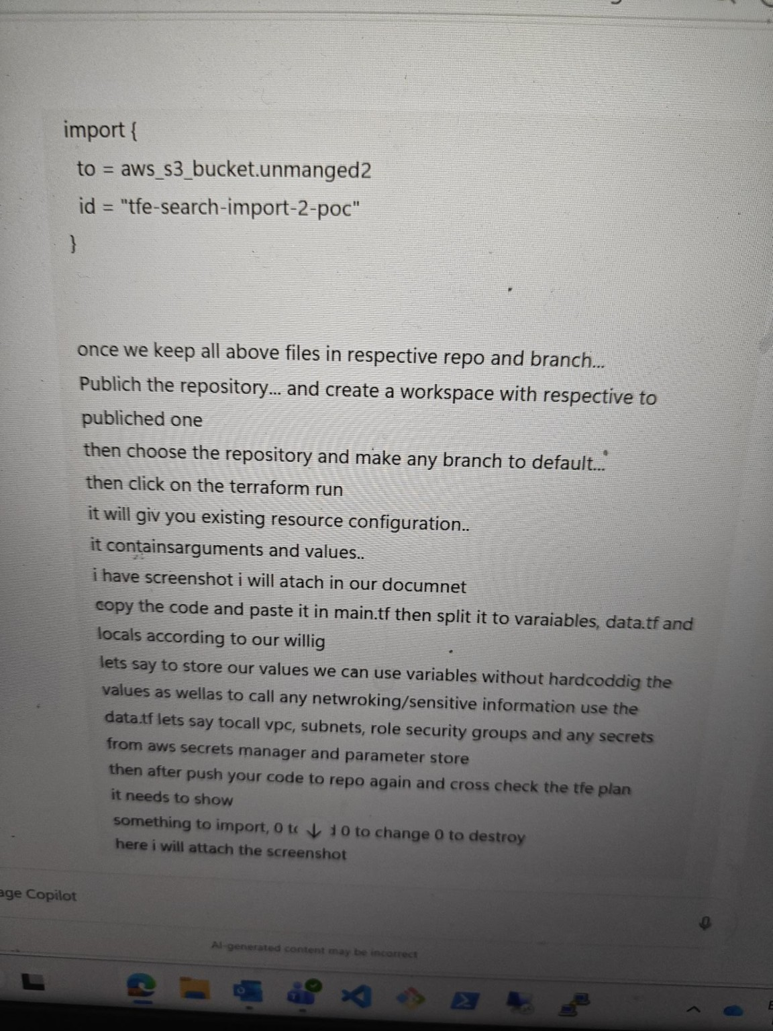
Figure 4 – Example plan validation output. Place this screenshot after Section 7.1. Annotate the screenshot if needed to highlight import, change, or destroy counts.

7.2 Plan Outcome Interpretation
Plan Result | Meaning | Action
Import expected resources | Existing AWS resources will be brought under Terraform state management. | Proceed after review.
0 to change | No configuration change is expected for the imported resources. | Preferred result when onboarding unchanged infrastructure.
Unexpected changes | Terraform configuration does not fully match the existing resource or dependencies. | Review and correct before apply.
Destroy / replacement | Terraform intends to remove or replace an existing resource. | STOP and investigate before apply.

8. Apply and Post-Import Verification
- Obtain the required review/approval according to the team's change-management process.
- Apply the validated TFE run.
- Confirm that the import completed successfully.
- Verify the resources in the Terraform state.
- Run a subsequent plan, if required, to confirm there are no unexpected changes after the import.
- Record the imported resource addresses and any important implementation notes.

8.1 Post-Import Checks
- Confirm EC2 instance IDs, instance attributes, tags, networking, and security groups.
- Confirm S3 bucket name, region, encryption, versioning, public access settings, and other applicable configuration.
- Confirm RDS cluster and cluster instance identifiers, engine configuration, networking, security groups, encryption, and other applicable settings.
- Confirm dependencies are represented correctly through data sources or managed resources.
- Confirm the repository contains the final maintainable configuration and the import/search files required by the workflow.

9. Troubleshooting and Common Checks
Resource not found during search/import: Verify AWS account, region, provider configuration, permissions, and the resource type/query.
Import address error: Verify that the 'to' address exactly matches the Terraform resource address used in the configuration.
Unexpected changes in plan: Compare generated configuration with the actual AWS resource. Check omitted/default arguments, tags, dependencies, and provider behavior.
Plan shows destroy or replacement: Do not apply. Review resource identifiers, immutable attributes, dependencies, and whether the configuration accurately represents the existing resource.
Sensitive values appear in configuration: Remove hard-coded secrets and use the approved secret-management mechanism.
Multiple resources of same type: Use separate search/import entries with unique Terraform addresses and the correct resource IDs.

10. Execution Checklist
- Dedicated IaC repository created/selected.
- TFE workspace created and connected to the correct repository.
- Correct branch configured.
- AWS provider and region configured.
- Required resource types identified.
- search.tfquery.hcl created and reviewed.
- import.tf created with correct Terraform addresses and AWS resource IDs.
- Search/import executed in TFE.
- Generated configuration reviewed.
- Generated configuration refactored into main.tf, variables.tf, locals.tf, data.tf, etc.
- No credentials or secrets hard-coded.
- Changes pushed to the repository.
- TFE plan reviewed.
- No unexpected changes or destroys.
- Approval obtained before apply.
- Import/apply completed successfully.
- Post-import plan/verification completed.

11. Screenshot Placement Guide
For a clean and readable document, use the screenshots as evidence immediately after the step they demonstrate.
Figure | Where to place it | What it should demonstrate
Figure 1 | Section 3.1 – Search Query | EC2/RDS search list definitions.
Figure 2 | Section 4.4 – Import Blocks | Import blocks and resource IDs.
Figure 3 | Section 5.2 – TFE Search Results | TFE search/import output and generated configuration.
Figure 4 | Section 7.1 – Plan Review | Terraform plan showing the expected import/change/destroy summary.
Formatting recommendation
Keep screenshots centered, use a consistent width, and add a short figure caption. If a screenshot contains sensitive account IDs, names, IP addresses, or other confidential information, redact it before publishing the document.

12. Document Control
Version | Date | Author | Description
1.0 | 18-Aug-2026 | Cloud / DevOps Team | Initial work instruction for TFE Search and Import workflow

