VRINDA STORES – 2022 DATA ANALYSIS PROECT

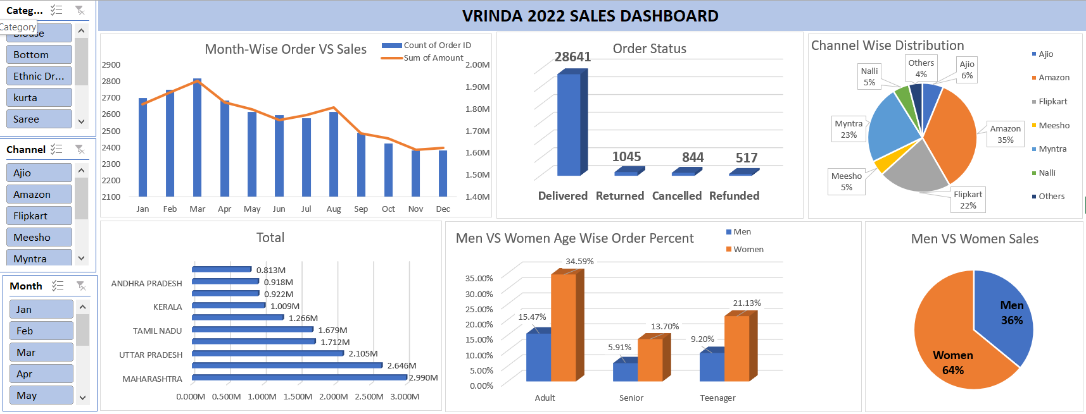

**Sales Data Analysis - Project Documentation**

**1. Project Overview**

This project aims to analyse sales data to identify key trends, customer preferences, and factors influencing revenue generation. By leveraging Excel tools such as pivot tables, pivot charts, and conditional formatting, a comprehensive analysis was performed on various dimensions like **monthly sales performance, customer demographics, regional contributions, and sales channels**.

The primary objective was to derive actionable insights to improve decision-making for Vrinda Store, a retail business. The analysis focuses on identifying the highest-selling categories, gender-based purchase behaviour, age-wise buying trends, and the most effective sales channels.

**2. Data Analysis and Insights**

To extract meaningful patterns from raw sales data, various **pivot tables and pivot charts** were utilized. These tools enabled easy aggregation and visualization of data, making complex relationships clearer and more interpretable.

**Key Questions Answered:**

1. **Which month had the highest sales?**  
   By using a **pivot table with date grouping**, monthly sales trends were analysed. A corresponding **pivot chart** provided a visual representation of peak sales months.
2. **Who purchased more – men or women?**  
   A **pivot table segmenting sales by gender** helped determine that women accounted for **~65% of total purchases**, making them the primary customer base.
3. **Which states contributed the most to sales?**  
   A **pivot table grouped by state** showed that Maharashtra, Karnataka, and Uttar Pradesh contributed **~35% of total sales**. This insight helps in geographically targeting promotions and advertisements.
4. **Which age group is the most active in purchasing?**  
   By creating an **age-based pivot table**, the analysis showed that the **30-49 age group** had the highest purchase frequency, contributing around **50% of total sales**.
5. **What is the impact of different sales channels?**  
   A **pivot chart analysing sales across platforms** (Amazon, Flipkart, Myntra, etc.) highlighted that **~80% of total sales** came from these three e-commerce platforms, making them the most profitable sales channels.
6. **Which product category had the highest sales?**  
   A **pivot table grouped by product categories** identified the top-selling category, enabling the business to focus on inventory and targeted marketing strategies.

**3. How Pivot Tables and Charts Helped in Analysis**

Pivot tables and pivot charts were instrumental in simplifying the analysis and enabling efficient data-driven decision-making. Their key benefits in this project include:

* **Summarizing Large Data Sets:** Instead of manually sorting and filtering sales data, pivot tables automatically aggregated **total sales, customer demographics, and regional contributions**.
* **Dynamic Data Filtering:** The use of slicers and filters in pivot tables allowed quick comparisons of sales performance based on gender, age group, region, and product categories.
* **Visual Representation:** Pivot charts provided an **easy-to-understand graphical summary** of complex numerical data, enabling clear trend identification.
* **Trend Analysis:** By grouping data into **monthly sales trends**, business stakeholders could identify peak seasons and optimize inventory accordingly.
* **Decision-Making Support:** The analysis provided actionable insights, such as focusing marketing campaigns on **women aged 30-49 years in Maharashtra, Karnataka, and Uttar Pradesh**, and investing more in promotions on **Amazon, Flipkart, and Myntra**.

**4. Final Conclusion and Business Recommendations**

Based on the analysis, several strategic recommendations can be made to enhance Vrinda Store’s sales performance:

* **Target Audience:** Since **women (65%) in the 30-49 age group** are the most frequent buyers, marketing efforts should be tailored towards this demographic.
* **Geographic Focus:** **Maharashtra, Karnataka, and Uttar Pradesh** contribute the highest to sales, so localized promotions and targeted ads should be launched in these regions.
* **Sales Channel Optimization:** With **Amazon, Flipkart, and Myntra driving 80% of total sales**, increasing visibility and exclusive deals on these platforms can boost revenue.
* **Product Strategy:** Identifying and promoting best-selling product categories ensures better inventory management and maximized profitability.

**Next Steps**

Moving forward, additional analysis can be performed to refine pricing strategies, customer retention plans, and personalized recommendations based on purchase history. The insights gained from this project can serve as the foundation for future data-driven decisions, ensuring sustained business growth.