**UML DIAGRAMS**

Fig 1: Use case diagram for CargoMasters

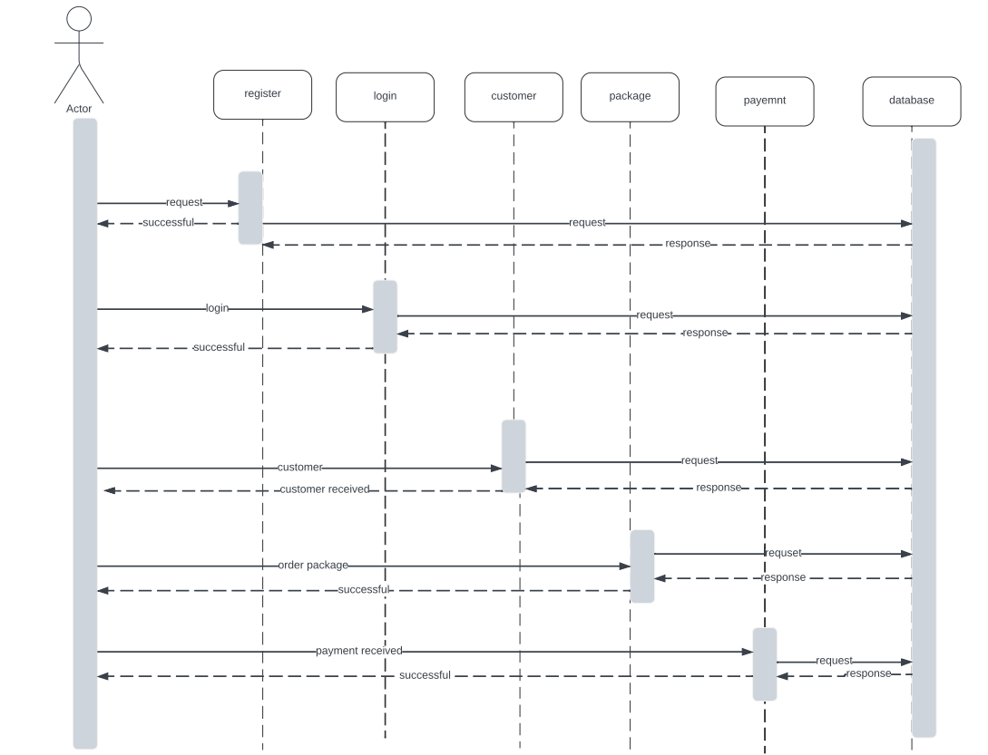

Fig 2: Sequence diagram for CargoMasters

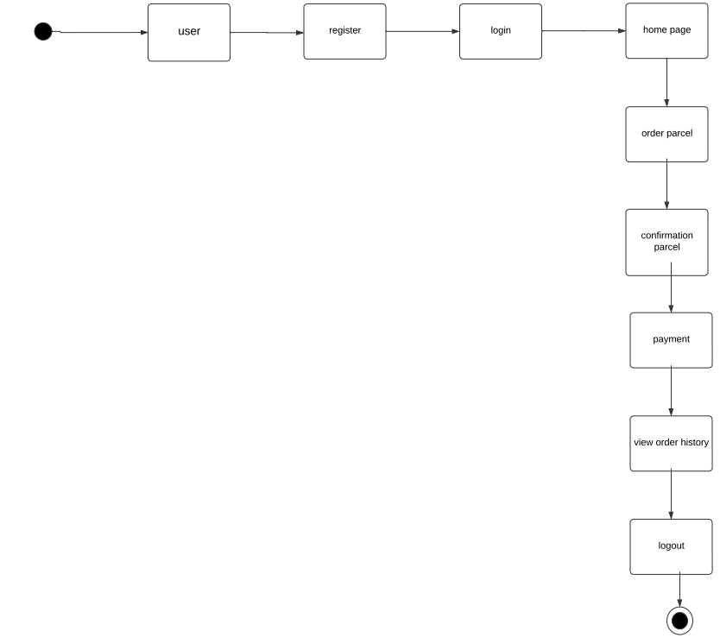

Fig 3: State chart diagram for CargoMasters

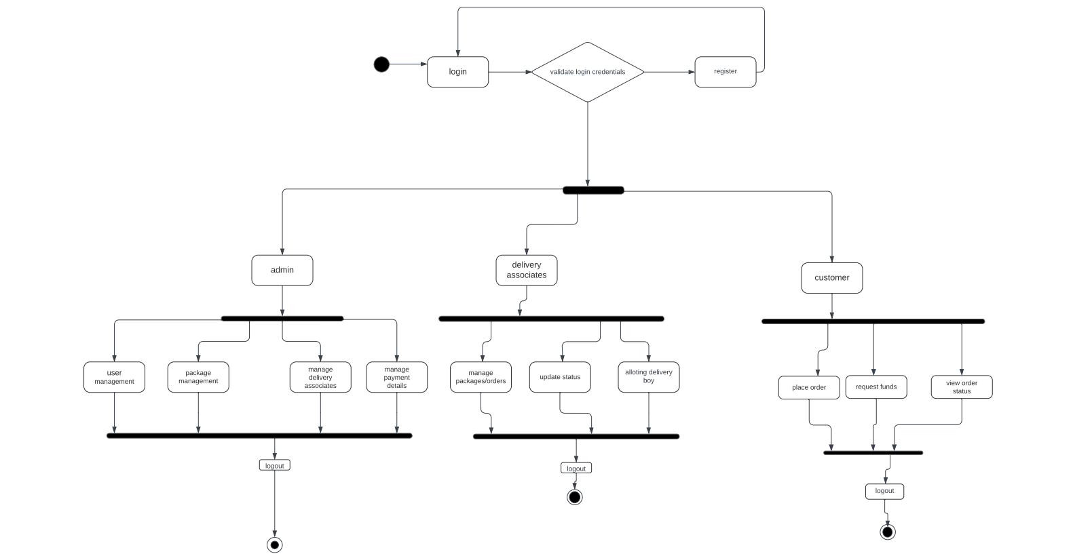

Fig 4. Activity diagram for CargoMasters

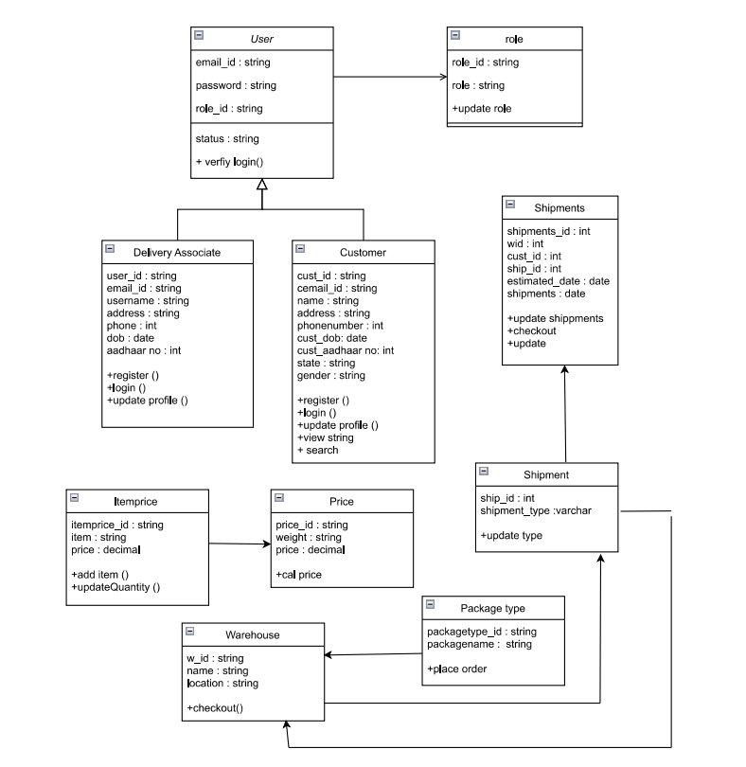

Fig 5. Class diagram for CargoMasters

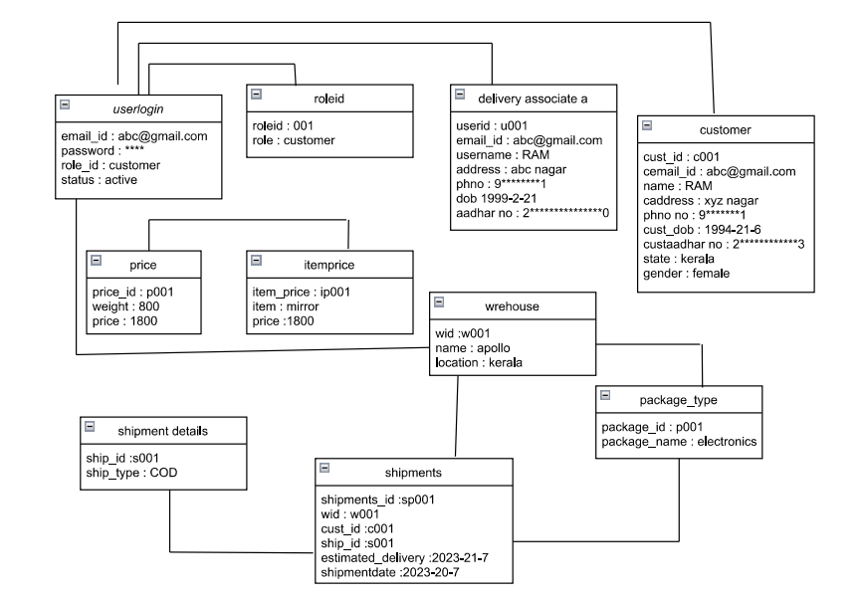

Fig 6. Object diagram for CargoMasters

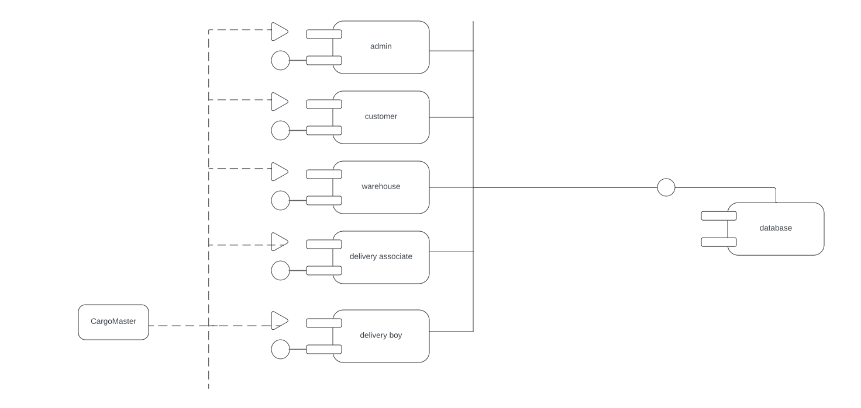

Fig 7. Component diagram for CargoMasters

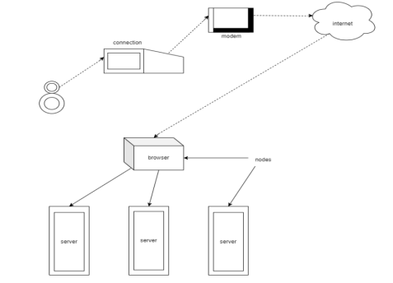

Fig 8. Deployment diagram for CargoMasters

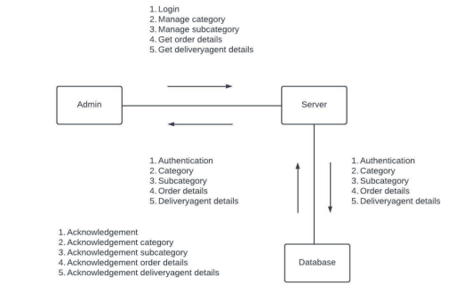

Fig 9. Collaboration diagram for CargoMasters