FINS5545 | FINTECH PROJECT 2026
SignalYield
Systematic Multi-Asset Funds with News-Sentiment Analytics
Part B report
Student: z5652591
Sample: 2020-01-01 to 2023-12-31 | OOS: 2021-2023
Generated evidence build: 14 August 2026

AI-assisted editable draft. The student must verify every number, complete the 50-headline manual review, and rewrite the final economic interpretation in their own words before submission.

Executive summary
SignalYield is an educational investment-product prototype for a financially literate user who wants transparent, comparable access to systematic equity, crypto and multi-asset funds. The product converts the audited Part A data foundation into 12 investable fund simulations, a sector news-sentiment index, and an investor dashboard. Every fund is evaluated using a monthly expanding-window walk-forward design: information available by a rebalance date sets weights that become effective on the next trading day.
The strongest baseline risk-adjusted result was equity_equal_weight with an annualised Sharpe ratio of 0.85, annualised return of 13.2%, and maximum drawdown of -20.3%. Crypto funds delivered high returns but also exceptionally high volatility and drawdowns, so the evidence does not support presenting crypto as a low-risk substitute for equities. Combined minimum variance was almost identical to equity minimum variance because the optimiser assigned little economic value to volatile crypto exposure.
The finance-enhanced VADER model reduced the neutral-headline rate from 49.6% to 47.8%. A fixed, untuned sentiment fusion improved the minimum-variance equity fund in this sample, especially for the contrarian direction, but this is exploratory rather than proof of a stable forecasting relation. Two robustness extensions add practical depth: Ledoit-Wolf covariance shrinkage and a 0-100 basis-point transaction-cost curve.

1. Product and investor proposition
SignalYield addresses a presentation gap rather than claiming a new source of guaranteed alpha. A user can compare consistent OOS metrics, inspect a fund's latest target holdings, combine precomputed funds in an allocation builder, and view sector news sentiment as context. The interface avoids raw-data and model execution at runtime: it reads committed CSV evidence, making the app faster, cheaper to host, and easier to audit. The commercial analogy is a systematic fund platform earning a management fee; in this project it remains an educational prototype and not personal financial advice.
The product design deliberately separates evidence from choice. Performance tables describe historical simulations; the fact sheet explains one fund; the allocation builder performs only a linear combination of saved OOS returns; and sentiment is labelled as noisy context. This reduces the risk that visual polish is mistaken for predictive certainty.

2. Funds and backtest design
The fund universe is a three-by-four matrix: equity-only, crypto-only and combined equity-plus-crypto universes crossed with equal weight, minimum variance, maximum Sharpe and risk parity. All optimised funds are long-only and fully invested. Equal weight is an important estimation-free benchmark; minimum variance uses the covariance matrix; maximum Sharpe uses estimated mean returns and covariance with a zero risk-free rate; and risk parity seeks equal contributions to portfolio variance. These choices follow the mean-variance diversification tradition [1] while retaining a simple benchmark that can be hard to beat after estimation error [3].
Equity and combined funds require 252 trading-day observations before their first live return; crypto requires 365 calendar days. Estimation expands from the start of the sample, rebalancing occurs monthly, and each new weight is effective one trading day after estimation. The first live dates are 5 January 2021 for equity and combined funds and 2 January 2021 for crypto. An automated audit confirms estimation_end is strictly earlier than effective_date for all 432 fund-rebalance records. Equity and combined statistics use 252-day annualisation; crypto uses 365 days. Baseline transaction costs are zero and average rebalance turnover is reported rather than hidden.
Design choice | Implementation | Reason
Window | Expanding | Uses growing history without discarding early data
Rebalance | Monthly | Balances responsiveness and implementation burden
Timing | Weights live next day | Prevents same-day information leakage
Constraints | Long-only; sum to 1 | Clear and investable educational mandate
Risk-free rate | 0 | Transparent Sharpe convention allowed by brief
Table 1. Frozen baseline backtest design, specified before OOS evaluation.

3. Out-of-sample fund results
Figure A1 and Table A1 report all 12 funds. Equity equal weight achieved a Sharpe ratio of 0.85, ahead of the three optimised equity alternatives. This is economically plausible: estimating means and covariances from a short, non-stationary sample can introduce enough error to offset theoretical gains. Maximum Sharpe was the weakest equity method on risk-adjusted performance and also had the highest turnover, consistent with sensitivity to estimated means.
Crypto risk parity and equal weight produced annualised returns of 35.3% and 33.7%, but their annualised volatility was about 79%-80% and maximum drawdowns exceeded 80%. Minimum variance reduced crypto volatility to 64.3%, still far above every equity fund. These results make a critical product distinction: high ending wealth does not imply a tolerable investor journey. The dashboard therefore shows drawdown and volatility alongside return.
Combined risk parity recorded the strongest combined-fund Sharpe (0.80), while combined equal weight returned 15.2% annually with a 0.77 Sharpe. Combined minimum variance matched equity minimum variance to numerical precision. Its low-volatility objective largely rejected crypto, so adding a broad universe did not force diversification into assets that worsened the estimated risk objective. Figure A4 makes that allocation mechanism visible.
Illustrative fund | Return | Vol | Sharpe | Max DD
Combined Min Variance | 7.0% | 12.8% | 0.59 | -18.3%
Combined Risk Parity | 13.0% | 17.2% | 0.80 | -22.9%
Crypto Risk Parity | 35.3% | 78.8% | 0.78 | -80.4%
Equity Equal Weight | 13.2% | 16.2% | 0.85 | -20.3%
Table 2. Selected OOS results, 2021-2023; annualised, risk-free rate 0.
A fund-selection implication follows. A moderate-risk user should not choose only from return rankings: equity equal weight and combined risk parity offer stronger balance, while crypto allocations require explicit drawdown tolerance. No result is a forecast, and three OOS years are not enough to establish a permanent ranking.

4. News sentiment and structured-unstructured fusion
The sentiment pipeline retains raw casing and punctuation because VADER uses intensifiers, capitals and punctuation [6]. Headlines are scored individually, aggregated to ticker-day, and then equal-weighted across tickers within each sector. Missing-news observations remain distinguishable from neutral news. The signal is lagged by one equity trading day before it can affect a weight; weekend headlines mapped to Monday are first usable on Tuesday.
The finance lexicon extension adjusts a pre-specified set of domain words while preserving the VADER rules. It lowered the neutral classification rate by 1.76 percentage points across 146,830 headlines. That is coverage evidence, not an accuracy claim. Financial dictionaries are useful because ordinary-language polarity can differ from financial usage [7], but the required independent 50-headline student review is still outstanding. The generated template and validator make that limitation explicit and reproducible.
Fusion starts from the equity minimum-variance fund. Fixed lambda values of 0, +1 and -1 preserve the base, momentum and contrarian directions without tuning on the full OOS period. The base Sharpe was 0.59; momentum reached 0.62; and contrarian reached 0.75. Contrarian also increased annualised return from 7.0% to 10.0% and reduced maximum drawdown from -18.3% to -16.8%. Both signs are retained; the better realised sign was not retroactively selected as the model.
The fusion result is promising but fragile. It covers one base portfolio, one market episode and an automatically proposed lexicon. Headlines may reflect events already incorporated in prices, publisher selection, and sector coverage differences. Tetlock's evidence that media tone can relate to market activity motivates testing [8], but does not establish causality here.

5. Innovation and robustness

5.1 Ledoit-Wolf covariance shrinkage
The first robustness extension replaces sample covariance only for the covariance-sensitive minimum-variance and maximum-Sharpe funds. Ledoit-Wolf shrinks the sample matrix toward a structured target using an intensity estimated within each expanding window [5]. It is not tuned against OOS performance, and the canonical 12-fund files remain byte-for-byte unchanged.
Family | Method | LW Sharpe | Change
Combined | Max Sharpe | 0.42 | -0.012
Combined | Min Variance | 0.58 | -0.013
Crypto | Max Sharpe | 0.56 | +0.040
Crypto | Min Variance | 0.75 | +0.097
Equity | Max Sharpe | 0.61 | +0.014
Equity | Min Variance | 0.58 | -0.006
Table 3. Ledoit-Wolf versus sample-covariance OOS Sharpe, 2021-2023.
Shrinkage materially helped crypto minimum variance (+0.097 Sharpe) and modestly helped crypto maximum Sharpe (+0.040). Its effect was small or negative for the other four comparisons. The honest conclusion is conditional: covariance regularisation appears most valuable in the volatile crypto universe, but it does not uniformly dominate the baseline.

5.2 Transaction-cost sensitivity
The second check deducts turnover multiplied by fixed one-way costs of 0, 10, 25, 50 and 100 basis points on post-launch rebalance dates. Costs do not alter portfolio formation. At 50 bps, maximum-Sharpe funds suffer the largest Sharpe reductions: -0.040 for equity and -0.030 for combined, reflecting total turnover of 5.64 and 6.31 times capital. Risk parity changes by roughly 0.001 or less, and equal weight incurs no post-launch rebalance turnover under the implemented constant-target convention. Figure A8 shows the full curves rather than one chosen cost assumption.
This strengthens product interpretation. A theoretically appealing optimiser can be operationally inferior if unstable estimates drive trading. The cost model is still simplified: it omits bid-ask variation, nonlinear market impact, tax and asset-specific liquidity. It should therefore be read as sensitivity, not a precise live implementation forecast.

6. App and investor journey
The six-page Streamlit journey is Home, Fund Comparison, Fund Fact Sheet, Allocation Builder, Sentiment Analytics and Robustness Lab. Home establishes scope and risk disclosure. Comparison filters the 12 funds. Fact Sheet combines return, drawdown and current target holdings. Allocation Builder enforces a 100% total and combines only shared saved OOS dates. Sentiment Analytics exposes the sector index and base-versus-tilt evidence. Robustness Lab makes estimator and cost assumptions inspectable rather than hiding them in a technical appendix.
The deployed architecture is deliberately thin: it imports neither NLTK nor an optimiser and never downloads the raw data. This separates research from delivery, shortens load time, and allows app acceptance tests to confirm that every page opens from committed artifacts. At the time of this draft the code is in a private GitHub repository; the brief requires the student to make it public at hand-in and complete the authenticated Streamlit deployment.

7. Critical reflection and recommendations
First, preserve simple benchmarks. Equal weight led the equity Sharpe ranking, and risk parity was competitive with lower turnover than maximum Sharpe. A live product should present optimisation as a choice with estimation risk, not an automatic upgrade. Second, treat crypto as a separately disclosed risk budget. Its drawdowns exceeded 75% even for minimum variance; user allocations should include suitability warnings and scenario-based loss communication. Third, validate the text model before any production claim. Complete the stratified manual review, inspect sector-specific errors, and only then decide whether the finance lexicon improved human agreement.
Three further recommendations follow. (1) Extend the OOS sample before changing parameters, because three years can be dominated by one regime. (2) Add an asset-specific execution model and turnover-aware optimisation only after the current fixed-bps curves are documented. (3) Run a true untouched holdout for the sentiment tilt; the current fixed-sign comparison is transparent but not strong enough to market as predictive. I would not recommend tuning lambda, changing windows, or selecting an estimator merely to improve the displayed Sharpe. Those actions would trade honest evidence for backtest fit.

Conclusion
SignalYield meets the core product objective with 12 reproducible walk-forward funds, transparent fact-sheet evidence, lagged sector sentiment, structured-unstructured fusion and a tested investor interface. Its strongest contribution is not one winning fund but a traceable decision system: baseline assumptions remain frozen, extensions are separately labelled, negative or mixed robustness results are retained, and limitations are visible to the user.

Appendix A. Required and extension exhibits
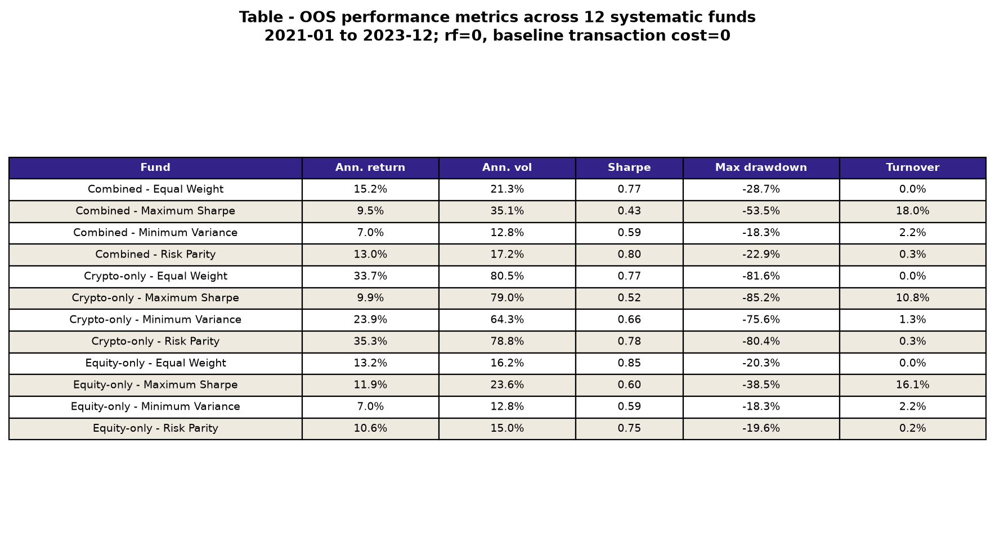
Table A1. OOS performance metrics for all 12 funds, 2021-2023; annualised, rf=0.

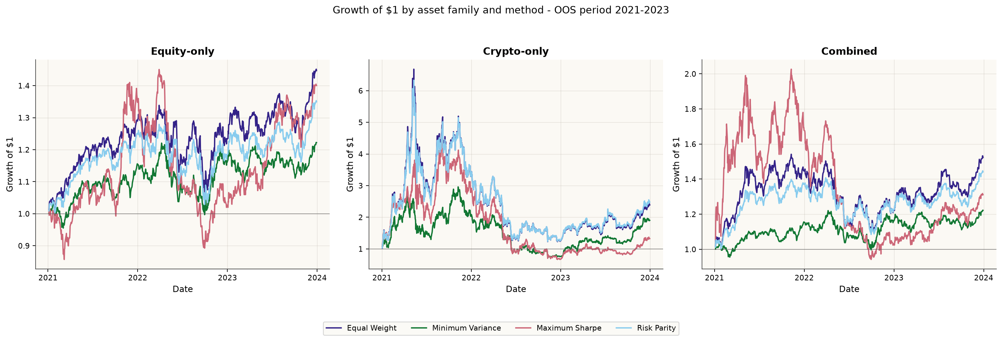
Figure A1. Growth of $1 across funds and methods, OOS 2021-2023.
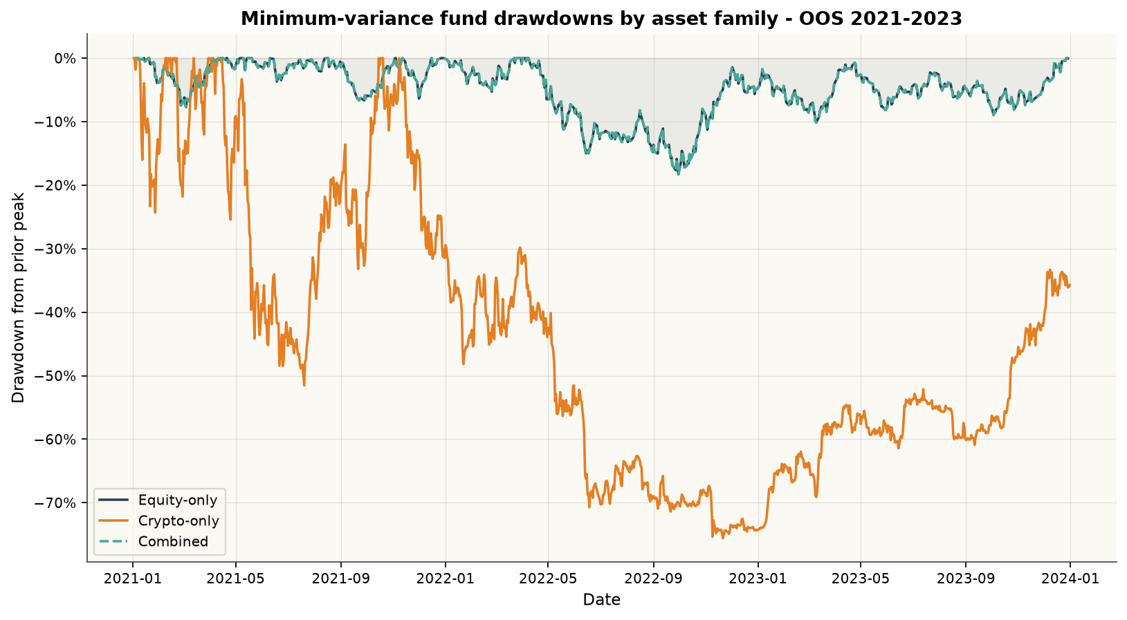
Figure A2. Minimum-variance drawdown by asset family, OOS 2021-2023.

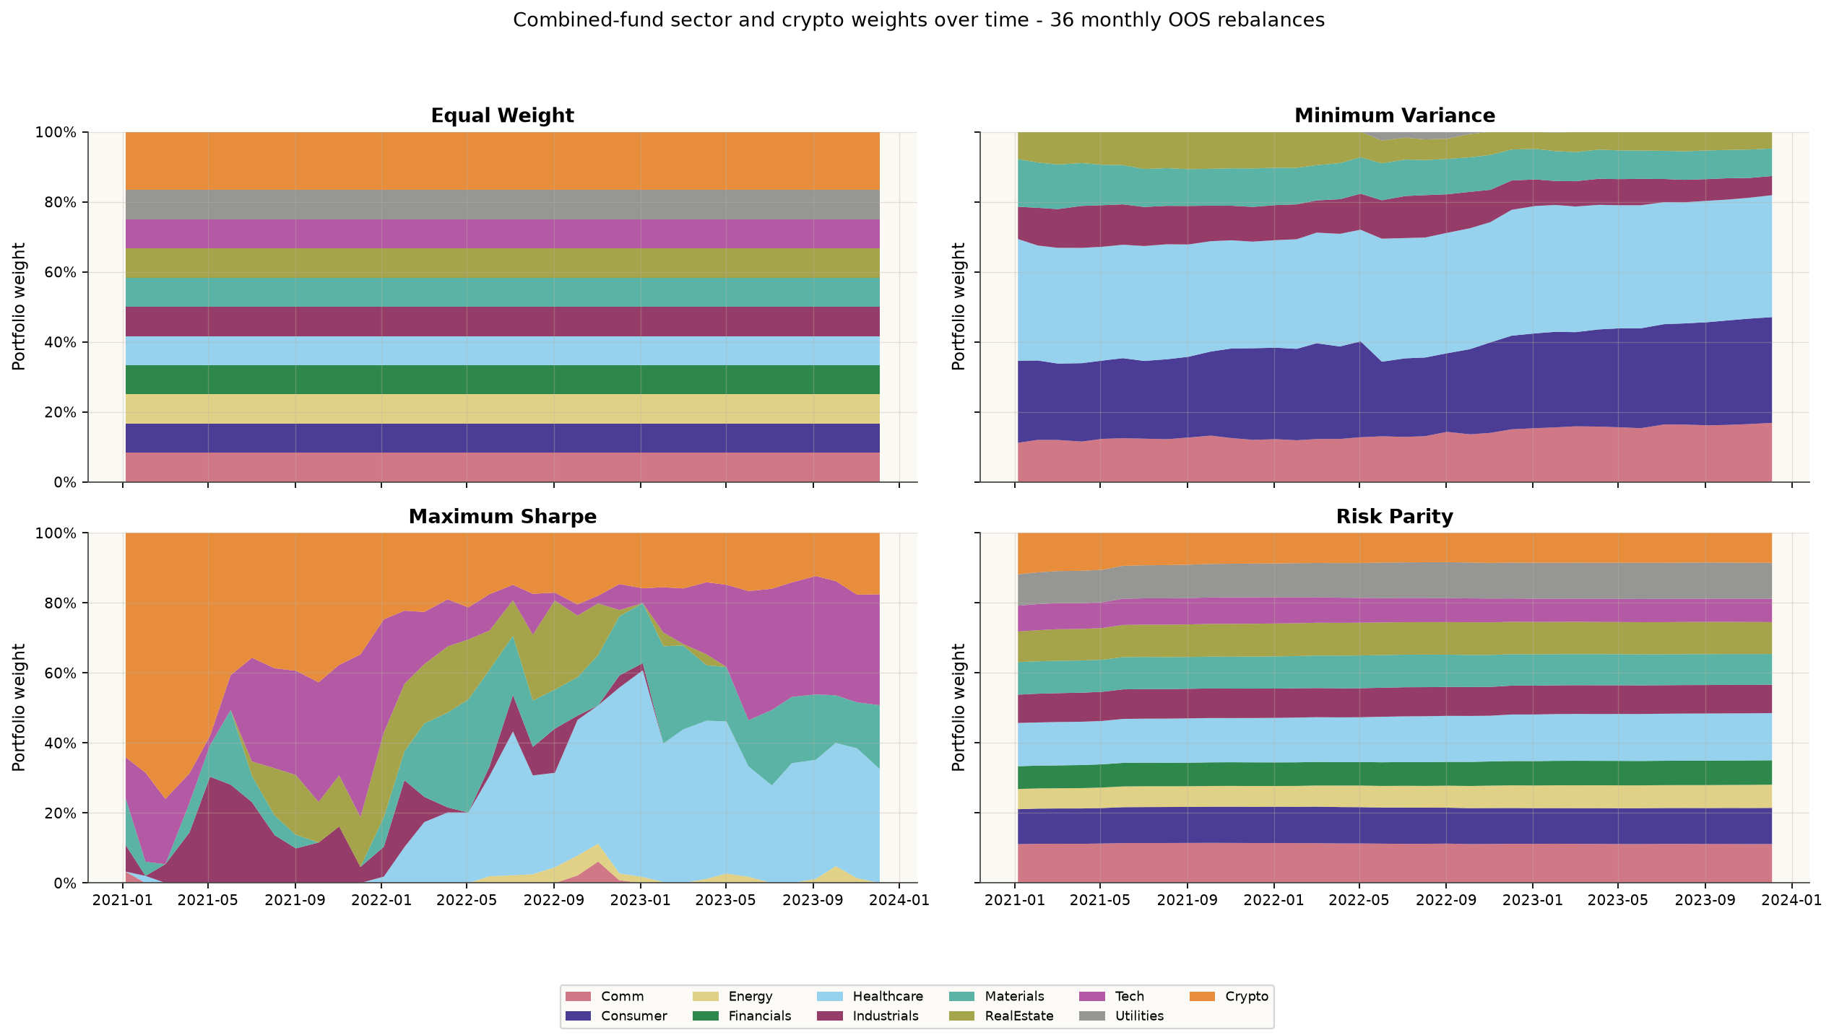
Figure A3. Combined-fund sector and crypto weights across 36 monthly rebalances.
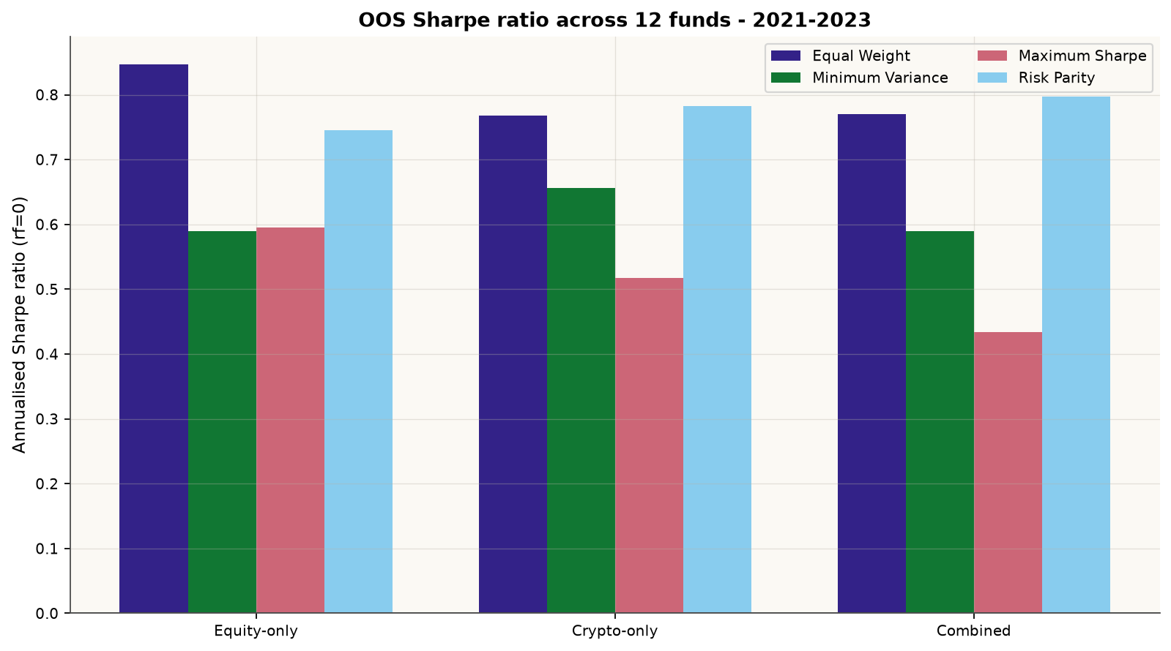
Figure A4. Annualised Sharpe ratios across the 12 funds, OOS 2021-2023.

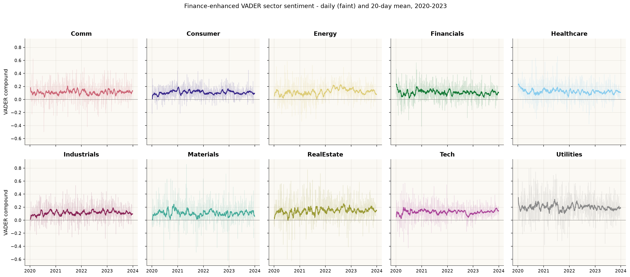
Figure A5. Finance-enhanced VADER sector sentiment, daily and 20-day mean, 2020-2023.
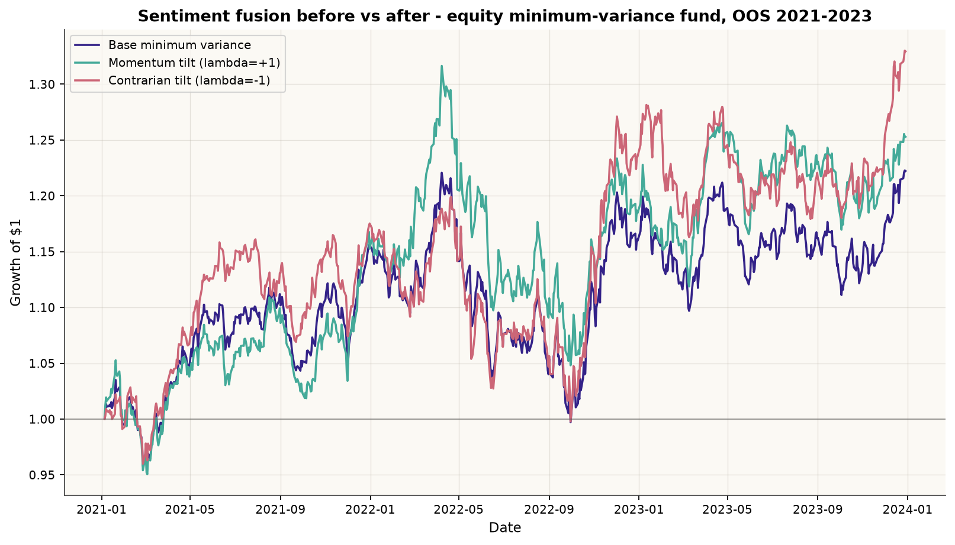
Figure A6. Equity minimum-variance base versus fixed sentiment tilts, OOS 2021-2023.

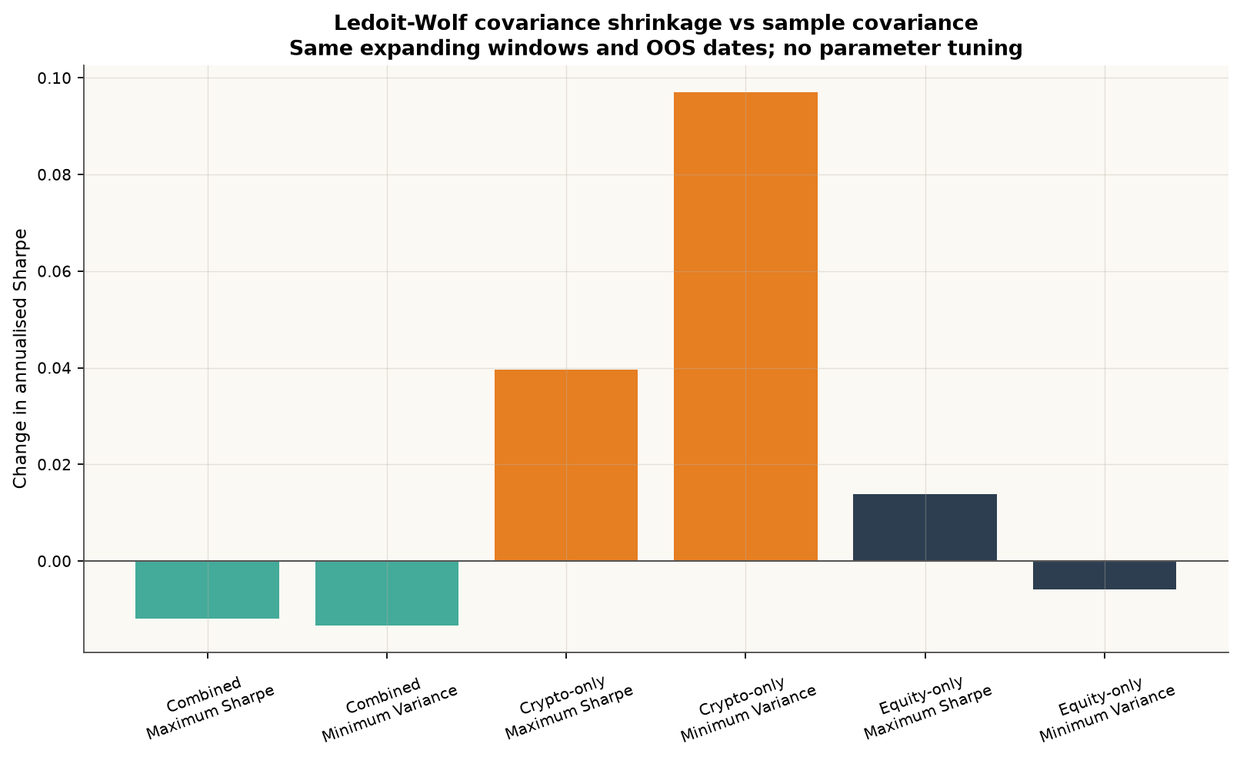
Figure A7. OOS Sharpe change under untuned Ledoit-Wolf covariance shrinkage.
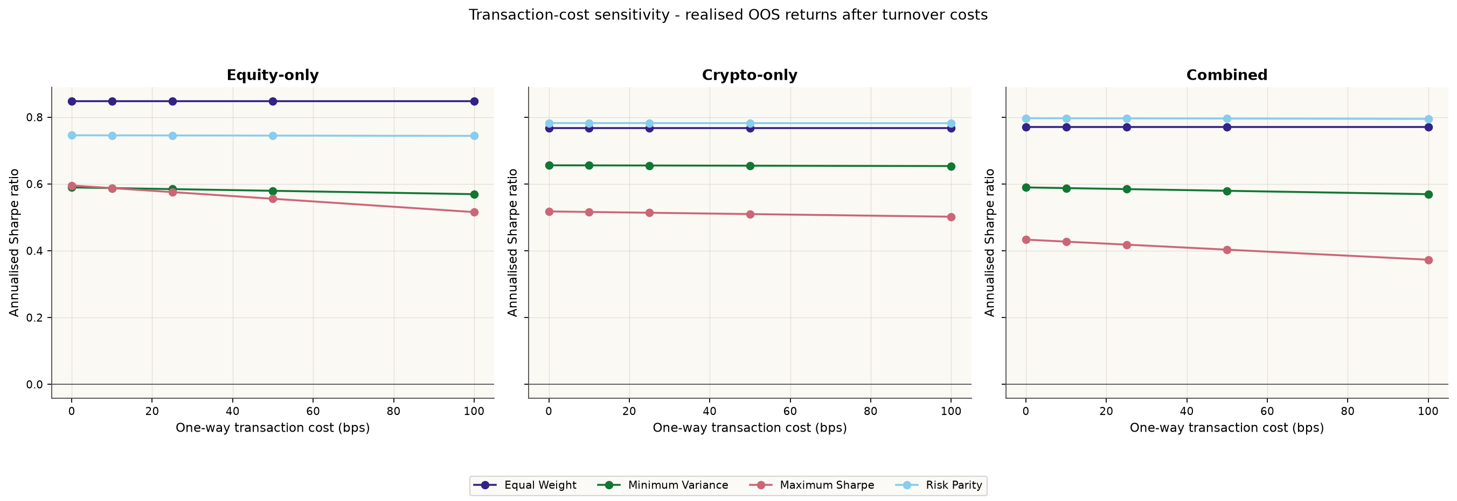
Figure A8. OOS Sharpe sensitivity to one-way costs from 0 to 100 bps.

Appendix B. Reproducibility and AI transparency
The complete evidence is rebuilt by running python scripts/run_part_b.py from the repository root. It writes app data, report tables and figures. Automated tests cover portfolio timing, sentiment lagging, fusion invariants, robustness and all six app pages. scripts/check_handin.py audits required files and frozen data access. Detailed prompts, corrections and AI limitations are recorded in ai/prompt_log_part_b.md and report/QA_REPORT.md.
Evidence | Location
12-fund returns and weights | results/data/fund_returns.csv; fund_weights.csv
Sector sentiment | results/data/sector_sentiment_index.csv
Fund metrics | results/tables/performance_metrics.csv
Robustness tables | results/tables/shrinkage_comparison.csv; transaction_cost_sensitivity.csv
Manual review workflow | results/tables/sentiment_manual_review_template.csv; scripts/validate_sentiment_review.py
Table B1. Key reproducible evidence paths.
AI produced code and this editable draft under student direction. The student remains responsible for inspecting the code, completing the manual labels, checking all outputs, and rewriting the final analysis and economic interpretation in their own voice. No AI-generated labels are represented as human validation.

References
[1] Markowitz, H. (1952). Portfolio Selection. Journal of Finance, 7(1), 77-91. https://doi.org/10.1111/j.1540-6261.1952.tb01525.x
[2] Sharpe, W. F. (1966). Mutual Fund Performance. Journal of Business, 39(1), 119-138. https://doi.org/10.1086/294846
[3] DeMiguel, V., Garlappi, L., and Uppal, R. (2009). Optimal Versus Naive Diversification: How Inefficient Is the 1/N Portfolio Strategy? Review of Financial Studies, 22(5), 1915-1953. https://doi.org/10.1093/rfs/hhm075
[4] Maillard, S., Roncalli, T., and Teiletche, J. (2010). The Properties of Equally Weighted Risk Contribution Portfolios. Journal of Portfolio Management, 36(4), 60-70. https://doi.org/10.3905/jpm.2010.36.4.060
[5] Ledoit, O., and Wolf, M. (2004). A Well-Conditioned Estimator for Large-Dimensional Covariance Matrices. Journal of Multivariate Analysis, 88(2), 365-411. https://doi.org/10.1016/S0047-259X(03)00096-4
[6] Hutto, C. J., and Gilbert, E. (2014). VADER: A Parsimonious Rule-Based Model for Sentiment Analysis of Social Media Text. Proceedings of ICWSM, 8(1), 216-225. https://doi.org/10.1609/icwsm.v8i1.14550
[7] Loughran, T., and McDonald, B. (2011). When Is a Liability Not a Liability? Textual Analysis, Dictionaries, and 10-Ks. Journal of Finance, 66(1), 35-65. https://doi.org/10.1111/j.1540-6261.2010.01625.x
[8] Tetlock, P. C. (2007). Giving Content to Investor Sentiment: The Role of Media in the Stock Market. Journal of Finance, 62(3), 1139-1168. https://doi.org/10.1111/j.1540-6261.2007.01232.x
[9] Bailey, D. H., Borwein, J. M., Lopez de Prado, M., and Zhu, Q. J. (2014). The Probability of Backtest Overfitting. Journal of Computational Finance, 20(4), 39-69. https://doi.org/10.21314/JCF.2016.322

