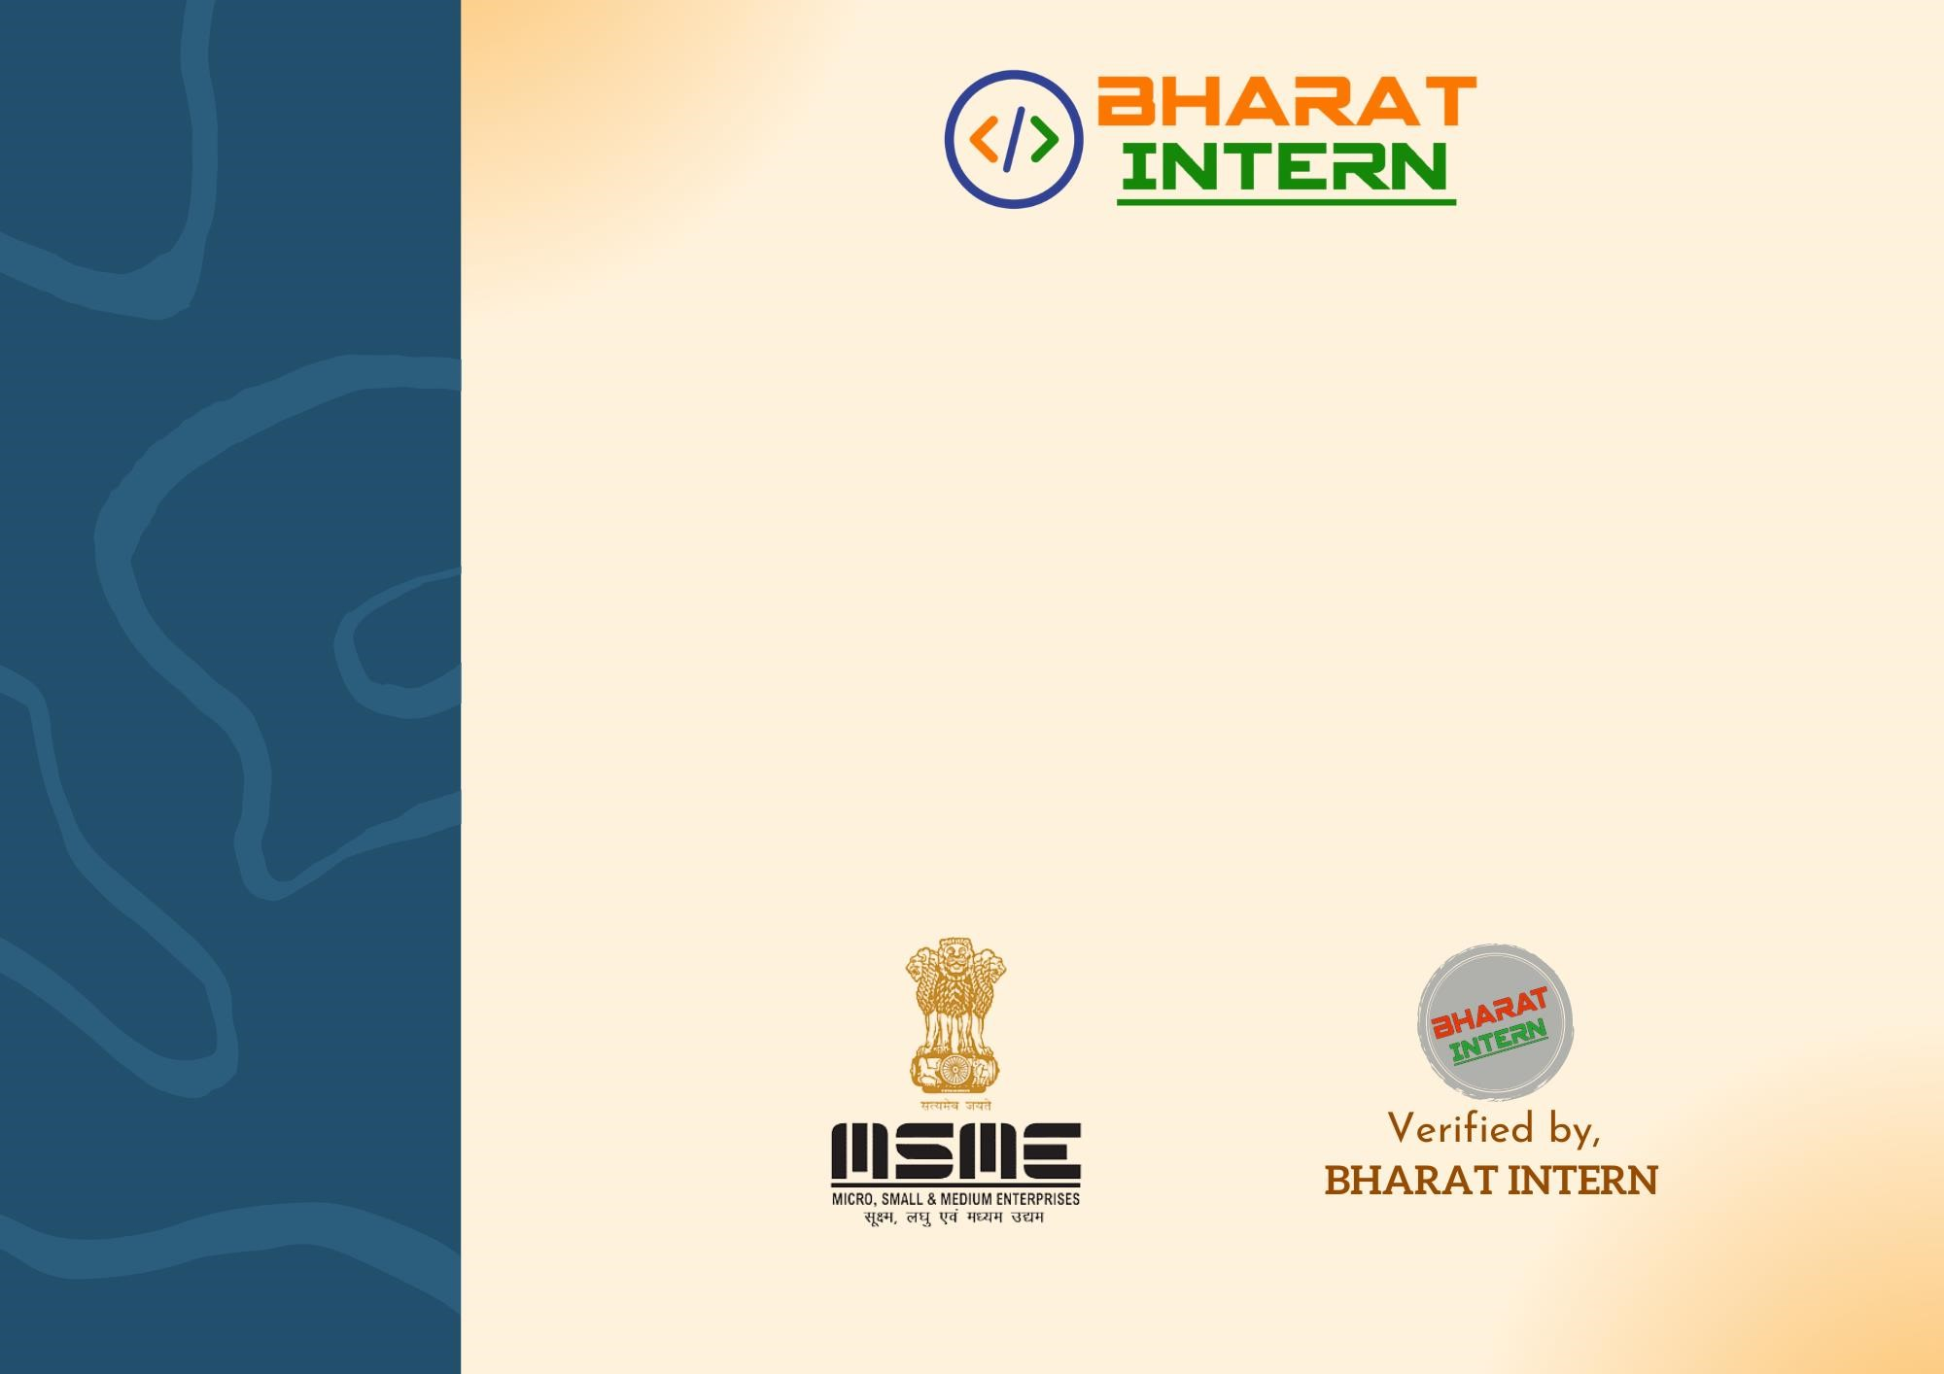

RUPENDER

**successfully completed th**

**e**

**Virtual Internship Program at**

**BHARAT INTERN in**

**Web Development**

**as an active**

**participant from**

**July**

**10**

**,2023 to**

**Ju**

**ly**

**10**

**,**

**2023**

**.**

Completion Certificate

Proudly Presented to