SIMATS ENGINEERING (SAVEETHA SCHOOL OF ENGINEERING)
Department of Computer Science and Engineering
CO5 ASSESSMENT TOOL 1 – Research Paper Review / Literature Survey

Course Code: | CSA10 | Course Title: | Software Engineering
CO Assessed: | CO5 | Assessment: | Assessment Tool 1 – Research Paper Review / Literature Survey
Weightage: | 20% | Total Marks: | 25
CO5 Statement: | Evaluate emerging technologies and societal impacts, maintaining and evolving software systems responsibly
Student Name: | S RUPESH | Reg. No.: | 192571055
Date: | 22.08.2026 | Duration: | 60 minutes

Code of Conduct
I __________________________ (Name / Reg No) certify that this submission is my original work and that I have adhered to the guidelines specified for this assessment. I understand that any violation of academic integrity rules will result in disciplinary action.
Signature of the Student: _________________________
Annexure A – Research Paper Review / Literature Survey
Instructions to Students:
Each student is assigned an individual problem statement. Based on the assigned problem statement, conduct a literature survey and review relevant research papers to understand the existing approaches, techniques, technologies, limitations, and research gaps related to the problem.
The literature survey should include:
- Identify and select relevant research papers related to the assigned problem statement from reputed journals, conferences, or scholarly databases.
- Summarize the objectives, methodologies, technologies, datasets, and major findings of the selected research papers.
- Compare the existing approaches based on suitable parameters such as accuracy, performance, scalability, efficiency, methodology, or other problem-specific metrics.
- Identify the limitations and challenges of the existing research approaches.
- Analyze the literature to identify the research gap or unresolved issues related to the assigned problem.
- Discuss the possible improvements or future research directions based on the identified research gap.
- Prepare a comparative literature survey table containing details such as author/year, research problem, methodology, dataset/tools, key findings, limitations, and research gap.
- Provide proper citations and references using a consistent referencing style.
Deliverable: Submit a Research Paper Review / Literature Survey Report containing the selected research papers, individual paper reviews, comparative analysis, identified research gaps, future directions, and properly formatted references.

Rubrics for Calculation
Evaluation Criteria | Excellent (4 Marks) | Good (3 Marks) | Satisfactory (2 Marks) | Needs Improvement (1 Mark)
Selection & Review of Research Papers(25%) | Selects highly relevant, recent, credible papers and provides comprehensive reviews of objectives, methodology, tools, datasets, and findings | Selects relevant papers and provides good reviews with minor gaps | Selects moderately relevant papers with basic reviews | Papers are irrelevant or reviews are incomplete
Comparative Analysis(20%) | Provides a detailed comparison of methodologies, tools, datasets, results, and performance using a clear comparison table | Provides a good comparison with relevant parameters | Provides limited comparison with few parameters | Little or no meaningful comparison
Critical Analysis & Research Gap(25%) | Clearly analyzes limitations and identifies significant, well-supported research gaps | Identifies relevant limitations and research gaps | Identifies basic gaps with limited analysis | Research gaps are unclear or missing
Future Directions & Relevance(15%) | Proposes practical and innovative future directions directly relevant to the assigned problem statement | Proposes relevant future directions | Provides general future suggestions | Future directions are missing or unrelated
Documentation, Citations & References(15%) | Excellent academic structure, clear presentation, accurate citations, and consistent referencing | Well-organized with minor formatting/citation issues | Adequately documented with some errors | Poorly organized with inadequate or incorrect references

Criteria | Mark
Selection & Review of Research Papers(25%) | /5
Comparative Analysis(20%) | /5
Critical Analysis & Research Gap(25%) | /5
Future Directions & Relevance(15%) | /5
Documentation, Citations & References(15%) | /5
TOTAL | /25

AI-BASED SMART MINING SAFETY AND EQUIPMENT
MONITORING PLATFORM
Research Paper Review / Literature Survey Report

1. Introduction and Industry Context
Mining continues to be one of the most hazardous industrial sectors in the world. Workers operate in confined underground shafts, open-pit excavations, and processing plants where they are continuously exposed to toxic and combustible gases, extreme temperatures, dust, structural instability, and heavy moving machinery. Alongside these environmental hazards, mining equipment such as crushers, conveyor belts, drilling rigs, and haul trucks operates under extreme mechanical stress, making unplanned breakdowns a frequent and costly occurrence. Conventional safety practices in the mining industry still depend heavily on periodic manual inspection, scheduled maintenance checklists, and reactive emergency response, all of which are inherently limited in their ability to anticipate hazards before they escalate into accidents.
The convergence of the Internet of Things (IoT), wearable sensor technology, unmanned aerial vehicles (drones), artificial intelligence (AI), and cloud analytics is redefining how the mining industry approaches occupational safety and asset reliability. These technologies collectively enable continuous, real-time monitoring of environmental conditions, worker physiological status, and equipment health, and they allow predictive models to flag abnormal conditions well before a failure or hazardous event occurs. This shift from reactive to proactive and predictive safety management is often referred to as the emergence of the “smart mine” or “Intelligent Mine”, aligned with the broader Industry 4.0 movement.
This report presents a structured literature survey conducted in support of the assigned problem statement: the design of an AI-based Smart Mining Safety and Equipment Monitoring Platform. The survey reviews existing academic and industry research on IoT-based worker monitoring, predictive maintenance using machine learning, environmental hazard sensing, drone-assisted inspection, and computer-vision-based hazard detection, in order to identify current capabilities, compare methodologies, and expose the research gaps that a new platform in this space would need to address.

2. Problem Statement
Mining industries experience accidents due to equipment failures, hazardous gas emissions, and delayed emergency response. Conventional monitoring systems rely on periodic inspections, which limits proactive risk management. An AI-powered mining safety platform should therefore monitor environmental conditions, worker health, and equipment status using IoT devices; predict equipment failures before they occur; detect hazardous situations as they emerge; generate emergency alerts automatically; and provide real-time dashboards that improve both worker safety and mine productivity.

3. Objectives
• Monitor mining equipment continuously using IoT-enabled sensors.
• Detect hazardous environmental conditions such as toxic/combustible gas build-up, poor air quality, and abnormal temperature.
• Predict equipment failures in advance using machine learning models trained on sensor data.
• Track worker safety and physiological well-being using wearable devices.
• Generate automated emergency alerts to workers, supervisors, and emergency responders.
• Analyze mining operations data to surface actionable operational insights.
• Improve occupational safety culture and regulatory compliance.
• Reduce operational risks and unplanned downtime across the mine site.

4. Literature Survey Methodology
To ensure the review was systematic rather than anecdotal, the literature search followed a structured six-step process, illustrated in Figure 1. Search terms combined the core concepts of the assigned problem statement -- “IoT mine safety”, “wearable sensors underground miners”, “predictive maintenance mining equipment machine learning”, “gas hazard detection AI”, “drone UAV mining safety”, and “computer vision anti-collision mine” -- and were run against scholarly sources including MDPI (Sensors, Applied Sciences), Springer, ScienceDirect, PMC/NCBI, IEEE-indexed conference proceedings, and preprint repositories such as arXiv. Papers were screened for relevance to underground or surface mining safety and equipment monitoring, and prioritized for recency (2021-2026) and methodological clarity.
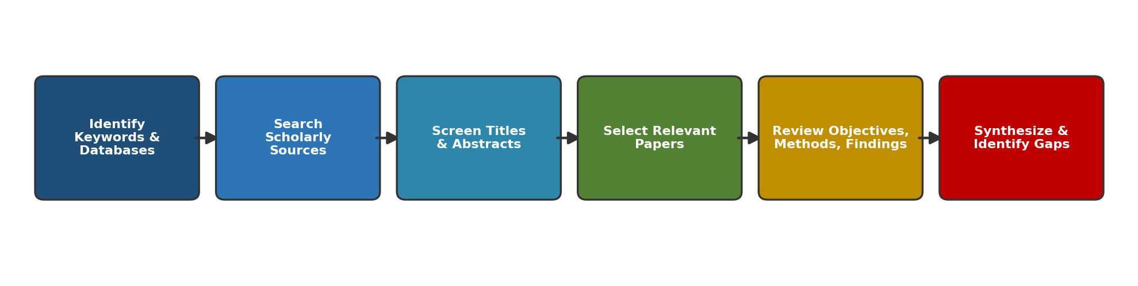
Figure 1. Literature survey methodology followed for this review.

5. Selection and Review of Research Papers
Twelve papers were selected as most directly relevant to the assigned problem statement, spanning four thematic clusters: (i) IoT and wearable-based worker safety monitoring, (ii) machine-learning-based predictive maintenance of mining/industrial equipment, (iii) environmental and gas hazard sensing, and (iv) drone/computer-vision-based hazard detection. Each paper is reviewed below in terms of its objective, methodology/technology, dataset or experimental setting, and key findings.

5.1 IoT and Wearable-Based Worker Safety Monitoring

Real-Time Monitoring of Underground Miners’ Status Based on Mine IoT System
Jiang, Chen, Zhang, Zhang & Yang (2024), Sensors, 24(3), 739. DOI: 10.3390/s24030739
Objective: Design a mine IoT system that consolidates worker vital-sign and positioning data into two wearable terminals to reduce physical burden while enabling real-time risk warnings.
Methodology / Technology: An electronic bracelet captures vital-sign data over Bluetooth, while an integrated miner lamp performs multi-gas detection, personnel positioning, and wireless communication. Data transport combines 5G communication with UWB positioning base stations and distributed MIMO networking. A back-propagation neural network estimates miner fatigue from vital signs, using the correlation between saliva pH and fatigue as the modelling basis.
Key Findings: The positioning subsystem achieved a deviation of less than 0.3 m, and end-to-end data transmission latency was kept below 20 ms, supporting near-real-time risk warning and a unified visualization platform for underground personnel status.
Limitations: The fatigue-estimation model depends on a physiological proxy (saliva pH) that is not yet standard in field deployments, and the approach requires dense 5G/UWB base-station infrastructure that may not be economically viable for smaller or older mines.

A Robust End-to-End IoT System for Supporting Workers in Mining Industries
Sensors 24(11), 3317 (2024). DOI: 10.3390/s24113317
Objective: Develop a smart-garment-based IoT system usable in both open-pit and underground mines that continues to function even when communication links are broken.
Methodology / Technology: A wearable smart garment embeds sensors for continuous physiological and environmental data collection; the system architecture is designed to overcome infrastructural limitations in communication, data management, and storage that are typical of harsh mining environments.
Key Findings: The system demonstrated resilience in adverse conditions for both surface and underground mines, and was shown to simplify complex data collection even under intermittent connectivity.
Limitations: The paper does not report large-scale, long-duration field trials, so garment durability and sensor drift over months of continuous underground use remain open questions.

IoT-Based Coal Mine Worker Monitoring System (CMWMS)
International research publication (2024/2025), ResearchGate.
Objective: Propose a wearable-sensor-based coal mine worker monitoring system to track vital signs, environmental conditions, and worker location in real time.
Methodology / Technology: Wearable devices measure heart rate, body temperature, and respiratory rate, combined with environmental sensors for gas levels and ambient temperature; data is transmitted wirelessly to a central monitoring station for algorithmic analysis.
Key Findings: The integrated CMWMS architecture demonstrated comprehensive monitoring capability across both health and environmental parameters, supporting early detection of potential health risks.
Limitations: The review is largely architectural/conceptual; quantitative accuracy or false-alarm rates for the detection algorithms are not clearly benchmarked against a labelled dataset.

Research on Intelligent Monitoring and Protection Equipment of Vital Signs of Underground Personnel in Coal Mines: A Review
PMC11722757 (2024/2025 review article).
Objective: Survey the state of the art in wearable vital-sign monitoring devices for underground coal mine personnel and the wireless network architectures that connect them.
Methodology / Technology: Literature review methodology synthesizing multiple prior wearable/IoT studies, examining sensor types, cloud-based processing pipelines, and star-topology wireless sensor networks for underground deployment.
Key Findings: IoT connectivity for wearables enables centrally managed, integrated monitoring that combines environmental and vital-sign data into a single safeguard system, improving processing efficiency and reducing device size/power draw.
Limitations: As a review, it does not itself validate a single system; it highlights that underground network infrastructure upgrades remain a significant deployment challenge across the surveyed studies.

An IoT System for Monitoring and Alerting Safety in Coal Mines
ResearchGate preprint (2025).
Objective: Build and test a wearable-coat-based safety monitoring system integrating gas and health sensors for coal miners.
Methodology / Technology: Sensors for humidity, temperature, hazardous gas concentration (CO, methane) and heart rate are connected via GPIO, analog, digital, and I²C interfaces on a wearable coat; the system was tested under conditions simulating real mining scenarios.
Key Findings: The prototype reliably detected dangerous CO and methane concentrations and triggered warnings when safe thresholds were crossed, while simultaneously tracking pulse and oxygen saturation.
Limitations: Testing was conducted in simulated rather than live underground conditions, so real-world electromagnetic interference, dust ingress, and battery endurance were not fully evaluated.

5.2 Machine-Learning-Based Predictive Maintenance of Equipment

AI-Driven Predictive Maintenance in Mining: A Systematic Literature Review on Fault Detection, Digital Twins, and Intelligent Asset Management
MDPI Applied Sciences, 15(6), 3337 (2025). DOI: 10.3390/app15063337
Objective: Systematically review the state of AI-driven predictive maintenance research for mining assets such as crushers, conveyor belts, mills, and ventilation systems.
Methodology / Technology: A systematic literature review of 166 high-impact studies drawn from Scopus and Web of Science, categorized by fault-detection algorithm, hybrid AI model, and real-time monitoring technique, including bibliometric analysis of research trends.
Key Findings: Deep learning, reinforcement learning, and digital twins are increasingly adopted for anomaly detection and maintenance-process optimization; AI-driven approaches are shown to extend equipment lifecycles while reducing failure rates.
Limitations: The review identifies persistent challenges of data standardization, model scalability across different mine sites, and interoperability between legacy SCADA systems and modern AI platforms.

Machine Learning-Based Predictive Models for Enhancing Safety and Preventing Failures in Mining Operations
Safety in Extreme Environments, Springer Nature (2025).
Objective: Apply ensemble machine learning models to mining equipment sensor data to predict failures and strengthen safety measures.
Methodology / Technology: A case study on mining equipment maintenance compared multiple ensemble classifiers, including XGBoost and Random Forest, for equipment failure prediction using operational sensor data.
Key Findings: XGBoost and Random Forest achieved reported accuracies of 98.55% and 98.20% respectively, with superior precision and recall relative to baseline models, underscoring the strength of ensemble tree-based methods for this task.
Limitations: High reported accuracy is drawn from a case study on a specific asset class and may not generalize to all mining equipment types or to sites with sparser historical failure records.

Predictive Maintenance in Underground Mining Equipment Using Artificial Intelligence
ResearchGate (2025).
Objective: Develop an AI-based predictive maintenance framework specifically for underground mining equipment operating under extreme conditions.
Methodology / Technology: IoT sensors monitor temperature, pressure, oil condition, and mechanical wear in real time; machine learning models are trained on this multi-parameter sensor stream to identify predictive failure patterns.
Key Findings: The framework achieved an 8% reduction in maintenance costs and a 10% increase in equipment availability, demonstrating measurable operational and safety benefit from predictive scheduling.
Limitations: Reported gains come from a single deployment case; the paper does not report performance under multi-site or multi-vendor equipment heterogeneity.

Machine-Learning-Based Predictive Maintenance: Data-Driven Equipment Failure Forecasting
Proc. SPIE Vol. 13731, 137310Q (2025/2026).
Objective: Compare Artificial Neural Network (ANN) and Support Vector Machine (SVM) classifiers for forecasting industrial equipment failures within an IoT + BIM data-driven maintenance framework.
Methodology / Technology: A predictive maintenance framework integrating IoT sensor streams, Building Information Modelling (BIM) context, and ML models (ANN, SVM, Random Forest) was validated through an industrial facility case study, evaluated on accuracy, recall, and F1-score.
Key Findings: ANN outperformed SVM on accuracy, recall, and F1-score, making it the preferred model for forecasting failures, while SVM offered stronger precision, making it useful where false positives must be minimized; Random Forest additionally offered interpretability via feature importance.
Limitations: The comparative study notes the need for further work on deep sequential models (LSTM, Transformer) and edge deployment to reduce latency, which were left to future work rather than validated here.

Predictive Maintenance of Mining Centrifuges Using Machine Learning and Deep Learning Models
Alqaraleh et al., Engineering, Technology & Applied Science Research, 16(1), 31722-31732 (2026).
Objective: Apply neural-network-based predictive maintenance to industrial centrifuges used in mineral processing and separation.
Methodology / Technology: Sensor data on vibration and temperature from industrial centrifuges was analyzed using AI/ML techniques, including convolutional and recurrent neural network architectures, for anomaly detection and failure prediction.
Key Findings: The neural-network-based approach was shown to detect anomalies and predict failures effectively, reducing costs, minimizing downtime, and extending equipment lifespan for this critical class of mineral-processing machinery.
Limitations: The paper reports high initial implementation cost, data-quality dependency, and cybersecurity risk as adoption barriers, alongside interpretability challenges typical of deep architectures.

5.3 Environmental Hazard Sensing and Drone-Based Monitoring

Internet of Things LoRaWAN-Based Wireless Sensors Network for Underground Mine Monitoring
MDPI Sensors / PMC11548223 (2024).
Objective: Evaluate a LoRaWAN-based wireless sensor network as a low-cost alternative to cabled monitoring infrastructure in underground mines.
Methodology / Technology: Review and implementation study of an IoT sensor ecosystem using LoRa wireless connectivity for a data-acquisition system, eliminating the need for expensive protective cabling in expanding underground mines.
Key Findings: The LoRaWAN-based wireless sensor network reliably transmitted real-time data through physical barriers under complex underground conditions, offering a scalable, secure, and cost-competitive alternative to manual readings and cabled sensor installations.
Limitations: Wireless propagation in deep or geologically complex underground mines can still be inconsistent, and the paper notes that network planning must be carefully tailored to each mine’s geometry.

Hazardous Gas Monitoring with IoT-Enabled Drone in Underground Tunnels and Cavities
Clean Energy and Sustainability, SCIEPublish (2024).
Objective: Design a UAV prototype capable of performing on-demand gas concentration measurement campaigns during mining and tunnelling operations.
Methodology / Technology: A tailor-made UAV embeds an IoT-based multi-gas sensor platform to automate oxygen and CO2 (and other harmful gas) concentration measurement in hard-to-reach underground spaces, replacing fixed-platform and hand-carried gas detectors.
Key Findings: The drone-based approach was able to capture spatial and temporal gas variation that fixed sensors and manual readings could not, reducing the field-technician cost associated with routine atmospheric surveys.
Limitations: Flight time, GPS-denied navigation underground, and payload constraints limit continuous, 24/7 coverage compared to fixed sensor networks, so drones are best used as a complement rather than a replacement for fixed sensing.

The Future of Mine Safety: A Comprehensive Review of Anti-Collision Systems Based on Computer Vision in Underground Mines
Imam, Baïna, Tabii, Ressami, Adlaoui, Benzakour & Abdelwahed (2023), Sensors, 23(9), 4294. DOI: 10.3390/s23094294
Objective: Systematically survey computer-vision-based anti-collision and pedestrian-detection systems designed to prevent collisions between mobile mining machinery and personnel in underground mines.
Methodology / Technology: A PRISMA-guided systematic review categorized existing anti-collision studies by sensor type (visual, LiDAR, thermal, hybrid) and evaluated their effectiveness specifically for deep underground, low-visibility environments.
Key Findings: Deep-learning-based pedestrian and obstacle detection substantially improves early-warning capability for mobile-machine collisions, though performance depends heavily on lighting, dust density, and camera placement in the reviewed studies.
Limitations: The review highlights that most existing computer-vision systems have been validated in controlled or surface conditions, with comparatively few large-scale deployments in active, dust-heavy underground faces.
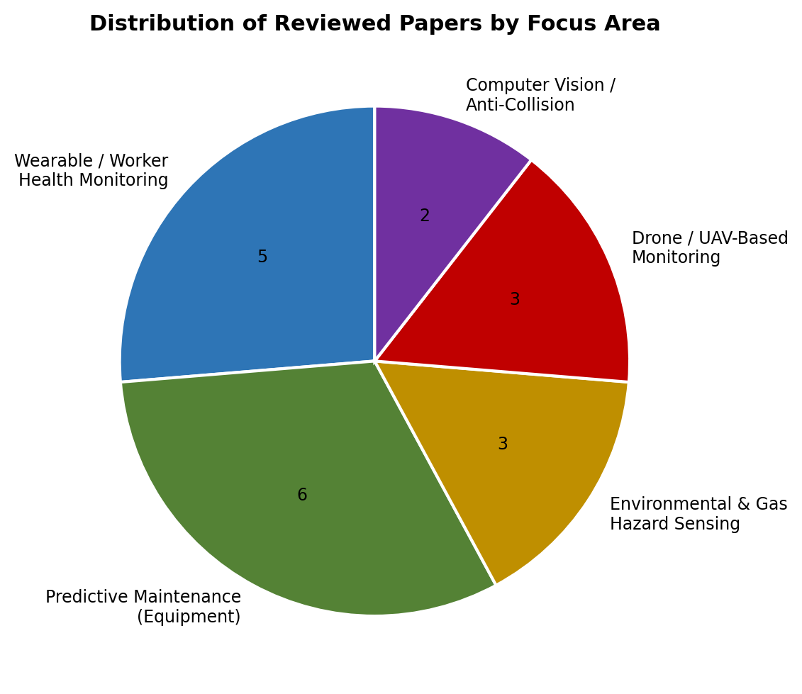
Figure 2. Distribution of the twelve reviewed papers across the four thematic focus areas identified in this survey.

6. Comparative Literature Survey Table
Table 1 consolidates the reviewed literature into a single comparative view, covering author/year, the specific research problem addressed, methodology, dataset/tools used, key findings, principal limitations, and the research gap each study leaves open. This table directly supports the comparative-analysis requirement of the assignment brief.
Author / Year | Research Problem | Methodology | Dataset / Tools | Key Findings | Limitations | Research Gap
Jiang et al. (2024) | Underground miner health & position monitoring | Wearable bracelet + miner lamp; 5G/UWB; BP neural network | Field vital-sign & positioning data | <0.3 m positioning accuracy; <20 ms latency | Requires dense 5G/UWB infrastructure | Low-infrastructure fatigue estimation
Sensors 24(11) 3317 (2024) | Worker support in open-pit & underground mines | Smart-garment IoT system | Prototype field testing | Functions under broken connectivity | No long-duration field trial reported | Long-term garment durability data
CMWMS (2024/25) | Coal miner vital-sign & environment tracking | Wearable + environmental sensors, wireless transmission | Prototype sensor readings | Comprehensive real-time monitoring | No benchmarked accuracy metrics | Standardized accuracy/false-alarm benchmarking
PMC11722757 (2024/25) | Vital-sign device landscape for coal miners | Literature review of wearable IoT architectures | Secondary literature | IoT enables centralized integrated safeguard | Underground network upgrade remains hard | Unified low-cost network standard
IoT Coal Mine Safety Coat (2025) | Gas + health hazard detection wearable | Wearable coat, GPIO/I2C sensors | Simulated mining conditions | Reliable CO/methane threshold alerts | Simulated, not live underground testing | Real underground validation
MDPI Appl. Sci. 15(6) 3337 (2025) | AI predictive maintenance for mining assets | Systematic review, 166 studies | Scopus / Web of Science corpus | DL, RL, digital twins improve fault detection | Data standardization & interoperability gaps | Cross-site model transferability
Springer Safety Extreme Env. (2025) | Equipment failure prediction for safety | XGBoost & Random Forest ensembles | Mining equipment sensor case study | 98.55% (XGBoost), 98.20% (RF) accuracy | Single asset-class case study | Multi-asset generalization
Predictive Maint. Underground Mining AI (2025) | AI predictive maintenance for underground equipment | IoT sensors (temp, pressure, oil, wear) + ML | Field deployment case study | 8% cost reduction, 10% availability increase | Single-site deployment | Multi-vendor equipment heterogeneity
SPIE 13731 137310Q (2025/26) | ANN vs SVM for equipment failure forecasting | ANN, SVM, Random Forest comparison | IoT + BIM industrial facility data | ANN best accuracy/recall; SVM best precision | LSTM/Transformer left as future work | Sequential deep models for failure trends
Alqaraleh et al. (2026) | Predictive maintenance of mining centrifuges | CNN/RNN on vibration & temperature data | Industrial centrifuge sensor data | Effective anomaly detection, reduced downtime | High cost, data quality, cybersecurity risk | Lightweight edge-deployable models
MDPI/PMC11548223 (2024) | Low-cost underground sensor connectivity | LoRaWAN wireless sensor network | Underground mine deployment review | Reliable transmission through physical barriers | Geometry-dependent propagation reliability | Adaptive network planning per mine layout
SCIEPublish CleanEnergy (2024) | Hazardous gas measurement in tunnels | IoT multi-gas sensor UAV | Tunnelling operation trials | Captures spatial/temporal gas variation | Limited flight time, GPS-denied navigation | Persistent (non-flight-limited) aerial coverage
Imam et al. (2023) | Anti-collision for underground mobile machinery | PRISMA systematic review, computer vision | Secondary literature (vision/LiDAR studies) | DL detection improves early warning | Few large-scale dusty underground trials | Robust low-visibility deployment validation
Table 1. Comparative literature survey across the twelve reviewed studies.

7. Comparative Analysis
Across the reviewed literature, three broad methodological patterns emerge for the assigned problem statement:
• Sensing-and-alerting systems (wearables, gas sensors, smart helmets) are relatively mature and inexpensive to prototype, but most reported evaluations rely on simulated or short-duration field tests rather than sustained underground operation, and rarely report quantitative accuracy or false-alarm rates.
• Predictive maintenance research shows the strongest quantitative results, with ensemble tree-based models (Random Forest, XGBoost) and neural networks (ANN, CNN, RNN) consistently outperforming simpler baselines such as SVM, achieving reported accuracies above 98% in mining-specific case studies. This suggests ensemble and deep-learning approaches are best suited to the equipment-failure-prediction objective of the platform.
• Drone- and computer-vision-based hazard detection extends monitoring into spaces that fixed sensors and workers cannot safely reach, but is constrained by flight endurance, GPS-denied underground navigation, and environment-dependent detection accuracy (dust, low light).
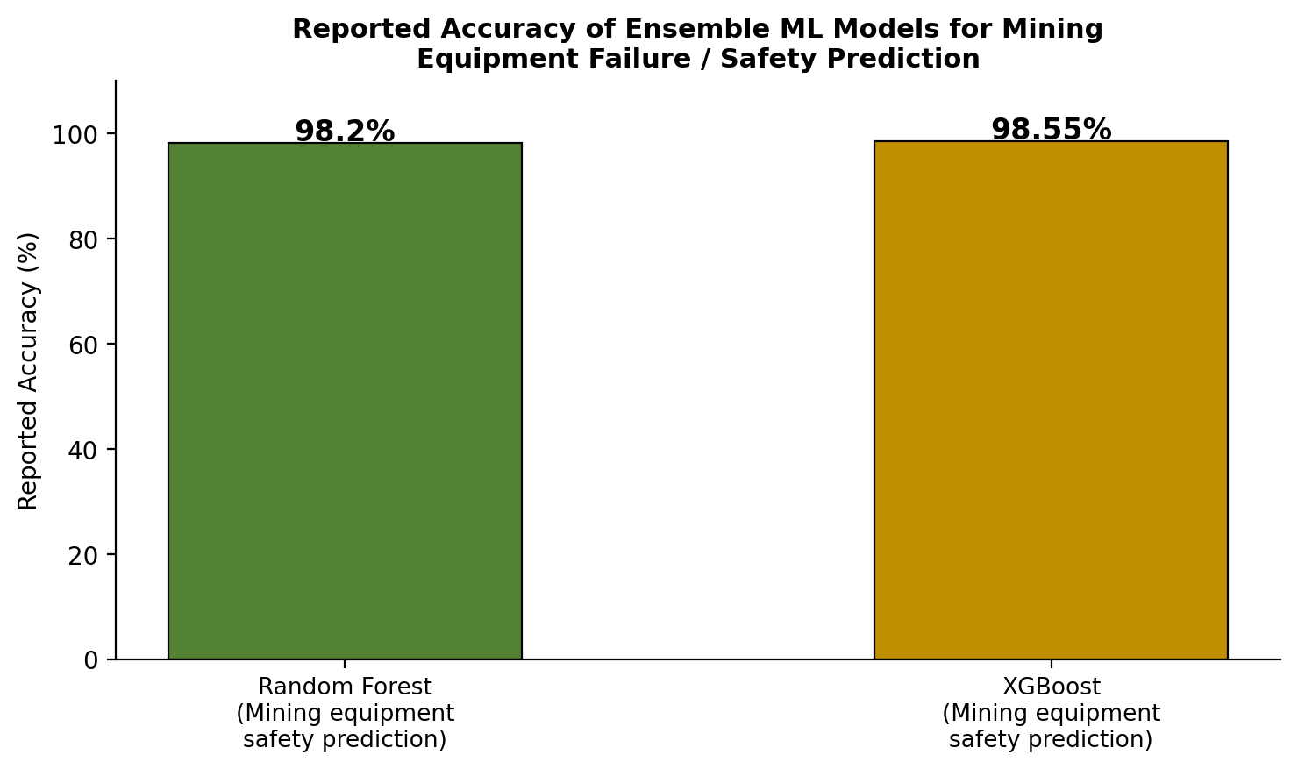
Figure 3. Reported accuracy of ensemble machine learning models for mining equipment failure/safety prediction, as documented in the reviewed studies.
In terms of scalability and cost, wireless technologies such as LoRaWAN and Zigbee are consistently favoured over cabled installations because they eliminate expensive cable protection in expanding mine geometries, while 5G/UWB combinations offer higher positioning accuracy and lower latency at the cost of denser, more expensive infrastructure. This is a direct trade-off the proposed platform must resolve based on mine size, budget, and criticality of real-time response.

8. Critical Analysis and Research Gap
While the reviewed literature demonstrates strong individual capability in worker monitoring, predictive maintenance, and hazard sensing, several cross-cutting gaps limit the direct applicability of existing work to a single, unified Smart Mining Safety and Equipment Monitoring Platform as described in the assigned problem statement:
1. Fragmented, single-purpose systems. Most reviewed studies address worker safety, equipment maintenance, or environmental sensing as separate systems rather than a single integrated platform that correlates worker location, equipment condition, and environmental hazard data in real time to support unified decision-making.
2. Limited real-world, long-duration validation. Several wearable and gas-sensing prototypes (e.g., the IoT coal mine safety coat) were validated only in simulated conditions rather than active underground mines over extended periods, leaving open questions about sensor drift, durability, and false-alarm rates in practice.
3. Infrastructure cost versus performance trade-off is under-explored. High-accuracy, low-latency systems (5G/UWB) require infrastructure investment that may be infeasible for small or legacy mines, while low-cost wireless options (LoRaWAN, Zigbee) sacrifice some positioning precision; few studies model this trade-off explicitly for decision-makers.
4. Generalization across equipment types and sites. Predictive maintenance studies report very high accuracy (96-99%) but typically validate on a single asset class (e.g., centrifuges) or single-site deployment, so model transferability across heterogeneous mining equipment fleets remains an open research question.
5. Drone autonomy in GPS-denied underground environments. UAV-based gas and structural monitoring is well developed for open-pit and tunnel entrances, but autonomous, continuous underground drone operation (navigation, battery endurance, data relay) is still an emerging capability rather than a solved problem.
6. Cybersecurity and data governance. Several predictive-maintenance papers flag cybersecurity risk as an adoption barrier for connected mining assets, yet this dimension is rarely addressed with concrete safeguards within the safety-monitoring literature itself.
These gaps collectively define the research opportunity for the proposed AI-Based Smart Mining Safety and Equipment Monitoring Platform: a single, correlated, cost-adaptive system that unifies wearable, environmental, and equipment-condition data streams under one AI analytics layer, rather than treating each as an isolated point solution.

9. Proposed System Architecture
Building on the research gaps identified above, a four-layer architecture is proposed for the AI-based platform, shown in Figure 4. The sensing layer combines wearable physiological sensors, fixed environmental IoT sensors, equipment-mounted condition sensors, and drone-based inspection payloads. An edge gateway layer performs local pre-processing and handles wireless transport (LoRaWAN/Zigbee for cost-sensitive zones, 5G/UWB where low-latency positioning is critical). A cloud/edge AI analytics layer applies the ensemble and neural-network models validated in the literature -- Random Forest/XGBoost and ANN/CNN architectures -- for predictive maintenance, hazard classification, and worker fatigue/health risk scoring. Finally, an application layer delivers a real-time safety dashboard, automated multi-channel emergency alerts, and regulatory compliance reporting.
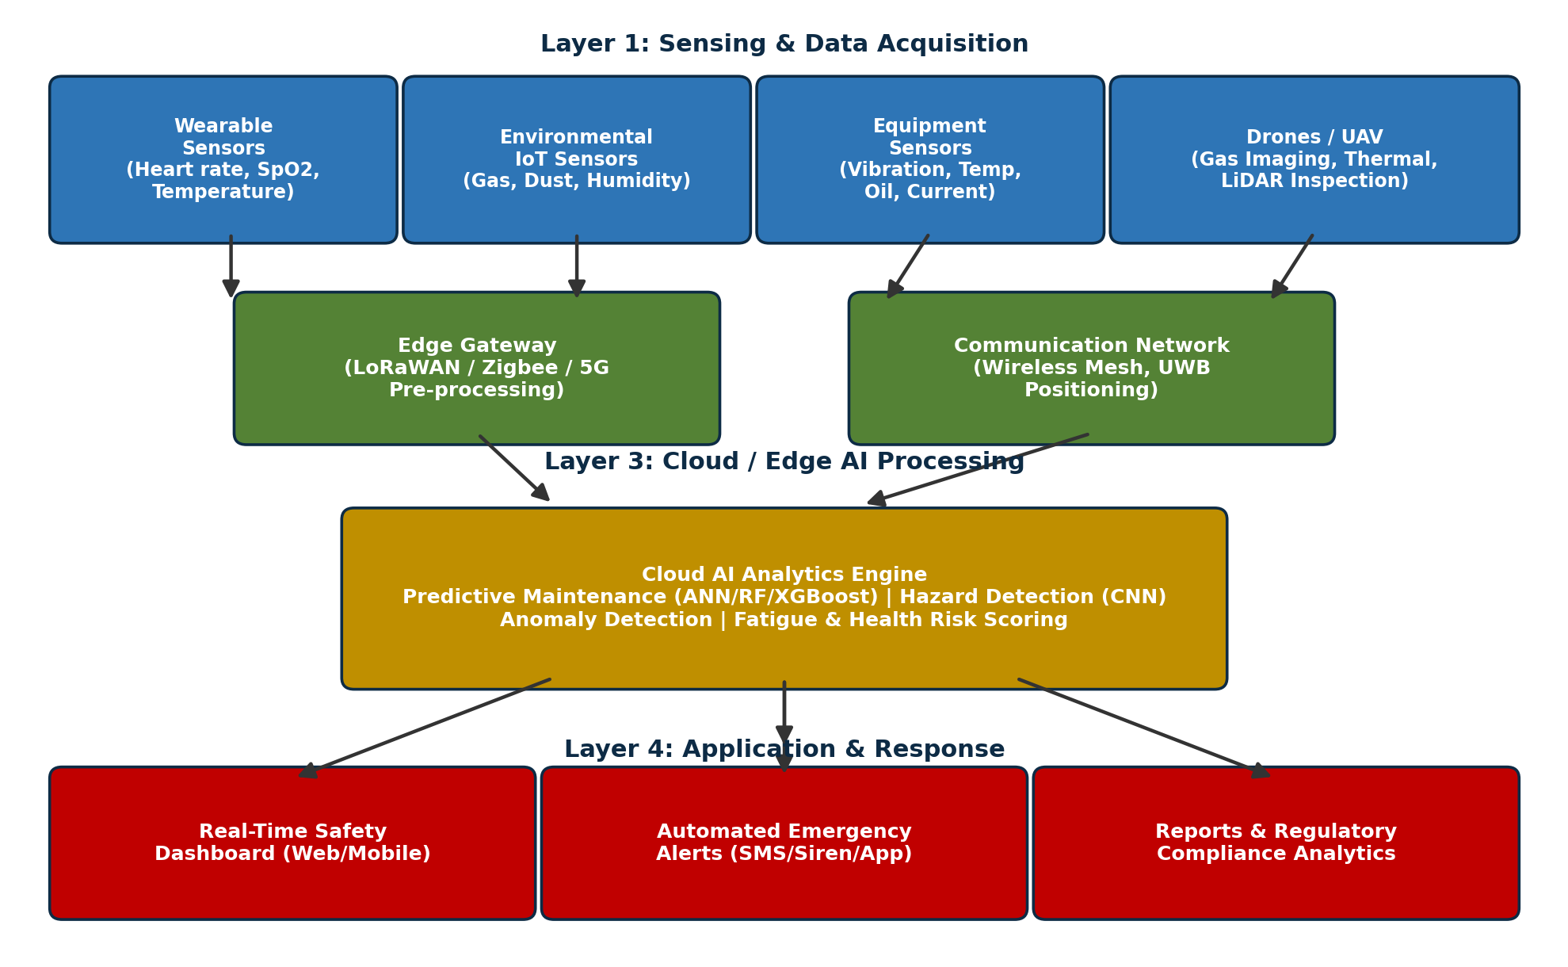
Figure 4. Proposed four-layer architecture for the AI-Based Smart Mining Safety and Equipment Monitoring Platform, synthesized from the reviewed literature.

9.1 Mapping Architecture Components to Reviewed Literature
Architecture Layer | Design Choice | Supporting Literature
Sensing | Wearable bracelet + smart helmet/garment for vitals | Jiang et al. (2024); Sensors 24(11) 3317
Sensing | Environmental multi-gas, temperature, humidity sensors | IoT Coal Mine Safety Coat (2025); CMWMS
Sensing | Drone-based gas imaging & structural inspection | SCIEPublish Clean Energy (2024)
Connectivity | LoRaWAN for cost-sensitive wide-area coverage | MDPI/PMC11548223 (2024)
Connectivity | 5G + UWB for high-precision positioning | Jiang et al. (2024)
AI Analytics | XGBoost / Random Forest for equipment failure prediction | Springer Safety Extreme Env. (2025)
AI Analytics | ANN for failure forecasting where recall is prioritized | SPIE 137310Q (2025/26)
AI Analytics | CNN-based computer vision for anti-collision | Imam et al. (2023)
Application | Real-time dashboard + automated multi-channel alerts | Synthesized from all reviewed studies

10. Future Directions and Relevance
Based on the identified research gaps, the following future research and development directions are proposed for advancing the AI-Based Smart Mining Safety and Equipment Monitoring Platform:
1. Unified multi-modal AI fusion. Develop models that jointly ingest wearable, environmental, and equipment sensor streams to produce a single, correlated site-risk score, rather than separate alerts from isolated subsystems.
2. Edge-deployable lightweight models. Compress ensemble and neural-network predictive-maintenance models (e.g., via pruning or quantization) so they can run on low-power edge gateways underground, reducing dependence on continuous cloud connectivity and lowering response latency.
3. Autonomous underground drone fleets. Extend GPS-denied SLAM-based navigation research so that inspection drones can operate continuously and autonomously within active underground tunnels for gas and structural monitoring, rather than only in open-pit or tunnel-entrance contexts.
4. Transfer learning across mine sites and equipment fleets. Investigate transfer-learning and federated-learning approaches so predictive-maintenance models trained at one mine or on one equipment class can adapt efficiently to new sites and asset types with limited additional labelled data.
5. Digital twin integration. Combine the sensing and AI analytics layers with a live digital twin of the mine to allow supervisors to simulate hazard-response scenarios and equipment-maintenance schedules before committing resources.
6. Standardized safety-AI benchmarking. Establish common, publicly reported accuracy, latency, and false-alarm-rate benchmarks across mining safety AI studies, addressing the current inconsistency where many prototypes report qualitative rather than quantitative performance.
7. Cybersecurity-by-design for connected mine assets. Embed encryption, device authentication, and anomaly-based intrusion detection directly into the IoT/AI platform architecture rather than treating security as an afterthought.
These directions are directly relevant to the assigned problem statement because they address the specific shortfall identified in the comparative analysis: existing research demonstrates strong point solutions, but a genuinely unified, cost-adaptive, and secure platform for continuous mining safety and equipment monitoring remains an open engineering and research challenge.

11. Expected Outcomes
Improved worker safety: Continuous physiological and environmental monitoring enables earlier intervention before conditions become life-threatening.
Reduced mining accidents: Predictive hazard detection and anti-collision alerts reduce the frequency of gas-related and machinery-related incidents.
Lower equipment downtime: Predictive maintenance models flag developing faults before catastrophic failure, enabling planned rather than emergency repairs.
Better operational efficiency: Unified dashboards reduce the time supervisors spend reconciling data from disconnected legacy systems.
Faster emergency response: Automated multi-channel alerts and drone-based rapid-assessment capability shorten the time between hazard detection and rescue response.
Increased equipment reliability: Condition-based maintenance scheduling, informed by ensemble ML models, extends the useful operating life of critical assets.
Enhanced regulatory compliance: Automated logging and reporting of safety and environmental parameters simplifies compliance with occupational health and safety regulations.
Sustainable mining operations: Reduced accident rates, lower unplanned downtime, and optimized resource use collectively support the long-term sustainability of mining operations.

12. Conclusion
This literature survey reviewed twelve recent research papers spanning IoT-based worker monitoring, machine-learning-based predictive maintenance, environmental hazard sensing, and drone/computer-vision-based hazard detection in mining environments. The comparative analysis shows that while individual technologies -- wearable sensors, wireless sensor networks, ensemble machine learning models, and UAV-based inspection -- are already well-validated in isolation, no single reviewed study integrates all of these into one unified, cost-adaptive safety and equipment monitoring platform. Ensemble models such as XGBoost and Random Forest, along with ANN and CNN architectures, demonstrate the strongest quantitative performance for predictive maintenance and hazard classification tasks, making them strong candidates for the AI analytics layer of the proposed platform. The identified research gaps -- system fragmentation, limited long-duration real-world validation, infrastructure cost trade-offs, cross-site model generalization, underground drone autonomy, and cybersecurity -- define a clear and actionable direction for future work on an AI-Based Smart Mining Safety and Equipment Monitoring Platform capable of materially improving worker safety, equipment reliability, and operational sustainability in the mining industry.

13. References
A Robust End-to-End IoT System for Supporting Workers in Mining Industries. (2024). Sensors, 24(11), 3317. https://doi.org/10.3390/s24113317
AI-Driven Predictive Maintenance in Mining: A Systematic Literature Review on Fault Detection, Digital Twins, and Intelligent Asset Management. (2025). Applied Sciences, 15(6), 3337. https://doi.org/10.3390/app15063337
Alqaraleh, M. et al. (2026). Predictive Maintenance of Mining Centrifuges Using Machine Learning and Deep Learning Models. Engineering, Technology & Applied Science Research, 16(1), 31722-31732.
An IoT System for Monitoring and Alerting Safety in Coal Mines. (2025). ResearchGate preprint.
Hazardous Gas Monitoring with IoT Enabled Drone in Underground Tunnels and Cavities. (2024). Clean Energy and Sustainability, SCIEPublish.
Imam, M., Baïna, K., Tabii, Y., Ressami, E. M., Adlaoui, Y., Benzakour, I., & Abdelwahed, E. (2023). The Future of Mine Safety: A Comprehensive Review of Anti-Collision Systems Based on Computer Vision in Underground Mines. Sensors, 23(9), 4294. https://doi.org/10.3390/s23094294
Internet of Things Long-Range-Wide-Area-Network-Based Wireless Sensors Network for Underground Mine Monitoring. (2024). MDPI Sensors / PMC11548223.
IoT-Based Coal Mine Worker Monitoring System Using IoT. (2024/2025). ResearchGate.
Jiang, Y., Chen, W., Zhang, X., Zhang, X., & Yang, G. (2024). Real-Time Monitoring of Underground Miners’ Status Based on Mine IoT System. Sensors, 24(3), 739. https://doi.org/10.3390/s24030739
Machine Learning-Based Predictive Models for Enhancing Safety and Preventing Failures in Mining Operations. (2025). Safety in Extreme Environments, Springer Nature.
Machine-Learning-Based Predictive Maintenance: Data-Driven Equipment Failure Forecasting. (2025/2026). Proceedings of SPIE, 13731, 137310Q.
Predictive Maintenance in Underground Mining Equipment Using Artificial Intelligence. (2025). ResearchGate.
Research on Intelligent Monitoring and Protection Equipment of Vital Signs of Underground Personnel in Coal Mines: A Review. (2024/2025). PMC11722757.

