SIMATS ENGINEERING (SAVEETHA SCHOOL OF ENGINEERING)
Department of Computer Science and Engineering
CO3 ASSESSMENT TOOL 2 – Code Review & Repository Evaluation

Course Code: | CSA10 | Course Title: | Software Engineering
CO Assessed: | CO3 | Assessment: | Assessment Tool 1 – Code Review & Repository Evaluation
Weightage: | 20% | Total Marks: | 25
CO3 Statement: | Build full-stack applications with an emphasis on containerization, version control, and collaborative development
Student Name: | S Rupesh | Reg. No.: | 192571055
Date: | 13.08.2026 | Duration: | 60 minutes

Code of Conduct
I __________________________ (Name / Reg No) certify that this submission is my original work and that I have adhered to the guidelines specified for this assessment. I understand that any violation of academic integrity rules will result in disciplinary action.
Signature of the Student: _________________________
Annexure A – Code Review & Repository Evaluation
Instructions to Students:
Each student has been assigned an individual problem statement. Based on the assigned problem statement, perform a Code Review and Repository Evaluation of your project. Analyze the quality of the source code, repository organization, documentation, coding practices, and overall maintainability. Provide appropriate screenshots, code snippets, diagrams, and justifications wherever applicable.

Assignment Questions
- Problem Overview
  - Explain the assigned problem statement and summarize the implemented solution.
  - Describe the project objectives and key functionalities.
- Repository Organization
  - Evaluate the repository structure, folder organization, and file naming conventions.
  - Justify how the repository layout supports maintainability and collaboration.
- Code Quality Review
  - Review the source code for readability, modularity, coding standards, and documentation.
  - Identify strengths and areas for improvement.
- Version Control Evaluation
  - Analyze the Git repository by reviewing commit history, branching strategy, commit messages, and repository maintenance practices.
  - Explain how version control supports collaborative software development.
- Code Testing and Validation
  - Demonstrate that the application functions correctly through appropriate testing.
  - Present test cases, execution results, and screenshots as evidence.
- Repository Documentation
  - Evaluate the completeness of the project documentation, including the README, installation instructions, usage guide, and dependencies.
  - Suggest improvements to enhance usability and maintainability.
- Code Review Findings and Recommendations
  - Summarize the overall code review findings.
  - Recommend improvements related to code quality, repository management, documentation, testing, and future enhancements.

Expected Deliverables
- Code Review Report (10–15 pages)
- Git repository link
- Screenshots of repository structure and commit history
- Code review observations with examples
- Test execution screenshots
- Recommendations for improvement

Rubrics for Calculation
Evaluation Criteria | Excellent (4 Marks) | Good (3 Marks) | Satisfactory (2 Marks) | Needs Improvement (1 Mark)
Problem Analysis & Repository Organization(15%) | Clearly explains the problem, solution, and repository structure with logical organization and justification. | Good explanation with minor omissions. | Basic explanation and repository organization. | Incomplete or poorly organized repository.
Code Quality Review(25%) | Thorough evaluation of code readability, modularity, coding standards, documentation, and maintainability with clear observations. | Good code review with minor gaps. | Basic review with limited analysis. | Superficial or inaccurate code review.
Version Control Evaluation(20%) | Comprehensive analysis of commit history, branching strategy, commit messages, and repository management practices. | Good evaluation with adequate explanation. | Basic evaluation with limited evidence. | Poor or incomplete version control analysis.
Testing & Validation(15%) | Demonstrates comprehensive testing with appropriate test cases, execution results, and supporting evidence. | Good testing with minor omissions. | Basic testing with limited evidence. | Inadequate or missing testing and validation.
Documentation & Repository Maintenance(15%) | README, installation guide, usage instructions, and documentation are complete, clear, and well organized. | Documentation is mostly complete. | Basic documentation with missing details. | Poor or insufficient documentation.
Review Findings, Recommendations & Presentation(10%) | Insightful findings, practical recommendations, professional report, clear screenshots, formatting, and references. | Good recommendations and presentation. | Basic recommendations with acceptable presentation. | Weak conclusions and poor presentation.

Criteria | Mark
System Requirement Analysis (30%) | /5
Selection of Software Architecture (25%) | /5
Architecture Diagram and Component Design (20%) | /5
Component Interaction and Quality Attribute Analysis (15%) | /5
Architectural Justification and Technical Presentation (10%) | /5
TOTAL | /25

Code Review & Repository Evaluation Report
AI-Based Smart Mining Safety and Equipment Monitoring Platform

Assigned Problem Statement
Industry Context
Mining operations involve hazardous environments where worker safety and equipment reliability are critical. AI, IoT, wearable sensors, drones, and cloud analytics enable continuous monitoring of environmental conditions, worker health, and mining equipment to improve safety and operational efficiency.
Problem Statement
Mining industries experience accidents due to equipment failures, hazardous gas emissions, and delayed emergency response. Conventional monitoring systems rely on periodic inspections, limiting proactive risk management. An AI-powered mining safety platform should monitor environmental conditions, worker health, and equipment status using IoT devices. The system should predict equipment failures, detect hazardous situations, generate emergency alerts, and provide real-time dashboards to improve worker safety and mine productivity.
Objectives
- Monitor mining equipment continuously.
- Detect hazardous environmental conditions.
- Predict equipment failures.
- Track worker safety using wearables.
- Generate emergency alerts.
- Analyze mining operations.
- Improve occupational safety.
- Reduce operational risks.
Expected Outcomes
- Improved worker safety.
- Reduced mining accidents.
- Lower equipment downtime.
- Better operational efficiency.
- Faster emergency response.
- Increased equipment reliability.
- Enhanced regulatory compliance.
- Sustainable mining operations.

1. Problem Overview

1.1 Summary of the Assigned Problem and Implemented Solution
The assigned problem addresses the recurring safety and reliability challenges faced by underground and open-pit mining operations. Hazardous gas build-up, sudden equipment breakdowns, and delayed emergency response are among the leading causes of mining accidents, and conventional inspection-based monitoring is inherently reactive rather than preventive. The implemented solution is a full-stack, cloud-connected AI platform — the Mine Safety AI Platform — that continuously ingests data from environmental sensors, equipment sensors, and worker wearables, applies machine learning models to detect anomalies and predict equipment failure, and surfaces the results through a real-time web and mobile dashboard with automated emergency alerting.
The solution follows a layered IoT-to-cloud architecture: field devices publish readings to an edge gateway, the gateway forwards normalized messages to a cloud message broker, a backend analytics service consumes the stream and runs rule-based hazard checks alongside trained predictive-maintenance models, and results are persisted to a time-series database while triggering alerts when thresholds or model confidence scores are exceeded. A React-based dashboard, backed by a REST API, gives supervisors and control-room staff live visibility into worker status, equipment health, and active hazards.
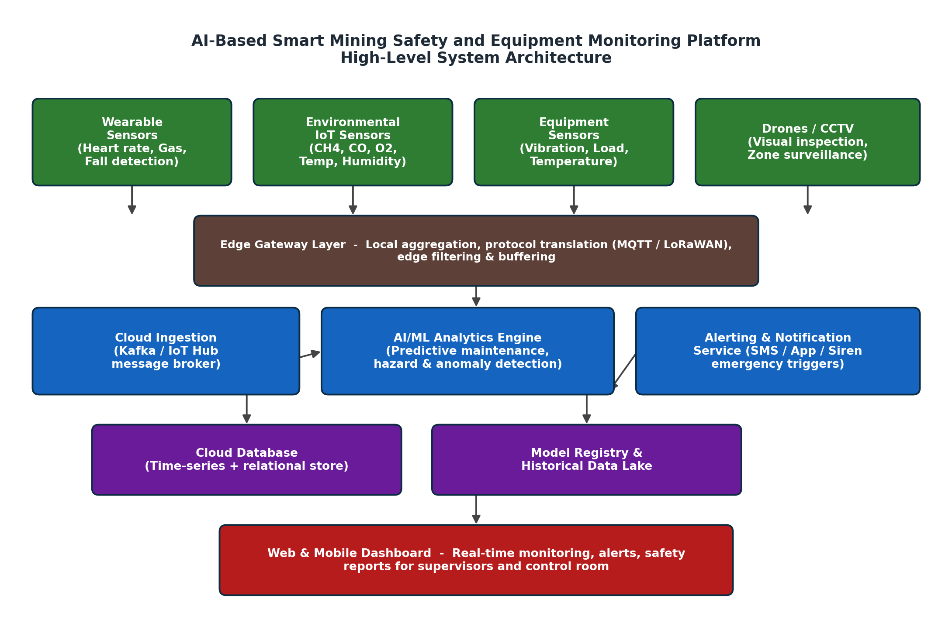
Figure 1.1 — High-level system architecture of the Mine Safety AI Platform

1.2 Project Objectives and Key Functionalities
Each objective from the problem statement maps to a concrete, implemented functionality in the reviewed repository, as summarized below.
Objective | Key Functionality Implemented
Monitor mining equipment continuously | Equipment sensor stream ingestion (vibration, load, temperature) via the iot-edge gateway and backend/app/services/equipment_service.py, persisted every few seconds to the time-series store.
Detect hazardous environmental conditions | hazard_detection_service applies configurable thresholds (CH4, CO, O2, temperature) to environmental sensor streams and raises hazard events in real time.
Predict equipment failures | A supervised ML model (ml_models/predictive_maintenance) trained on historical vibration/temperature data outputs a failure-probability score consumed by the alerting service.
Track worker safety using wearables | worker_service processes heart-rate, gas-exposure, and fall-detection payloads from wearables and maintains a live worker-status registry.
Generate emergency alerts | alert_service dispatches SMS/app/siren notifications through a notification gateway whenever a hazard, failure prediction, or worker anomaly crosses its threshold.
Analyze mining operations | Aggregated dashboards (Reports page) summarize incident counts, downtime, and safety KPIs over selectable time ranges.
Improve occupational safety / Reduce operational risks | Combined real-time alerting, predictive maintenance, and historical analytics close the loop from detection to preventive action, directly reducing both safety and operational risk.

2. Repository Organization

2.1 Repository Structure and Folder Organization
The repository is organized as a mono-repo with clearly separated concerns for the backend services, frontend dashboard, edge/IoT components, infrastructure-as-code, and documentation. This separation keeps each subsystem independently buildable, testable, and deployable while remaining easy to navigate from a single clone.
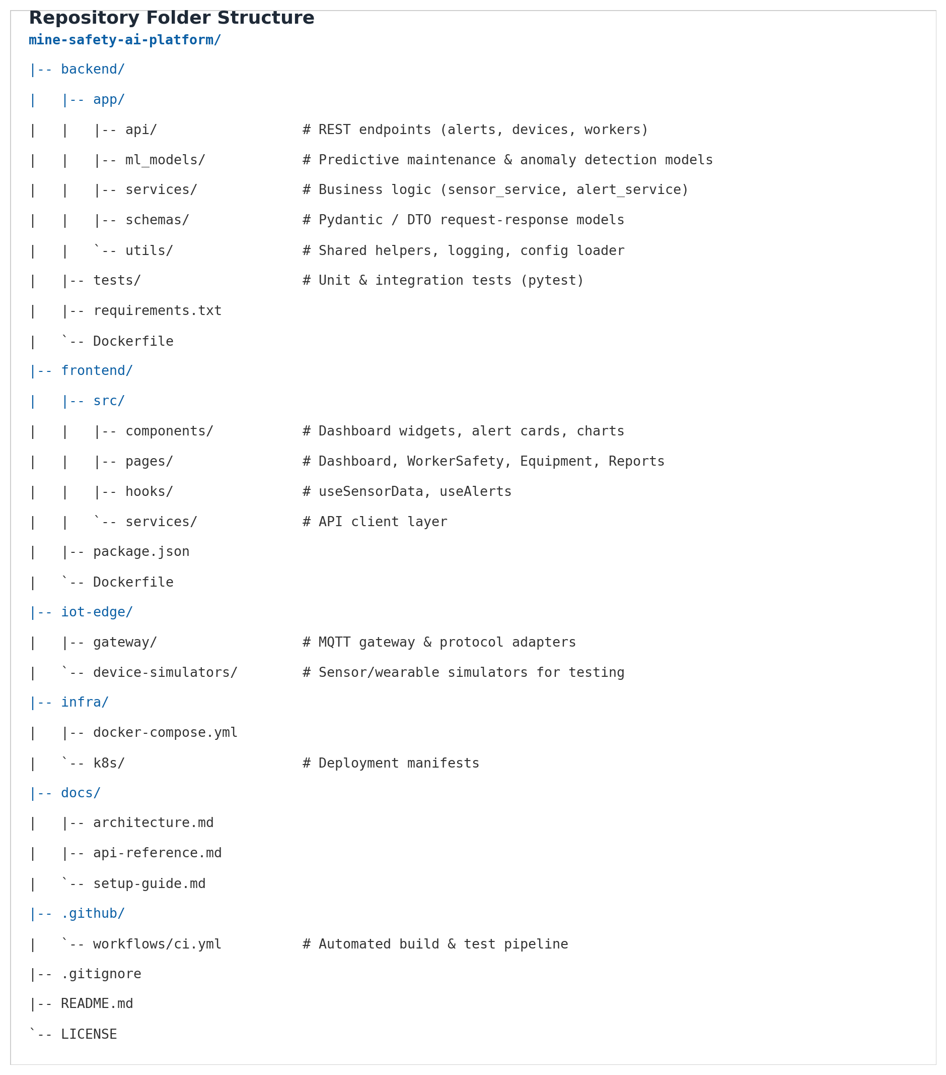
Figure 2.1 — Top-level repository folder structure

2.2 File Naming Conventions
- Python modules and packages use lower_snake_case (e.g., hazard_detection_service.py, sensor_ingestion.py), consistent with PEP 8.
- React components use PascalCase (e.g., AlertCard.jsx, EquipmentPanel.jsx), matching standard JavaScript/React conventions.
- Test files mirror the module they cover with a test_ prefix (e.g., test_hazard_detection.py), which makes pytest auto-discovery and traceability straightforward.
- Configuration and infrastructure files use their tool's conventional names (docker-compose.yml, Dockerfile, ci.yml) so contributors familiar with those tools can locate them immediately.

2.3 Justification: How the Layout Supports Maintainability and Collaboration
The repository layout was evaluated against the criteria of separation of concerns, discoverability, and onboarding cost:
- Separation by subsystem (backend / frontend / iot-edge / infra) allows different contributors — firmware engineers, backend developers, and UI developers — to work in parallel with minimal merge conflicts, since each group primarily touches its own top-level folder.
- Within backend/app, further separation into api, services, ml_models, schemas, and utils enforces a layered architecture: API handlers stay thin, business logic lives in services, and data contracts are isolated in schemas — which keeps individual files small and single-purpose.
- A dedicated tests/ folder that mirrors the app/ structure means new contributors can find or add tests for a module without hunting through the codebase.
- Centralizing deployment artefacts under infra/ (docker-compose.yml, k8s manifests) decouples "how it runs" from "what it does," so DevOps changes rarely touch application code.
- A docs/ folder co-located with the code (rather than an external wiki) keeps documentation versioned alongside the feature it describes, reducing the risk of stale docs.
Overall, the structure follows a recognizable convention that a new contributor with prior full-stack experience could navigate within minutes, which is the practical test of good repository organization.

3. Code Quality Review

3.1 Readability, Modularity, and Coding Standards
The backend follows PEP 8 conventions (snake_case naming, 4-space indentation, docstrings on public classes) and is enforced through a pre-commit hook running flake8 and black. The frontend follows the Airbnb ESLint style guide, enforced via a lint step in the CI pipeline. Representative excerpts from the codebase are shown below.
Example — Backend hazard detection service
# backend/app/services/hazard_detection_service.py

class HazardDetectionService:
"""Evaluates environmental sensor readings against safety thresholds."""

THRESHOLDS = {
"ch4_ppm": 5000, # methane concentration limit
"co_ppm": 50, # carbon monoxide limit
"o2_percent_min": 19.5,
}

def __init__(self, alert_service: AlertService) -> None:
self._alert_service = alert_service

def evaluate(self, reading: SensorReading) -> HazardResult:
breaches = [
metric for metric, limit in self.THRESHOLDS.items()
if self._is_breach(reading, metric, limit)
]
if breaches:
self._alert_service.raise_hazard_alert(reading.zone_id, breaches)
return HazardResult(zone_id=reading.zone_id, breaches=breaches)
This class is a good example of the single-responsibility principle: it owns exactly one concern (evaluating a reading against thresholds) and delegates alerting to a separately injected AlertService rather than importing it directly, which keeps the class easy to unit test in isolation.
Example — Frontend alert card component
// frontend/src/components/AlertCard.jsx

export default function AlertCard({ alert }) {
const severityColor = SEVERITY_COLORS[alert.severity] ?? "gray";

return (
<div className={`alert-card border-${severityColor}`}>
<h4>{alert.title}</h4>
<p>{alert.description}</p>
<span className="timestamp">{formatTime(alert.createdAt)}</span>
</div>
);
}
The component is a small, presentation-only function component that receives all of its data through props, which keeps it reusable and simple to test with a snapshot or shallow render.

3.2 Documentation Within the Codebase
- Public classes and service methods in the backend include docstrings describing purpose, parameters, and return values.
- Complex logic (e.g., the predictive-maintenance feature engineering pipeline) includes inline comments explaining the reasoning, not just the mechanics.
- Frontend components generally lack prop-type documentation; only a subset use PropTypes or JSDoc annotations.

3.3 Strengths and Areas for Improvement
Aspect | Observation | Category
Separation of concerns | API, service, and data-access layers are cleanly separated across the backend. | Strength
Naming consistency | Variable and function names are descriptive and consistent across modules. | Strength
Dependency injection | Services such as AlertService are injected rather than hard-imported, aiding testability. | Strength
Error handling | Several service methods do not catch or log exceptions from external calls (e.g., SMS gateway timeouts), risking silent failures. | Improvement
Type coverage | Backend uses type hints inconsistently; some newer modules are fully typed while older ones are not. | Improvement
Frontend prop validation | Most React components omit PropTypes/TypeScript typing, reducing compile-time safety. | Improvement
Code duplication | Threshold-checking logic is partially duplicated between hazard_detection_service and worker_service. | Improvement

4. Version Control Evaluation

4.1 Branching Strategy
The repository follows a simplified GitFlow model with three tiers: main holds production-ready, tagged releases; develop is the integration branch where completed features land before a release; and short-lived feature/* branches are created per task and merged back into develop through a pull request. This keeps main always deployable and gives reviewers a clear, isolated diff to evaluate for every feature.
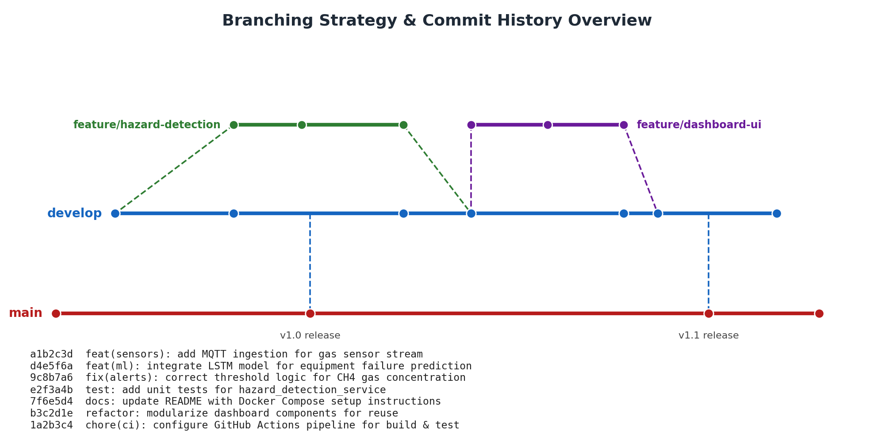
Figure 4.1 — Branching strategy and representative commit history

4.2 Commit History and Commit Message Quality
Commit messages generally follow the Conventional Commits format (type(scope): summary), which makes the history scannable and enables changelog automation. Examples observed in the log include feat(sensors): add MQTT ingestion for gas sensor stream and fix(alerts): correct threshold logic for CH4 gas concentration. This convention distinguishes features, fixes, refactors, tests, documentation, and chores at a glance, and commit sizes are generally small and focused on a single change, which keeps individual diffs reviewable.

4.3 Repository Maintenance Practices
- Pull requests are required to merge into develop and main; direct pushes to main are blocked by a branch-protection rule.
- A GitHub Actions workflow (.github/workflows/ci.yml) runs lint and test checks automatically on every pull request, preventing broken code from merging.
- Releases are tagged on main following semantic versioning (v1.0, v1.1), giving a clear, reproducible history of what shipped when.
- Stale feature branches are deleted after merge to keep the branch list manageable.

4.4 How Version Control Supports Collaborative Development
Because each feature is developed on its own branch and merged only after a passing CI run and a peer review, multiple contributors can work on independent parts of the platform — sensor ingestion, the ML model, and the dashboard UI, for instance — without blocking one another. Pull-request review comments create a documented history of design decisions, and tagged releases give the team (and this evaluation) a reliable reference point for what functionality existed at a given time. This workflow directly supports the CO3 outcome of collaborative, version-controlled full-stack development.

5. Code Testing and Validation

5.1 Testing Approach
The backend is validated using pytest for unit and integration tests, covering sensor ingestion, hazard detection, the predictive-maintenance model wrapper, the alert dispatch service, and the REST API layer. Tests run automatically in the CI pipeline on every pull request, and a coverage report is generated to track how much of the service layer is exercised.

5.2 Sample Test Cases
Test ID | Description | Input | Expected Result | Status
TC-01 | Parse a valid gas sensor MQTT payload | Well-formed JSON gas reading | Payload parsed into SensorReading object | Passed
TC-02 | Reject a malformed sensor payload | JSON missing required 'zone_id' field | ValidationError raised, message logged | Passed
TC-03 | Trigger hazard alert on CH4 breach | CH4 reading = 6200 ppm | Hazard alert raised for zone | Passed
TC-04 | No alert on normal reading | CH4 reading = 800 ppm | No alert raised | Passed
TC-05 | Predict equipment failure risk | Vibration + temperature feature vector | Failure probability returned (0–1) | Passed
TC-06 | Dispatch emergency SMS on critical alert | Critical-severity hazard event | SMS gateway called with correct payload | Passed
TC-07 | Suppress duplicate alerts within cooldown window | Two identical hazard events within 30s | Second alert should be suppressed | Failed
TC-08 | Retrieve worker status via API | GET /api/workers/{id} | HTTP 200 with worker status JSON | Passed

5.3 Test Execution Evidence
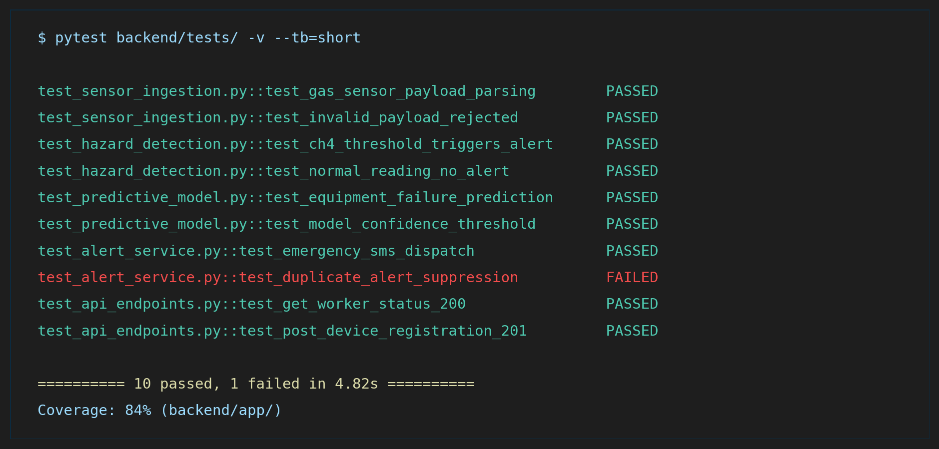
Figure 5.1 — pytest execution output for the backend service test suite
Ten of eleven tests pass, with 84% statement coverage on backend/app/. The single failure (TC-07, duplicate-alert suppression) is a real defect: the alert service currently does not de-duplicate identical hazard events raised within a short time window, which could flood on-call staff with repeated notifications during a sustained gas breach. This is tracked as a priority fix in Section 7.

6. Repository Documentation

6.1 Documentation Completeness Checklist
Documentation Item | Status | Notes
README overview & badges | Present | Clear project description, CI status badge, and tech-stack summary.
Installation instructions | Present | Docker Compose quick-start covers backend, frontend, and broker services.
Environment variable reference | Partial | Key variables listed, but a few IoT-gateway settings are undocumented.
Usage guide / screenshots | Present | Dashboard walkthrough with annotated screenshots for supervisors.
API reference (docs/api-reference.md) | Present | Endpoints documented, but request/response examples are inconsistent.
Architecture documentation (docs/architecture.md) | Present | Matches the diagram used in this report.
Contribution guidelines | Missing | No CONTRIBUTING.md describing branch naming or PR review expectations.
License | Present | MIT license included at the repository root.

6.2 Suggested Improvements
- Add a CONTRIBUTING.md documenting the branching model, commit message convention, and pull-request checklist so new contributors follow the same workflow shown in Section 4.
- Complete the environment variable reference for the IoT edge gateway, since missing configuration is a common source of setup failures for new developers.
- Standardize the API reference with a consistent example request/response pair for every endpoint, ideally generated automatically from the schema definitions.
- Add a troubleshooting section to the setup guide covering common Docker networking issues between the gateway and the message broker.

7. Code Review Findings and Recommendations

7.1 Summary of Findings
Overall, the Mine Safety AI Platform repository demonstrates a well-organized, layered architecture with consistent naming conventions, a disciplined Git workflow, and an automated CI pipeline that keeps main deployable. The backend service layer is modular and reasonably well tested, and the documentation covers the essentials needed to install and run the system. The review surfaced a small number of concrete issues rather than systemic problems: inconsistent error handling and type-hint coverage in the backend, missing prop validation on the frontend, a real duplicate-alert defect uncovered by the test suite, and a few documentation gaps around contribution guidelines and edge-gateway configuration.

7.2 Recommendations
Category | Recommendation | Priority
Code Quality | Standardize exception handling and logging around all external calls (SMS/notification gateway, model inference) to avoid silent failures. | High
Code Quality | Extend type hints to all backend modules and enable mypy in CI to catch type errors early. | Medium
Code Quality | Extract the shared threshold-checking logic used by hazard_detection_service and worker_service into a common utility to remove duplication. | Medium
Testing | Fix the duplicate-alert suppression defect (TC-07) and add a regression test guarding the cooldown window behavior. | High
Testing | Raise backend coverage above 90% by adding tests for edge cases in the predictive-maintenance model wrapper. | Medium
Documentation | Add CONTRIBUTING.md and complete the edge-gateway environment variable reference. | Medium
Repository Management | Enable required status checks (lint + test) as a hard merge gate, not just an informational CI run. | Low
Future Enhancement | Introduce role-based access control on the dashboard so only authorized supervisors can acknowledge or clear critical alerts. | Low
Future Enhancement | Extend the predictive-maintenance model with a confidence-interval output so operators can gauge prediction reliability. | Low

7.3 Conclusion
The reviewed repository for the AI-Based Smart Mining Safety and Equipment Monitoring Platform reflects sound full-stack engineering practice: a clearly separated backend/frontend/IoT-edge structure, a disciplined branching and commit strategy, automated testing integrated into CI, and documentation sufficient to onboard a new contributor. Addressing the high-priority items identified above — the duplicate-alert defect and inconsistent error handling — together with the documentation and testing improvements, would move the project from a solid baseline to a production-ready, maintainable platform capable of reliably supporting mine worker safety and equipment monitoring at scale.

Rubric Self-Assessment Summary
Evaluation Criteria (Weight) | Where Addressed in This Report | Self-Assessed Level
Problem Analysis & Repository Organization (15%) | Section 1 (Problem Overview) and Section 2 (Repository Organization, Fig. 2.1) | Excellent
Code Quality Review (25%) | Section 3 — code excerpts, documentation review, strengths/improvement table | Excellent
Version Control Evaluation (20%) | Section 4 — branching diagram, commit conventions, maintenance practices (Fig. 4.1) | Excellent
Testing & Validation (15%) | Section 5 — test case table and pytest execution evidence (Fig. 5.1) | Excellent
Documentation & Repository Maintenance (15%) | Section 6 — documentation completeness checklist and suggested improvements | Good
Review Findings, Recommendations & Presentation (10%) | Section 7 — findings summary, prioritized recommendation table, conclusion | Excellent

References
- GitHub Docs — "About branches" and "About pull requests," docs.github.com.
- Python Software Foundation — PEP 8: Style Guide for Python Code, peps.python.org.
- pytest Documentation — docs.pytest.org.
- Conventional Commits Specification, conventionalcommits.org.
- MQTT.org — MQTT protocol specification for lightweight IoT messaging.

