SIMATS ENGINEERING (SAVEETHA SCHOOL OF ENGINEERING)
Department of Computer Science and Engineering
CO2 ASSESSMENT TOOL 2 – Architecture Design Assignment

Course Code: | CSA10 | Course Title: | Software Engineering
CO Assessed: | CO2 | Assessment: | Assessment Tool 2 – Architecture Design Assignment
Weightage: | 20% | Total Marks: | 25
CO2 Statement: | Perform detailed requirements analysis, design scalable architectures, and prioritize features with a focus on cross-disciplinary skills
Student Name: | S RUPESH | Reg. No.: | 192571055
Date: | 13.08.2026 | Duration: | 60 minutes

Code of Conduct
I __________________________ (Name / Reg No) certify that this submission is my original work and that I have adhered to the guidelines specified for this assessment. I understand that any violation of academic integrity rules will result in disciplinary action.
Signature of the Student: _________________________
Annexure A – Architecture Design Assignment
Instructions to Students:
Each student will be assigned an individual software project problem statement. Based on the assigned problem, analyze the system requirements and design an appropriate software architecture by applying software engineering principles. Your submission should demonstrate your ability to select, justify, and evaluate a suitable architectural style.

Question
Based on your assigned problem statement, perform an Architecture Design Analysis and prepare an architecture design report by answering the following questions:

1. Analyze System Requirements
- Study the given problem statement and identify the system objectives.
- Analyze the functional and non-functional requirements that influence the software architecture.
- Identify key quality attributes such as scalability, maintainability, reliability, availability, performance, and security.

2. Select a Suitable Software Architecture
- Select an appropriate architectural style for the proposed system (e.g., Layered Architecture, Client-Server, MVC, Microservices, Event-Driven, Service-Oriented Architecture, Serverless, or Hybrid Architecture).
- Justify why the selected architecture is the most suitable for the given problem.

3. Draw the Software Architecture Diagram
- Design a clear architecture diagram illustrating the overall structure of the proposed system.
- Include all major layers/components, databases, external systems, APIs, and communication mechanisms.
- Use appropriate software architecture notations and labels.

4. Explain Components and Their Interactions
- Describe the purpose and responsibilities of each architectural component.
- Explain how the components communicate and exchange data.
- Illustrate the overall workflow of the system.

5. Discuss Quality Attributes
Evaluate how the proposed architecture addresses the following aspects:
- Scalability
- Security
- Performance
- Reliability
- Maintainability
- Availability

6. Justify Architectural Decisions
- Explain the rationale behind your architectural choices.
- Discuss the trade-offs considered while selecting the architecture.
- Explain how the chosen architecture supports future enhancements, system integration, and long-term maintainability.
Rubrics for Calculation
Evaluation Criteria | Excellent (4 Marks) | Good (3 Marks) | Satisfactory (2 Marks) | Needs Improvement (1 Mark)
System Requirement Analysis | Thoroughly analyzes the problem statement, accurately identifies functional and non-functional requirements, and clearly explains quality attributes influencing the architecture. | Analyzes most requirements with minor omissions or limited explanation. | Identifies only basic requirements with partial analysis. | Requirement analysis is incomplete, inaccurate, or lacks clarity.
Selection of Software Architecture | Selects the most appropriate architectural style with strong technical justification aligned to system requirements. | Selects a suitable architecture with reasonable justification. | Architecture is partially suitable with limited justification. | Inappropriate architecture selected or justification is missing.
Architecture Diagram and Component Design | Produces a clear, complete, and well-structured architecture diagram with all major components, interfaces, and interactions accurately represented. | Diagram is mostly complete with minor omissions or notation issues. | Diagram includes only essential components and lacks sufficient detail. | Diagram is incomplete, unclear, or technically incorrect.
Component Interaction and Quality Attribute Analysis | Clearly explains component responsibilities, interactions, and thoroughly discusses scalability, security, performance, reliability, maintainability, and availability. | Explains most components and quality attributes with minor gaps. | Provides limited explanation of interactions and addresses only some quality attributes. | Component interactions and quality attributes are poorly explained or missing.
Architectural Justification and Technical Presentation | Provides strong justification for architectural decisions, discusses trade-offs and future enhancements, and presents a well-organized, professional report. | Provides adequate justification with minor gaps; report is well organized. | Limited justification with minimal discussion of trade-offs or future scope; report needs improvement. | Justification is weak or absent; report lacks organization and technical clarity.

Criteria | Mark
System Requirement Analysis | /5
Selection of Software Architecture | /5
Architecture Diagram and Component Design | /5
Component Interaction and Quality Attribute Analysis | /5
Architectural Justification and Technical Presentation | /5
TOTAL | /5

SIMATS ENGINEERING (SAVEETHA SCHOOL OF ENGINEERING)
Department of Computer Science and Engineering
CO2 ASSESSMENT TOOL 2 – Architecture Design Assignment
Course Code | Course Title | CO Assessed | Assessment
CSA10 | Software Engineering | CO2 | AT2 – Architecture Design Assignment
Assigned Problem Statement (Q.38): AI-Based Smart Mining Safety and Equipment Monitoring Platform
Mining operations involve hazardous environments where worker safety and equipment reliability are critical. Conventional periodic-inspection systems cannot proactively manage risk. This report presents an AI, IoT, and cloud-analytics driven architecture that continuously monitors environmental conditions, worker health, and equipment status; predicts equipment failures; detects hazardous situations; generates emergency alerts; and provides real-time dashboards to improve worker safety and mine productivity.

1. System Requirements Analysis

1.1 System Objectives
Based on the problem statement, the platform must achieve the following objectives:
- Continuously monitor mining equipment health and operating parameters.
- Detect hazardous environmental conditions (toxic/flammable gases, temperature, humidity) in real time.
- Predict equipment failures before they occur using machine learning on sensor telemetry.
- Track individual worker safety and physiological status using wearable devices.
- Generate immediate emergency alerts to workers, supervisors, and rescue teams.
- Analyze mining operations data to support planning and continuous improvement.
- Improve occupational safety and regulatory compliance.
- Reduce operational risk, downtime, and accident-related losses.

1.2 Functional Requirements
Functional requirements define what the system must do:
- Collect real-time data from gas sensors, equipment sensors, wearables, drones, and RFID tags.
- Detect hazardous gas concentrations (CH4, CO, CO2) and abnormal environmental readings against safety thresholds.
- Monitor worker vital signs (heart rate, SpO2, body temperature) and detect falls or immobility.
- Continuously track equipment parameters (vibration, load, temperature, RPM) and run predictive-maintenance models.
- Automatically generate multi-channel emergency alerts (SMS, siren, push notification, dashboard pop-up) when thresholds are breached.
- Provide a real-time dashboard for control-room supervisors showing live worker locations, equipment status, and hazard zones.
- Maintain historical records of incidents, sensor readings, and maintenance actions for compliance audits.
- Support role-based access for workers, supervisors, safety officers, and administrators.
- Integrate with external emergency-response and regulatory reporting systems.
- Continue core safety monitoring locally and buffer data when underground network connectivity is lost.

1.3 Non-Functional Requirements and Quality Attributes
Non-functional requirements determine the quality attributes that most strongly shape the architecture:
Quality Attribute | Non-Functional Requirement
Scalability | The system shall support thousands of concurrent sensor and wearable data streams across multiple mine sites without performance loss.
Reliability | Safety-critical hazard-detection and alerting services shall maintain at least 99.9% uptime.
Availability | Core safety functions (gas detection, worker alerts) must keep working at the edge even during cloud/network outages.
Performance | Hazard detection and alert generation shall complete within 2 seconds of an anomalous reading.
Security | All data in transit and at rest shall be encrypted; every API and dashboard shall enforce authentication and authorization.
Maintainability | The system shall be composed of loosely coupled, independently deployable services to simplify updates and testing.

2. Selected Software Architecture

2.1 Architectural Style: Hybrid Edge–Cloud IoT Architecture with Event-Driven Microservices
The proposed platform adopts a hybrid architecture that combines a layered Edge–Cloud IoT reference structure with an event-driven microservices application layer. Field devices and an edge-computing tier handle time-critical local processing, while cloud-hosted microservices communicate asynchronously through a publish/subscribe event bus (MQTT/Kafka) for scalable, decoupled processing, analytics, and alerting.

2.2 Justification for the Selected Architecture
This hybrid style is the most suitable choice for the mining safety platform for the following reasons:
- Real-time, event-heavy workload: Gas leaks, equipment anomalies, and worker health emergencies are discrete events that must be detected and routed instantly — an event-driven backbone (Kafka/MQTT) is naturally suited to this, unlike a purely request-response client-server design.
- Heterogeneous, high-volume IoT sources: Wearables, gas sensors, equipment sensors, drones, and RFID tags produce continuous, high-frequency streams; microservices allow each data category (equipment, health, hazards) to be ingested and scaled independently.
- Connectivity is unreliable underground: A pure cloud-centric (client-server) design would fail whenever network connectivity drops. The edge-computing layer performs local anomaly detection and buffering so safety-critical alerts still function offline.
- Independent scalability and fault isolation: Microservices such as Hazard Detection and Predictive Maintenance can be scaled, updated, or restarted independently, so a failure or update in one service (e.g., Analytics) never disrupts safety-critical alerting.
- Extensibility: New sensor types, ML models, or mine sites can be added as new services/topics without redesigning the whole system — important given the project's stated objective of long-term, sustainable mining operations.
Alternative styles were considered and rejected as the primary style: a monolithic layered architecture alone would be simple to build but could not scale independently or tolerate partial failure; a plain client-server model would struggle with the real-time, high-throughput alerting requirement; a pure serverless approach was ruled out because always-on edge inference and persistent device connections are not well suited to function-per-invocation billing. Elements of layered design (for organizing the edge tier) and of Service-Oriented Architecture (for the API Gateway) are nonetheless retained inside the hybrid model, which is why it is classified as a hybrid architecture.

3. Software Architecture Diagram
The diagram below shows the complete system structure across seven layers — from field sensors through to external systems — including all major components, data stores, APIs, and communication mechanisms.
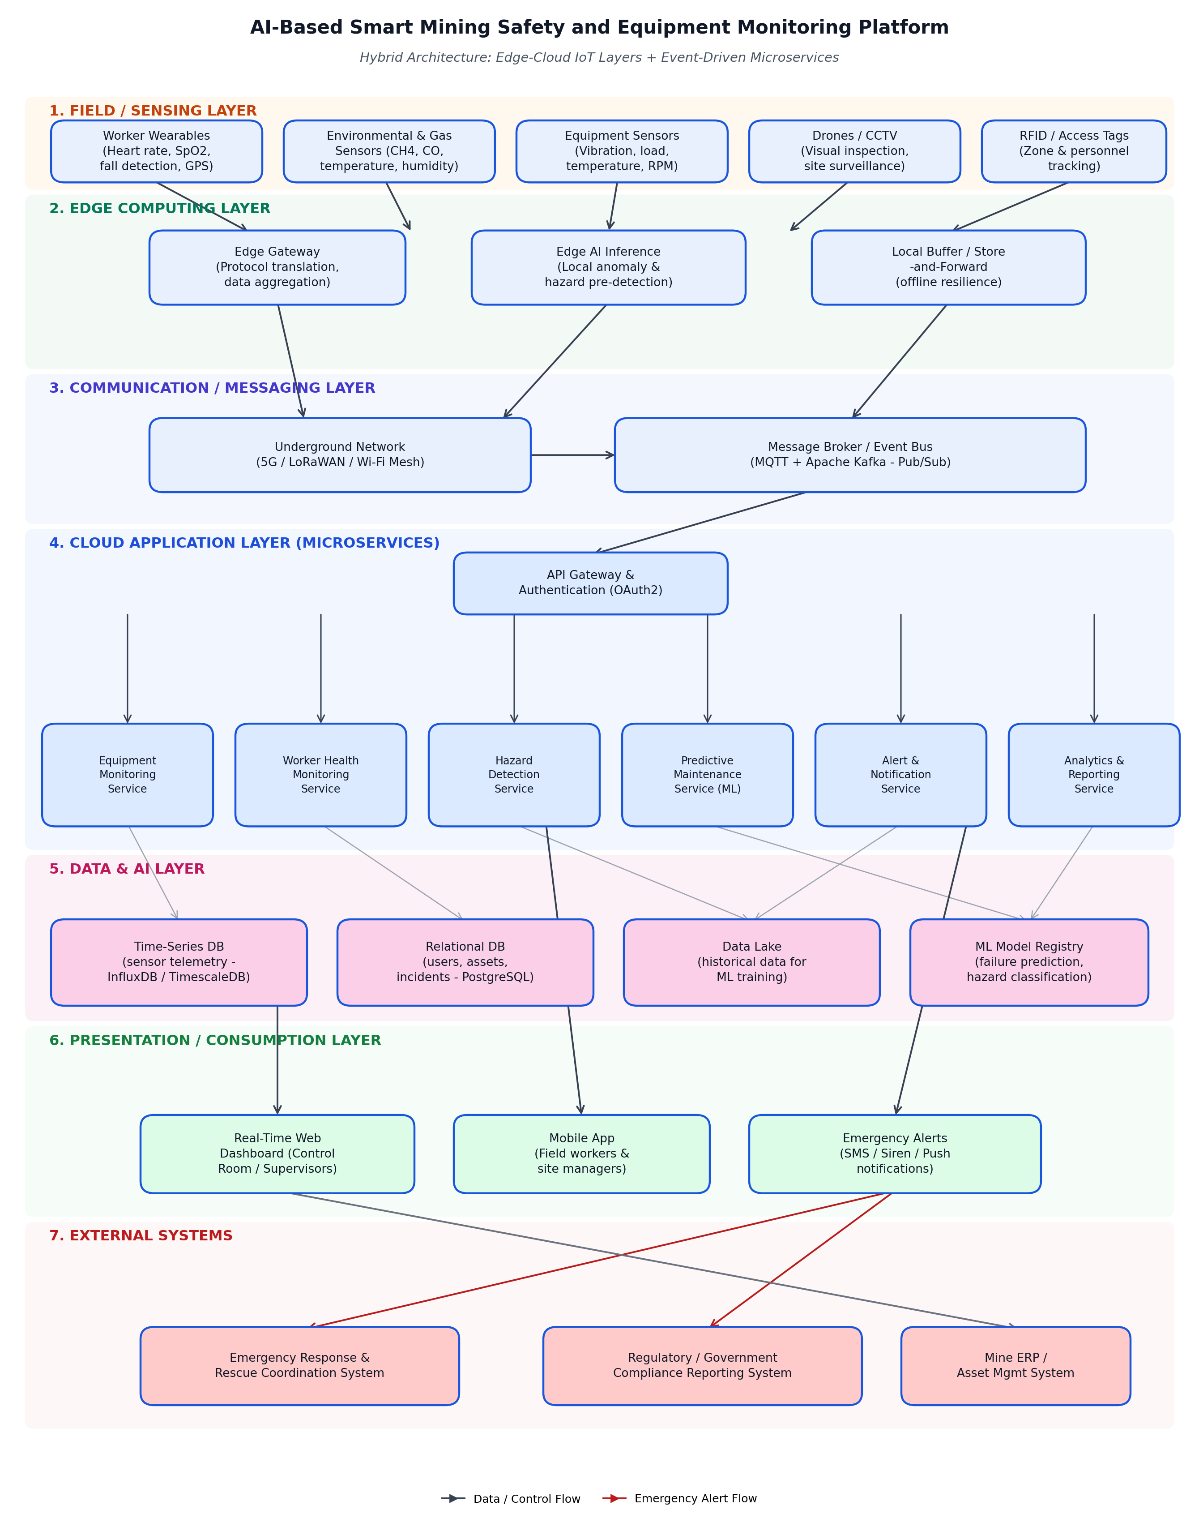
Figure 1: Hybrid Edge–Cloud Architecture of the AI-Based Smart Mining Safety and Equipment Monitoring Platform

4. Components and Their Interactions

4.1 Component Responsibilities
Component | Responsibility
Wearables / Gas / Equipment Sensors, Drones, RFID | Capture raw physical data: worker vitals and location, gas/environmental readings, equipment vibration and load, visual inspection footage, and zone/personnel tags.
Edge Gateway | Aggregates and translates protocols from heterogeneous devices (BLE, Zigbee, Modbus) into a common IoT format for onward transmission.
Edge AI Inference | Runs lightweight ML models locally to flag obvious anomalies immediately, reducing latency and cloud dependency for critical hazards.
Local Buffer / Store-and-Forward | Queues data locally during network outages and forwards it once connectivity is restored, preventing data loss.
Underground Network (5G/LoRaWAN/Wi-Fi Mesh) | Provides the wireless transport connecting edge devices to the cloud across the mine site.
Message Broker / Event Bus (MQTT + Kafka) | Decouples data producers from consumers; publishes sensor/event topics that multiple microservices subscribe to independently.
API Gateway & Authentication | Single secure entry point for all client and service requests; handles routing, OAuth2 authentication, and rate limiting.
Equipment Monitoring Service | Tracks live equipment status and operating parameters against safe operating ranges.
Worker Health Monitoring Service | Processes wearable data to track worker vitals, fatigue, and location in real time.
Hazard Detection Service | Analyzes environmental/gas data streams to detect hazardous conditions and classify severity.
Predictive Maintenance Service (ML) | Applies trained failure-prediction models to equipment telemetry to forecast breakdowns before they occur.
Alert & Notification Service | Subscribes to hazard/health/equipment events and triggers multi-channel emergency alerts (SMS, siren, push, dashboard).
Analytics & Reporting Service | Aggregates historical data for operational insights, KPI dashboards, and compliance reports.
Time-Series DB / Relational DB / Data Lake / ML Registry | Persist sensor telemetry, transactional records, historical data for training, and versioned ML models respectively.
Dashboard, Mobile App, Emergency Alerts | Present real-time status to control-room supervisors and field workers, and deliver emergency notifications.
Emergency Response, Regulatory, and ERP Systems | External systems that receive escalated alerts, compliance reports, and asset/maintenance data.

4.2 Communication and Data Exchange
Devices communicate with the edge gateway over short-range protocols (BLE/Zigbee/Modbus); the gateway forwards normalized data to the cloud over the underground 5G/LoRaWAN network using MQTT. The message broker (Kafka) persists and distributes these events to every subscribed microservice in parallel, so, for example, a single gas reading is consumed simultaneously by the Hazard Detection Service and the Analytics Service without either blocking the other. Microservices expose REST/gRPC APIs behind the API Gateway for the dashboard and mobile app, which use OAuth2 tokens for authenticated, role-based access. Alerts generated by the Alert & Notification Service are pushed to clients via WebSockets/push notifications for immediate delivery, and escalated automatically to the external emergency-response and regulatory systems.

4.3 System Workflow
The figure below illustrates the end-to-end flow from sensing to emergency response.
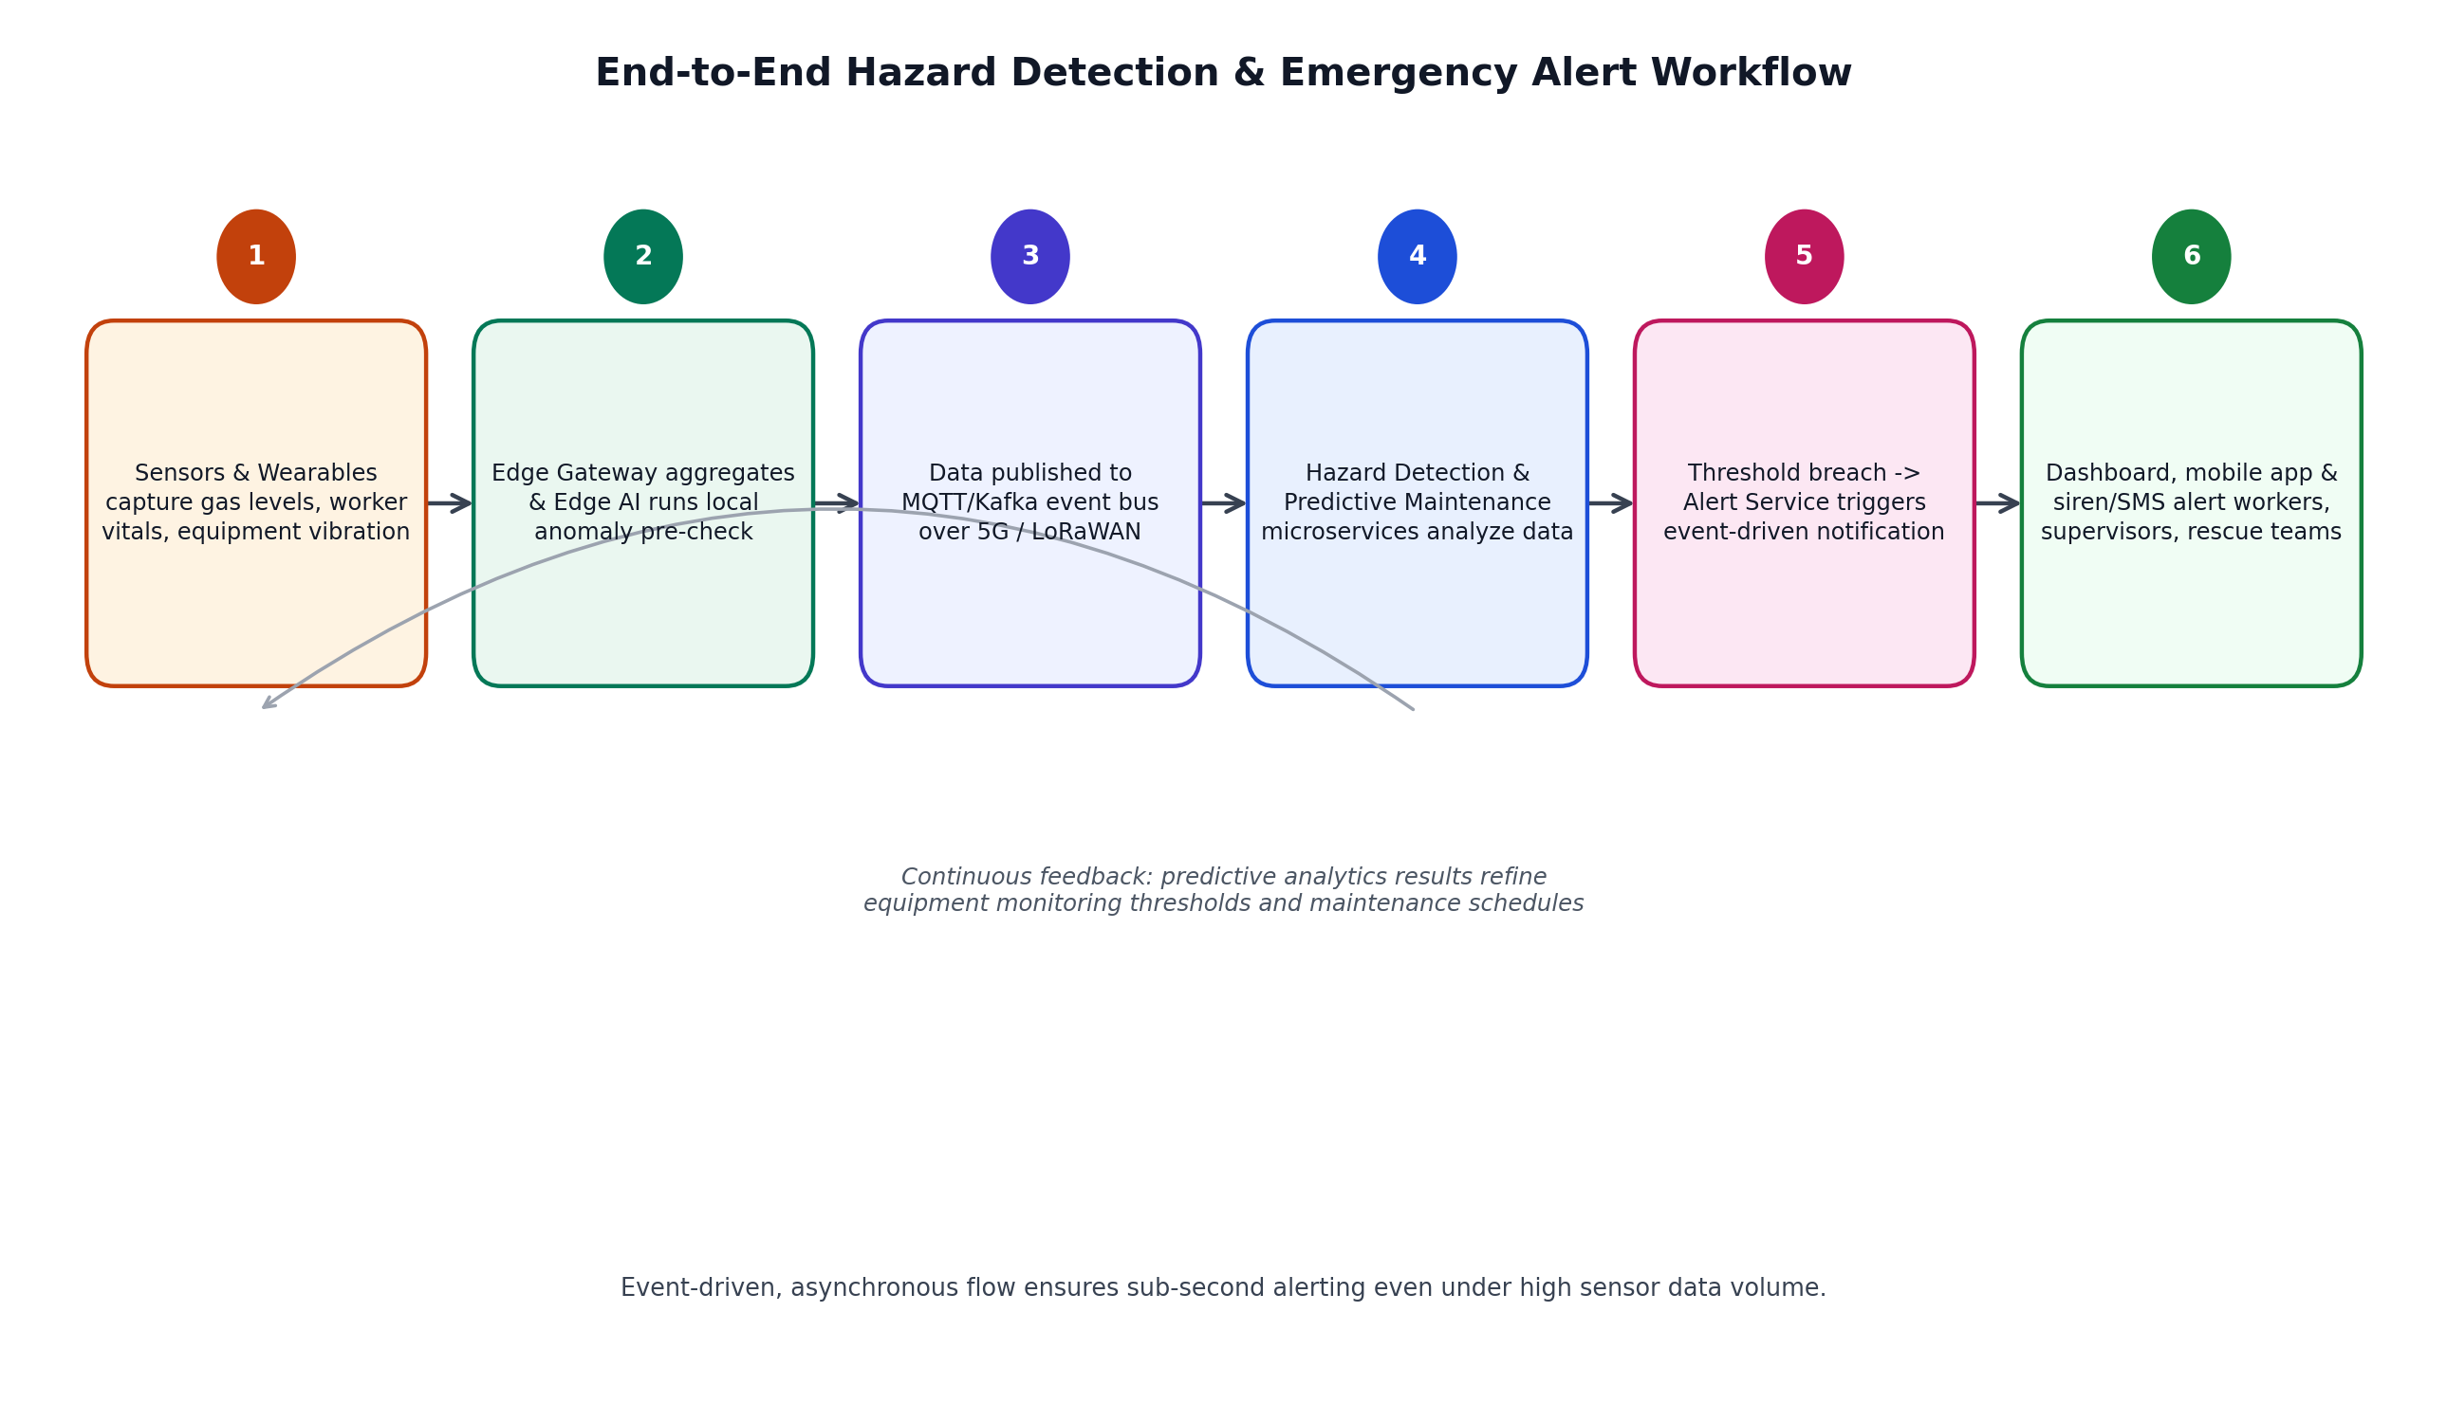
Figure 2: End-to-End Hazard Detection and Emergency Alert Workflow
As shown above, raw data captured by sensors and wearables is pre-filtered at the edge, published to the event bus, and analyzed in parallel by the Hazard Detection and Predictive Maintenance services. Any threshold breach triggers the Alert & Notification Service, which instantly informs dashboards, mobile apps, and physical alarms; outputs from predictive maintenance also feed back continuously to refine equipment-monitoring thresholds, closing the loop between detection and prevention.

5. Discussion of Quality Attributes

5.1 Scalability
The event-driven microservices design scales horizontally: Kafka topics can be partitioned so that additional consumer instances of the Hazard Detection or Analytics services are added as sensor volume or the number of mine sites grows, without redesigning the system. Each microservice can also be scaled independently based on its own load profile (e.g., Predictive Maintenance during batch model runs versus Alert Service during an incident spike).

5.2 Security
All communication uses TLS encryption in transit, and data at rest in the databases is encrypted. The API Gateway enforces OAuth2-based authentication and role-based access control so that, for example, field workers cannot access administrative configuration. Device-level authentication (X.509 certificates or pre-shared keys) prevents rogue devices from injecting false sensor data, which is critical given that false readings could trigger unnecessary evacuations or, worse, suppress genuine hazard alerts.

5.3 Performance
Edge AI inference performs first-pass anomaly detection within milliseconds, so hazard alerts do not have to wait on a round trip to the cloud. Kafka's low-latency publish/subscribe model and the API Gateway's asynchronous request handling keep end-to-end alert latency under the 2-second target even under high sensor throughput.

5.4 Reliability
Loose coupling through the event bus means that a fault in one microservice (e.g., Analytics) does not cascade to safety-critical services (Hazard Detection, Alert & Notification). Kafka's persistent, replicated log guarantees that events are not lost even if a consumer service temporarily goes down, and message replay allows a recovered service to catch up automatically.

5.5 Maintainability
Because each capability is implemented as an independently deployable microservice with a well-defined API, developers can update, test, and redeploy the Predictive Maintenance model or the Alert logic without touching or redeploying the rest of the system. This modular structure also makes it easier to onboard new sensor types or mine sites over time.

5.6 Availability
The edge-computing layer keeps core safety monitoring and local alerting operational even when the connection to the cloud is lost, directly addressing the intermittent-connectivity conditions typical of underground mining. Cloud services are deployed redundantly across availability zones, and the local buffer ensures no sensor data is permanently lost during an outage.

6. Justification of Architectural Decisions

6.1 Rationale
The architecture was designed around the two dominant constraints of the problem: the need for near-instant hazard/alert response, and the unreliable connectivity of underground mining environments. Placing lightweight AI inference and buffering at the edge directly satisfies the availability and performance requirements, while an event-driven microservices cloud layer satisfies the scalability, reliability, and maintainability requirements identified in Section 1.3. Every major design decision therefore traces back to a specific, previously identified quality attribute rather than being chosen arbitrarily.

6.2 Trade-offs Considered
- Complexity vs. resilience: A microservices/event-driven design is more complex to build, deploy, and monitor than a single monolithic application, but this complexity is accepted because it is what enables independent scaling and fault isolation for safety-critical functions.
- Eventual consistency vs. strict consistency: Asynchronous event processing means dashboards may show data that is a few hundred milliseconds old rather than perfectly synchronous; this is an acceptable trade-off given the large gain in throughput and decoupling, and safety-critical alerts are still delivered within the 2-second target.
- Edge hardware cost vs. safety guarantees: Deploying edge gateways and local AI inference hardware underground increases capital cost compared to a cloud-only design, but it is essential to keep safety alerting functional when connectivity drops.

6.3 Support for Future Enhancements and Long-Term Maintainability
The chosen architecture supports future growth in several concrete ways:
- New mine sites can be onboarded simply by deploying additional edge gateways that publish to the same cloud event bus, without changing existing services.
- New sensor types (e.g., additional gas types or seismic sensors) or new ML models can be introduced as new event topics/services without disrupting existing ones.
- The API Gateway provides a stable integration point for future systems, such as autonomous vehicle coordination or a digital-twin visualization of the mine.
- Because services are independently deployable, the platform can adopt CI/CD pipelines for frequent, low-risk updates, supporting long-term maintainability and faster regulatory-compliance updates.

7. Conclusion
The AI-Based Smart Mining Safety and Equipment Monitoring Platform is best served by a hybrid Edge–Cloud IoT architecture built around event-driven microservices. This design directly satisfies the system's functional requirements for continuous monitoring, hazard detection, predictive maintenance, and emergency alerting, while its quality-attribute-driven structure ensures the platform is scalable, secure, high-performing, reliable, maintainable, and available even in the harsh, connectivity-constrained conditions typical of underground mining. The architecture is well positioned to support future enhancements and long-term operational growth.

