DATA SCIENCE PROJECT REPORT
Customer Segmentation using RFM and K-Means
From raw order data to actionable customer segments, a predictive model and a scoring application
Item | Detail
Prepared by | Rupjit Das
Data | DataCo Supply Chain dataset: 180,519 order-item rows aggregated to 20,652 customers
Techniques | RFM feature engineering, EDA, K-Means clustering, Random Forest classification
Tools | Python (Pandas, scikit-learn, Matplotlib, Seaborn), FastAPI, Streamlit

Executive Summary
Order-level data was converted into a customer-level dataset and clustered into five segments across 20,652 customers. A classifier reproduces the segments so new customers can be scored instantly through an API and web app.
- Profit is concentrated. High-Value Profitable customers are 19.5% of the base but generate 71.0% of profit at a 16.7% margin.
- Margin is the biggest opportunity. Regular Mid-Value customers (27.2% of customers, 37.3% of revenue) earn only a 3.2% margin; lifting it to the company average (10.8%) would add about 1.04M profit (~26% of the total).
- Segments are stable and predictable. Re-clustering with other seeds gives an adjusted Rand index of 0.998 or higher, and a Random Forest reproduces the segments with 98.4% accuracy (macro F1 0.98).

1. Data and Features
Eight columns of the order data were used and aggregated to one row per customer (joined explicitly on Customer Id; no duplicates or missing values). Six features feed the model; average order value was calculated but excluded because it is a ratio of Monetary and Frequency.
Feature | Definition | Aggregation
Recency | Days from last order to snapshot date (latest order + 1 day) | snapshot − max(order date)
Frequency | Number of distinct orders | nunique(Order Id)
Monetary | Total sales value | sum(Sales)
Avg. discount rate | Average item discount rate | mean(Discount Rate)
Product categories | Distinct departments purchased from | nunique(Department)
Total profit | Profit from the customer (can be negative) | sum(Profit per Order)

2. Exploratory Analysis
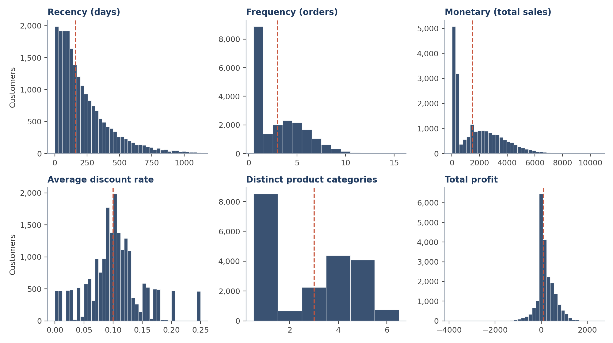
Figure 1. Feature distributions (dashed line = median)
- 43% of customers bought once, and the top 20% by spend generate about 50% of revenue.
- Recency is right-skewed (median 160 days, mean 221); 19.7% of customers are loss-making, with profit ranging from −3,869 to +2,442.
- Revenue is only a moderate proxy for profit (r = 0.46), so profit is clustered as its own feature. Frequency and Monetary overlap strongly (r = 0.93), and discount rate is uncorrelated with everything else (|r| ≤ 0.01).

3. Segmentation Model
Features were standardised (StandardScaler) and clustered with K-Means (n_init = 10, random_state = 42). The elbow is gradual and the silhouette score is 0.367 at k = 5, similar to neighbouring values, so k = 5 was chosen because fewer clusters could not separate profit from spend and each of the five segments leads to a distinct action. A silhouette near 0.37 indicates moderate separation: groups are real but their edges overlap.
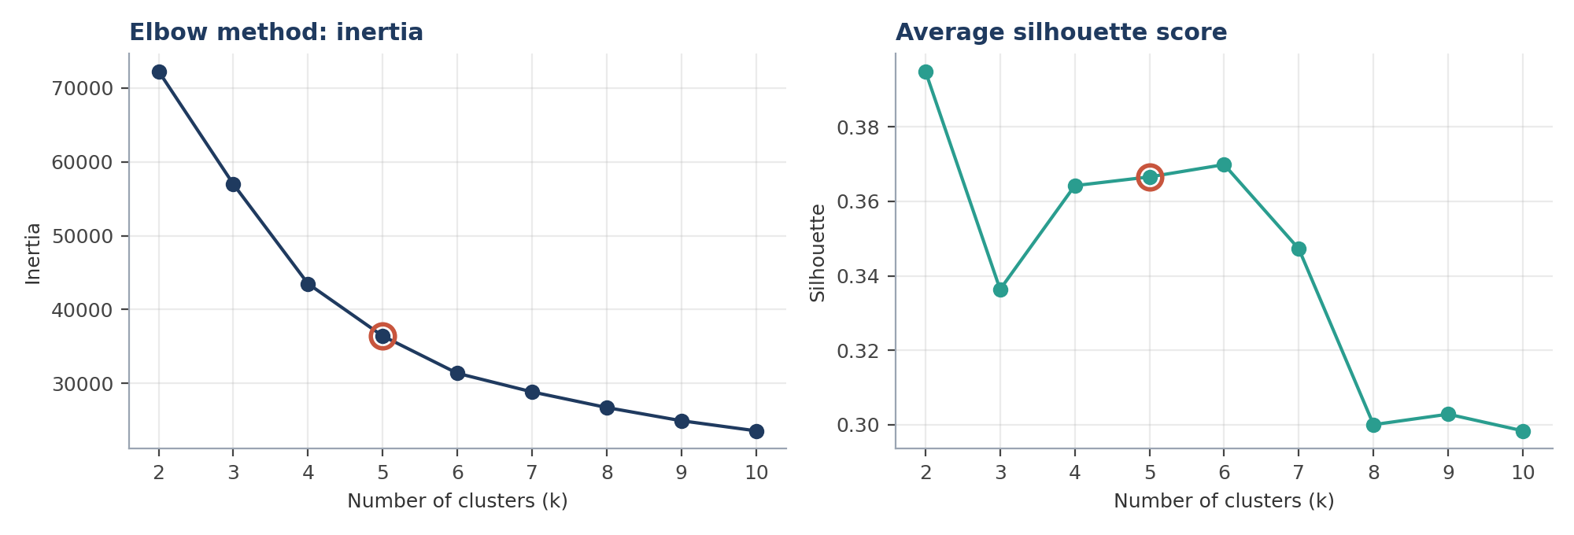
Figure 2. Elbow and silhouette scores for k = 2 to 10 (k = 5 circled)
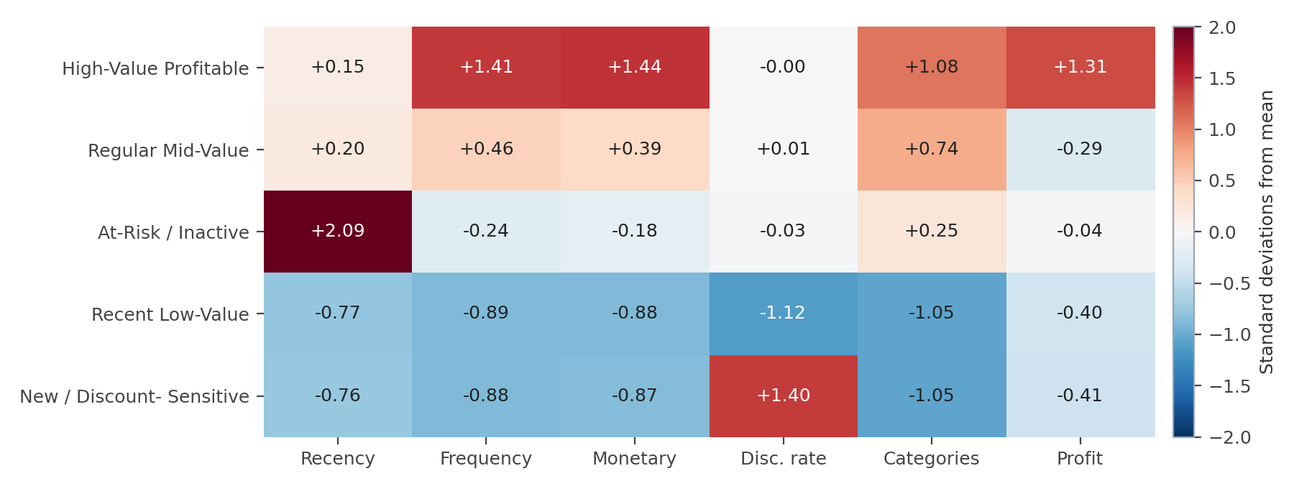
Figure 3. Average standardised feature values per segment (red = above average, blue = below)

4. Segment Results
Total revenue is 36.78M and total profit 3.97M (overall margin 10.8%).
Segment | Customers | % cust. | Revenue (M) | % rev. | % profit | Margin | Loss-making
High-Value Profitable | 4,021 | 19.5% | 16.88 | 45.9% | 71.0% | 16.7% | 1.8%
Regular Mid-Value | 5,615 | 27.2% | 13.72 | 37.3% | 11.0% | 3.2% | 33.9%
At-Risk / Inactive | 2,351 | 11.4% | 3.47 | 9.4% | 10.4% | 11.9% | 19.5%
Recent Low-Value | 4,788 | 23.2% | 1.50 | 4.1% | 4.5% | 11.9% | 18.8%
New / Discount-Sensitive | 3,877 | 18.8% | 1.22 | 3.3% | 3.1% | 10.2% | 19.0%
Table 1. Segment contribution (loss-making = % of customers with negative profit)
Segment | Recency (days) | Orders | Avg. spend | Avg. order value | Discount | Categories | Profit / cust.
High-Value Profitable | 251 | 6.6 | 4,198 | 647 | 10% | 4.7 | 700
Regular Mid-Value | 260 | 4.3 | 2,443 | 581 | 10% | 4.1 | 78
At-Risk / Inactive | 638 | 2.6 | 1,476 | 573 | 10% | 3.3 | 176
Recent Low-Value | 68 | 1.0 | 312 | 303 | 5% | 1.0 | 37
New / Discount-Sensitive | 69 | 1.0 | 314 | 302 | 17% | 1.0 | 32
Table 2. Average customer profile per segment
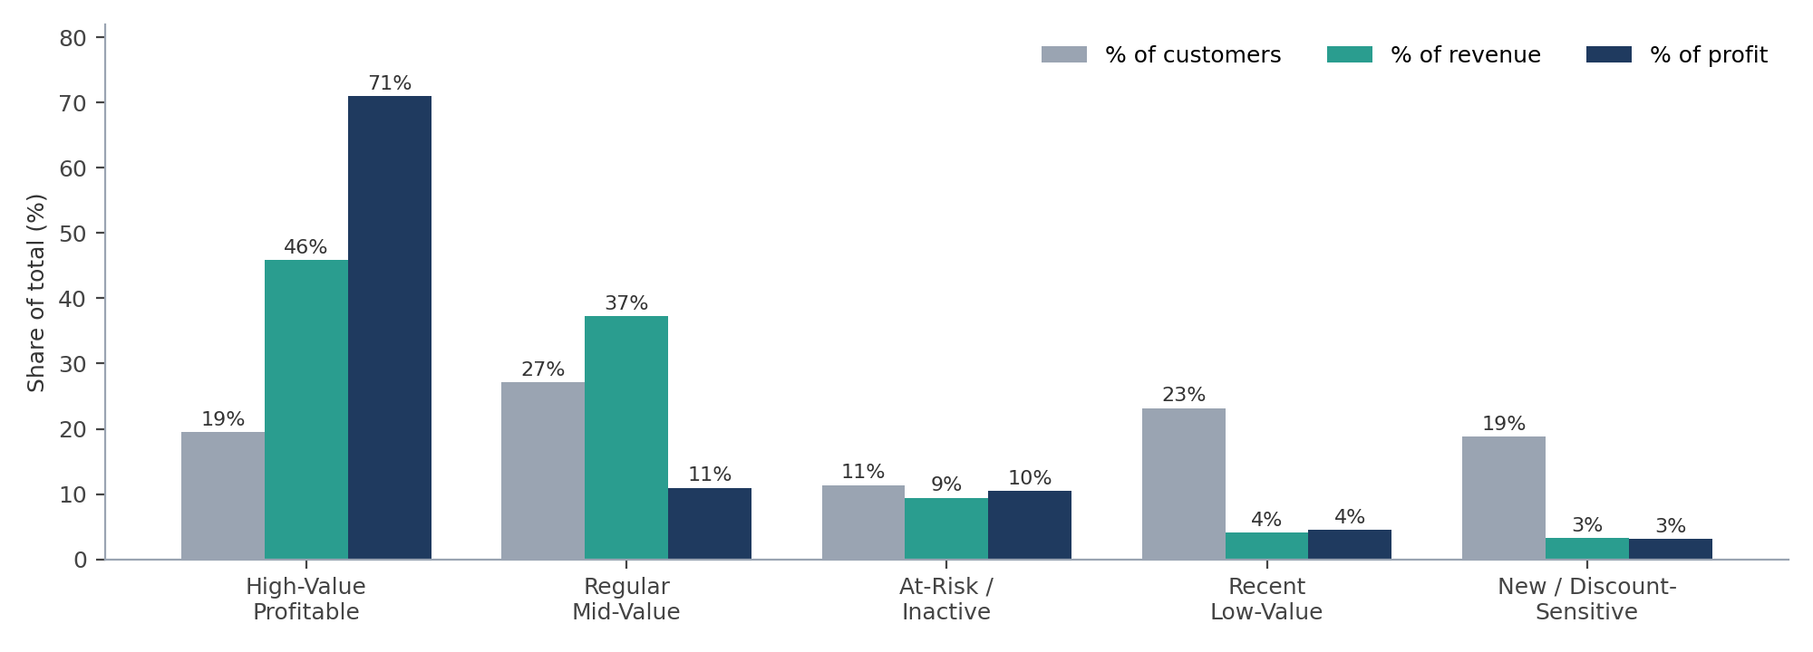
Figure 4. Share of customers, revenue and profit by segment
Key insights
- Same behaviour, very different profit. High-Value Profitable and Regular Mid-Value customers have similar recency, discount rate (10%) and order value (647 vs. 581), yet profit per customer is 700 vs. 78. Product mix, pricing or fulfilment cost are the likely causes and need a product-level drill-down.
- At-Risk customers are recoverable value: 638 days since last order on average, but 3.47M in revenue and 0.41M in profit at a 11.9% margin.
- Discounts cost less than expected. Discount-Sensitive customers use 17% discounts vs. 5% for Recent Low-Value, yet margin is only 1.7 points lower. The two single-order segments are 42% of customers but 7% of revenue.

5. Predictive Model and Application
A Random Forest (200 trees) predicts the segment from the six standardised features using a stratified 80/20 split (16,521 train / 4,131 test). Accuracy is 98.4%, with precision and recall of 0.96 or higher in every segment. Discount rate (0.268) and recency (0.226) are the most important features.
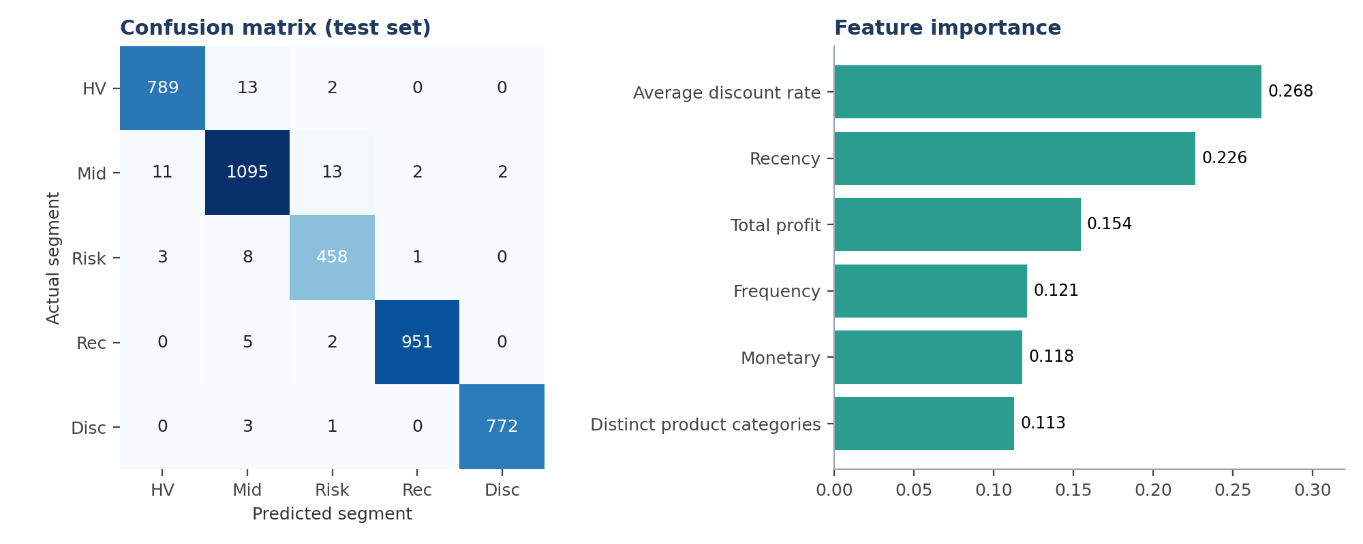
Figure 5. Test-set confusion matrix (left) and feature importance (right)
Because the labels come from K-Means on the same features, this accuracy shows the classifier reproduces the clustering, not that the segments are independently validated. The saved scaler, K-Means and Random Forest were checked for consistency: refitting K-Means reproduces the saved labels exactly.
Application. A FastAPI backend loads the saved artefacts and exposes POST /predict (returns segment, description and recommended action) and GET /health. A Streamlit interface lets a user enter the six values and view the predicted segment and next action.

6. Recommendations
Segment | Recommended action | Goal | Priority
High-Value Profitable | Loyalty rewards and personalised offers; avoid unnecessary discounts | Retain | 1 (High)
Regular Mid-Value | Product-level margin review; check pricing, shipping and order costs; set discount limits | Fix margin | 1 (High)
At-Risk / Inactive | Win-back campaign, starting with the highest past spenders | Re-activate | 2 (High)
Recent Low-Value | Second-purchase nudges: follow-ups, cross-sell, loyalty sign-up | Grow | 3 (Medium)
New / Discount-Sensitive | Replace blanket discounts with targeted offers and bundles; test lower discounts | Reduce discounting | 3 (Medium)

7. Limitations and Next Steps
- Moderate separation (silhouette 0.37). Test Gaussian mixtures and log-transformed features, and confirm on a later time period.
- Validate commercially. Test the recommended actions with a holdout group, and explain the Regular Mid-Value margin gap by product and department.
- Keep names and clusters in sync. Segment names are mapped to cluster numbers in code and must be rechecked after every retrain; the Streamlit playbook should use the same names as the backend.
- Refresh periodically and track customer movement between segments over time.

