PIZZA SALES SQL QUERIES
A ) All KPI’s
-- 1) Total Revenue
select sum(Total_price) as Gross_Revenue
from pizza_sales;
Output:-
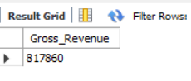

-- 2) Average Order values
select round((Sum(total_price) / count(distinct order_id)),2) as Avg_order_values
from Pizza_sales;
Output:-
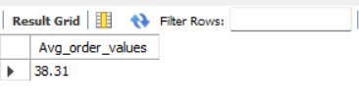

-- 3) Total Pizzas Sold
Select Sum(Quantity) as Total_pizza_sold
from pizza_sales;
Output:-
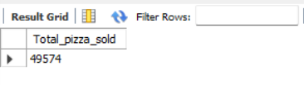

-- 4) Total Orders
select count(distinct Order_id) as Total_orders
from pizza_sales;
Output:-
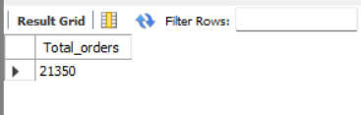

-- 5) avg of pizza per order
Select dayname(Str_to_Date(order_date,'%y-%m-%d')) as day_name,
count(distinct order_id) as total_orders
from pizza_sales
group by dayname(Str_to_Date(order_date,'%y-%m-%d'));
Output:-
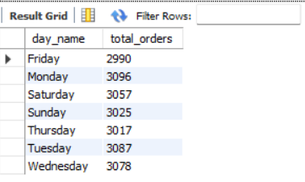

B) ALL IMPORTANT CHART’S:-
-- 1) Hourly (Daily) treand of total_orders
select Date_format(t.order_time_dt,'%h %p') as order_hour,
count(distinct order_id) as total_orders
from (select order_id,
str_to_date(order_time, '%H:%i:%s') as order_time_dt
from pizza_sales) t
where t.order_time_dt is not null
group by order_hour
order by min(t.order_time_dt);
Output:-
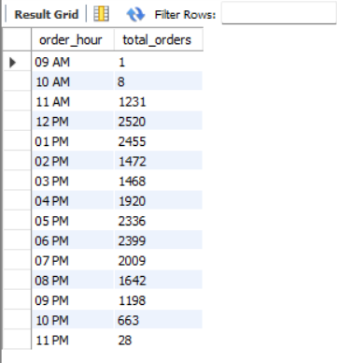

-- 2)Month wise total orders
select max(date_format(Str_to_date(order_date,"%Y-%m-%d" ),"%M")) as order_month,
count(distinct order_id) as total_orders
from pizza_sales
group by month(str_to_date(order_date, "%Y-%m-%d" ))
order by month(str_to_date(order_date, "%Y-%m-%d" ));
Output:-
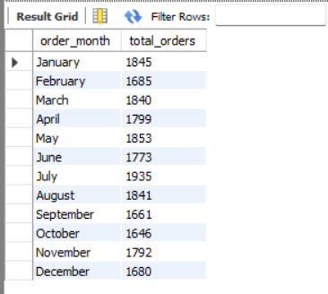
-- 3)percentage of total pizza category
select pizza_category,
sum(Quantity) as total_quantity,
round(sum(quantity) * 100 / (select sum(quantity) from pizza_sales),2) as percentage_of_sales
from pizza_sales
group by pizza_category
order by percentage_of_sales desc;
Output:-
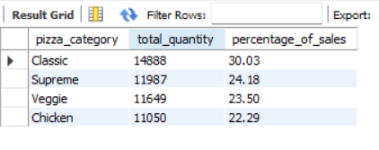
-- 4)percentage of total sails by pizza Size
select pizza_size,
round(sum(total_price),2) as total_sales,
round(sum(total_price) * 100/(select sum(total_price) from pizza_sales),2) as Percentage_of_total_pizza_size
from pizza_sales
group by pizza_size;
Output:-
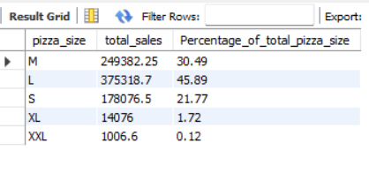
-- 5)total pizza sold by pizza category
select pizza_name,
round(sum(total_price),2) as Gross_Revenue
from pizza_sales
group by pizza_name;
Output:-
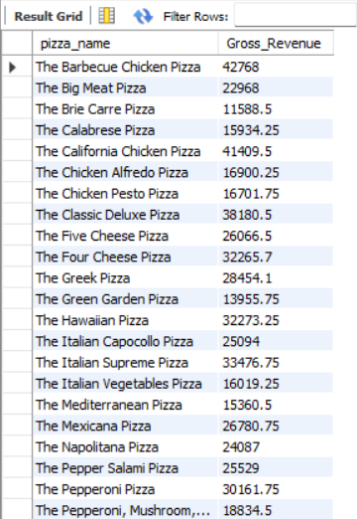
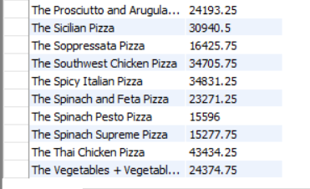
-- 6) Top 5 best sellers by pizza sales revanue
select pizza_name,
sum(total_price) as total_revenu
from pizza_sales
group by pizza_name
order by total_revenu desc
limit 5 ;
Output:-
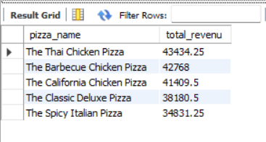
-- 7) Bottom 5 best sellers by pizza sales revanue
select pizza_name,
sum(total_price) as total_revenue
from pizza_sales
group by pizza_name
order by total_revenue asc
limit 5;
Output:-
