MINI PROJECT REPORT
ON
SMART DUSTBIN
USING ULTRASONIC SENSOR AND ARDUINO UNO
SUBMITTED BY: -
NAME: RUSHIKESH RATHOD , MAYUR JADHAV, UDAY SURYVANSHAM
PRN: 250105231190, 250105231246, 250105231774
DIV/ROLL NO: A /36
• INTRODUCTION: -
A Smart Dustbin is an automation-based waste bin that opens its lid automatically when a person brings a hand or waste near it and closes the lid after a short delay. The main purpose of this project is to make waste disposal more hygienic, convenient, and touch-free.
The system uses an ultrasonic sensor to measure the distance of an object from the dustbin. An Arduino UNO processes the sensor data and controls a servo motor connected to the lid. When an object comes within the programmed distance, the Arduino rotates the servo motor and opens the lid.
This project is simple, low-cost, easy to demonstrate, and suitable for mini projects in electronics, computer engineering, electrical engineering, IoT, and embedded systems.
• WHAT IS AUTOMATION?
Automation means using technology to perform a task automatically with little or no human intervention.
In a traditional dustbin, a person has to touch or lift the lid manually.
Traditional system:
Person approaches → Touches lid → Opens lid → Throws waste → Closes lid
In an automated system:
Person approaches → Sensor detects object → Arduino processes signal → Servo opens lid
After the person moves away:
No nearby object → Arduino waits for a short time → Servo closes lid
Therefore, automation makes the waste-disposal process more convenient, hygienic, and user-friendly.
• WHAT IS A SMART DUSTBIN?
A Smart Dustbin is an electronic waste bin that can perform one or more automatic functions such as opening the lid without touch, detecting the fill level, or sending a notification when it becomes full. In this mini project, the main function is automatic lid opening.
The project consists mainly of :
• Arduino UNO
• HC-SR04 ultrasonic sensor
• Servo motor (such as SG90)
• Dustbin or model container
• 5V power supply / USB cable
• Breadboard
• Connecting wires
The ultrasonic sensor detects a nearby hand or object. The Arduino reads the measured distance and operates the servo motor. The servo then opens or closes the dustbin lid.
• OBJECTIVES: -
1. To develop a touch-free automatic dustbin lid.
2. To detect a hand or object using an ultrasonic sensor.
3. To control a servo motor using Arduino UNO.
4. To improve hygiene by reducing the need to touch the dustbin.
5. To understand the working of distance sensors and microcontrollers.
6. To create a simple automation application using embedded programming.
7. To build a low-cost and easy-to-demonstrate student project.
• BASIC PRINCIPLE: -
The Smart Dustbin works on the principle of ultrasonic distance measurement. The HC-SR04 sensor sends a short ultrasonic pulse and receives the reflected echo from a nearby object.
The Arduino measures the time taken by the pulse to return and calculates the distance. If the measured distance is less than the programmed threshold, the Arduino commands the servo motor to rotate and open the lid.
The sequence is:
Hand / Object → Ultrasonic Sensor → Arduino UNO → Servo Motor → Dustbin Lid
If the object is within the selected range, the lid opens. After a short delay, the servo returns to its initial angle and the lid closes.
• BLOCK DIAGRAM:
-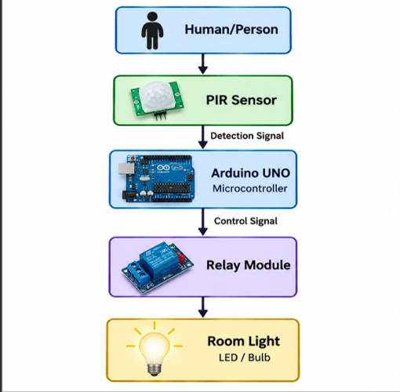

Block diagram explanation: The ultrasonic sensor is the input device, the Arduino UNO performs processing, and the servo motor acts as the output device that moves the dustbin lid.

• COMPONENTS REQUIRED: -
Sr. No. | Component | Quantity | Purpose
1 | Arduino UNO | 1 | Main controller
2 | HC-SR04 Ultrasonic Sensor | 1 | Detects nearby hand/object
3 | SG90 / similar Servo Motor | 1 | Opens and closes lid
4 | Breadboard | 1 | Prototype connections
5 | Jumper Wires | As required | Electrical connections
6 | USB Cable / 5V Supply | 1 | Power and programming
7 | Dustbin / Model Container | 1 | Physical body
8 | Cardboard / Bracket / Tape | As required | Mounting the servo and lid

• WHAT IS ARDUINO UNO?
Arduino UNO is a microcontroller development board commonly used for electronics and automation projects. It receives signals from sensors, processes those signals according to the uploaded program, and controls output devices.
In this project:
Input: Ultrasonic sensor
Processing: Arduino UNO
Output: Servo motor / dustbin lid
Important features:
• ATmega328P microcontroller
• Digital input/output pins
• Analog input pins
• USB connection
• 5V operating logic
• Can be programmed using Arduino IDE

• WHAT IS HC-SR04 ULTRASONIC SENSOR?
The HC-SR04 is a distance-measuring sensor that uses ultrasonic sound waves. It has four main pins: VCC, Trig, Echo, and GND.
Working: Arduino sends a short pulse to the Trig pin. The sensor emits an ultrasonic wave. The wave reflects from an object and returns to the sensor. The Echo pin remains HIGH for a time related to the travel time of the sound wave.
Distance can be estimated by:
Distance (cm) = Echo time × 0.034 / 2

• WHAT IS A SERVO MOTOR?
A servo motor is a small motor that can rotate to a specific angle. It is commonly used in robotics and automation projects where controlled movement is required.
A typical SG90 servo has three wires: power (5V), ground (GND), and signal. The signal wire is connected to an Arduino digital pin. The Arduino sends control pulses to set the servo angle.
In this project:
Arduino → Servo motor → Dustbin lid
For example, the lid may remain near 0° when closed and rotate near 90° when the dustbin is opened. The exact angles can be changed according to the mechanical arrangement.

• HOW DOES THE SMART DUSTBIN WORK?
The complete working can be divided into six steps.
Step 1: Power ON
Power is supplied to the Arduino, ultrasonic sensor, and servo motor.
Step 2: Distance Monitoring
The ultrasonic sensor repeatedly measures the distance in front of the dustbin.
Step 3: Object Detection
When a hand or object comes within the programmed distance, the Arduino detects that the distance is smaller than the threshold.
Step 4: Arduino Processing
Arduino executes the programmed instructions and sends a control signal to the servo.
IF OBJECT IS NEAR:
Distance < Set Limit
↓
Arduino detects nearby object
↓
Servo rotates
↓
Dustbin lid opens
Step 5: Delay
The lid remains open for a short period so the user can throw the waste.
Step 6: Lid Closing
After the delay, the servo returns to the closed position and the system continues monitoring.
• CIRCUIT CONNECTION
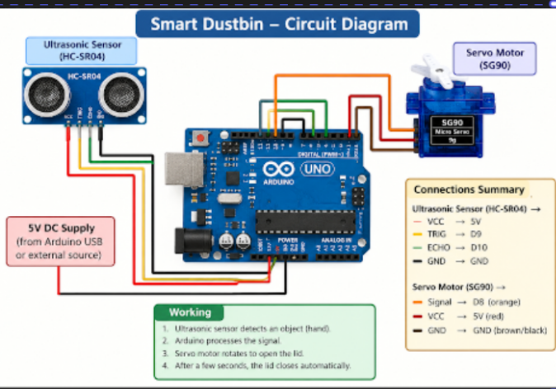

A simple low-voltage prototype can be connected as follows:
Component Pin | Arduino Connection | Function
HC-SR04 VCC | 5V | Sensor power
HC-SR04 GND | GND | Ground
HC-SR04 Trig | Digital Pin 9 | Trigger pulse
HC-SR04 Echo | Digital Pin 10 | Echo input
Servo Signal | Digital Pin 6 | Servo control
Servo VCC | 5V | Servo power
Servo GND | GND | Common ground

• CIRCUIT DIAGRAM CONCEPT: -

• SOFTWARE REQUIRED: -
Arduino IDE is used to write, compile, and upload the program to Arduino UNO.
The general process is:
Write Code
↓
Compile
↓
Connect Arduino
↓
Select Board & Port
↓
Upload
↓
Test Project

• SAMPLE ARDUINO CODE: -
# #include <Servo.h>
Servo lidServo;
const int trigPin = 9;
const int echoPin = 10;
const int servoPin = 6;
long duration;
float distance;
void setup() {
pinMode(trigPin, OUTPUT);
pinMode(echoPin, INPUT);
lidServo.attach(servoPin);
lidServo.write(0); // Lid closed
}
void loop() {
digitalWrite(trigPin, LOW);
delayMicroseconds(2);
digitalWrite(trigPin, HIGH);
delayMicroseconds(10);
digitalWrite(trigPin, LOW);
duration = pulseIn(echoPin, HIGH, 30000);
if (duration > 0) {
distance = duration * 0.034 / 2;
if (distance > 0 && distance < 20) {
lidServo.write(90); // Open lid
delay(2500);
lidServo.write(0); // Close lid
delay(500);
}
}
delay(100);
}
• CODE EXPLANATION: -
trigPin = 9 → Sends the ultrasonic trigger pulse.
echoPin = 10 → Receives the echo pulse from the sensor.
servoPin = 6 → Sends the control signal to the servo motor.
pulseIn() → Measures the duration of the Echo HIGH pulse.
distance = duration × 0.034 / 2 → Converts echo time to approximate distance in centimeters.
if (distance < 20) → Checks whether an object is within 20 cm.
lidServo.write(90) → Opens the lid.
lidServo.write(0) → Returns the lid to the closed position.

• ESTIMATED COST: -
Component | Approx. Cost (₹) | Remarks
Arduino UNO compatible board | 350–600 | Depends on brand
HC-SR04 ultrasonic sensor | 70–120 | Common student module
SG90 servo motor | 120–200 | Micro servo
Breadboard & jumper wires | 150–250 | If not already available
Dustbin / cardboard model | 100–300 | Depends on model
USB cable / power arrangement | 100–200 | Optional if already available
A reasonable student prototype can usually be built at low cost, especially if the Arduino, breadboard, or wires are already available.

• ADVANTAGES: -
1. Touch-Free Operation – The lid opens without touching the dustbin.
2. Better Hygiene – Reduces direct contact with the dustbin surface.
3. Low Cost – Uses commonly available student electronics components.
4. Easy to Implement – Arduino and ultrasonic sensors are simple to program and test.
5. Convenient – Useful in homes, classrooms, laboratories, offices, and public areas.
6. Expandable – Fill-level monitoring, buzzer alerts, displays, or IoT features can be added later.
7. Good Learning Project – Demonstrates sensors, microcontrollers, servo control, and automation.

• LIMITATIONS: -
1. The ultrasonic sensor can sometimes give unstable readings depending on object shape and angle.
2. The lid mechanism must be light enough for the selected servo motor.
3. Very close or very far objects may not be measured reliably.
4. The basic project does not detect whether the dustbin is full.
5. Repeated nearby movement may cause unnecessary lid operation if the threshold is not adjusted properly.
6. A stable power supply is required, especially when the servo motor moves.

• APPLICATIONS: -
Smart dustbins can be used in:
1. Homes
2. Classrooms
3. College laboratories
4. Offices
5. Hospitals and clinics
6. Libraries
7. Canteens
8. Hotels
9. Shopping areas
10. Public buildings
11. Smart homes
12. Small automation demonstrations

• FUTURE SCOPE: -
A. Fill-Level Detection
A second ultrasonic sensor can be mounted inside the dustbin to measure how full it is. When the waste reaches a selected level, an LED, buzzer, or message can indicate that the bin needs to be emptied.
B. IoT Monitoring
An ESP32 or ESP8266 can be used to connect the smart dustbin to Wi-Fi. The system could send fill-level information to a mobile application or webpage.
C. Wet and Dry Waste Separation
Additional sensors and separate compartments can be used to build a more advanced waste-segregation prototype.
D. LCD / OLED Display
A small display can show distance, lid status, fill percentage, or warning messages.
E. Buzzer or LED Alert
The system can produce an alert when the dustbin is full or when a sensor error occurs.
F. Battery / Solar Power
A rechargeable battery or small solar arrangement can be explored for portable or outdoor models.

• SAFETY PRECAUTIONS: -
1. Use only low-voltage power for the student prototype.
2. Do not short the 5V and GND connections.
3. Keep the electronic parts away from water and wet waste.
4. Mount the servo securely so that the moving lid does not pull the wires.
5. Switch off the power before changing circuit connections.
6. If a separate power supply is used for the servo, connect the grounds properly.
• COMMON PROBLEMS AND TROUBLESHOOTING: -
Problem | Possible Solution
Lid does not open | Check sensor wiring, servo signal pin, and uploaded code.
Servo shakes continuously | Check power supply and make sure the servo is not mechanically blocked.
Wrong distance values | Check Trig/Echo pins and sensor alignment.
Lid opens from too far away | Reduce the distance threshold in the program.
Arduino restarts when servo moves | Use a stable 5V supply and ensure a common ground.

• RESULT: The Smart Dustbin prototype successfully demonstrates automatic lid opening using an ultrasonic sensor, Arduino UNO, and servo motor. When a hand or object is brought within the programmed distance, the lid opens automatically and closes after a short delay.
The project shows how simple sensors and actuators can be combined with a microcontroller to create a useful touch-free automation system.

• CONCLUSION: -
The Smart Dustbin using Ultrasonic Sensor and Arduino UNO is a simple and useful automation project. The system detects a nearby hand or object using an ultrasonic sensor and uses Arduino to control a servo motor connected to the dustbin lid.
The project demonstrates important concepts such as automation, distance sensing, microcontrollers, embedded programming, servo control, and touch-free operation.
Because the system is inexpensive and easy to modify, it can serve as a basic model for smart waste-management projects. By adding fill-level sensing, Wi-Fi connectivity, displays, alerts, or waste-segregation features, the project can be further developed into a more advanced smart dustbin system.

THANK YOU

