**3.2.2 Magnitude and Phase of Discrete-Time Systems**

For the discrete-time system described by the following difference equation,

$$y\left(n\right)=0.9y\left(n-1\right)+0.3x\left(n\right)+0.24x(n-1)$$

**i**: Compute the impulse response.

**ii**: Draw a system diagram.

**iii**: Take the Z-transform of the difference equation using the linearity and the time shifting properties of the Z-transform.

**iv**: Find the transfer function, defined as

$$H\left(z\right)=\frac{Y_{(z)}}{X_{(z)}}$$

**v:** Use Matlab to compute and plot the magnitude and phase responses， $\left|H(e^{jω})\right|$ and∠ $H(e^{jω}$), for $-π<ω<π$. You may use Matlab commands phase and abs.

**4.4.3 System Analysis**

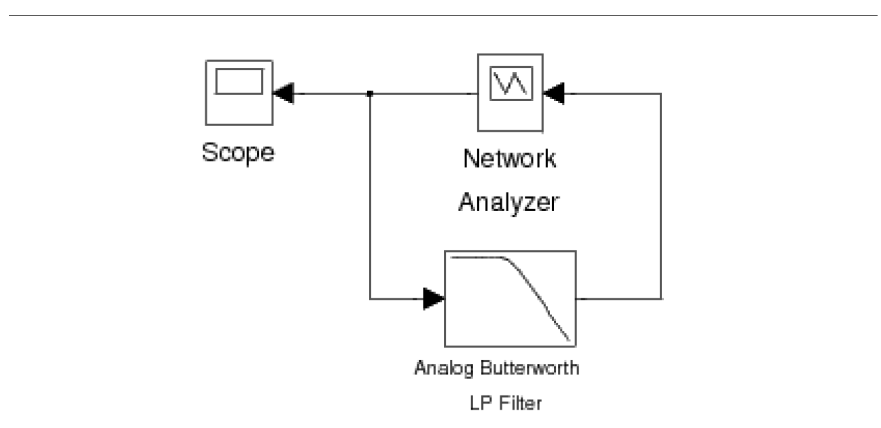

**Figure 3.6**: Simulink model for the continuous-time system analysis experiment using a network analyzer.



Double click the icon labeled CT System Analysis using a Network Analyzer to bring up a system as shown in Figure 4.6. This system includes a Network Analyzer model for measuring the frequency response of a system. The Network Analyzer works by generating a weighted chirp signal (shown on the Scope) as an input to the system-under-test. The analyzer measures the frequency response of the input and output of the system and computes the transfer function. By computing the inverse Fourier transform, it then computes the impulse response of the system. Use this setup to compute the frequency and impulse response of the given fourth order Butterworth filter with a cut-o frequency of 1Hz. Print the figure showing the magnitude response, the phase response and the impulse response of the system. To use the tall mode to obtain a larger printout, type orient('tall'); directly before you print.

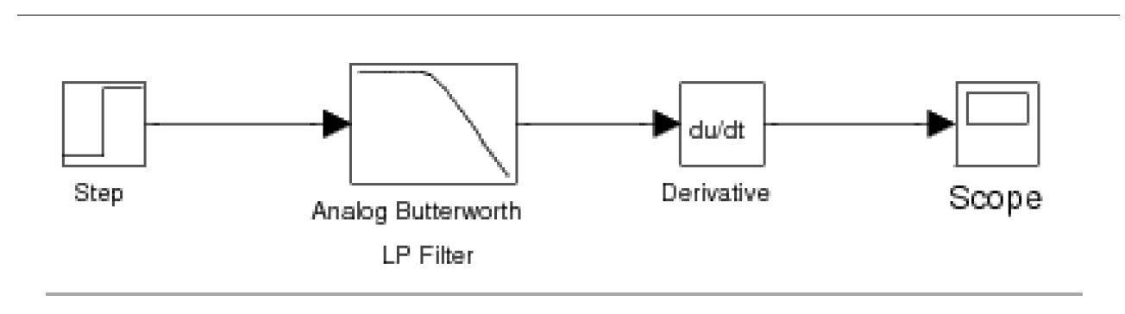

**Figure 3.7**: Simulink model for the continuous-time system analysis experiment using a unit step.



An alternative method for computing the impulse response is to input a step into the system and then to compute the derivative of the output. The model for doing this is given in the CT System Analysis using a Unit Step block. Double click on this icon and compute the impulse response of the filter using this setup (Figure 4.7). Make sure that the characteristics of the filter are the same as in the previous setup. After running the simulation, print the graph of the impulse response.

Inlab Report: Hand in the printout of the output of the Network Analyzer (magnitude and phase of the frequency response, and the impulse response) and the plot of the impulse response obtained using a unit step. What are the advantages and disadvantages of each method?

**3.5.2 System Analysis**

For help on printing Simulink system windows click print.pdf.

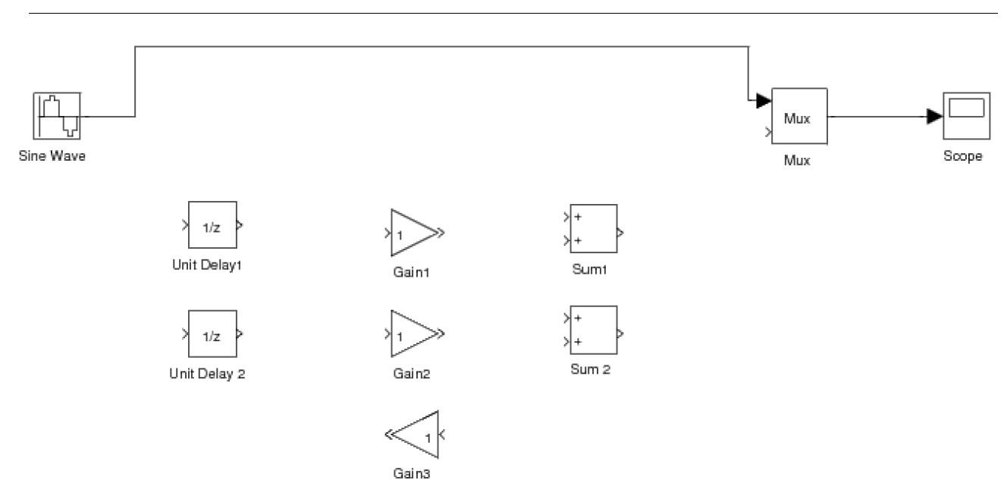

**Figure 3.8**: Incomplete Simulink setup for the discrete-time system analysis experiment.



Double click the icon labeled DT System Analysis to bring up an incomplete block diagram as shown in Figure 3.8. It is for a model that takes a discrete-time sine signal, processes it according to a difference equation and plots the multiplexed input and output signals in a graph window. Complete this block diagram such that it implements the following difference equation given in "Magnitude and Phase of Discrete-Time

Systems" (Section 3.2.2: Magnitude and Phase of Discrete-Time Systems) of the background exercises.

$$y\left(n\right)=0.9y\left(n-1\right)+0.3x\left(n\right)+0.24x(n-1)$$

You are provided with the framework of the setup and the building blocks that you will need. You can change the values of the Gain blocks by double clicking on them. After you complete the setup, adjust the frequency of Sine Wave to the following frequencies: $ω=π/16,ω=π/8,$ and $ω=π/4$. For each frequency, make magnitude response measurements using the input and output sequences shown in the graph window. Compare your measurements with the values of the magnitude response $︱H(e^{jω})︱$ which you computed in the background exercises at these frequencies.

An alternative way of finding the frequency response is taking the DTFT of the impulse response. Use your DTFT function to find the frequency response of this system from its impulse response. The impulse response was calculated in "Magnitude and Phase of Discrete-Time Systems" (Section 3.2.2: Magnitude and Phase of Discrete-Time Systems) of the background exercises. Plot the impulse response, and the magnitude and phase of the frequency response in the same figure using the subplot command.

Inlab Report: Hand in the following: 1) Printout of your completed block diagram. 2) Table of both the amplitude measurements you made and their theoretical values. 3) Printout of the figure with the impulse response, and the magnitude and phase of the frequency response.