Program1

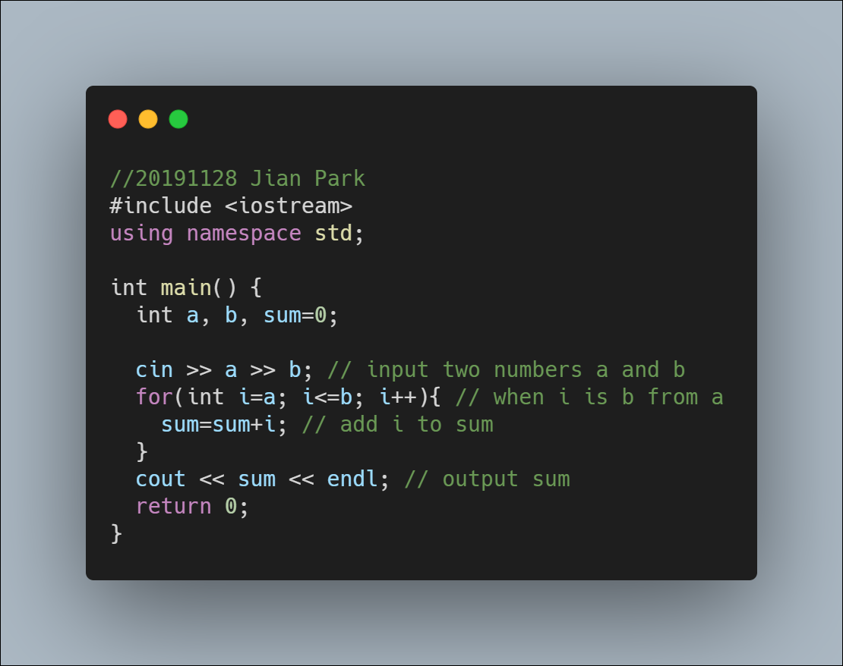

To get the sum of all integer numbers use for loop.

Program2

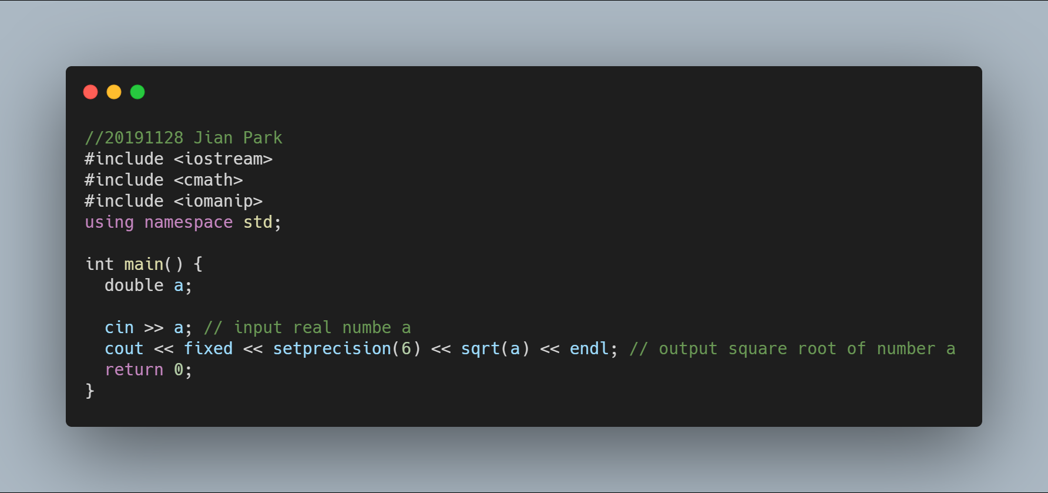

‘setprecision(6)’ with ‘fixed’ is print floats with 6 digits after the decimal.

And sqrt(a) function is get square root of a.

Program3

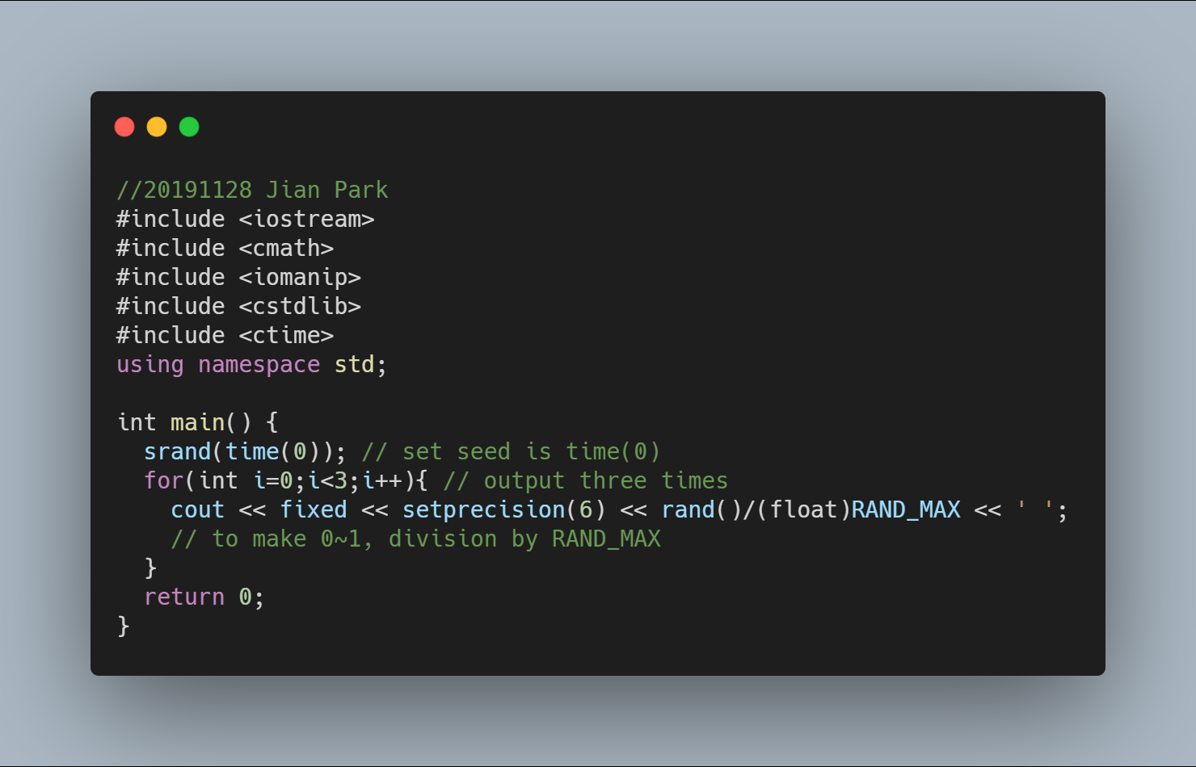

To make different random number for all run time, set seed is time(0).

And to get 0~1 range, division by RAND_MAX that max number for rand().