Program1

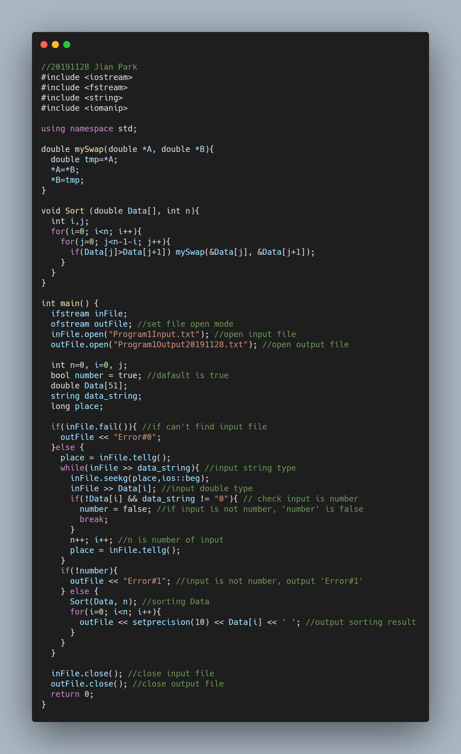

Define mySwap() function using point. The function receives address of A and B. Then put value of A in ‘tmp’. And put value of B in value of A and put value of tmp in value of B.

Sort function is Sorting array Date which length is n. When I is starting at 0, j also be starting at 0 to n-i-1. As j progresses, it compares adjacent array values ​​and call mySwap() when the j-th value is greater than the j+1-th value.

‘inFile.fail()’ is true, it’s means can’t find input file. (Error#0)

Data_string is string type, Data[i] is double type. When contains anything else than numbers, Data[i] is false and Data_string is not ‘0’. (Error#1)

Program2

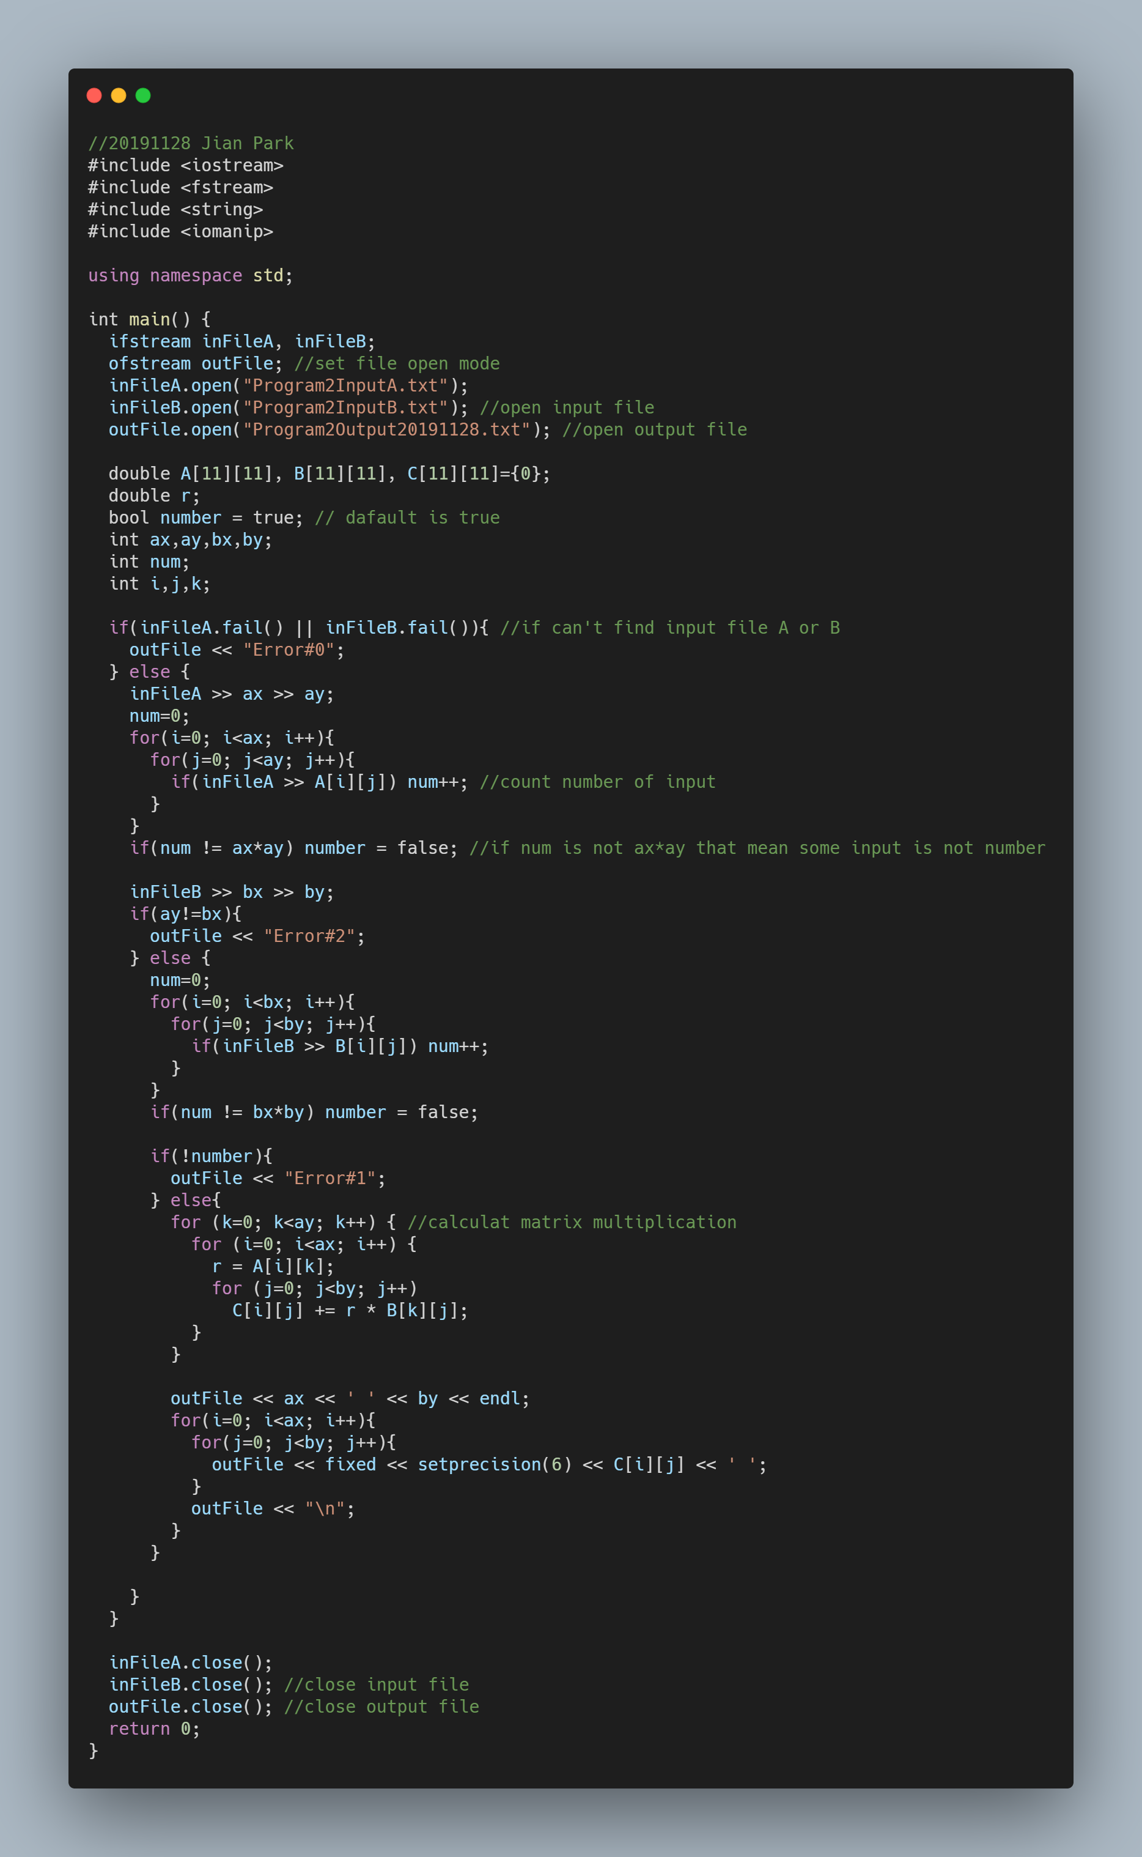

Matrix multiplication is multiplication is put sum of A[i][k] * B[k][j] in C[i][j] when k is 0 to ay (==by).

‘inFileA.fail()’ or ‘inFileB.fail()’ is true, it’s means can’t find input file. (Error#0)

‘num’ is count number of input. Each file must input x*y times. So if num is different ax*ay (or bx*by when input file B), they contains anything else than numbers. (Error#1)

When ay is different bx, AB is not defined for the matrices A and B. (Error#2)