Program1

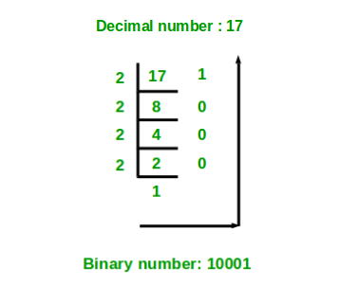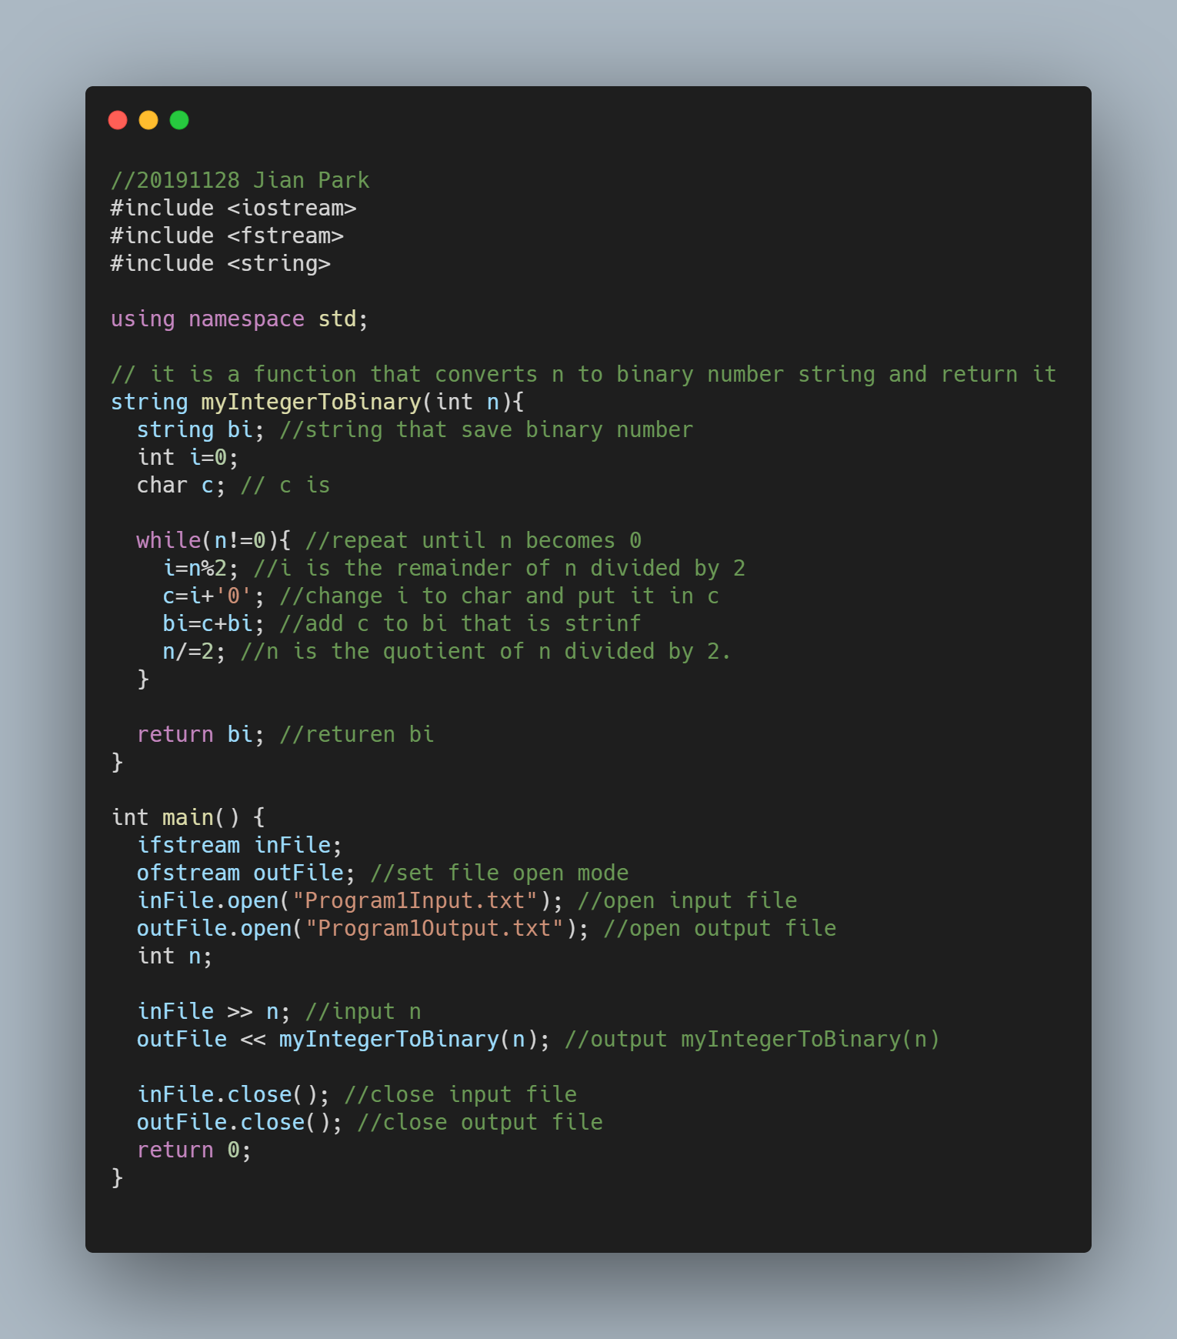

The binary number of n is the reverse of the remainder of n divided by 2

So input n and until n become zero, n divided by 2.

To reverse of the remainder, bi = c + bi, not bi = bi + c

Program2

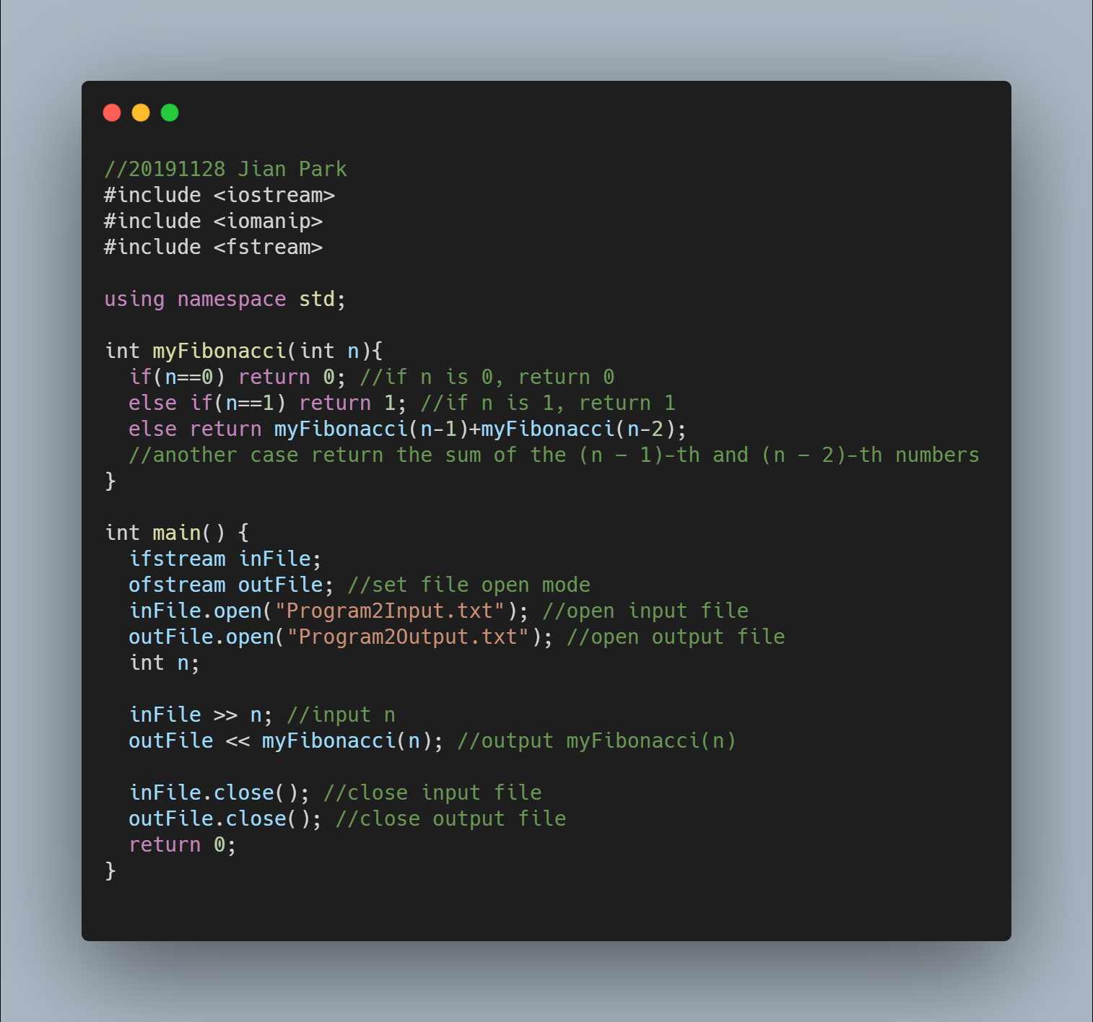

Fibonacci sequence are 0 and 1. The n-th number of the Fibonacci sequence for n ≥ 2 is then defined as the sum of the (n − 1)-th and (n − 2)-th numbers.

So if n is 0, return 0 and if n is 1, return 1. Another case return the sum of the (n − 1)-th and (n − 2)-th numbers that is myFibonacci(n-1)+ myFibonacci(n-2)