**Лабораторное занятие № 18.**

**Тема: разработка проекта “ Snake”**

**Цель: разработать проект “ Snake”**

Ход работы:

1.Создание поля.

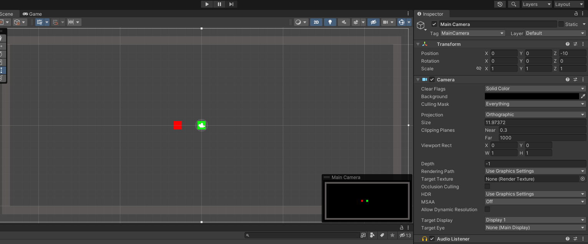

**Рис.18.1** – Поле.

2. Создание игрока (Snake)

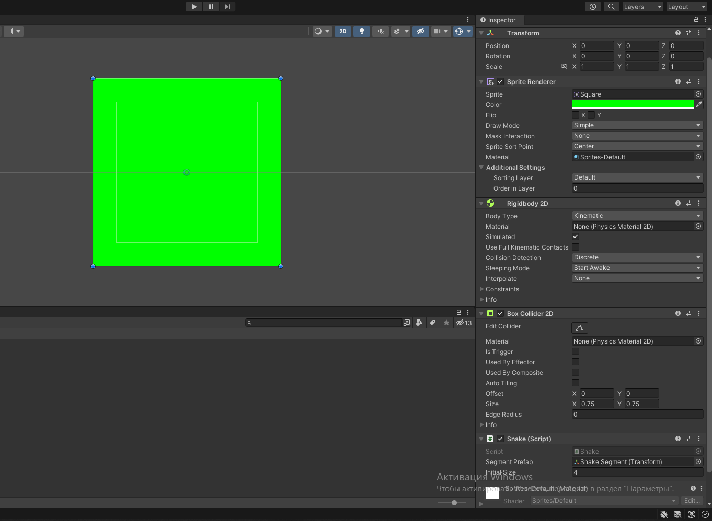

**Рис.18.2** – Inspector Snake.

3. Создание объекта (Food)

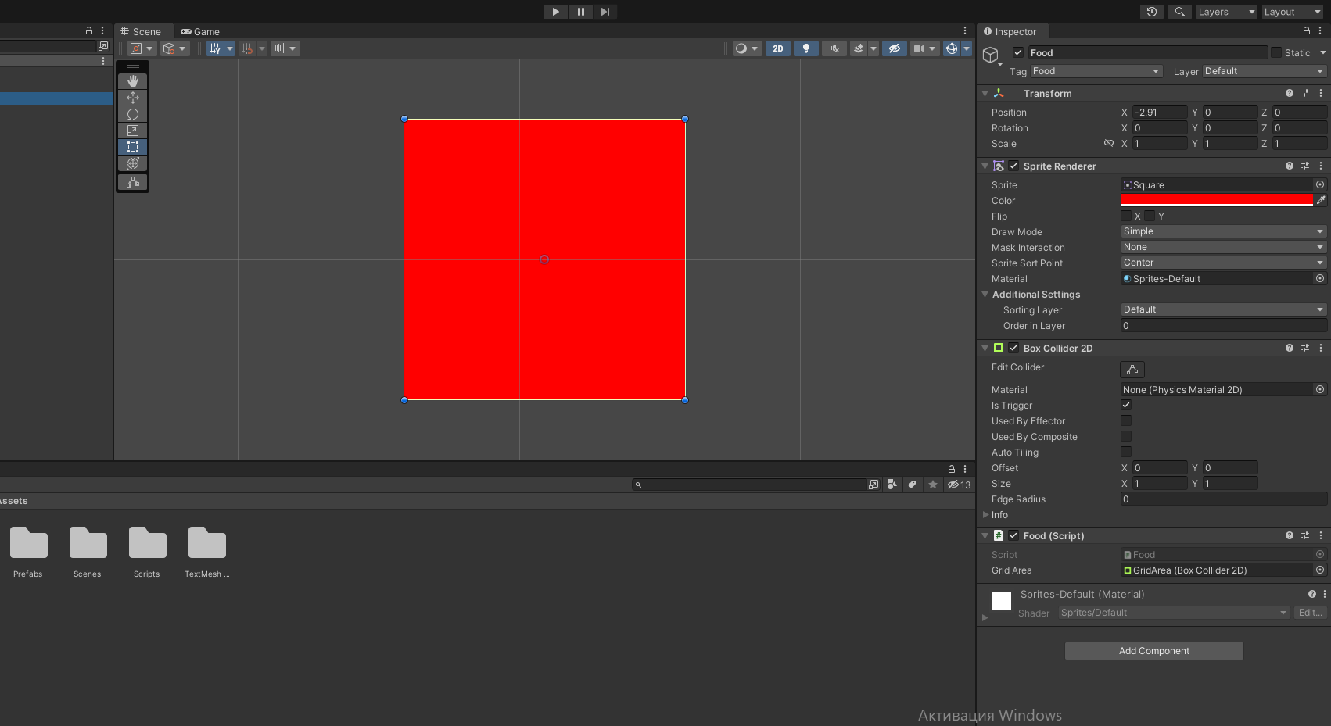

Рис.18.3 – Inspector Food

4.Итог работы.

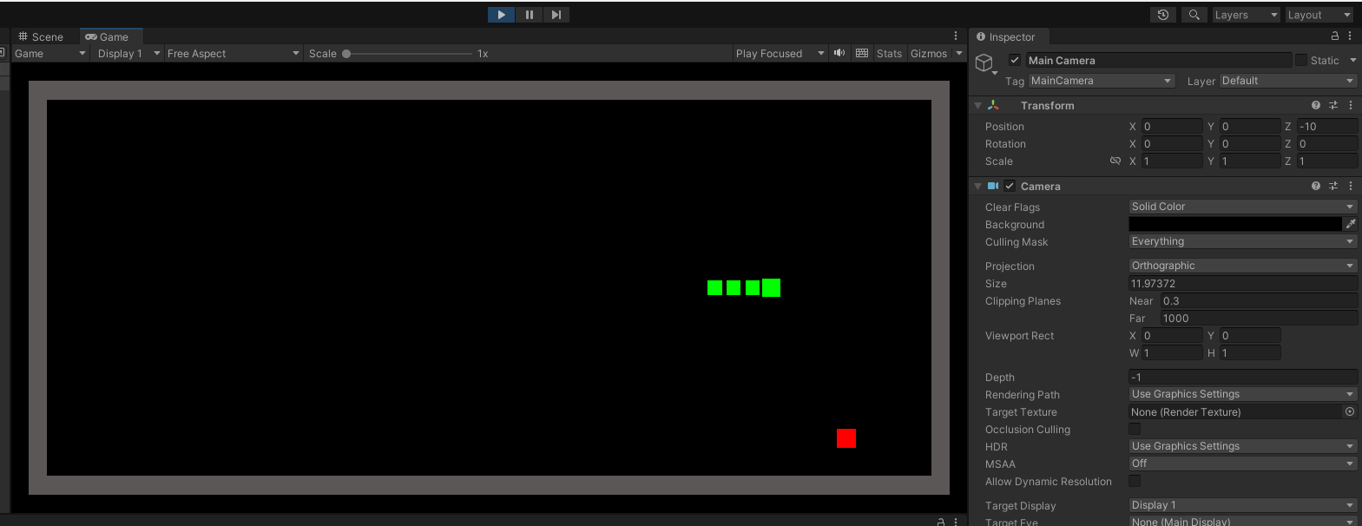

Рис.18.4 – Итог работы.

5.Создание скриптов.

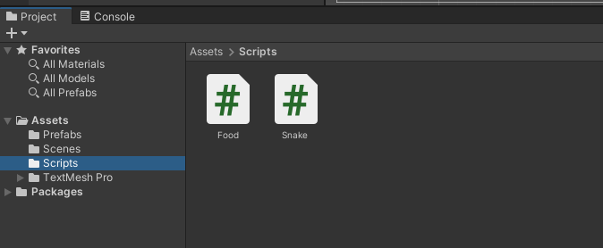

Рис.18.5 – Скрипты.

Скрипты:

**Food**

using UnityEngine

public class Food : MonoBehaviour

{

public BoxCollider2D gridArea;

private void Start()

{

RandomizePosition();

}

private void RandomizePosition()

{

Bounds bounds = this.gridArea.bounds;

float x = Random.Range(bounds.min.x, bounds.max.x);

float y = Random.Range(bounds.min.y, bounds.max.y);

this.transform.position = new Vector3(Mathf.Round(x), Mathf.Round(y), 0.0f);

}

private void OnTriggerEnter2D(Collider2D other)

{

if (other.tag == "Player")

{

RandomizePosition();

}

}

}

**Snake**

using System.Collections;

using System.Collections.Generic;

using UnityEngine;

public class Snake : MonoBehaviour

{

private Vector2 _direction = Vector2.right;

private List<Transform> _segments = new List<Transform>();

public Transform segmentPrefab;

public int initialSize = 4;

private void Start()

{

ResetState();

}

private void Update()

{

if (Input.GetKeyDown(KeyCode.W))

{

_direction = Vector2.up;

}

else if (Input.GetKeyDown(KeyCode.S))

{

_direction = Vector2.down;

}

else if (Input.GetKeyDown(KeyCode.A))

{

_direction = Vector2.left;

}

else if (Input.GetKeyDown(KeyCode.D))

{

_direction = Vector2.right;

}

}

private void FixedUpdate()

{

for (int i = _segments.Count - 1; i > 0; i--)

{

_segments[i].position = _segments[i - 1].position;

}

this.transform.position = new Vector3(

Mathf.Round(this.transform.position.x) + _direction.x,

Mathf.Round(this.transform.position.y) + _direction.y,

0.0f);

}

private void Grow()

{

Transform segment = Instantiate(this.segmentPrefab);

segment.position = _segments[_segments.Count - 1].position;

_segments.Add(segment);

}

private void ResetState()

{

for (int i = 1; i < _segments.Count; i++)

{

Destroy(_segments[i].gameObject);

}

_segments.Clear();

_segments.Add(this.transform);

for (int i = 1; i < this.initialSize; i++)

{

_segments.Add(Instantiate(this.segmentPrefab));

}

this.transform.position = Vector3.zero;

}

private void OnTriggerEnter2D(Collider2D other)

{

if (other.tag == "Food")

{

Grow();

}

else if (other.tag == "Obstacle")

{

ResetState();

}

}

}