**Лабораторное занятие № 23.**

**Тема: разработка игры “ hophophop”**

**Цель: разработать игру “ hophophop”**

Ход работы:

1.Перекидываю ресурсы.

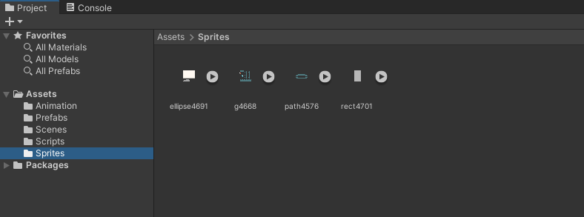

**Рис. 23.1** – Папка Sprites

2.Создание игрока (Player).

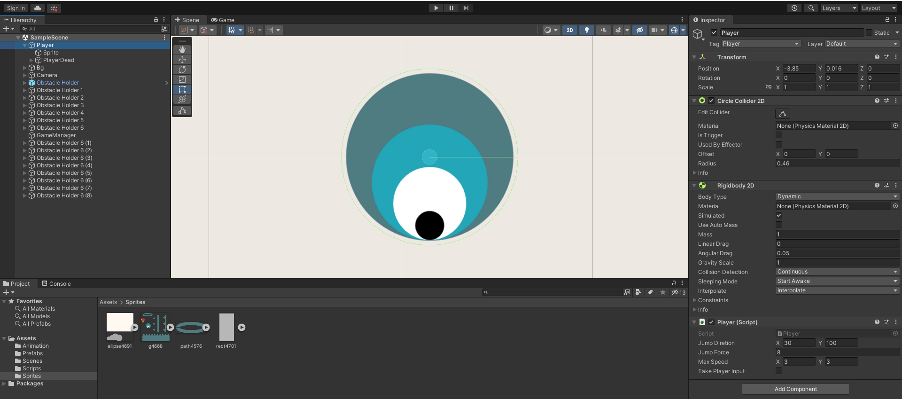

**Рис. 23.2** – Player.

3.Создание игрового поля.

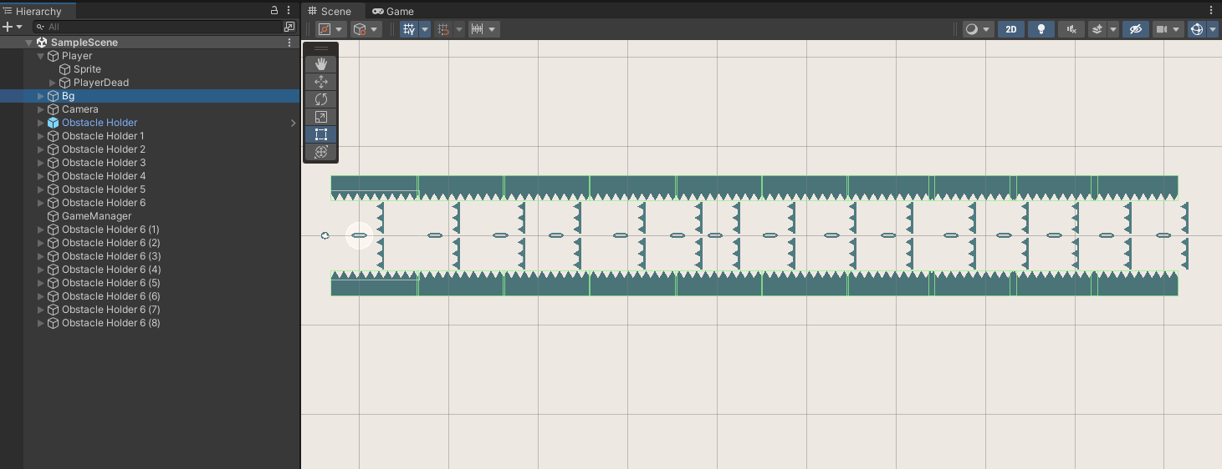

**Рис. 23.3** – игровое поле.

4.Создаю анимацию после смерти игрока.

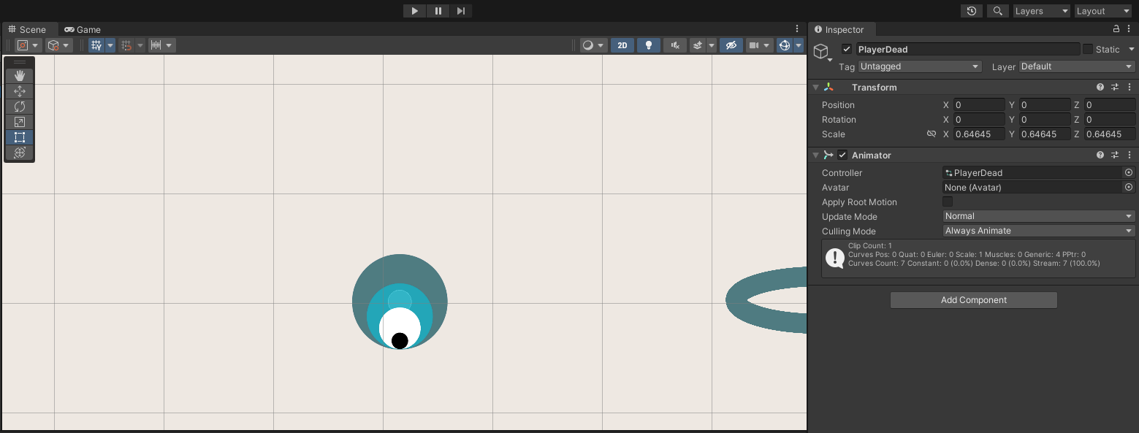

**Рис. 23.4** – анимация после смерти игрока.

**5**.Создание фона.

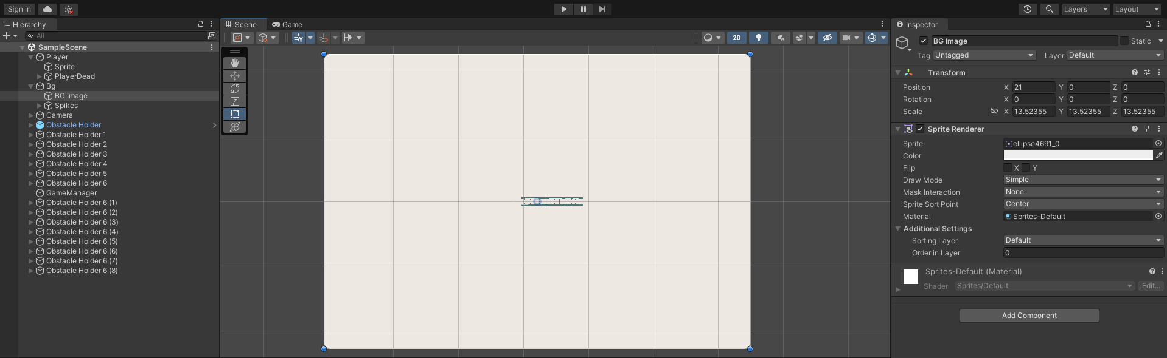

**Рис. 23.5** – Создание фона.

6.Создание Скриптов.

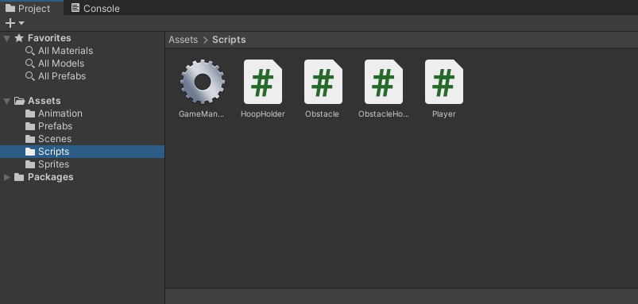

**Рис. 23.6** – Scripts.

**Скрипты**:

**GameManager**.cs

using UnityEngine.SceneManagement;

using UnityEngine;

public class GameManager : MonoBehaviour

{

// Start is called before the first frame update

void Start()

{

}

public void RestartScene()

{

SceneManager.LoadScene(SceneManager.GetActiveScene().buildIndex);

}

}

HoopHolder.cs

using System.Collections;

using System.Collections.Generic;

using UnityEngine;

public class HoopHolder : MonoBehaviour

{

public Transform obstacle;

bool obstacleCompleted;

// Start is called before the first frame update

void Start()

{

}

public void OnCollisionEnter2D(Collision2D collision)

{

if (collision.collider.tag == "Player")

{

FindObjectOfType<Player>().takePlayerInput = true;

}

}

public void OnTriggerEnter2D(Collider2D collision)

{

if (obstacleCompleted) return;

if (collision.tag == "Player")

{

FindObjectOfType<Player>().takePlayerInput = false;

obstacle.GetComponent<Obstacle>().RemoveObstacle();

DestroyGameObject();

}

}

public void DestroyGameObject()

{

GetComponentInParent<ObstacleHolder>().PlayDeadAnimation();

Destroy(gameObject);

}

}

Obstacle.cs

using System.Collections;

using System.Collections.Generic;

using UnityEngine;

public class Obstacle : MonoBehaviour

{

void Start()

{

}

public void OnCollisionEnter2D(Collision2D collision)

{

if (collision.collider.tag == "Player")

{

}

}

public void RemoveObstacle()

{

Destroy(gameObject);

}

}

ObstacleHolder.cs

using System.Collections;

using System.Collections.Generic;

using UnityEngine;

public class ObstacleHolder : MonoBehaviour

{

Animator animator;

// Start is called before the first frame update

void Start()

{

animator = GetComponent<Animator>();

}

// Update is called once per frame

public void PlayDeadAnimation()

{

animator.SetTrigger("Destroy");

Destroy(gameObject, 2f);

}

}

Player.cs

using System.Collections;

using System.Collections.Generic;

using UnityEngine;

public class Player : MonoBehaviour

{

public Vector2 jumpDiretion;

public int jumpForce;

Rigidbody2D rgbd;

Vector2 currentSpeed;

public Vector2 maxSpeed;

public bool takePlayerInput;

Animator animator;

GameManager gameManager;

// Start is called before the first frame update

void Start()

{

rgbd = GetComponent<Rigidbody2D>();

rgbd.gravityScale = 0;

animator = GetComponent<Animator>();

gameManager = FindObjectOfType<GameManager>();

}

// Update is called once per frame

void Update()

{ if (takePlayerInput) return;

if (Input.GetMouseButtonDown(0))

{

if (rgbd.gravityScale != 1) { rgbd.gravityScale = 1; }

rgbd.AddForce(jumpDiretion * jumpForce * Time.deltaTime);

ControlSpeed();

}

void ControlSpeed()

{

currentSpeed = rgbd.velocity;

if (currentSpeed.x != maxSpeed.x) { currentSpeed.x = maxSpeed.x; }

if (currentSpeed.y != maxSpeed.y) { currentSpeed.y = maxSpeed.y; }

rgbd.velocity = currentSpeed;

}

}

public void PlayerDead()

{

Invoke("RestartScene", 1);

animator.SetTrigger("Dead");

}

public void RestartScene()

{

gameManager.RestartScene();

}

}