**Лабораторное занятие № 24.**

**Тема: Разработка игры “ Circle”**

**Цель: Разработать игру “ Circle”**

Ход работы:

1.Перекидываю ресурсы (Sprites)

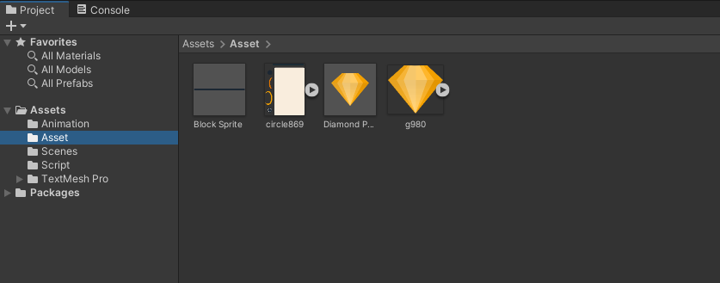

**Рис. 24.1** – Папка Sprites

**2**.Создание игрока (Player)

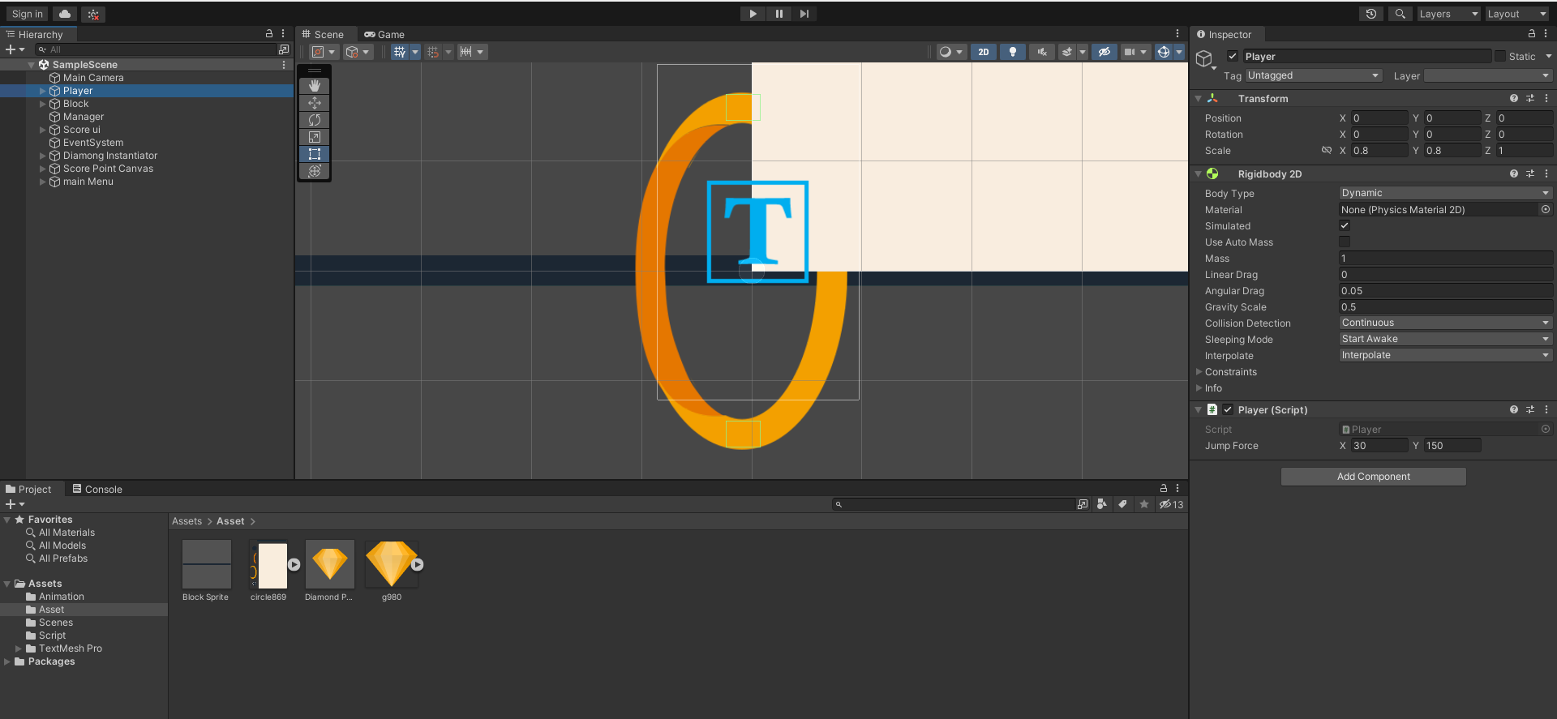

**Рис. 24.2** – Player.

**3**.Создание фона.

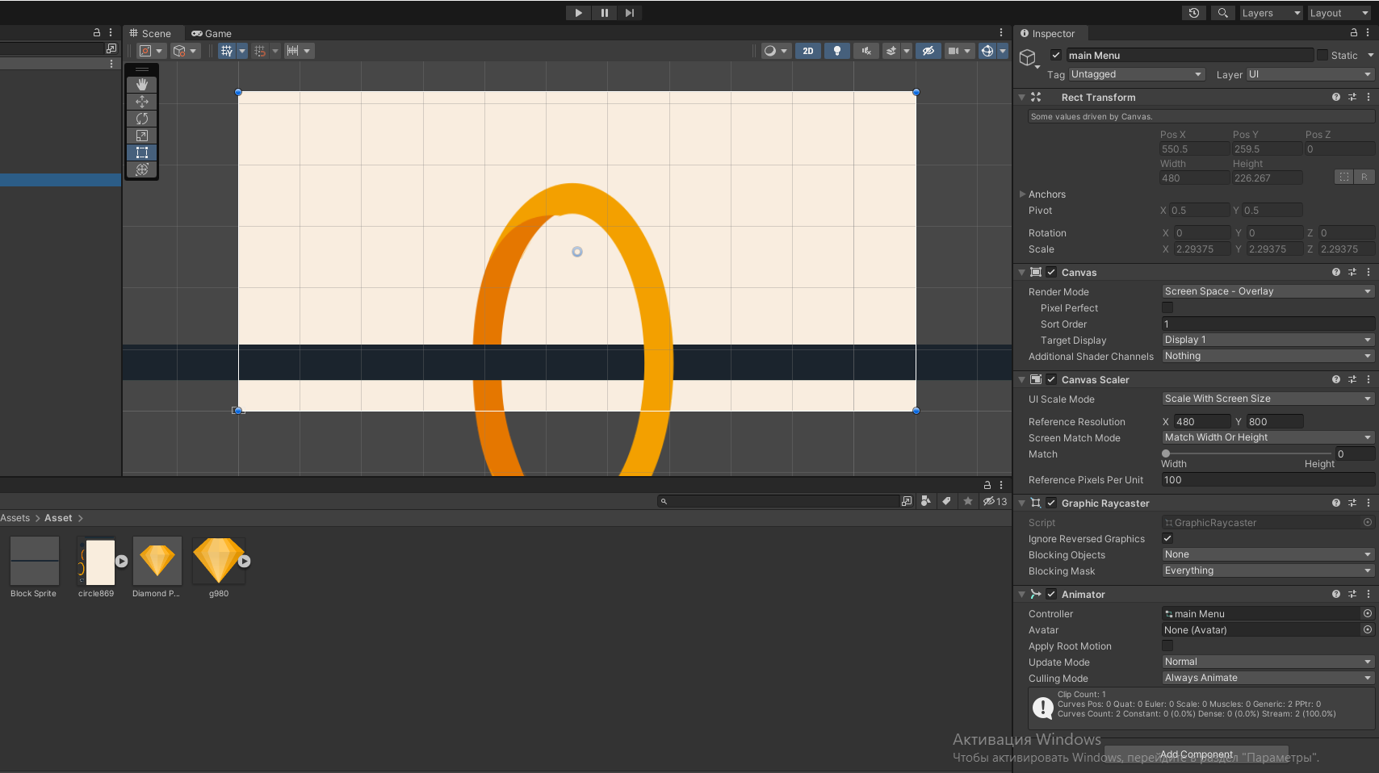

**Рис. 24.3** – Создание фона.

**4**.Dead Collider.

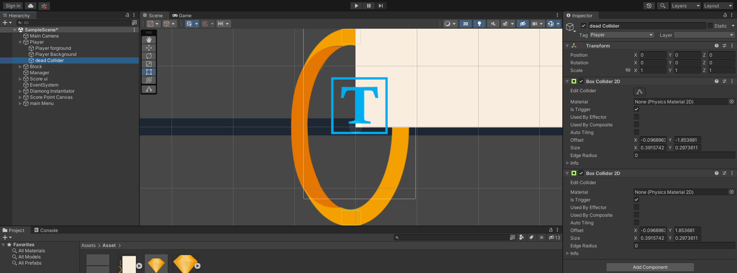

**Рис. 24.4** – Dead Collider.

5.Создаю препятствие.

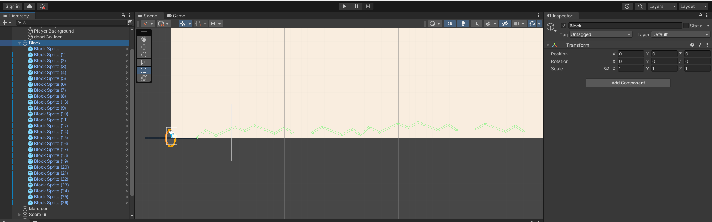

**Рис. 24.5** – Block.

6.Создаю счёт (ScoreText и DiamondText).

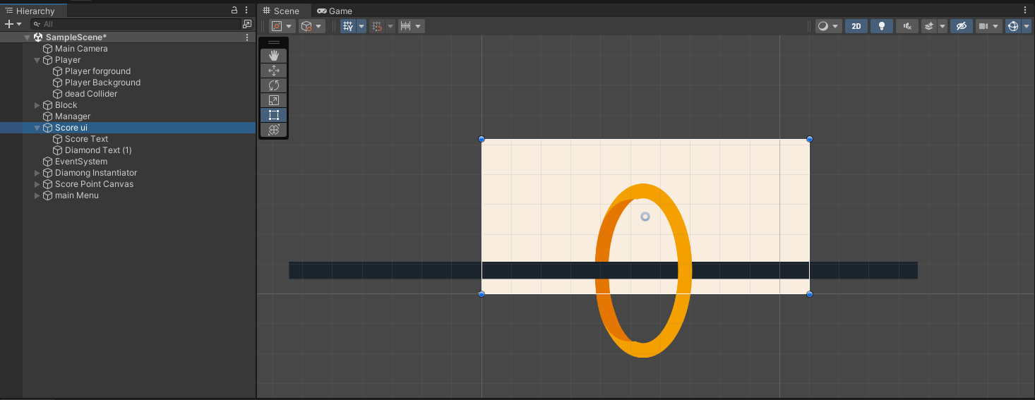

**Рис. 24.6** – ScoreText и DiamondText.

7.Inspector ScoreUI.

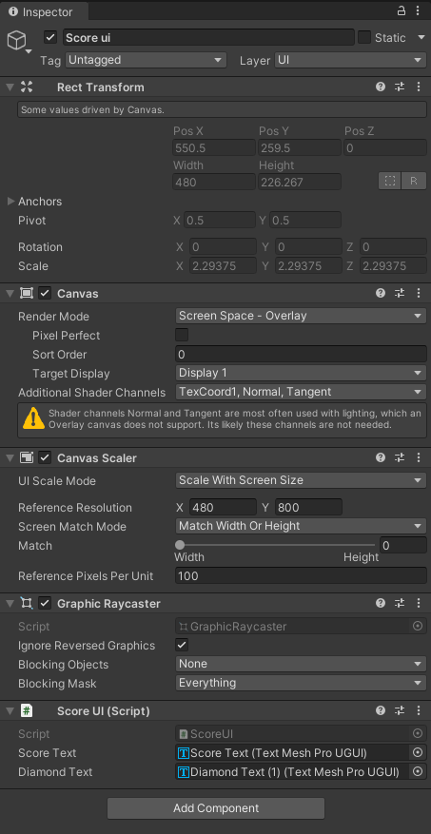

**Рис. 24.7** – Inspector ScoreUI.

8.Создание Скриптов.

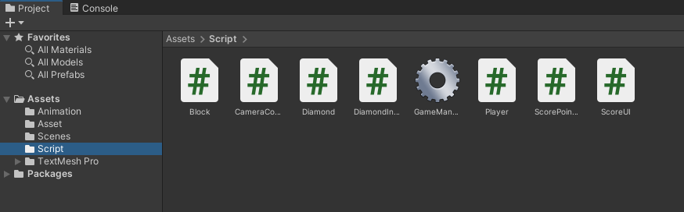

**Рис. 24.8** – Scripts.

**Скрипты:**

**Block.cs**

using System.Collections;

using System.Collections.Generic;

using UnityEngine;

public class Block : MonoBehaviour

{

// Start is called before the first frame update

void Start()

{

}

// Update is called once per frame

void Update()

{

}

public void OnTriggerEnter2D(Collider2D collision)

{

if(collision.tag == "Player")

{

Debug.Log("hit by player");

FindObjectOfType<GameManager>().gameOver = true;

}

}

}

**CameraController.cs**

using System.Collections;

using System.Collections.Generic;

using UnityEngine;

public class CameraController : MonoBehaviour

{

public Transform playerTransform;

// Start is called before the first frame update

void Start()

{

}

// Update is called once per frame

void Update()

{

transform.position = new Vector3(playerTransform.position.x, transform.position.y, -10);

}

}

**Diamond.cs**

using System.Collections;

using System.Collections.Generic;

using UnityEngine;

public class Diamond : MonoBehaviour

{

// Start is called before the first frame update

void Start()

{

}

// Update is called once per frame

void Update()

{

}

public void OnTriggerEnter2D(Collider2D collision)

{

if(collision.tag== "Player")

{

//add points

FindObjectOfType<ScoreUI>().IncrementDiamond(1);

FindObjectOfType<ScorePointCanvas>().DiamondHit(collision.transform.position);

Destroy(gameObject);

}

}

}

**DiamondInstantiator.cs**

using System.Collections;

using System.Collections.Generic;

using UnityEngine;

public class DiamondInstantiator : MonoBehaviour

{

Transform[] childTransform;

public GameObject DiamondPrefab;

// Start is called before the first frame update

void Awake()

{

childTransform = new Transform[transform.childCount];

for (int i = 0; i < childTransform.Length; i++)

{

childTransform[i] = transform.GetChild(i);

}

InstantiateDiamond();

}

// Update is called once per frame

void Update()

{

}

void InstantiateDiamond()

{

for (int i = 0; i < childTransform.Length; i++)

{

if(Random.value > 0.4f)

{

Instantiate(DiamondPrefab, childTransform[i].position, Quaternion.identity);

}

}

}

}

**GameManager.cs**

using System.Collections;

using System.Collections.Generic;

using UnityEngine;

public class GameManager : MonoBehaviour

{

public bool gameOver;

// Start is called before the first frame update

void Start()

{

}

// Update is called once per frame

void Update()

{

}

}

**Player.cs**

using UnityEngine;

public class Player : MonoBehaviour

{

public Vector2 jumpForce;

Vector2 currentVelocity;

Rigidbody2D rgbd;

GameManager gameManager;

ScoreUI scoreUi;

// Start is called before the first frame update

void Start()

{

rgbd = GetComponent<Rigidbody2D>();

rgbd.gravityScale = 0;

gameManager = FindObjectOfType<GameManager>();

scoreUi = FindObjectOfType<ScoreUI>();

}

// Update is called once per frame

void Update()

{

if (gameManager.gameOver) { rgbd.bodyType = RigidbodyType2D.Static;return; }

if (Input.GetMouseButtonDown(0))

{

if (rgbd.gravityScale != 0.5f) { rgbd.gravityScale = 0.5f; }

rgbd.AddForce(jumpForce);

SpeedController();

scoreUi.IncrementScore(1);

}

}

void SpeedController()

{

currentVelocity = rgbd.velocity;

currentVelocity.x = Mathf.Clamp(currentVelocity.x, 2, 2);

currentVelocity.y = Mathf.Clamp(currentVelocity.y, 0, 2);

rgbd.velocity = currentVelocity;

}

}

**ScorePointCanvas.cs**

using UnityEngine;

public class ScorePointCanvas : MonoBehaviour

{

Animator animator;

// Start is called before the first frame update

void Start()

{

animator = GetComponent<Animator>();

}

public void DiamondHit(Vector2 position)

{

transform.position = position;

animator.SetTrigger("Play");

}

}

**ScoreUI.cs**

using UnityEngine;

public class ScoreUI : MonoBehaviour

{

int Score,Diamond;

public TMPro.TextMeshProUGUI ScoreText;

public TMPro.TextMeshProUGUI DiamondText;

// Start is called before the first frame update

public void IncrementScore(int value)

{

Score += value;

UpdateDisplay();

}

public void IncrementDiamond(int value)

{

Diamond += value;

UpdateDisplay();

}

void UpdateDisplay()

{

ScoreText.text = Score.ToString();

DiamondText.text = Diamond.ToString();

}

}