**SWE 455: Software Maintenance and Evolution**

**Slicing Sheet**

**2nd trimester 22-23**

**Exercise 1:**

Calculate static slice of a given program using **StaticSlicer.**

|  |  |  |
| --- | --- | --- |
| 1. begin 2. x=(z+y); 3. z=3; 4. y=(y+x); 5. x=(a-b); 6. b=(z+a); 7. z=y; 8. end; | **Write Answers;** | **Screenshots:** |
| (7,{z})= [2 , 4 , 7] |  |
| (7,{x})= [5] |  |
| (7,{y})= [2 , 4] |  |
| (7,{b})= [3 , 6] |  |
| (7,{a})= [] |  |

**Exercise 2:**

Calculate the static slice for the given program, using the following slicing criterion:

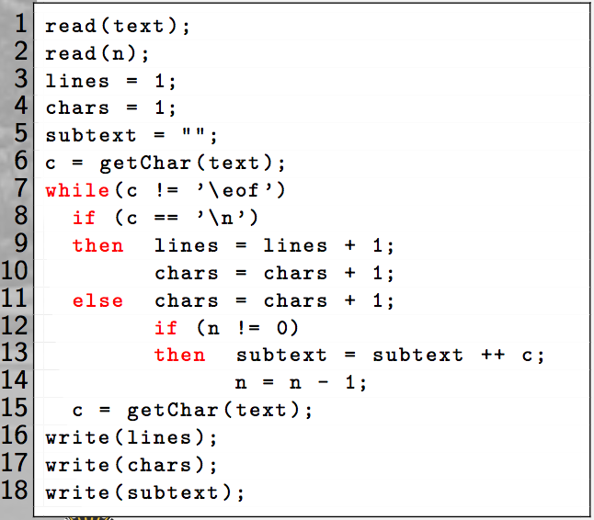

|  |  |
| --- | --- |
| **Slice criterion** | **Slice** |
| **<16, lines>** | [ 1,3,6,7,8,9,15,16] |
| **<17, chars>** | [1,4,6,7,8,9,10,11,15,17] |
| **<3, lines>** | [3,9,16] |

Sales kit