**Render : https://mvc-recipesapp.onrender.com**

**Create Recipe**

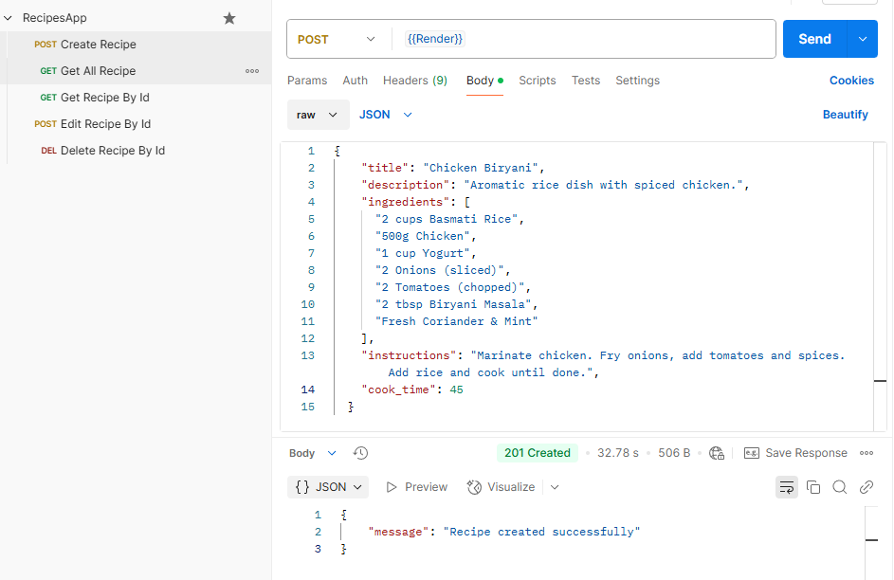

**Get All Recipes**

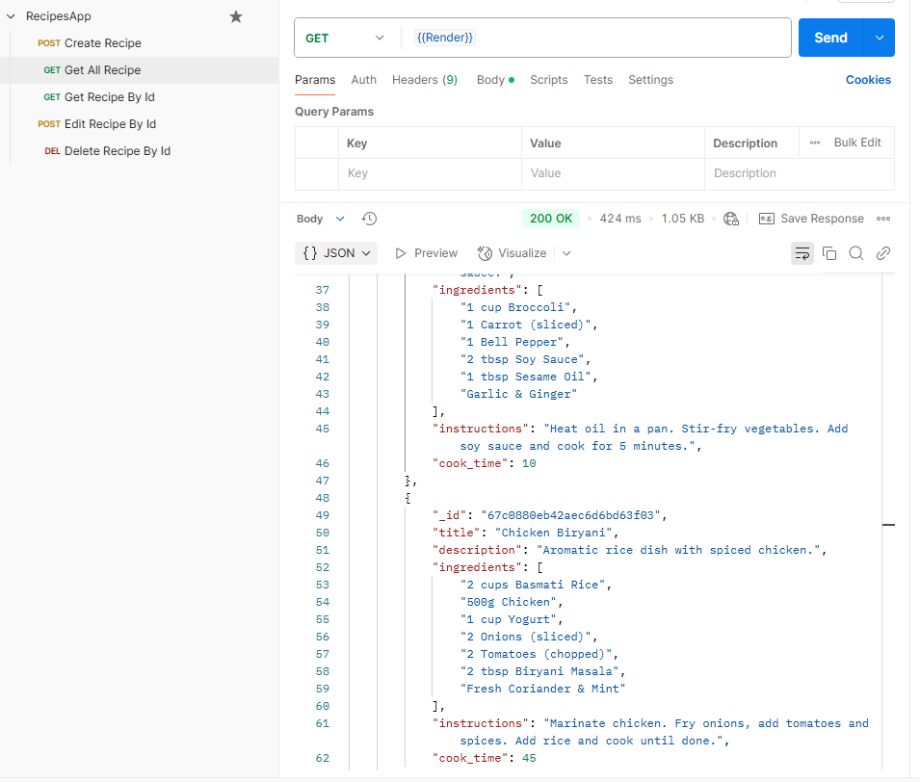

**Get Recipe By Id**

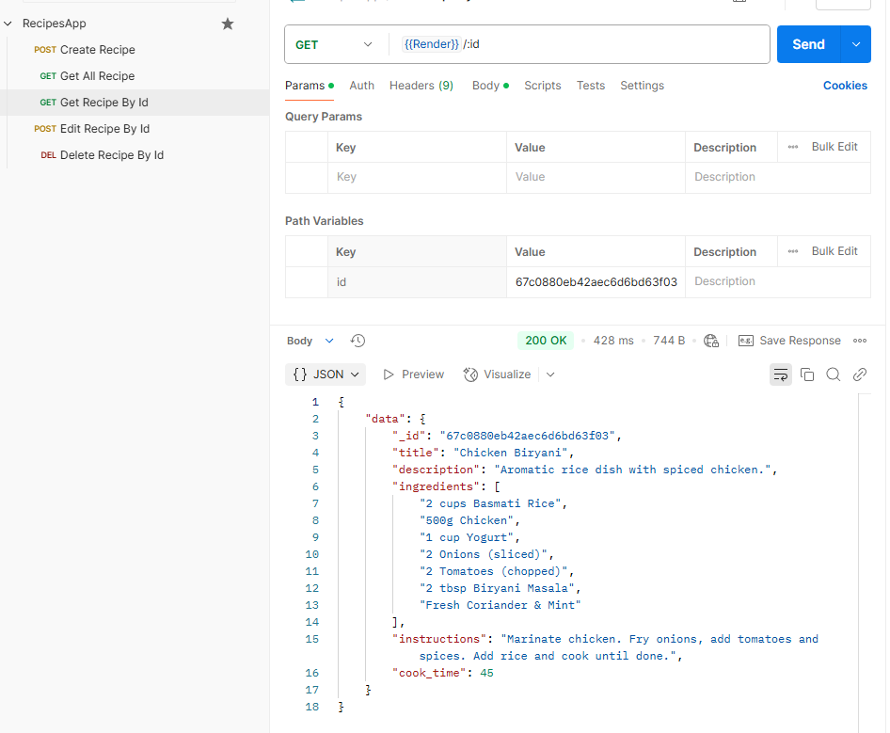

**Edit Recipe By Id**

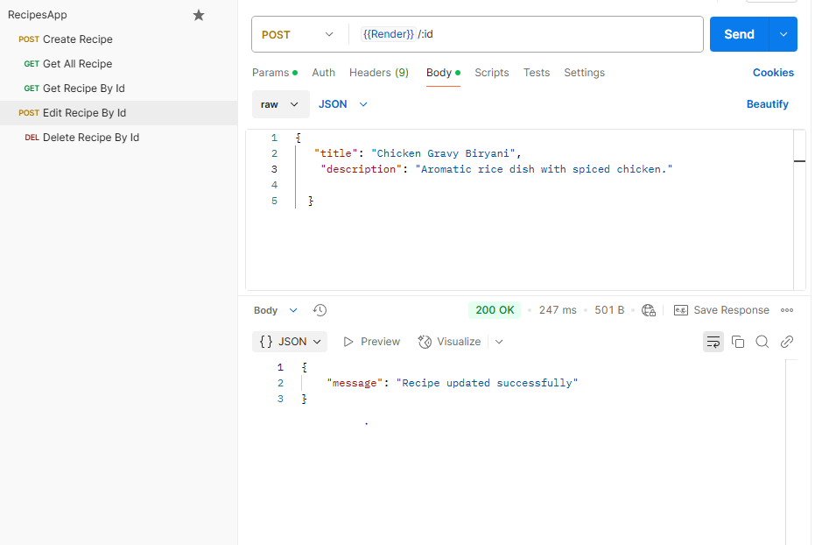

**Delete Recipe By Id**

