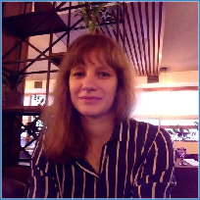**Anna Romanovska**

Rivne, Rivnenska obl. | +380995262620 | [sup2a1nn@gmail.com](mailto:sup2a1nn@gmail.com)

# Work experience

## Accountant

ТОВ "Ріва-Трейд"

## Сashier

"Фоззі"

# Education

National University of Water and Environmental Engineering Master Degree in Economy

## IT Step Computer Academy

“Development of web projects in Python”

# Skills

Programming Languages/ Technologies

* HTML/CSS/SCSS
* Python

RDBMS

* PostgreSQL
* SQLite

May 2017 - Today

April 2014 - October 2016

September 2010 - June 2013

September 2019 - September 2020

Frameworks

* Bootstrap
* Django

Operating Systems

* Microsoft Windows 7/8/10

**Professional Summary**

Knowledge of HTML, CSS, Bootstrap, Java Script. Also: Python, Django framework, React JS. My main advantage is the desire for new knowledge, new experience. Focused on creating clean, robust code.

Very responsible, so I will follow the deadlines.

Quick learner, who constantly learning something new.