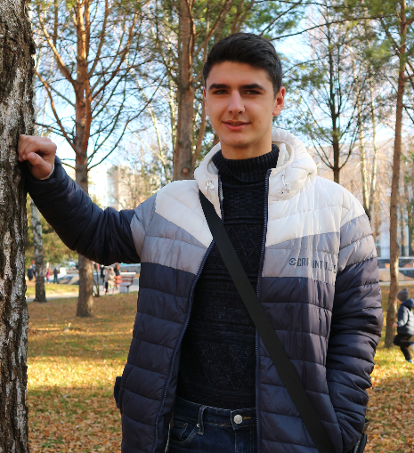 **Personal information**

*name - Fugel Vladislav*

*Valentinovich*

*contacts:*

* phone: +380970472569 / +380731554944
* email: [fuhel_ak21@nuwm.edu.ua](mailto:fuhel_ak21@nuwm.edu.ua)

(personal) - [vladfyhel@gmail.com](mailto:vladfyhel@gmail.com)

*address: Pavlyuchenko 5/1, Rivne, Ukraine.*

***skills:***

1. *Average knowledge of languages:*
   * *C++*
   * *C#*
   * *java*
2. *I have little experience in C#(ASP.NET.CORE)*

***languages:***

Ukrainian *–* native language.

English *–* Upper intermediate (B2)

***education:***

*I study at the National University of Water Management and Environmental Sciences in the specialty (121) Software Engineering (Internet of Things) for a bachelor's degree.*

*Date of entry – 01.09.2021*

***personal qualities:***

*I am eager to seek and learn new knowledge and skills.*

*ready to help anyone on the team to achieve the goal.*

*I pay attention to details when performing the task.*

*friendly, purposeful and ready to cooperate.*