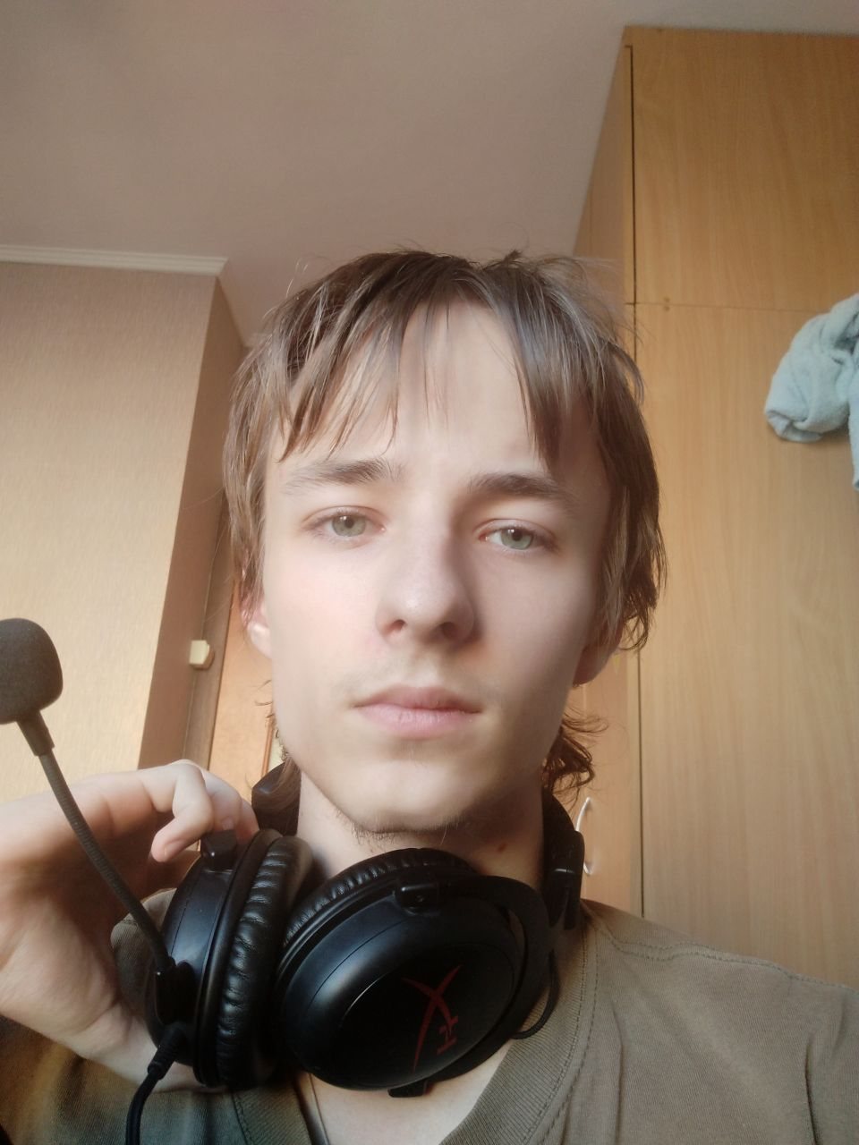**Melnychuk Oleksandr**

**Student**

|  |  |
| --- | --- |
| **Contact Information** | [melnychuk.o.s_ak21@nuwm.edu.ua](mailto:melnychuk.o.s_ak21@nuwm.edu.ua)  [melnychuk.sashok@gmail.com](mailto:melnychuk.sashok@gmail.com)  +380982009685 |
| **Job experience** | I don’t have any job experience and programing in group but ready to cooperate and learn new knowledges together. |
| **Skills** | Programming languages/technologies   * Basics of C++/C#/Java * Working with 2D in Unity   Operating Systems   * Windows XP/7/8/10 * Ubuntu |
| **Education** | Studying in NUWM in the first year.  Faculty: Software Engineering |