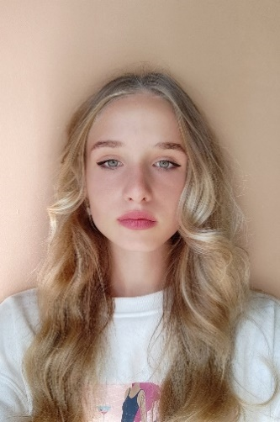**Stetsyuk Sofiya**

**Contact:**

Address: Rivne region, the village of Kolodenka, Rivnenska Street, 40. 35306

Phone: +380975435528

E-mail: sofiaso.sofiasoo@gmail.com

|  |  |
| --- | --- |
| **Sth about me** | Hi! My name if Sofiya and I from Ukraine! And I’m proud to be Ukrainian. In short I finish at the school this year, so I am 17.  I have always been excited with math and other exact sciences. I have started my learning of programing in 8 class, that was Pascal, then Python. Now, I am studying in IT Step and know 4 languages: Python, C++ and basic level Java w C# (the last one I am learning in IT-step school now).  As for me, programing is sth which can fascinate me, gives rest to my mind and allows to be “disconnected from the world”. |
| **Skills** | **Languages:**  -Ukrainian – native language  -Russian – free speaker (but I can’t use it anymore due to my political views)  -English B2  **Programing languages:**  -C++  -Python  -C# (in progress)  -basic level Java  **Programing environments:**  -Visual Studio  -Visual Studio Code  -PyCharm  **Operating Systems**   * Windows 7/10 * Linux   **Other skills:**  - OOP Design Using UML  - Paterns using C++  -Microsoft Office Word/ Microsoft PowerPoint/ Microsoft Excel  - Basic Sony Vegas Pro/Adobe Premier Pro |
| **Education** | -Regional Scientific Lyceum in Rivne city  -Computer Academy "ITSTEP", Rivne, 2021 – present |
| **Hobbies** | -Programing  -Self-improvement  -Reading  -Psychology  -Sport |