|  |  |  |
| --- | --- | --- |
| Summary | Incorrect marge of footer |  |
| Project | vodiy.ua |  |
| Component | layout of site |  |
|  |  |  |
| Bug ID | ID number | 1 |
|  | Submit Date | 06.04.2022 |
|  | Name | Timer at the bottom of page cover a part of footer |
|  | Reporter | ***Fyhel Vladyslav*** |
|  |  |  |
| Bug overview | URL | <https://vodiy.ua/pdr/test/?complect=6&bilet=-1> |
|  | Summary | If there is a timer on page, it cover a botom half of footer with name of site and picture. |
| Environment | OS | Windows 10 x64 |
|  | Browser | Chrome Version 87.0.4280.141 |
|  |  |  |
| Bug details | Steps to reproduce | Open [https://vodiy.ua/](https://vodiy.ua/%20) , than click "Тести ПДР Онлайн" and scroll down to the footer. |
|  |  |  |
|  | Expected result | After scroling down on this page we must see full name of site and picture. |
|  | Actual result | Picture and name of site are covered |
|  |  |  |
| Bug tracking | Severity | **Simple** |
|  | Priority | **Low** |
|  | Assigned to |  |

**EXAMPLE:** That is how a bug looks like.

(it is the bottom of page)

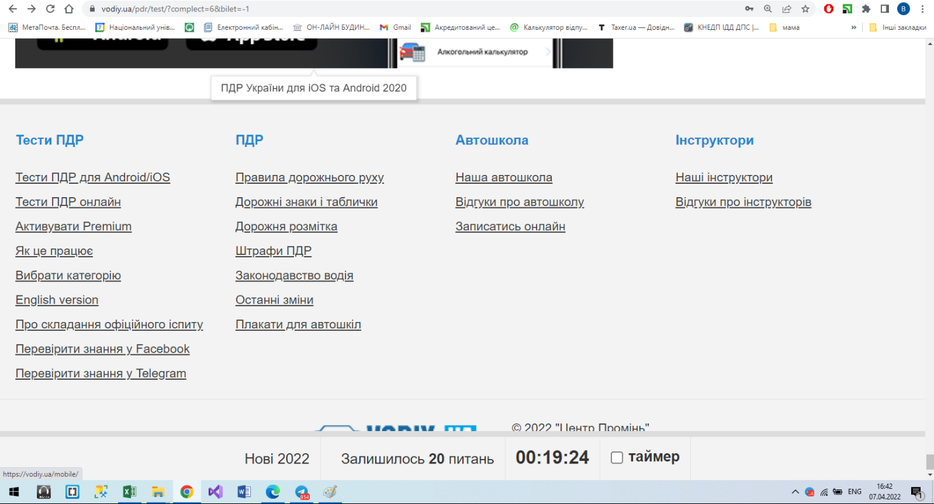

**Offer:** That is how the page should looks like.

