|  |  |
| --- | --- |
| **ID number** | 1 |
| **Summary** | The “Рекомендуємо” link is displayed over the options of the dropdown list after opening the dropdown list |
| **Descriprion** | The “Рекомендуємо” link is displayed over the options of the dropdown list after opening it  Actual result: The “Рекомендуємо” link is displayed over the options of the dropdown list after opening it  Expected result: The “Рекомендуємо” link isn’t shown over the dropdown list after opening it Requirement ID: - Reproduced on: Opera 85.0.4341.47 OS: Windows 10  Reproducibility: always Workaround:- |
| **Steps to reproduce** | 1. Open URL: <https://bukva.ua/> 2. Choose “ Книги” option 3. Pay attention to the “Рекомендуємо” link |
| **Severity** | Minor |
| **Priority** | Normal |

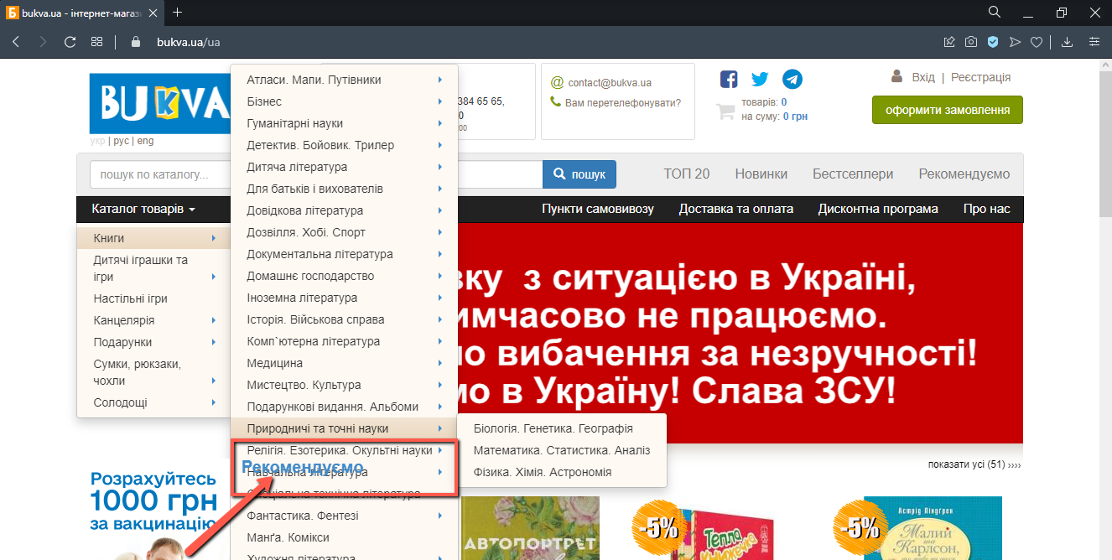

|  |  |  |  |
| --- | --- | --- | --- |
| **TestSuite** | Smoke |  |  |
| **TestCase Name** | New user registration positive test |  |  |
| **TestCase ID** | #00001 |  |  |
|  |  |  |  |
| **Author** | Anna Romanovska |  |  |
| **Date** | 04/06/2022 |  |  |
| **Environment** | Google Chrome 99.0.4844.82 |  |  |
| **Purpose** | check the possibility to register a new user |  |  |
|  |  |  |  |
| **Precondition** | Open page<http://127.0.0.1/>primewire.mx/home | | |
| **#** | **Steps** | **Expected results** | **IsPassed** |
| 1 | Press the “Login/Register” link | The modal window “Create an Account” is opened |  |
| 2 | Fill in your name | Name is filled in | TRUE |
| 3 | Fill in email address | Email address is filled in | TRUE |
| 4 | Fill in password | Password is filled in | TRUE |
| 5 | Fill in password confirmation | Password confirmation is filled in | TRUE |
| 6 | Press "Register" button | We are redirected to home page | TRUE |
| 7 | Login to the site with new credentials using the “Login/Register” link | Login is successful. | TRUE |
| **PostCondition** | clear test data | | |
|  |  |  |  |
| **The last test execution** | 04/06/2022 |  |  |