| **Name** | Yushchuk Oleh |
| --- | --- |

| **ID number** | 1 |
| --- | --- |
| **Summary** | When the site is in German, in the "Angebot" tab at the very bottom there is a field for a photo with dimensions, but there is no photo, as is the description |
| **Description** | Actual result: When the site is in German, in the "Angebot" tab at the very bottom there is a field for a photo with dimensions, but there is no photo, as is the description.  Expected result: The photo is shown and there is a description in German and Polish  Requirement ID: -  Browser: Google Chrome 99.0.4844.84  OS Windows: 7 x64 professional  Reproducibility: always  Workaround:- |
| **Steps to reproduce** | 1. Open URL: <http://loft-concept.pl/> 2. Choose German language 3. Choose “Angebot” tab  4. Scroll the lowest place |
| **Severity** | Trivial |
| **Priority** | Normal |

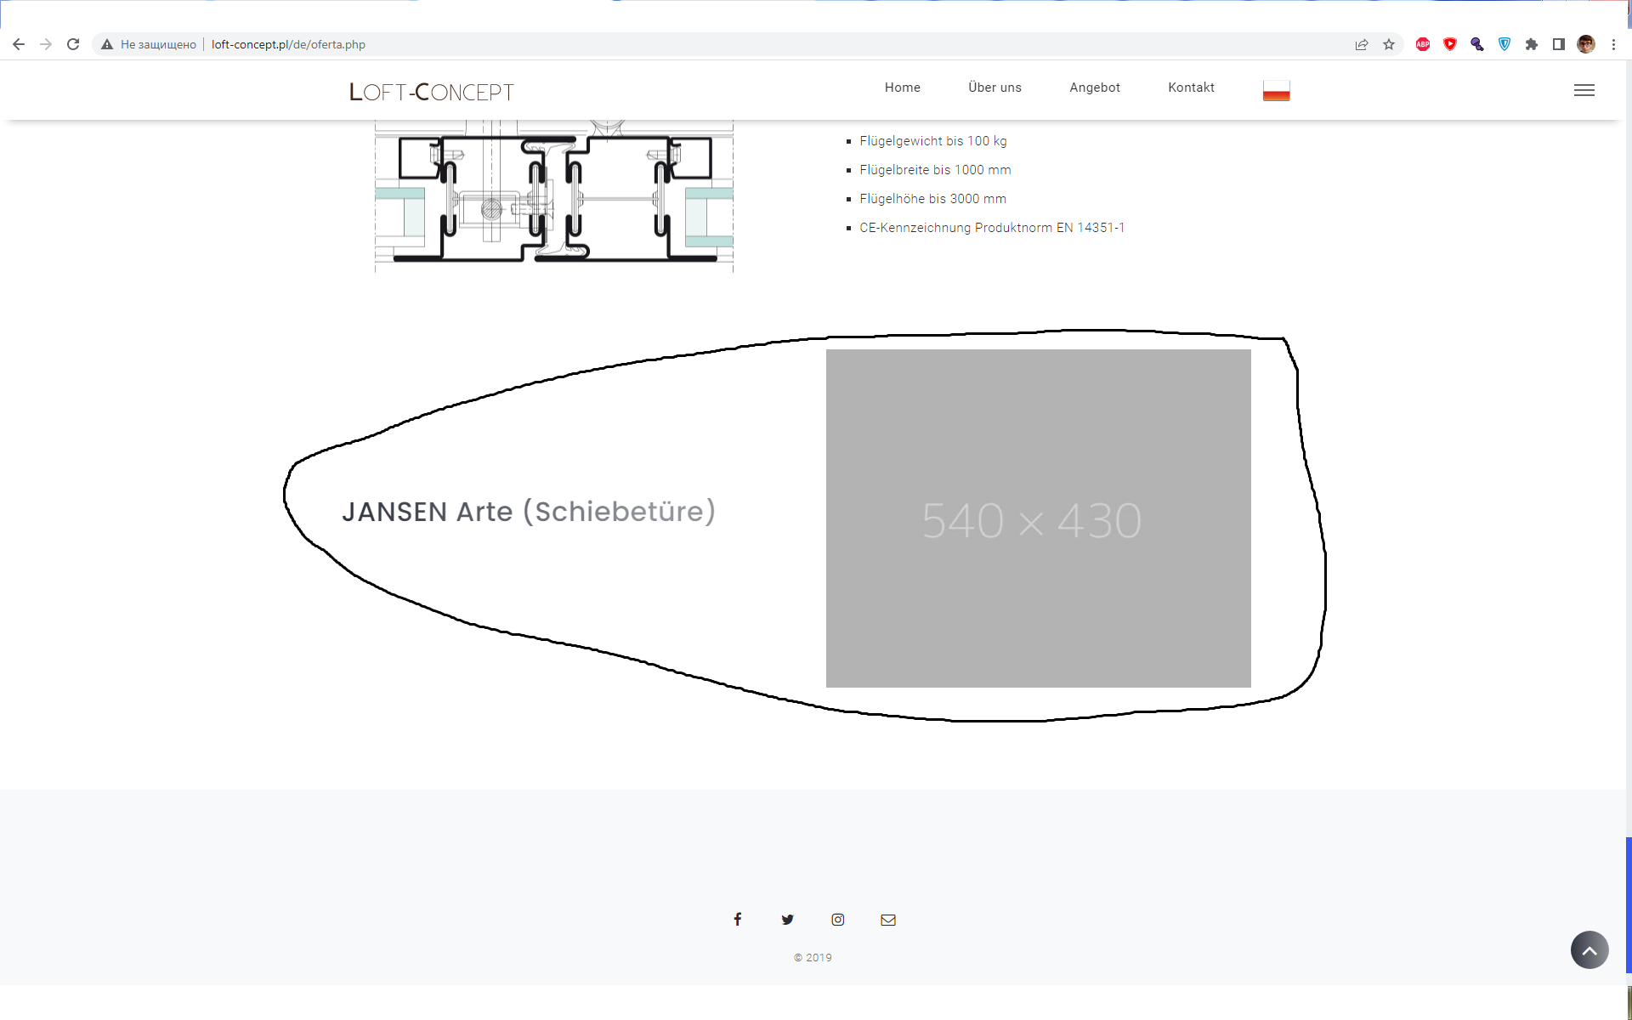

| **TestSuite** | Smoke |  |  |
| --- | --- | --- | --- |
| **TestCase Name** | New user registration positive test |  |  |
| **TestCase ID** | #01 |  |  |
| **Author** | Oleh Yushchuk |  |  |
| **Date** | 13/04/2022 |  |  |
| **Environment** | Google Chrome 99.0.4844.82 |  |  |
| **Purpose** | check the possibility to register a new user |  |  |
|  |  |  |  |
| **Precondition** | Open https://prom.ua/ |  |  |
| **#** | **Steps** | **Expected results** | **IsPassed** |
| 1 | Press the “Login/Register” link | The modal window “Create an Account” is opened |  |
| 2 | Fill in your name | Name is filled in | True |
| 3 | Fill in email address | Email address is filled in | True |
| 4 | Fill in password | Password is filled in | True |
| 5 | Fill in password confirmation | Password confirmation is filled in | True |
| 6 | Press "Register" button | We are redirected to home page | True |
| 7 | Login to the site with new credentials using the “Login/Register” link | Login is successful. | True |
|  |  |  |  |
| **The first test execution** | 06/04/2022 |  |  |
| **The last test execution** | 13/04/2022 |  |  |