Curriculum Vitae

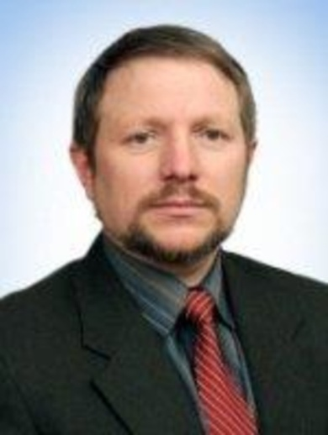
Dr. Yuriy Turbal
st. Knyazia Romana, 13/43, Rivne, Ukraine,33022.
Tel: mob. : + 380980841880;
E-mail: turbaly@gmail.com
y.v.turbal@nuwm.edu.ua

Professional Summary
University Professor with a wide range of knowledge and experience looking to become an asset to a prestigious university in need.
Experience
2012-Present
Professor of the Department of Applied Mathematics at the National University of Water and Environmental Engeneering (NUWEE), Rivne, Ukraine,director of the Educational and Scientific institute of distance education at the NUWEE.
Taught such courses as C ++ programming, mathematical modelling, stochastic modeling, software testing, algorithms and data structures.
2004-2012
Head of the departament of information systems at the International university of economics and humanities named after academician Stepan Demianchuk, Rivne, Ukraine.
Academic degrees
- Candidate of Physical and Mathematical Sciences, specialty "Probability Theory and Mathematical Statistics" (Taras Shevchenko State University of Kiev,1996).
- Doctor of Engineering Sciences in the field of mathematical simulation and methods of calculation ( V.N.Karazin Kharkiv National university, 2016).
Education
Graduated with honors from the faculty of cybernetics, Taras Shevchenko State University of Kiev (1993).
Specialty - applied mathematics, qualification - mathematician, teacher .
Research and post-graduate experience:
- Author of the number of methods for estimating parameters and testing hypotheses about the distribution function of the random process, practically worked with a large time series.
- Author of a number of methods and approaches to mathematical and computer modeling of geophysical processes, including special methods of data extrapolation, in particular models of seismic processes based on the soliton approach.
- Developer of the software for soliton analysis of seismic processes.
- Author of the book "Fundamentals of modern programming" (in Ukrainian) and around 50 papers in peer-reviewed journals and conference proceedings. The last papers are published in the journals included to the Scopus and Web of Sciense.
- Reviewer of several journals and books in the field of applied mathematics published by Elsevier and Springer.
- Strong post-graduate teaching experience in probability, statistics, stochastic processes, time series, C ++ programming, mathematical modelling, stochastic modeling, algorithms and data structures.
- Supervisor of 1 post-doctoral fellow, 5 PhD students (with doctoral work concluded), and 20 MSc degrees.
Research interests
Mathematical and computer modelling, big data, new approaches to data extrapolation and forecasting of geophysical processes, time series, seismic processes modelling and forecasting.

