# ВХІДНІ ДАННІ

Номер залікової книжки: *9303*

Номер залікової книжки у двійковій системі числення: *0010 0100 0101 0111*

|  |  |  |  |  |  |  |  |  |
| --- | --- | --- | --- | --- | --- | --- | --- | --- |
| $$h_{9}$$ | $$h_{8}$$ | $$h_{7}$$ | $$h_{6}$$ | $$h_{5}$$ | $$h_{4}$$ | $$h_{3}$$ | $$h_{2}$$ | $$h_{1}$$ |
| 0 | 0 | 1 | 0 | 1 | 0 | 1 | 1 | 1 |

|  |  |  |  |
| --- | --- | --- | --- |
| ***h*8** | ***h*4** | ***h*2** | **Порядок з’єднання фрагментів** |
| 0 | 0 | 1 | 2, 4, 3 |

|  |  |  |  |
| --- | --- | --- | --- |
| ***h*8** | ***h*7** | ***h*3** | **Логічні умови** |
| 0 | 1 | 1 | X1, X2, not X1, |

|  |  |  |  |
| --- | --- | --- | --- |
| ***h*9** | ***h*4** | ***h*1** | **Послідовність керуючих сигналів** |
| 0 | 0 | 1 | Y1, (Y1 Y2), Y3, (Y4 Y5), У4,У1 |

|  |  |  |
| --- | --- | --- |
| ***h*6** | ***h*2** | **Сигнал, тривалістю 2*t*** |
| 0 | 1 | Y2 |

|  |  |  |
| --- | --- | --- |
| ***h*6** | ***h*5** | **Тригери** |
| 0 | 1 | D |

|  |  |  |  |
| --- | --- | --- | --- |
| ***h*3** | ***h*2** | ***h*1** | **Логічні елементи** |
| 1 | 1 | 1 | 3І-НЕ, 3АБО-НЕ |

|  |  |
| --- | --- |
| ***h*4** | **Тип автомата** |
| 0 | Мілі |

# Частина 1

Cинтез функціональна схема керуючого автомата:

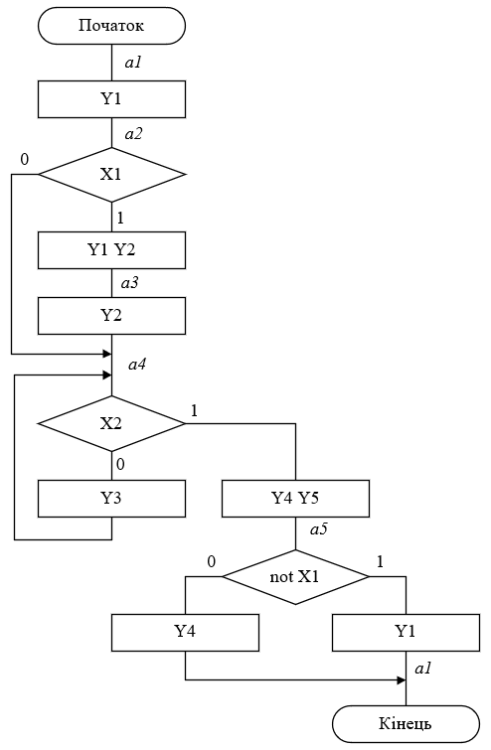

Рис. 1 Граф-схема алгоритму для автомату Мілі

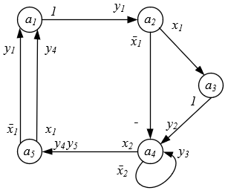

Рис. 2 Граф автомату Мілі

|  |  |  |  |
| --- | --- | --- | --- |
| *Таблиця 1. Пряма таблиця переходів-виходів автомату Мілі* | | | |
| $$a_{m}$$ | $$a_{s}$$ | $$X$$ | $$Y$$ |
| $$a_{1}$$ | $$a_{2}$$ | 1 | $$y_{1}$$ |
| $$a_{2}$$ | $$a_{4}$$ $$a_{3}$$ | $$\overline{x_{1}}$$ $$x_{1}$$ | $$-$$ $$y_{2}$$ |
| $$a_{3}$$ | $$a_{4}$$ | 1 | $$y_{2}$$ |
| $$a_{4}$$ | $$a_{5}$$ $$a_{4}$$ | $$x_{2}$$ $$\overline{x_{2}}$$ | $$y_{4}y_{5}$$ $$y_{3}$$ |
| $$a_{5}$$ | $$a_{1}$$ $$a_{1}$$ | $$\overline{x_{1}}$$ $$x_{1}$$ | $$y_{1}$$ $$y_{4}$$ |

У вихідному автоматі кількість станів $М=5$, отже, кількість елементів пам'яті:

$$m=\left|\log_{2}{M}\right|=\left|\log_{2}{5}\right|=3$$

Кодуємо внутрішні стани автомата, використовуючи для цього карту Карно (рис. 3) і по можливості метод сусіднього кодування.

|  |  |  |  |  |  |  |  |  |  |  |  |  |  |  |  |  |  |  |
| --- | --- | --- | --- | --- | --- | --- | --- | --- | --- | --- | --- | --- | --- | --- | --- | --- | --- | --- |
| |  |  |  |  |  |  |  | | --- | --- | --- | --- | --- | --- | --- | | |  | | --- | |  | |  | | 01 | 11 | 10 | 00 | | 1 |  |  |  |  | | 0 | $$a_{3}$$ |  | $$a_{5}$$ | $$a_{1}$$ | | $$a_{5}-100$$ $$a_{4}-011$$ $$a_{3}-010$$ $$a_{2}-001$$ $$a_{1}-000$$ |

Рис. 3 Карта Карно для кодування станів автомата

Будуємо пряму структурну таблицю переходів-виходів автомата Мілі (табл. 2). У даній таблиці в стовпцях $K\left(a_{m}\right)$ і $K\left(a_{s}\right)$ вказується код вихідного стану і стану переходу відповідно.

|  |  |  |  |  |  |  |  |  |  |  |  |  |  |  |  |  |  |  |
| --- | --- | --- | --- | --- | --- | --- | --- | --- | --- | --- | --- | --- | --- | --- | --- | --- | --- | --- |
| *Таблиця 2. Структурна таблиця переходів-виходів автомата Мілі* | | | | | | | | | | | | | | | | | | |
| $$a_{m}$$ | $$K\left(a_{m}\right)$$ | | | $$a_{s}$$ | $$K\left(a_{s}\right)$$ | | | $$x_{2}$$ | $$x_{1}$$ | $$y_{5}$$ | $$y_{4}$$ | $$y_{3}$$ | $$y_{2}$$ | $$y_{1}$$ | $$D_{3}$$ | $$D_{2}$$ | $$D_{1}$$ |
| $$Z_{3}$$ | $$Z_{2}$$ | $$Z_{1}$$ |
| $$a_{1}$$ | 0 | 0 | 0 | $$a_{2}$$ | 0 | 0 | 1 | - | - |  |  |  |  | **1** | 0 | 0 | 1 |
| $$a_{2}$$ | 0 | 0 | 1 | $$a_{4}$$ | 0 | 1 | 1 | - | 0 |  |  |  |  |  | 0 | 1 | 1 |
| $$a_{2}$$ | 0 | 0 | 1 | $$a_{3}$$ | 0 | 1 | 0 | - | 1 |  |  |  | **1** |  | 0 | 1 | 0 |
| $$a_{3}$$ | 0 | 1 | 0 | $$a_{4}$$ | 0 | 1 | 1 | - | - |  |  |  | **1** |  | 0 | 1 | 1 |
| $$a_{4}$$ | 0 | 1 | 1 | $$a_{4}$$ | 0 | 1 | 1 | 0 | - |  |  | **1** |  |  | 0 | 1 | 1 |
| $$a_{4}$$ | 0 | 1 | 1 | $$a_{5}$$ | 1 | 0 | 0 | 1 | - | **1** | **1** |  |  |  | 1 | 0 | 0 |
| $$a_{5}$$ | 1 | 0 | 0 | $$a_{1}$$ | 0 | 0 | 0 | - | 0 |  |  |  |  | **1** | 0 | 0 | 0 |
| $$a_{5}$$ | 1 | 0 | 0 | $$a_{1}$$ | 0 | 0 | 0 | - | 1 |  | **1** |  |  |  | 0 | 0 | 0 |

|  |  |  |  |  |  |  |  |  |  |  |  |  |  |  |  |  |
| --- | --- | --- | --- | --- | --- | --- | --- | --- | --- | --- | --- | --- | --- | --- | --- | --- |
|  | |  |  |  | | --- | --- | --- | |  |  |  | | 0 | 0 | **0** | | 1 | 0 | **0** | | 0 | 1 | **1** | | 1 | 1 | **1** | |

Рис. 4 Таблиця переходів D-тригера

Будуємо діаграми Вейча для всіх функцій:

|  |  |  |  |  |  |  |  |  |
| --- | --- | --- | --- | --- | --- | --- | --- | --- |
| $$D_{1}$$ | $$Z_{2}$$ | | | |  |  |  |  |
| $$Z_{1}$$ | **1** | 0 |  |  |  |  | **1** | **1** |  |
| **1** | 0 |  |  |  |  | 0 | 0 | $$x_{1}$$ |
|  | **1** | **1** |  |  | 0 | 0 | **1** | **1** |
|  | **1** | **1** |  |  | 0 | 0 | **1** | **1** |  |
|  |  |  | |  |  |  | |  |

|  |  |  |  |  |  |  |  |  |
| --- | --- | --- | --- | --- | --- | --- | --- | --- |
|  |  | | | |  |  |  |  |
|  | **1** | 0 |  |  | ~ | ~ | **1** | **1** |  |
| **1** | 0 |  |  | ~ | ~ | **1** | **1** | $$x_{1}$$ |
|  | **1** | **1** | ~ | ~ | 0 | 0 | 0 | 0 |
|  | **1** | **1** | ~ | ~ | 0 | 0 | 0 | 0 |  |
|  |  |  | |  |  |  | |  |

|  |  |  |  |  |  |  |  |  |
| --- | --- | --- | --- | --- | --- | --- | --- | --- |
|  |  | | | |  |  |  |  |
|  | 0 | **1** | ~ |  |  |  | 0 | 0 |  |
| 0 | **1** | ~ |  |  |  | 0 | 0 | $$x_{1}$$ |
|  | 0 | 0 |  |  | 0 | 0 | 0 | 0 |
|  | 0 | 0 |  |  | 0 | 0 | 0 | 0 |  |
|  |  |  | |  |  |  | |  |

|  |  |  |  |  |  |  |  |  |
| --- | --- | --- | --- | --- | --- | --- | --- | --- |
|  |  | | | |  |  |  |  |
|  | 0 | 0 |  |  |  |  | 0 | 0 |  |
| 0 | 0 |  |  |  |  | 0 | 0 | $$x_{1}$$ |
|  | 0 | 0 |  |  | 0 | 0 | **1** | **1** |
|  | 0 | 0 |  |  | **1** | **1** | **1** | **1** |  |
|  |  |  | |  |  |  | |  |

|  |  |  |  |  |  |  |  |  |
| --- | --- | --- | --- | --- | --- | --- | --- | --- |
|  |  | | | |  |  |  |  |
|  | 0 | 0 |  |  |  |  | 0 | 0 |  |
| 0 | 0 |  |  | ~ | ~ | **1** | **1** | $$x_{1}$$ |
|  | **1** | **1** | ~ | ~ | 0 | 0 | 0 | 0 |
|  | **1** | **1** | ~ | ~ | 0 | 0 | 0 | 0 |  |
|  |  |  | |  |  |  | |  |

|  |  |  |  |  |  |  |  |  |
| --- | --- | --- | --- | --- | --- | --- | --- | --- |
|  |  | | | |  |  |  |  |
|  | **1** | 0 |  |  |  |  | 0 | 0 |  |
| **1** | 0 |  |  |  |  | 0 | 0 | $$x_{1}$$ |
|  | 0 | 0 |  |  | 0 | 0 | 0 | 0 |
|  | 0 | 0 |  |  | 0 | 0 | 0 | 0 |  |
|  |  |  | |  |  |  | |  |

|  |  |  |  |  |  |  |  |  |
| --- | --- | --- | --- | --- | --- | --- | --- | --- |
|  |  | | | |  |  |  |  |
|  | 0 | **1** | ~ |  |  |  | 0 | 0 |  |
| 0 | **1** | ~ |  | ~ | ~ | 0 | 0 | $$x_{1}$$ |
|  | 0 | 0 |  |  | **1** | **1** | 0 | 0 |
|  | 0 | 0 |  |  | 0 | 0 | 0 | 0 |  |
|  |  |  | |  |  |  | |  |

|  |  |  |  |  |  |  |  |  |
| --- | --- | --- | --- | --- | --- | --- | --- | --- |
|  |  | | | |  |  |  |  |
|  | 0 | **1** | ~ |  |  |  | 0 | 0 |  |
| 0 | **1** | ~ |  |  |  | 0 | 0 | $$x_{1}$$ |
|  | 0 | 0 |  |  | 0 | 0 | 0 | 0 |
|  | 0 | 0 |  |  | 0 | 0 | 0 | 0 |  |
|  |  | $$x_{2}$$ | |  |  | $$x_{2}$$ | |  |

$$y_{5}=Z_{1}Z_{2}x_{2}$$

Отже отримали наступні функції збудження тригерів:

$$D_{1}=\overline{Z_{1}} \overline{Z_{3}}∨Z_{2}\overline{Z_{3}}\overline{x_{2}}∨Z_{1}\overline{Z_{2}}\overline{x_{1}}$$

$$D_{2}=Z_{2}\overline{Z_{3}}\overline{x_{2}}∨\overline{Z_{1}}Z_{2}∨Z_{1}\overline{Z_{2}}$$

$$D_{3}=Z_{1}Z_{2}x_{2}$$

Функції виходів:

$$y_{1}=\overline{Z_{1}} \overline{Z_{2}} \overline{Z_{3}}∨\overline{Z_{1}} \overline{Z_{2}} \overline{x_{1}}$$

$$y_{2}=\overline{Z_{1}}Z_{2}∨Z_{1}\overline{Z_{2}}$$

$$y_{3}=Z_{1}Z_{2}\overline{Z_{3}}\overline{x_{2}}$$

$$y_{4}=Z_{1}Z_{2}x_{2}∨\overline{Z_{2}}Z_{3}x_{1}$$

$$y_{5}=Z_{1}Z_{2}x_{2}$$

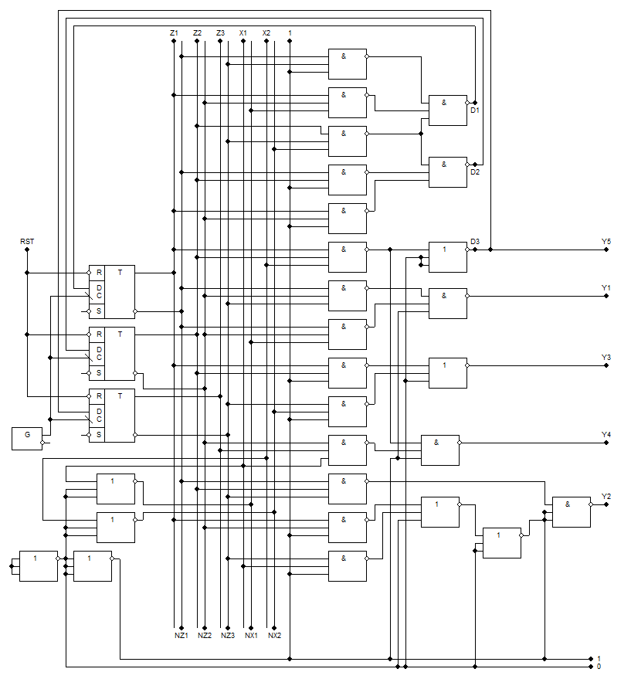

Рис. 5 Функціональна схема автомату Мілі

Побудуємо часову діаграму роботи автомата для кожної комбінацій значень логічних умов.

|  |  |  |  |  |  |  |  |  |  |  |  |  |  |  |  |  |  |  |  |  |  |  |  |  |  |  |  |  |  |  |  |  |  |  |  |  |  |  |  |  |  |  |  |  |  |  |  |  |  |  |  |  |  |  |  |  |  |  |  |  |  |  |  |  |  |  |  |  |  |  |  |  |  |  |  |  |  |  |  |  |  |  |  |  |  |  |  |  |  |  |  |  |  |  |  |  |  |  |  |  |  |  |  |  |  |  |  |  |  |  |  |  |  |  |  |  |  |  |  |  |  |  |  |  |  |  |  |  |  |  |  |  |  |  |  |  |  |  |  |  |  |  |  |  |  |  |  |  |  |  |  |  |  |  |  |  |  |  |  |  |  |  |  |  |  |  |  |  |  |  |  |  |  |  |  |  |  |  |  |  |  |  |  |  |  |  |  |  |  |  |  |  |  |  |  |  |  |  |  |  |  |  |  |  |  |  |  |  |  |  |  |  |  |  |  |  |  |  |  |  |  |  |  |  |  |  |  |  |  |  |  |  |  |  |  |  |  |  |  |  |  |  |  |  |  |  |  |  |  |  |  |  |  |  |  |  |  |  |  |  |  |  |  |  |  |  |  |  |  |  |  |  |  |  |  |  |  |  |  |  |  |
| --- | --- | --- | --- | --- | --- | --- | --- | --- | --- | --- | --- | --- | --- | --- | --- | --- | --- | --- | --- | --- | --- | --- | --- | --- | --- | --- | --- | --- | --- | --- | --- | --- | --- | --- | --- | --- | --- | --- | --- | --- | --- | --- | --- | --- | --- | --- | --- | --- | --- | --- | --- | --- | --- | --- | --- | --- | --- | --- | --- | --- | --- | --- | --- | --- | --- | --- | --- | --- | --- | --- | --- | --- | --- | --- | --- | --- | --- | --- | --- | --- | --- | --- | --- | --- | --- | --- | --- | --- | --- | --- | --- | --- | --- | --- | --- | --- | --- | --- | --- | --- | --- | --- | --- | --- | --- | --- | --- | --- | --- | --- | --- | --- | --- | --- | --- | --- | --- | --- | --- | --- | --- | --- | --- | --- | --- | --- | --- | --- | --- | --- | --- | --- | --- | --- | --- | --- | --- | --- | --- | --- | --- | --- | --- | --- | --- | --- | --- | --- | --- | --- | --- | --- | --- | --- | --- | --- | --- | --- | --- | --- | --- | --- | --- | --- | --- | --- | --- | --- | --- | --- | --- | --- | --- | --- | --- | --- | --- | --- | --- | --- | --- | --- | --- | --- | --- | --- | --- | --- | --- | --- | --- | --- | --- | --- | --- | --- | --- | --- | --- | --- | --- | --- | --- | --- | --- | --- | --- | --- | --- | --- | --- | --- | --- | --- | --- | --- | --- | --- | --- | --- | --- | --- | --- | --- | --- | --- | --- | --- | --- | --- | --- | --- | --- | --- | --- | --- | --- | --- | --- | --- | --- | --- | --- | --- | --- | --- | --- | --- | --- | --- | --- | --- | --- | --- | --- | --- | --- | --- | --- | --- | --- | --- | --- | --- | --- | --- | --- | --- | --- | --- | --- | --- | --- | --- | --- | --- | --- | --- | --- | --- | --- |
| |  |  |  |  |  |  |  |  | | --- | --- | --- | --- | --- | --- | --- | --- | |  |  |  |  |  |  |  |  | | 1 | 1 | 1 | 1 | 1 |  |  | |  |  |  |  |  |  |  |  | | 1 | 1 | 1 | 1 | 1 |  |  | |  |  |  |  |  |  |  |  | | 1 | 0 | 0 | 0 | 0 | 1 |  | |  |  |  |  |  |  |  |  | | 0 | 1 | 1 | 0 | 0 | 0 |  | |  |  |  |  |  |  |  |  | | 0 | 0 | 0 | 0 | 0 | 0 |  | |  |  |  |  |  |  |  |  | | 0 | 0 | 0 | 1 | 1 | 0 |  | |  |  |  |  |  |  |  |  | | 0 | 0 | 0 | 1 | 0 | 0 |  | |  |  |  |  |  |  |  |  | | 0 | 1 | 0 | 1 | 0 | 0 |  | |  |  |  |  |  |  |  |  | | 0 | 0 | 1 | 1 | 0 | 0 |  | |  |  |  |  |  |  |  |  | | 0 | 0 | 0 | 0 | 1 | 0 |  | | |  |  |  |  |  |  |  | | --- | --- | --- | --- | --- | --- | --- | |  |  |  |  |  |  |  | | 0 | 0 | 0 | 0 | 0 |  | |  |  |  |  |  |  |  | | 1 | 1 | 1 | 1 | 1 |  | |  |  |  |  |  |  |  | | 1 | 0 | 0 | 1 | 1 |  | |  |  |  |  |  |  |  | | 0 | 0 | 0 | 0 | 0 |  | |  |  |  |  |  |  |  | | 0 | 0 | 0 | 0 | 0 |  | |  |  |  |  |  |  |  | | 0 | 0 | 1 | 0 | 0 |  | |  |  |  |  |  |  |  | | 0 | 0 | 1 | 0 | 0 |  | |  |  |  |  |  |  |  | | 0 | 1 | 1 | 0 | 0 |  | |  |  |  |  |  |  |  | | 0 | 0 | 1 | 0 | 0 |  | |  |  |  |  |  |  |  | | 0 | 0 | 0 | 1 | 0 |  | |
|  |  |

|  |  |  |  |  |  |  |  |  |  |  |  |  |  |  |  |  |  |  |  |  |  |  |  |  |  |  |  |  |  |  |  |  |  |  |  |  |  |  |  |  |  |  |  |  |  |  |  |  |  |  |  |  |  |  |  |  |  |  |  |  |  |  |  |  |  |  |  |  |  |  |  |  |  |  |  |  |  |  |  |  |  |  |  |  |  |  |  |  |  |  |  |  |  |  |  |  |  |  |  |  |  |  |  |  |  |  |  |  |  |  |  |  |  |  |  |  |  |  |  |  |  |  |  |  |  |  |  |  |  |  |  |  |  |  |  |  |  |  |  |  |  |  |  |  |  |  |  |  |  |  |  |  |  |  |  |  |  |  |  |  |  |  |  |  |  |  |  |  |  |  |  |  |  |  |  |  |  |  |  |  |  |  |  |  |  |  |  |  |  |  |  |  |  |  |  |  |  |  |  |  |  |  |  |  |  |  |  |  |  |  |  |  |  |  |  |  |  |  |  |  |  |  |  |  |  |  |  |  |  |  |  |  |  |  |  |  |  |  |  |  |  |  |  |  |  |  |  |  |  |  |  |  |  |  |  |  |  |  |  |  |  |  |  |  |  |  |  |  |  |  |  |  |  |  |  |  |  |  |  |  |  |  |  |  |  |  |  |  |  |  |  |  |  |  |  |  |  |  |  |  |  |
| --- | --- | --- | --- | --- | --- | --- | --- | --- | --- | --- | --- | --- | --- | --- | --- | --- | --- | --- | --- | --- | --- | --- | --- | --- | --- | --- | --- | --- | --- | --- | --- | --- | --- | --- | --- | --- | --- | --- | --- | --- | --- | --- | --- | --- | --- | --- | --- | --- | --- | --- | --- | --- | --- | --- | --- | --- | --- | --- | --- | --- | --- | --- | --- | --- | --- | --- | --- | --- | --- | --- | --- | --- | --- | --- | --- | --- | --- | --- | --- | --- | --- | --- | --- | --- | --- | --- | --- | --- | --- | --- | --- | --- | --- | --- | --- | --- | --- | --- | --- | --- | --- | --- | --- | --- | --- | --- | --- | --- | --- | --- | --- | --- | --- | --- | --- | --- | --- | --- | --- | --- | --- | --- | --- | --- | --- | --- | --- | --- | --- | --- | --- | --- | --- | --- | --- | --- | --- | --- | --- | --- | --- | --- | --- | --- | --- | --- | --- | --- | --- | --- | --- | --- | --- | --- | --- | --- | --- | --- | --- | --- | --- | --- | --- | --- | --- | --- | --- | --- | --- | --- | --- | --- | --- | --- | --- | --- | --- | --- | --- | --- | --- | --- | --- | --- | --- | --- | --- | --- | --- | --- | --- | --- | --- | --- | --- | --- | --- | --- | --- | --- | --- | --- | --- | --- | --- | --- | --- | --- | --- | --- | --- | --- | --- | --- | --- | --- | --- | --- | --- | --- | --- | --- | --- | --- | --- | --- | --- | --- | --- | --- | --- | --- | --- | --- | --- | --- | --- | --- | --- | --- | --- | --- | --- | --- | --- | --- | --- | --- | --- | --- | --- | --- | --- | --- | --- | --- | --- | --- | --- | --- | --- | --- | --- | --- | --- | --- | --- | --- | --- | --- | --- | --- | --- | --- | --- | --- | --- | --- | --- | --- | --- | --- | --- | --- | --- | --- | --- | --- | --- | --- | --- | --- | --- | --- | --- | --- | --- | --- | --- | --- | --- |
| |  |  |  |  |  |  |  |  | | --- | --- | --- | --- | --- | --- | --- | --- | |  |  |  |  |  |  |  |  | | 1 | 1 | 1 | 1 | 1 | 1 |  | |  |  |  |  |  |  |  |  | | 0 | 0 | 0 | 0 | 0 | 0 |  | |  |  |  |  |  |  |  |  | | 1 | 0 | 0 | 0 | 0 | 0 |  | |  |  |  |  |  |  |  |  | | 0 | 1 | 1 | 0 | 0 | 0 |  | |  |  |  |  |  |  |  |  | | 0 | 0 | 0 | 1 | 1 | 1 |  | |  |  |  |  |  |  |  |  | | 0 | 0 | 0 | 0 | 0 | 0 |  | |  |  |  |  |  |  |  |  | | 0 | 0 | 0 | 0 | 0 | 0 |  | |  |  |  |  |  |  |  |  | | 0 | 1 | 0 | 1 | 1 | 1 |  | |  |  |  |  |  |  |  |  | | 0 | 0 | 1 | 1 | 1 | 1 |  | |  |  |  |  |  |  |  |  | | 0 | 0 | 0 | 0 | 0 | 0 |  | | |  |  |  |  |  |  |  |  | | --- | --- | --- | --- | --- | --- | --- | --- | |  |  |  |  |  |  |  |  | | 0 | 0 | 0 | 0 | 0 | 0 |  | |  |  |  |  |  |  |  |  | | 0 | 0 | 0 | 0 | 0 | 0 |  | |  |  |  |  |  |  |  |  | | 1 | 0 | 0 | 0 | 0 | 0 |  | |  |  |  |  |  |  |  |  | | 0 | 0 | 0 | 0 | 0 | 0 |  | |  |  |  |  |  |  |  |  | | 0 | 0 | 1 | 1 | 1 | 1 |  | |  |  |  |  |  |  |  |  | | 0 | 0 | 0 | 0 | 0 | 0 |  | |  |  |  |  |  |  |  |  | | 0 | 0 | 0 | 0 | 0 | 0 |  | |  |  |  |  |  |  |  |  | | 0 | 1 | 1 | 1 | 1 | 1 |  | |  |  |  |  |  |  |  |  | | 0 | 0 | 1 | 1 | 1 | 1 |  | |  |  |  |  |  |  |  |  | | 0 | 0 | 0 | 0 | 0 | 0 |  | |
| $$x_{1}=1, x_{2}=0$$ | $$x_{1}=0, x_{2}=0$$ |