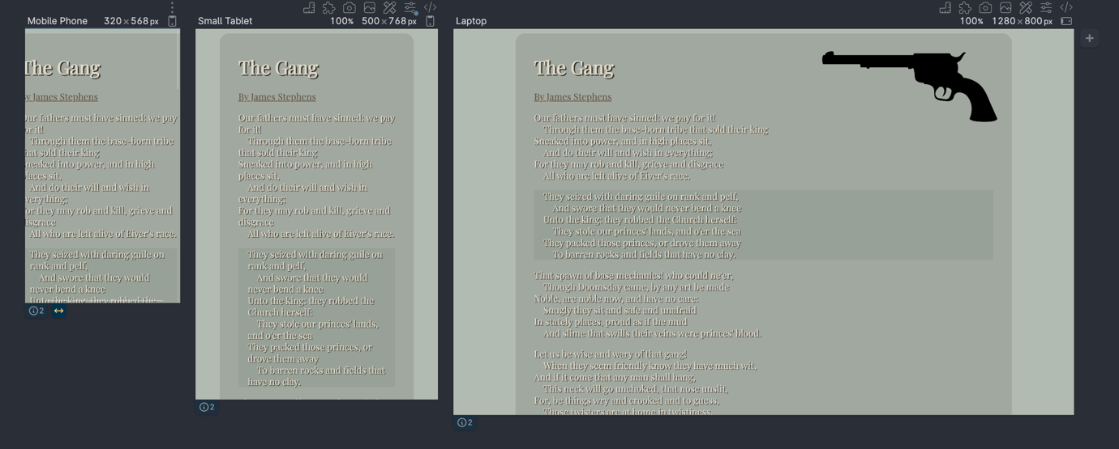

1. Above I cautioned you on not using a part of your computer that is linked to cloud storage. Give me a few sentences on why a developer should not use a Cloud folder for local repos.

Cloud storage can cause some sync issues as the service struggles to update changes.

1. In a paragraph or two explain to me how you're using some aspect(s) of Intrinsic Web Design concepts.

Instead of using multiple paragraph tags to separate the lines, I’m able to keep all the lines as part of a semantic paragraph while styling it with the use of the generic span tag and some css. Instead of using tables or other html elements to hack together the flow of the page, I can simply use positioning and margins to pull together a beautiful view. Additionally, I’m able to use media queries and viewport units to create a responsive design that looks good regardless of the resolution.

1. Give me a truthful estimate of the time you took on this project.

This project probably took me about 2-3 hours in terms of actual work. Most of the wasted time way trying to figure polyplane out. But I finally got it to work

1. Is there anything you liked or disliked about this assignment? Feel free to discuss both your likes and dislikes (just make sure I can tell which is which 😉).

I don’t have any strong opinions about the assignment

1. How could this assignment be improved?

I think the assignment is fine ☺

<https://github.com/RVCC-IDMX/poem-page-DavidTeju.git>