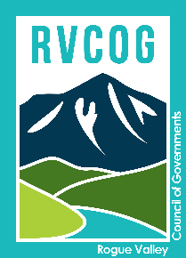
 | ROGUE VALLEY  Council of Governments | 155 N. First St.  P.O. Box 3275  Central Point, OR 97502
(541) 664-6674
fax (541) 664-7927

Date: September 4, 2026
To:
From:
Subject:

Yazeed Alrashdi | Associate Planner
Rogue Valley Council of Governments
155 N. 1st Street | P.O. Box 3275
Central Point, OR 97502
(541) 423-1378
www.rvcog.org | www.rvmpo.org | www.mrmpo.org

