rBergomi Pricing Variant Comparison
Comparison of three pricing methods within the rBergomi model, all using the Hybrid Scheme (BLP2017) for fBm simulation.

Summary Statistics
Variant | Avg RMSE | Med RMSE | Avg Time | Good (%) | N dates
Mixed Estimator | 14.91pp | 12.77pp | 33.8s | 9/27 | 27
Euler Antithetic | 14.86pp | 12.79pp | 29.7s | 10/27 | 27
Euler Standard | 18.65pp | 20.62pp | 42.6s | 6/27 | 27

RMSE Comparison
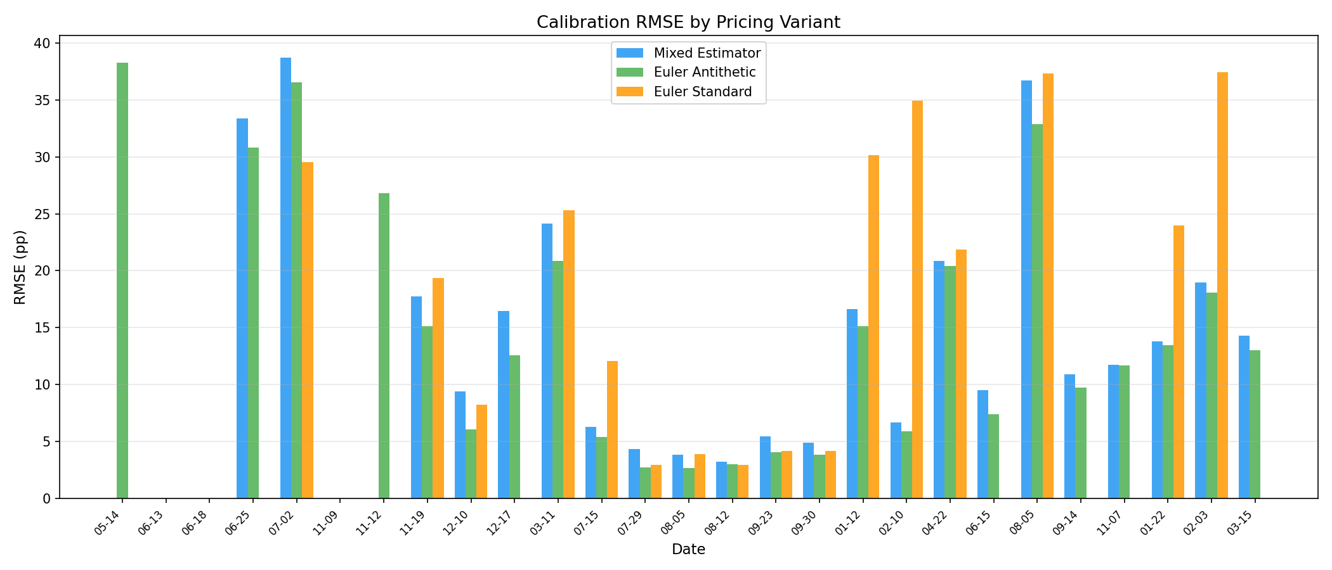

Speed Comparison
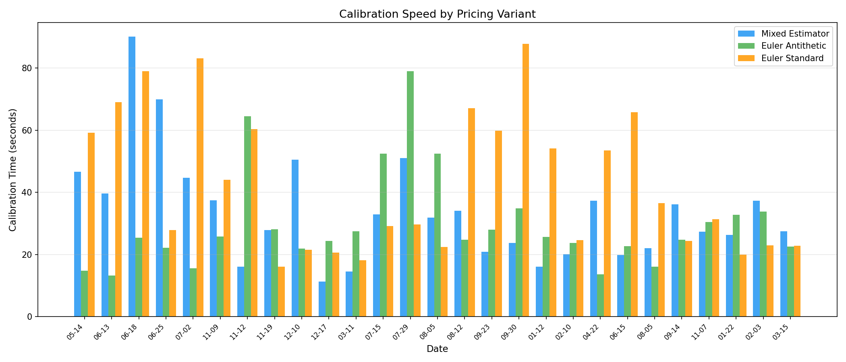

Parameter Comparison
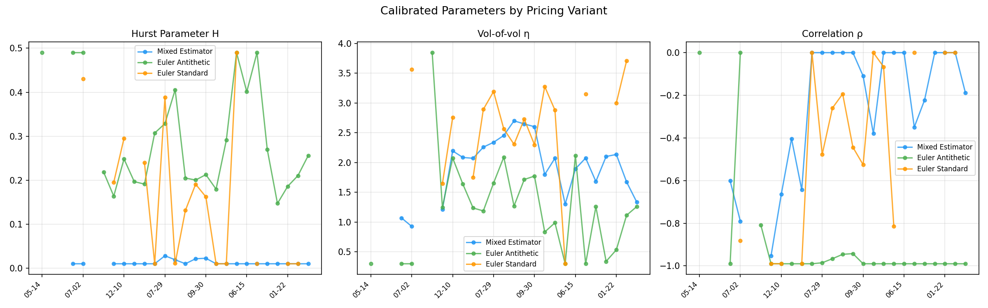

Per-Date Results
Date | Mix RMSE | Mix Time | Ant RMSE | Ant Time | Eul RMSE | Eul Time | Best | Best RMSE | Speedup
2022-05-14 | FAIL | 47s | 38.3 | 15s | FAIL | 59s | Euler | 38.3pp | 1.0x
2022-06-13 | FAIL | 40s | FAIL | 13s | FAIL | 69s | - | - | -
2022-06-18 | FAIL | 90s | FAIL | 25s | FAIL | 79s | - | - | -
2022-06-25 | 33.4 | 70s | 30.8 | 22s | FAIL | 28s | Euler | 30.8pp | 3.2x
2022-07-02 | 38.7 | 45s | 36.5 | 16s | 29.5 | 83s | Euler | 29.5pp | 5.3x
2022-11-09 | FAIL | 37s | FAIL | 26s | FAIL | 44s | - | - | -
2022-11-12 | FAIL | 16s | 26.8 | 64s | FAIL | 60s | Euler | 26.8pp | 1.0x
2022-11-19 | 17.7 | 28s | 15.2 | 28s | 19.4 | 16s | Euler | 15.2pp | 1.7x
2022-12-10 | 9.4 | 50s | 6.0 | 22s | 8.2 | 22s | Euler | 6.0pp | 2.3x
2022-12-17 | 16.5 | 11s | 12.6 | 24s | FAIL | 21s | Euler | 12.6pp | 2.2x
2023-03-11 | 24.1 | 15s | 20.9 | 27s | 25.3 | 18s | Euler | 20.9pp | 1.9x
2023-07-15 | 6.3 | 33s | 5.4 | 52s | 12.1 | 29s | Euler | 5.4pp | 1.8x
2023-07-29 | 4.3 | 51s | 2.8 | 79s | 2.9 | 30s | Euler | 2.8pp | 2.7x
2023-08-05 | 3.9 | 32s | 2.7 | 53s | 3.9 | 22s | Euler | 2.7pp | 2.3x
2023-08-12 | 3.2 | 34s | 3.0 | 25s | 3.0 | 67s | Euler | 3.0pp | 2.7x
2023-09-23 | 5.5 | 21s | 4.0 | 28s | 4.2 | 60s | Euler | 4.0pp | 2.9x
2023-09-30 | 4.9 | 24s | 3.9 | 35s | 4.2 | 88s | Euler | 3.9pp | 3.7x
2024-01-12 | 16.6 | 16s | 15.1 | 26s | 30.1 | 54s | Euler | 15.1pp | 3.4x
2024-02-10 | 6.7 | 20s | 5.9 | 24s | 34.9 | 25s | Euler | 5.9pp | 1.2x
2024-04-22 | 20.9 | 37s | 20.4 | 14s | 21.9 | 53s | Euler | 20.4pp | 3.9x
2024-06-15 | 9.5 | 20s | 7.4 | 23s | FAIL | 66s | Euler | 7.4pp | 1.1x
2024-08-05 | 36.7 | 22s | 32.9 | 16s | 37.3 | 37s | Euler | 32.9pp | 2.3x
2024-09-14 | 10.9 | 36s | 9.7 | 25s | FAIL | 24s | Euler | 9.7pp | 1.5x
2024-11-07 | 11.8 | 27s | 11.7 | 30s | FAIL | 31s | Euler | 11.7pp | 1.1x
2025-01-22 | 13.8 | 26s | 13.5 | 33s | 24.0 | 20s | Euler | 13.5pp | 1.6x
2025-02-03 | 19.0 | 37s | 18.1 | 34s | 37.5 | 23s | Euler | 18.1pp | 1.6x
2025-03-15 | 14.3 | 27s | 13.0 | 23s | FAIL | 23s | Euler | 13.0pp | 1.2x

