Rising Waters
A Machine Learning Approach to Flood Prediction

Project Description
Floods are among the most devastating natural disasters, claiming thousands of lives and displacing millions of people every year. Despite their recurring nature, the lack of timely and accurate early-warning systems continues to amplify their destructive impact. Conventional forecasting methods often fall short in predicting floods at the right time, leaving authorities and communities with insufficient opportunity to respond.
This project addresses that gap by building a machine learning-powered flood prediction system trained on historical weather data. Using classification algorithms — Decision Tree, Random Forest, K-Nearest Neighbours (KNN), and XGBoost — the system analyses meteorological features such as annual rainfall, cloud visibility, and seasonal rainfall patterns to predict the likelihood of a flood event.
The best-performing model is saved and integrated into a Flask web application, enabling concerned authorities and disaster management teams to monitor flood risk predictions through an intuitive and accessible user interface. The application is designed for deployment on IBM Cloud, making it scalable and accessible from any location.

Scenarios
Scenario 1: Early Flood Warning and Evacuation Planning
A meteorologist enters current rainfall and cloud visibility readings for a flood-prone district. The model analyses the inputs and predicts a high probability of flooding, allowing authorities to issue evacuation advisories several hours in advance.
Scenario 2: Disaster Response and Resource Allocation
A disaster relief coordinator uses the web application during monsoon season to monitor multiple regions simultaneously. By entering regional weather data for each area, the system provides instant flood risk classifications, helping prioritise resource deployment.
Scenario 3: Model Validation and Performance Assessment
A government analyst tests the model against historical flood event data to evaluate its accuracy. The XGBoost model achieves 96.55% accuracy on test data, confirming the system's reliability for operational use.

Technical Architecture
Rising Waters is built on a modular five-layer architecture that cleanly separates the user interface, presentation, application logic, machine learning, and data components, supported by a dedicated deployment pipeline that takes the application from local development to a publicly accessible cloud deployment.
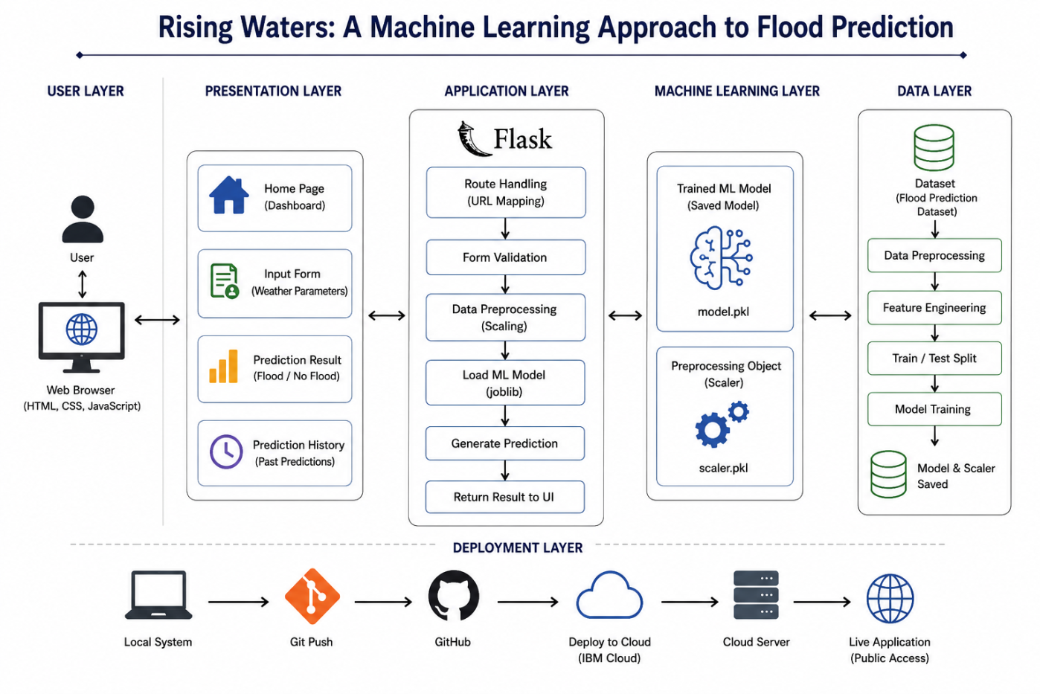
Layer Breakdown
- User Layer: The end user interacts with the system through a standard web browser (HTML, CSS, JavaScript).
- Presentation Layer: Provides the Home Dashboard, Input Form for weather parameters, Prediction Result display (Flood / No Flood), and Prediction History view.
- Application Layer (Flask): Handles route mapping, form validation, data preprocessing/scaling, loading the trained model via joblib, generating predictions, and returning results to the UI.
- Machine Learning Layer: Hosts the trained model (model.pkl) and the fitted preprocessing object (scaler.pkl) used for inference.
- Data Layer: Covers the flood prediction dataset, data preprocessing, feature engineering, train/test split, model training, and persistence of the final model and scaler.
- Deployment Layer: Local System → Git Push → GitHub → Deploy to Cloud (IBM Cloud) → Cloud Server → Live Public Application.
Live Application: https://rising-water-mnkl.onrender.com

Pre-requisites

Hardware Requirements
- Processor: Intel i3 or above
- RAM: Minimum 4 GB
- Storage: Minimum 2 GB free space
- Stable internet connection for dataset access and cloud deployment

Software Requirements
- Operating System: Windows / Linux / macOS
- Python 3.8 or above
- Anaconda Navigator / Jupyter Notebook
- Flask Framework
- HTML, CSS, JavaScript
- IBM Cloud account

Skills Required
- Machine Learning Algorithms (Decision Tree, Random Forest, KNN, XGBoost)
- NumPy and Pandas for data handling
- Matplotlib for data visualization
- Scikit-Learn for model building and evaluation
- Supervised Learning concepts
- Flask (Web Framework) for backend development
- K-Means Clustering and K-Nearest Neighbours Algorithm
- Version control with Git and GitHub

Project Workflow
The project was executed across five epics comprising twenty-four user stories, organised into six delivery milestones as outlined below.

Milestone 1: Data Collection
Activity 1.1: Source the Flood Prediction Dataset
- Identify and acquire a reliable historical weather dataset containing annual rainfall, monthly and seasonal rainfall figures, cloud visibility readings, and flood occurrence labels.
Activity 1.2: Import and Inspect the Dataset
- Load the dataset into a Jupyter Notebook using Pandas and review its shape, data types, and summary statistics.
Activity 1.3: Document Features and Target Variable
- Establish a clear data dictionary identifying input features and the binary flood/no-flood target variable.

Milestone 2: Visualizing and Analysing the Data
Activity 2.1: Exploratory Data Analysis
- Analyse distributions, correlations, and trends between rainfall patterns and flood occurrence using descriptive statistics.
Activity 2.2: Data Visualization
- Use Matplotlib to build histograms, box plots, correlation heatmaps, and seasonal rainfall trend charts to surface patterns in the data.
Activity 2.3: Identify Data Quality Issues
- Detect outliers, missing values, and class imbalance between flood and no-flood records to inform the preprocessing strategy.

Milestone 3: Data Pre-processing
Activity 3.1: Handle Missing Values and Outliers
- Clean the dataset by treating missing values and capping or removing extreme outliers identified during analysis.
Activity 3.2: Feature Engineering
- Derive seasonal rainfall aggregates and engineer additional features relevant to flood likelihood.
Activity 3.3: Feature Scaling
- Scale numerical features using a Scikit-Learn scaler and persist it as scaler.pkl for consistent use during inference.
from sklearn.preprocessing import StandardScaler
import joblib

scaler = StandardScaler()
X_train_scaled = scaler.fit_transform(X_train)
X_test_scaled = scaler.transform(X_test)

joblib.dump(scaler, "scaler.pkl")
Activity 3.4: Train/Test Split
- Split the pre-processed dataset into training and testing sets using an 80/20 ratio to evaluate model generalisation.

Milestone 4: Model Building
Activity 4.1: Train Multiple Classification Models
- Train Decision Tree, Random Forest, K-Nearest Neighbours, and XGBoost classifiers on the scaled training data.
from sklearn.tree import DecisionTreeClassifier
from sklearn.ensemble import RandomForestClassifier
from sklearn.neighbors import KNeighborsClassifier
from xgboost import XGBClassifier

models = {
"Decision Tree": DecisionTreeClassifier(),
"Random Forest": RandomForestClassifier(n_estimators=200),
"KNN": KNeighborsClassifier(n_neighbors=5),
"XGBoost": XGBClassifier(use_label_encoder=False, eval_metric="logloss"),
}

for name, model in models.items():
model.fit(X_train_scaled, y_train)
Activity 4.2: Evaluate and Compare Models
- Compare model performance using accuracy, precision, recall, and F1-score on the held-out test set.
Activity 4.3: Select the Best-Performing Model
- Select XGBoost as the production model after it achieved 96.55% accuracy on test data, outperforming the other candidates.
Activity 4.4: Persist the Trained Model
- Save the final XGBoost model as model.pkl using joblib for integration into the Flask application.
import joblib

best_model = models["XGBoost"]
joblib.dump(best_model, "model.pkl")

Milestone 5: Application Building
Activity 5.1: Design the Flask Application Structure
- Define the application layout with routes for the Home Page, Input Form, Prediction Result, and Prediction History, and set up the folder structure for templates and static assets.
Activity 5.2: Load the Model and Scaler at Startup
import joblib

model = joblib.load("model.pkl")
scaler = joblib.load("scaler.pkl")
Activity 5.3: Implement Route Handling in app.py
- Set up the home route to render the dashboard and a dedicated /predict route that accepts form data, scales it, and returns a prediction.
@app.route("/")
def home():
return render_template("index.html")

@app.route("/predict", methods=["POST"])
def predict():
annual_rainfall = float(request.form["annual_rainfall"])
cloud_visibility = float(request.form["cloud_visibility"])
seasonal_rainfall = float(request.form["seasonal_rainfall"])

features = np.array([[annual_rainfall, cloud_visibility, seasonal_rainfall]])
scaled_features = scaler.transform(features)

prediction = model.predict(scaled_features)[0]
result = "Flood" if prediction == 1 else "No Flood"

return render_template("result.html", prediction=result)
Activity 5.4: Build the Presentation Layer
- Develop the Home Page, Input Form (Weather Parameters), Prediction Result view, and Prediction History page using HTML, CSS, and JavaScript.
Activity 5.5: Connect Frontend to Backend
- Wire the input form to the /predict endpoint, validate weather parameter inputs client-side, and render the returned flood/no-flood classification dynamically.

Milestone 6: Deployment
Activity 6.1: Prepare for Deployment
- Finalise requirements.txt, confirm the application runs correctly on the local system, and remove any development-only configuration.
Activity 6.2: Push Code to GitHub
- Initialise a Git repository, commit the project files, and push the codebase to GitHub for version control.
Activity 6.3: Deploy to the Cloud
- Deploy the Flask application to a cloud server and configure it for public access, with IBM Cloud as the intended production target for scalable deployment.
Activity 6.4: Verify the Live Application
- Confirm the deployed application is publicly reachable and test the end-to-end flood prediction workflow across all input scenarios.
Current live deployment: https://rising-water-mnkl.onrender.com

Conclusion
Rising Waters is a machine learning-powered flood prediction system built with Flask that translates historical weather data into actionable, real-time flood risk assessments. By evaluating Decision Tree, Random Forest, K-Nearest Neighbours, and XGBoost classifiers, the project identified XGBoost as the most reliable model, achieving 96.55% accuracy on test data. The end-to-end workflow — spanning data collection, exploratory analysis, preprocessing, model building, and application development — culminates in a Flask web application designed for deployment on IBM Cloud, giving meteorologists, disaster relief coordinators, and government analysts a practical tool for early flood warning and response planning.
Looking ahead, Rising Waters has clear potential for expansion, including incorporating real-time weather API feeds, extending predictions to region-specific and multi-day forecasts, adding user authentication to track prediction history per user, and integrating geospatial mapping to visualise flood risk across districts. With continued refinement of the underlying models and broader data coverage, the platform is well-positioned to evolve from a predictive tool into a comprehensive flood-risk monitoring and early-warning system for disaster management teams.

