WebUI not recoring the page due to the content security policy

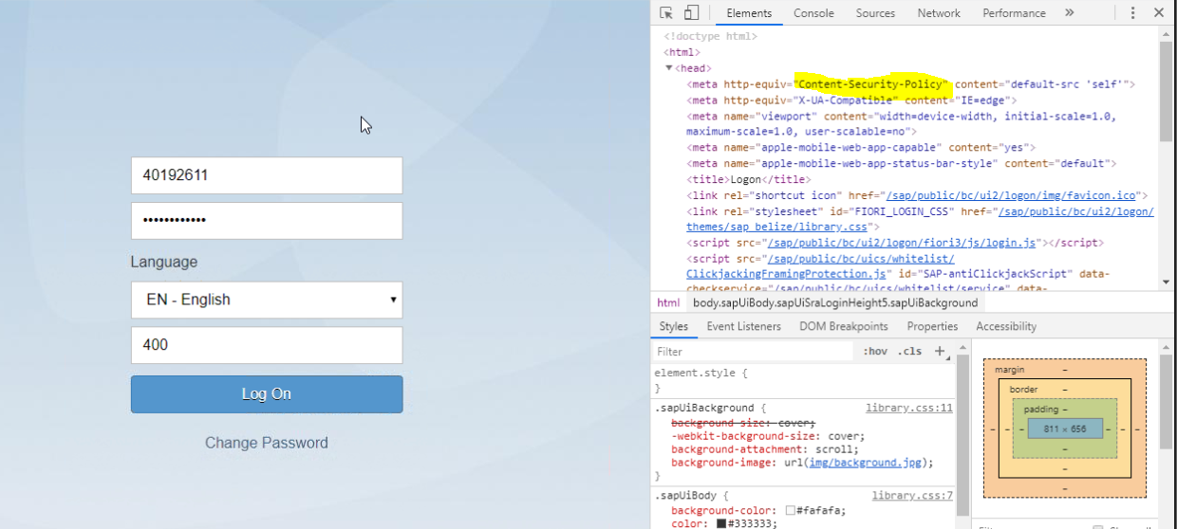

Selenium code to launch chrome driver

import org.openqa.selenium.By;    
import org.openqa.selenium.WebDriver;    
import org.openqa.selenium.WebElement;    
import org.openqa.selenium.chrome.ChromeDriver;    
public class Chrome {    
    public static void main(String[] args) {    
        // TODO Auto-generated method stub    
        ///System.setProperty("webdriver.chrome.driver", "C:\\Program Files\\IBM\\IBMIMShared\\plugins\\com.ibm.rational.test.rtw.webgui.selenium_1.5.200.v20180815_0002\\drivers\\chromedriver.exe");    
        WebDriver driver = new ChromeDriver();    
        driver.get("http://www.google.com");    
        WebElement hcl =driver.findElement(By.name("q"));    
        hcl.sendKeys("Ibra");    
        hcl.submit();    
        driver.quit();    
            
    }    
}

selenium code with AppDATa and user profile

