**Q3.) b.**

**#include<iostream.h>**

**#include<conio.h>**

**#include<string.h>**

**#include<stdio.h>**

**class student**

**{**

**int roll_no;**

**char name[100];**

**char course[100];**

**public:**

**student(int r , char n[] , char c[] = "Computer Engineering")**

**{**

**roll_no = r;**

**strcpy(name , n);**

**strcpy(course , c);**

**}**

**void display()**

**{**

**cout << "\n\nStudent information :";**

**cout << "\nRoll Num : " << roll_no ;**

**cout << "\nName : " << name;**

**cout << "\nCourse : " << course;**

**}**

**}; // class student end**

**void main(void)**

**{**

**clrscr();**

**student s1(101, "Ram" , "Civil Engineering");**

**// default paramerer will not run**

**student s2(103, "Raj" ); // default parameter will run**

**s1.display();**

**s2.display();**

**getch();**

**}**

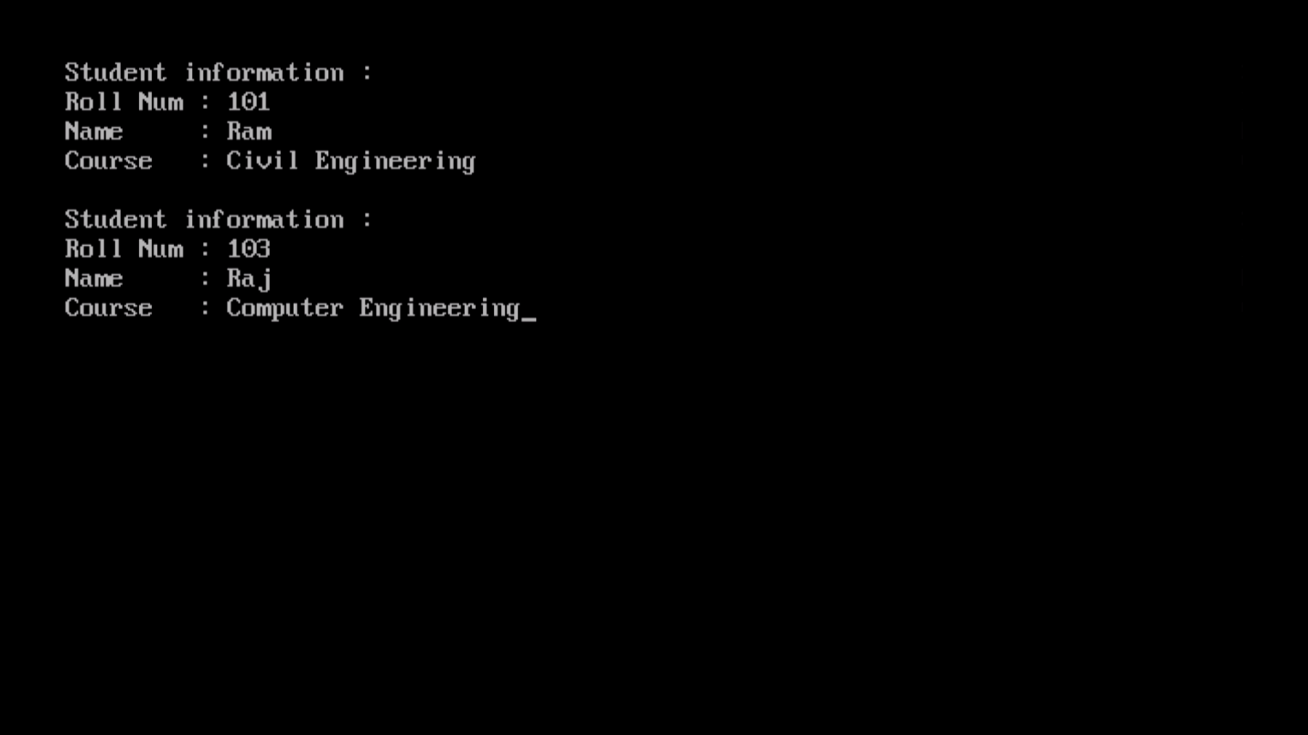

**Q2.) b.**

**( without reference argument in friend function)**

**#include<iostream.h>**

**#include<conio.h>**

**class xyz; // class declaration**

**class abc // class declaration and defination**

**{**

**int value1;**

**public:**

**abc(int x)**

**{**

**value1 = x;**

**}**

**void display()**

**{**

**cout <<"value 1 = " << value1;**

**}**

**friend void swap(abc , xyz); // friend function declaration**

**}; // class abc end**

**class xyz // class defination**

**{**

**int value2;**

**public:**

**xyz(int y)**

**{**

**value2 = y;**

**}**

**void display()**

**{**

**cout <<", value2 = " << value2 << endl;**

**}**

**friend void swap(abc , xyz); // friend function declaration**

**}; // class xyz end**

**void swap(abc o1 , xyz o2) // using reference argument**

**{**

**int temp;**

**temp = o1.value1;**

**o1.value1 = o2.value2;**

**o2.value2 = temp;**

**cout <<"value 1 = " << o1.value1 << ", value2 = " << o2.value2 << endl;**

**} // swap end**

**void main(void)**

**{**

**clrscr();**

**abc a(33);**

**xyz x(44);**

**a.display();**

**x.display();**

**swap(a , x);**

**getch();**

**}**

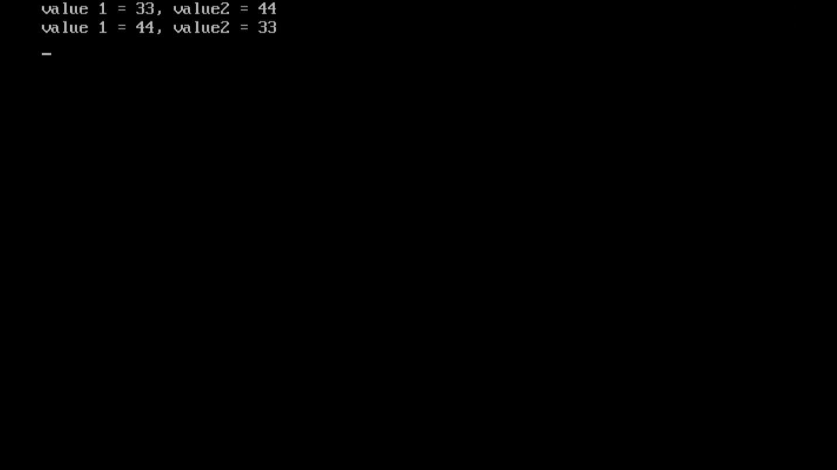

**Q2.) b.**

**( with reference argument in friend function)**

**#include<iostream.h>**

**#include<conio.h>**

**class xyz; // class declaration**

**class abc // class declaration and defination**

**{**

**int value1;**

**public:**

**abc(int x)**

**{**

**value1 = x;**

**}**

**void display()**

**{**

**cout <<"value 1 = " << value1;**

**}**

**friend void swap(abc & , xyz &);**

**// friend function declaration**

**// with reference argument**

**}; // class abc end**

**class xyz // class defination**

**{**

**int value2;**

**public:**

**xyz(int y)**

**{**

**value2 = y;**

**}**

**void display()**

**{**

**cout <<", value2 = " << value2 << endl;**

**}**

**friend void swap(abc & , xyz &);**

**// friend function declaration**

**// with reference argument**

**}; // class xyz end**

**void swap(abc &o1 , xyz &o2) // using reference argument**

**{**

**int temp;**

**temp = o1.value1;**

**o1.value1 = o2.value2;**

**o2.value2 = temp;**

**} // swap end**

**void main(void)**

**{**

**clrscr();**

**abc a(33);**

**xyz x(44);**

**a.display();**

**x.display();**

**swap(a , x);**

**a.display();**

**x.display();**

**getch();**

**}**

