Lab-04

File Creation
Code:
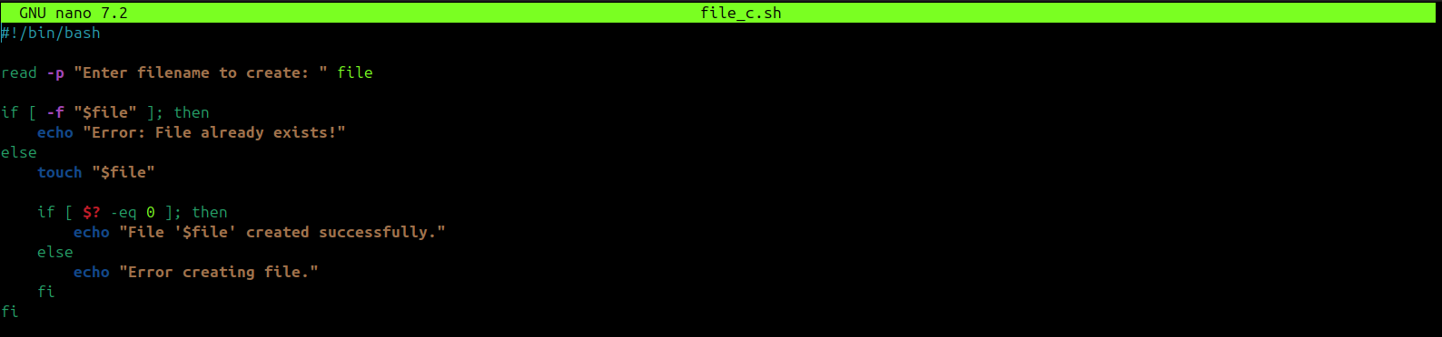

Output:

File Copying

Code:
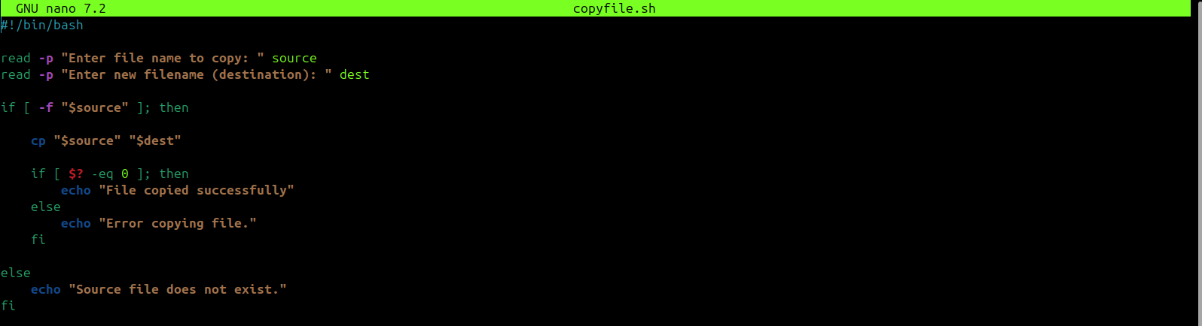

Output:
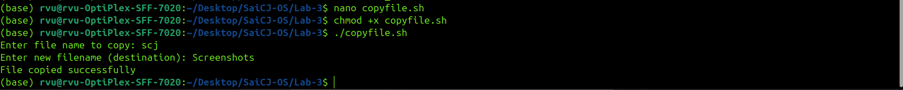

File Moving
Code:
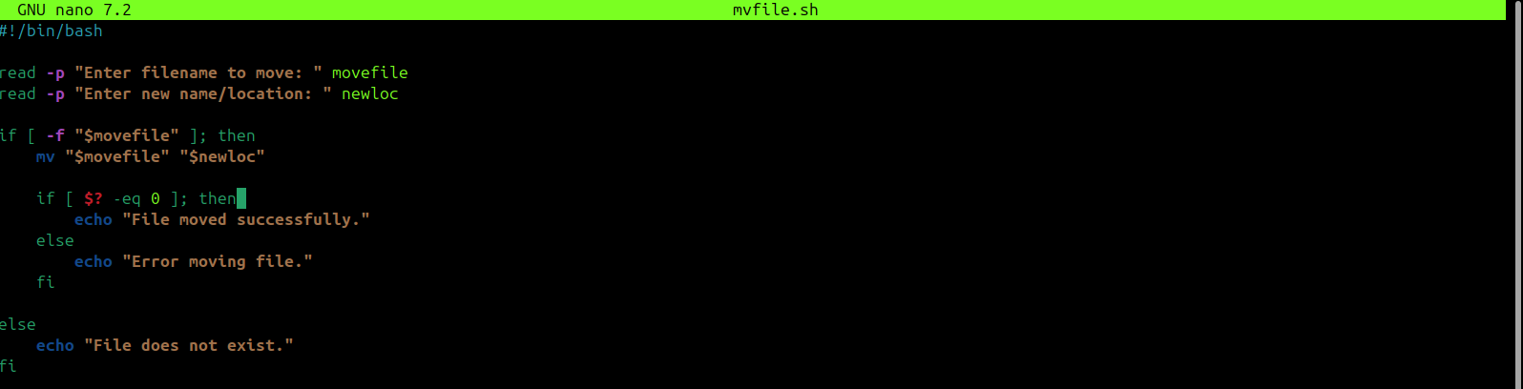

Output:

File Deletion

Code:
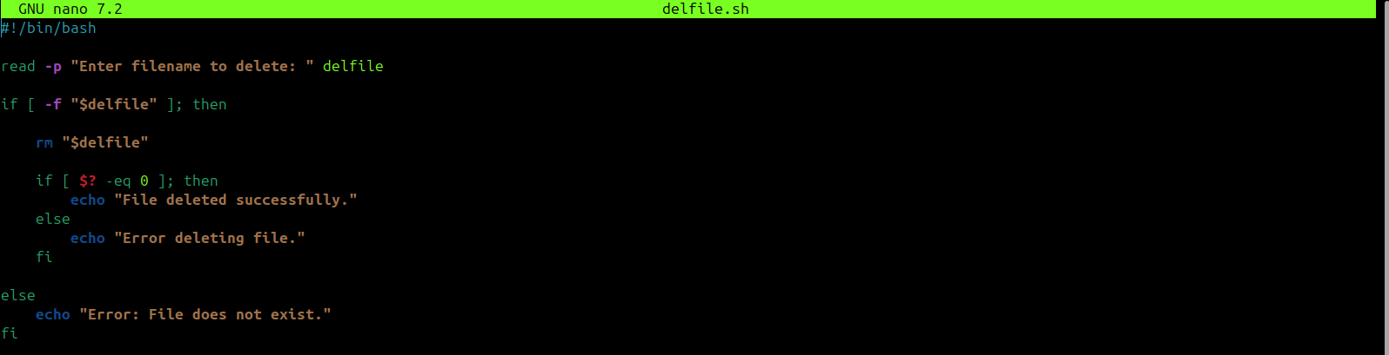

Output:

