File Permissions

Q. Write a shell script to modify file permissions and ownership using chmod and chown. Include user input for the filename and desired permissions, and display the new file permissions.

Code:
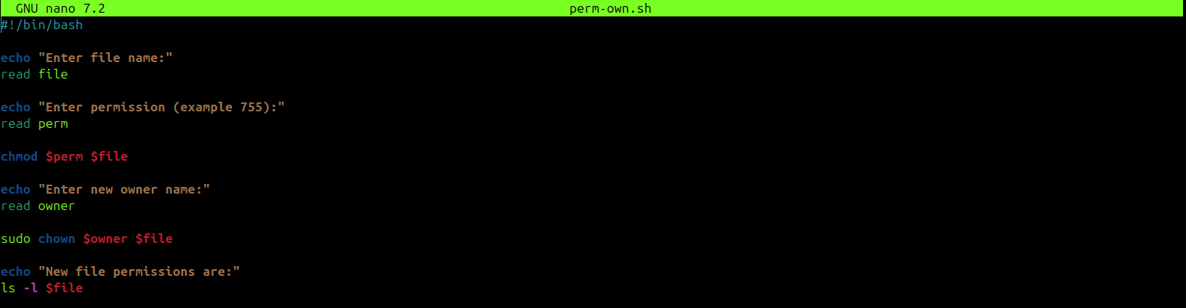

Output:
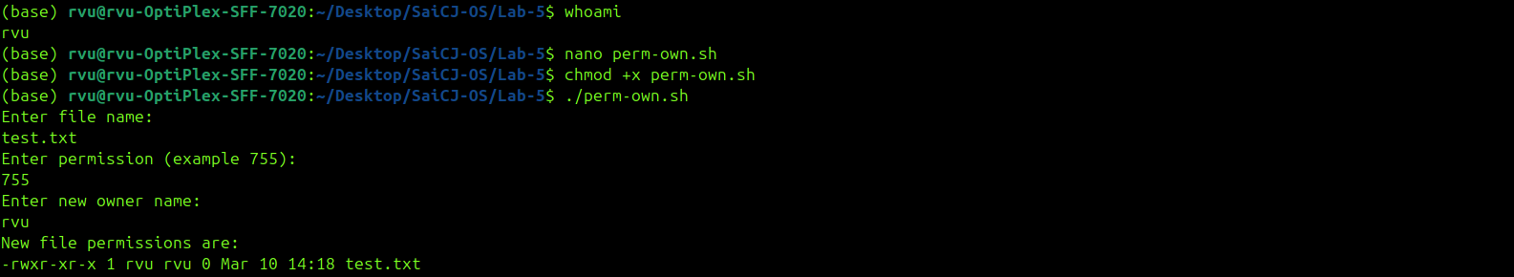

Q.Write a shell script to modify file permissions and ownership using chmod and chown. Include user input for the filename and desired permissions, and display the new file permissions.
Code:
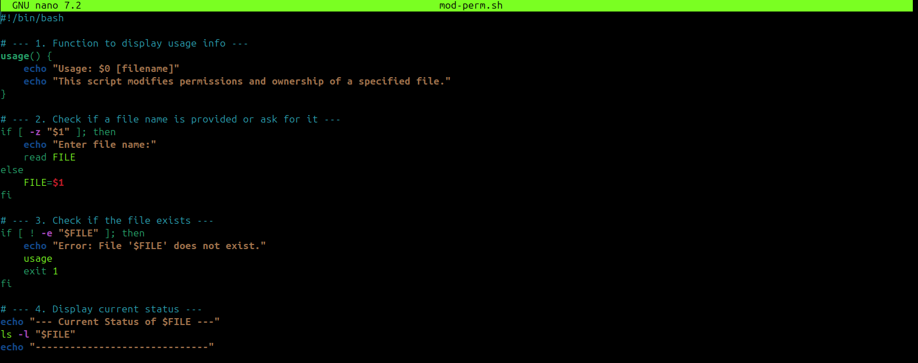
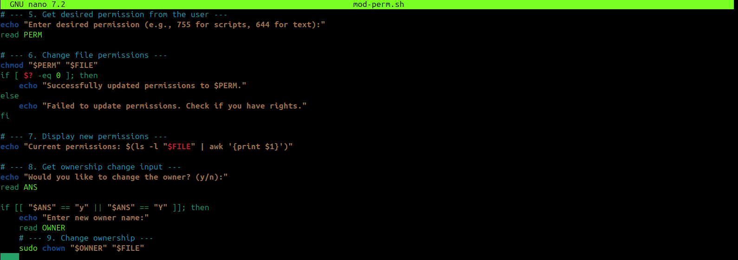
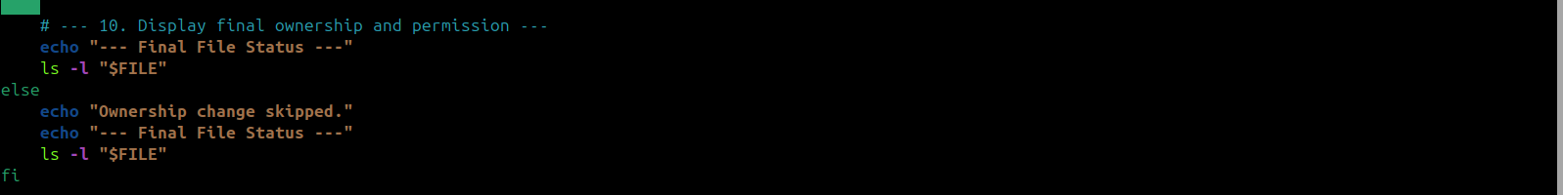

Output:
