what is operating system

Operating system is nothing but a software that enables communication between hardware and user…

Types of operating system:

Windows :

Microsoft Windows, also called Windows and Windows OS, computer operating system (OS) developed by Microsoft Corporation to run personal computers (PCs). Featuring the first graphical user interface (GUI) for IBM-compatible PCs, the Windows OS soon dominated the PC market.

Linux:

Linux is the best-known and most-used open source operating system.

Or

Operating System is system software that manages computer hardware, software resources, and provides common services for computer programs.

MAC os:

macOS is a series of proprietary graphical operating systems developed and marketed by Apple Inc. since 2001. It is the primary operating system for Apple's Mac computers. Within the market of desktop, laptop and home computers, and by web usage, it is the second most widely used desktop OS, after Microsoft Windows

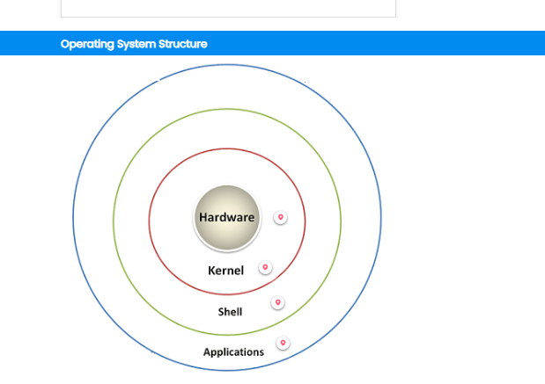

Applications:

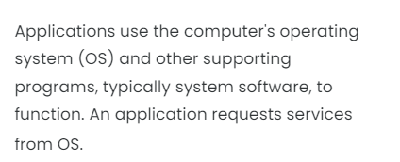

Shell:

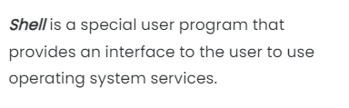

Kernel:

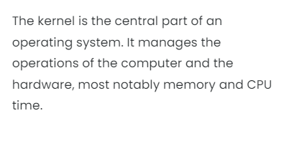

Hardware:

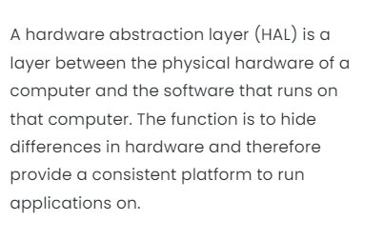

**Functions of Operating System**

**Process management:**

Processor management Keeps tracks of processor and status of the process

Memory management:

Memory management is the process of controlling and coordinating computer memory.

3.Error reporting could be used for reporting errors in Operating System.

DOS:

Disk operating system…

Open source operating system..

FreeDOS is an open source DOS-compatible operating system that you can use to play classic DOS games, run legacy business software, or develop embedded systems. Any program that works on MS-DOS should also run on FreeDOS. You can play your favorite DOS games on FreeDOS.16-Jul-2023

**What is RedHat?**

Red Hat is the world's leading provider of open-source software solutions, using a community-powered approach to reliable and high-performance cloud, Linux, middleware, storage, and virtualization technologies.

Why linux?

Installing Linux on your PC is a simple task, and it protects your system from harmful viruses and malware. The main important aspect of these types of platforms is “Security” and while building the Linux platform it was taken into consideration. It is more stable when compared to the Windows platform.

>A Windows user needs to interoperate with Linux.

>In application development, Linux hosts the application or its runtime.

>In cloud computing, the cloud instances in the private or public cloud environment use Linux as the operating system.

>With mobile applications or the Internet of Things (IoT), the chances are high that the operating system of your device uses Linux.

>If you are looking for new opportunities in IT, Linux skills are in high demand.

Distributions in linux:

1)Red hat

2)Fedora

3)Cent os

4)susi

5)Debian

6)ubuntu

7)Mint

* Red Hat Enterprise Linux is a popular enterprise Linux distribution that is known for its stability and security. It is based on the Fedora distribution and is supported by Red Hat.
* Fedora is a community-driven Linux distribution that is known for its cutting-edge features and software. It is not as stable as RHEL, but it is a good choice for users who want to try out new technologies.
* CentOS is a free and open source clone of RHEL. It is a good choice for businesses and organizations that want the stability and security of RHEL without the cost of a commercial subscription.
* SuSE Linux Enterprise Server is a commercial Linux distribution that is known for its ease of use and comprehensive software selection. It is a good choice for businesses and organizations that need a stable and supported Linux platform.
* Debian is a popular Linux distribution that is known for its stability and security. It is a good choice for home users and hobbyists who want a reliable and customizable Linux platform.
* Linux Mint is a user-friendly Linux distribution that is based on Ubuntu. It is a good choice for home users who want a simple and easy-to-use Linux platform.
* Ubuntu is a popular Linux distribution that is known for its user-friendliness and community support. It is a good choice for home users and businesses that want a reliable and easy-to-use Linux platform.

Ssd->solid state drive……….

File permissions: File permissions are core to the security model used by Linux systems. They determine who can access files and directories on a system and how.

**Types of Linux File permissions**

1.Read : (r)

Read permission give you the authority to open and read a file. Read permission on a directory gives you the ability to lists its content.

2.Write: (w)

Write permission gives you the authority to modify the contents of a file. The write permission on a directory gives you the authority to add, remove and rename files stored in the directory.

3.Execute: (x)

In Windows, an executable program permissions usually has an extension ".exe" and which you can easily run. In Unix/Linux, you cannot run a program unless the execute permission is set. If the execute is not set, you might still be able to see/modify the program code(provided read & write permissions are set), but not run it.

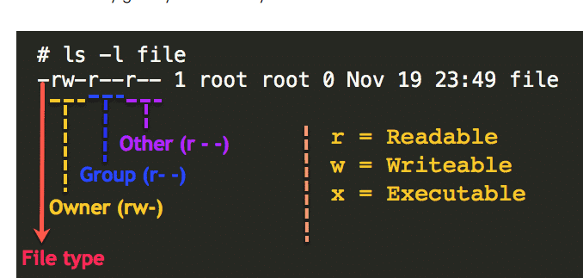

File type ->owner ->group ->other

Ownership:

Owner -User:

User is the owner of the file. By default, the person who created a file becomes its owner. Hence, a user is also sometimes called an owner.

Group:

Group is nothing but collection of users…The main aim of a group is to define a previliges like read,write and execute permission for a given resource that can be shared among the multiple users within the group….

Or

GROUP-user-group can contain multiple users. All users belonging to a group will have the same Linux group permissions access to the file.

Others:

Other user who has access to a file. This person has neither created the file, nor he belongs to a user group who could own the file. Practically, it means everybody else. Hence, when you set the permission for others, it is also referred as set permissions for the world.

Ports:

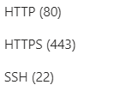

Rdp-3389

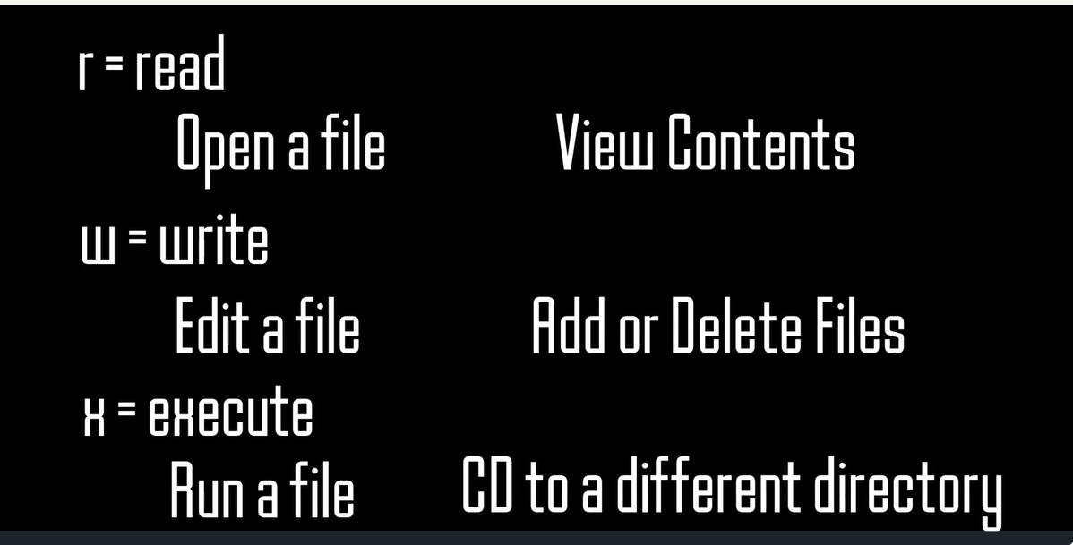

How do you view Linux file permissions?

The ls command along with its -l (for long listing) option will show you metadata about your Linux files, including the permissions set on the file.

$ ls -l

drwxr-xr-x. 4 root root 68 Jun 13 20:25 tuned

-rw-r--r--. 1 root root 4017 Feb 24 2022 vimrc

* File type: -
* Permission settings: rw-r--r--
* Extended attributes: dot (.)
* User owner: root
* Group owner: root

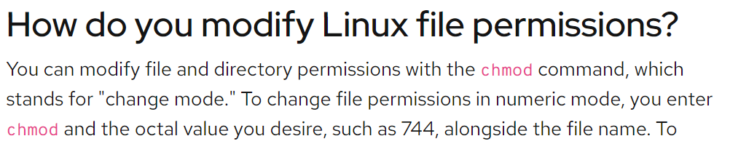

. In symbolic mode, chmod u represents permissions for the user owner, chmod g represents other users in the file's group, chmod o represents other users not in the file's group. For all users, use chmod a.

Lab:

Ssh username@ip address

Click yes

Then ip address

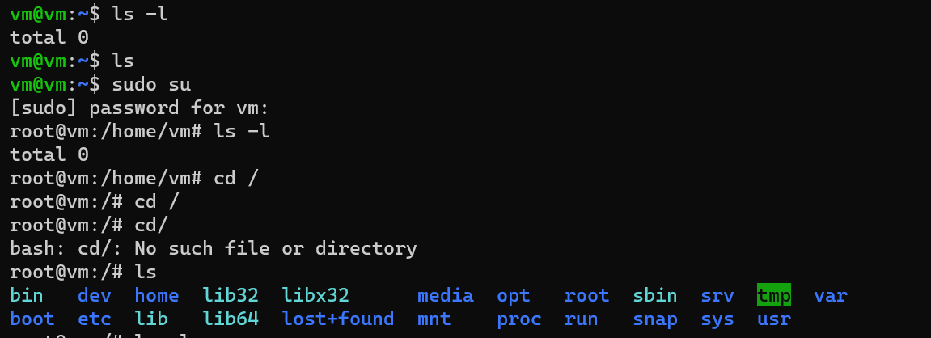

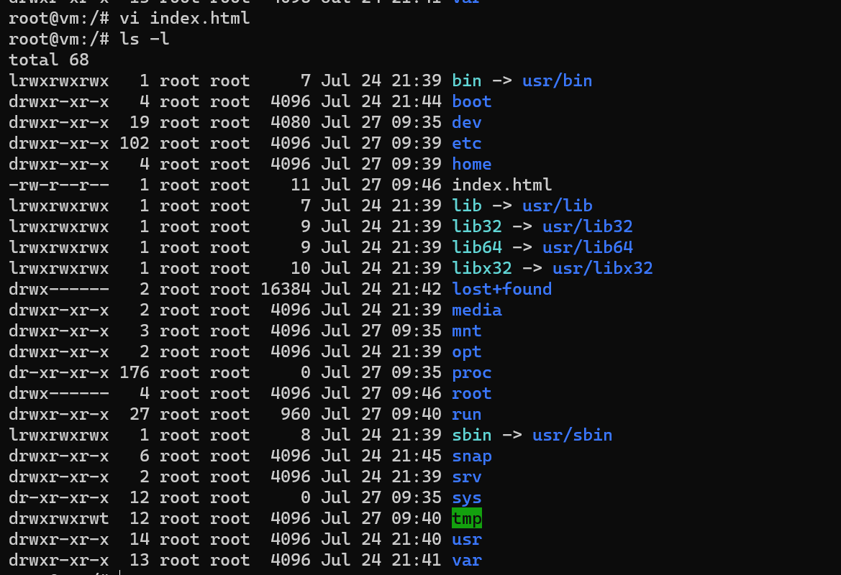

Index.html file is created …..and it has permission like this -rw-r- -r - -

File type -owner-group -other…….

Now change the file permissions of index.html using chmod(change mode)

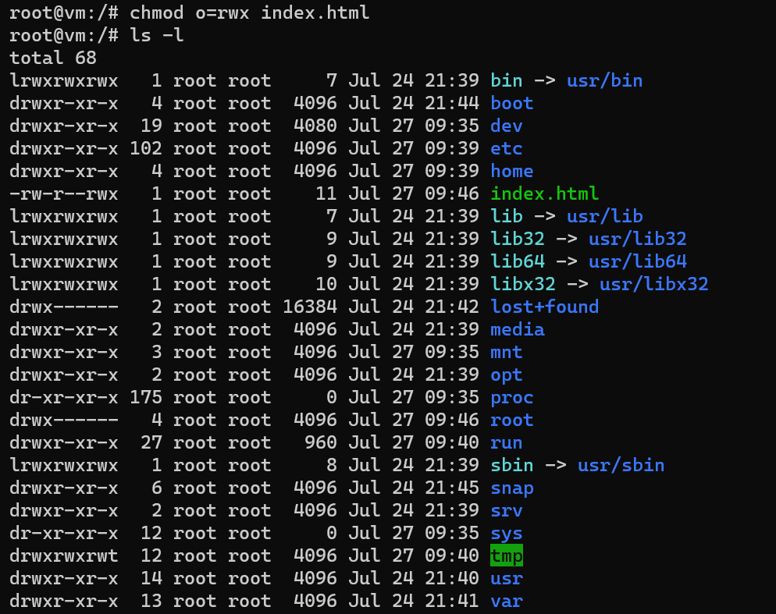

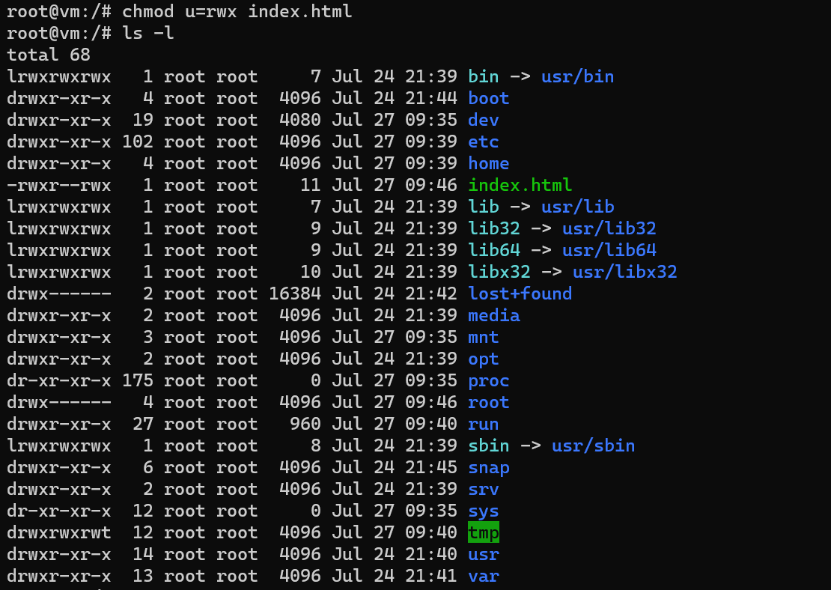

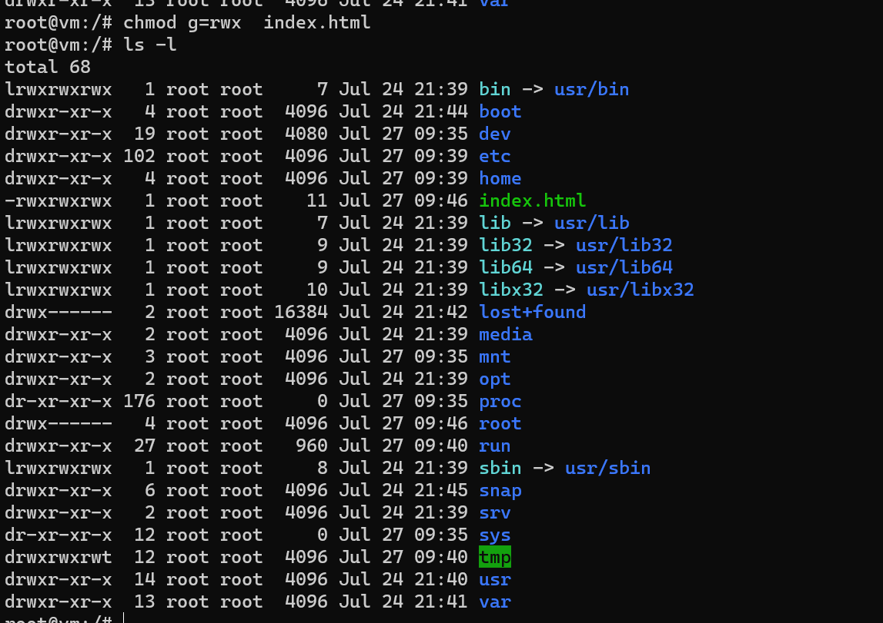

Now the file permissions of index.html has changed….now access has given to everyone….owner,group,others…

If we want to disable any permissions for any body…

chmod o=index.html

chmod u=index.html

chmod g=index.html

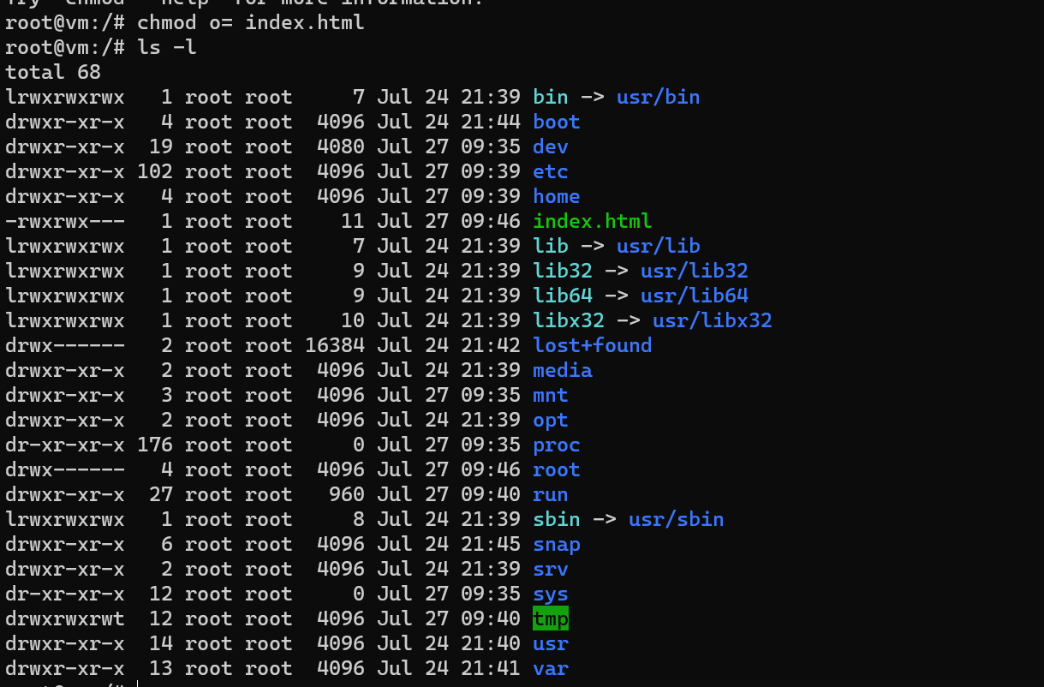

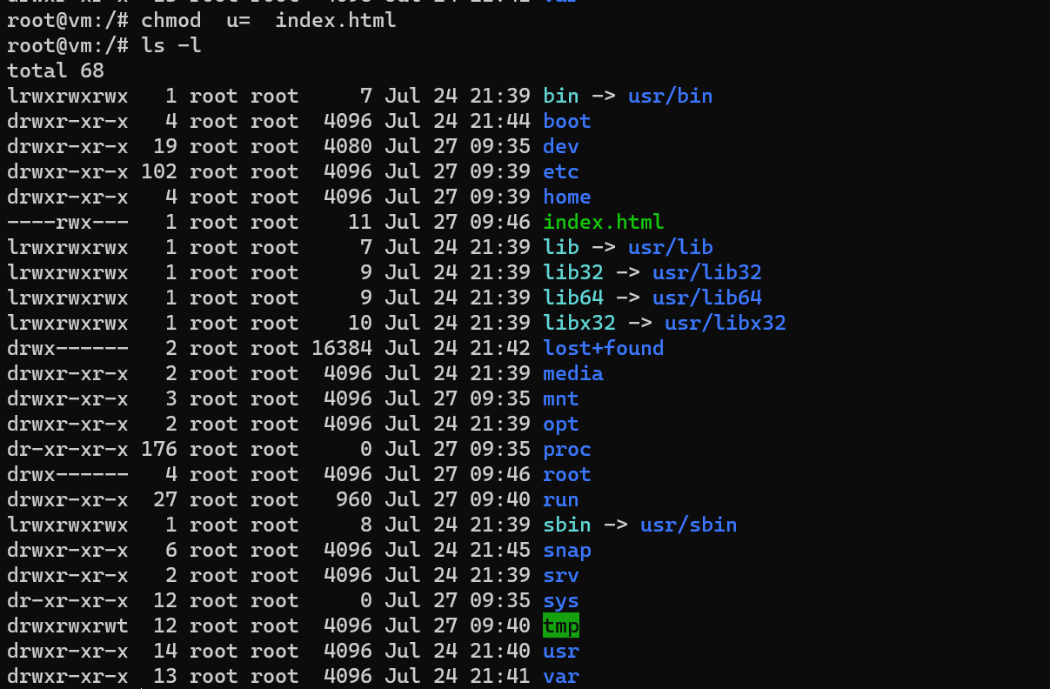

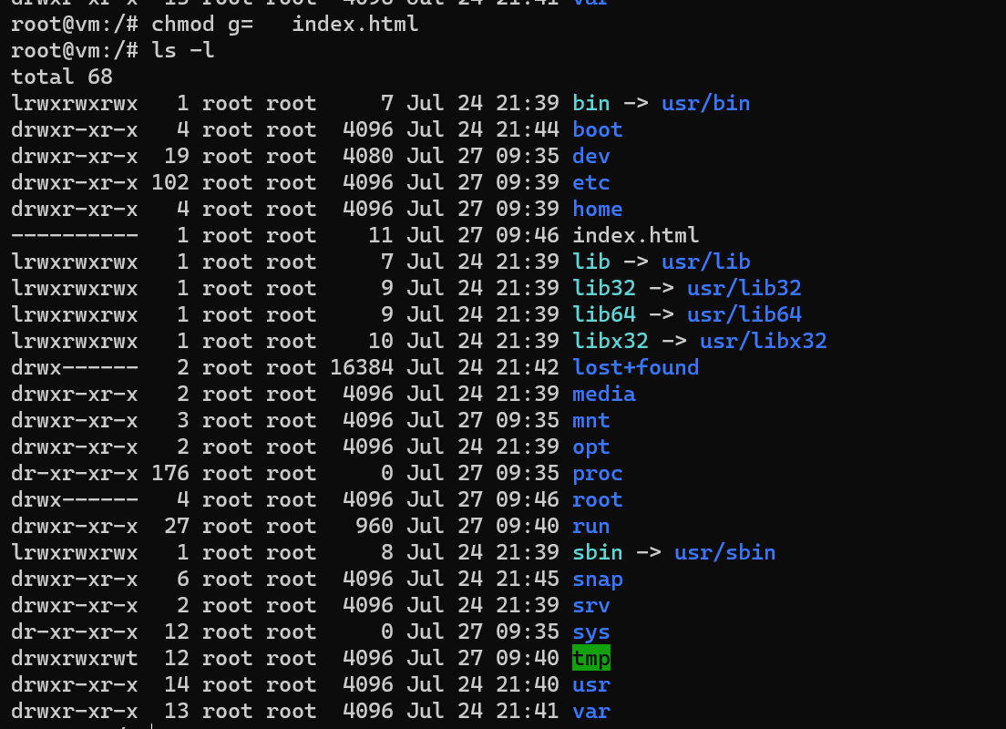

. For all users, use chmod a.

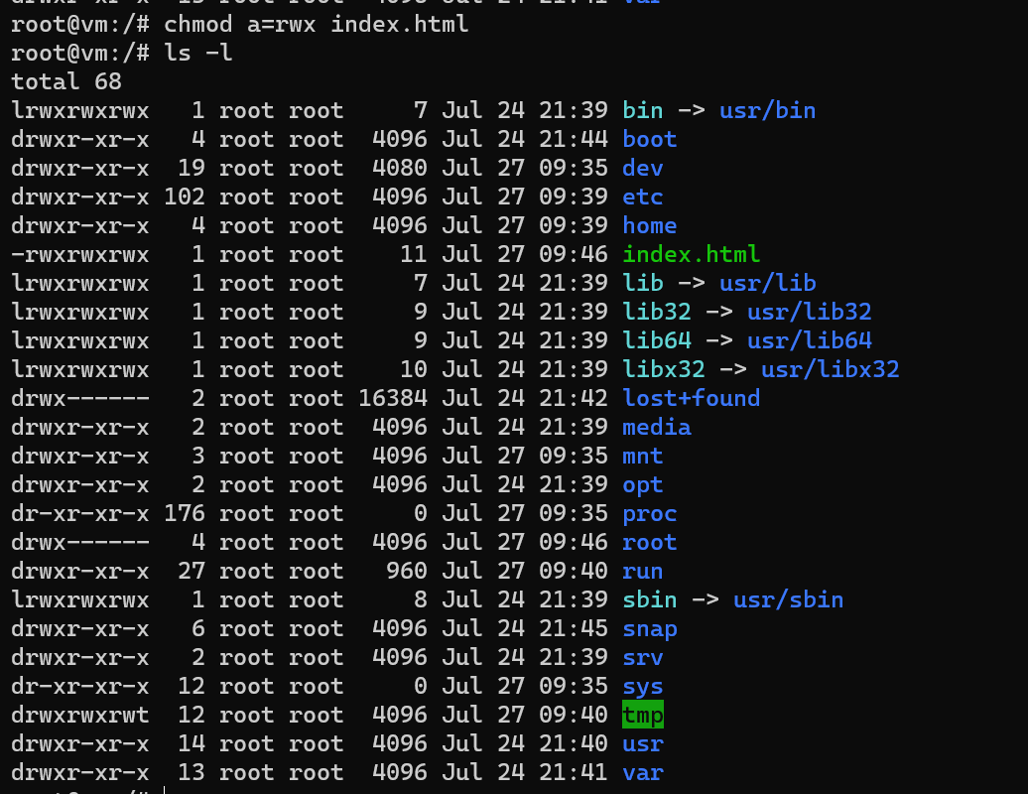

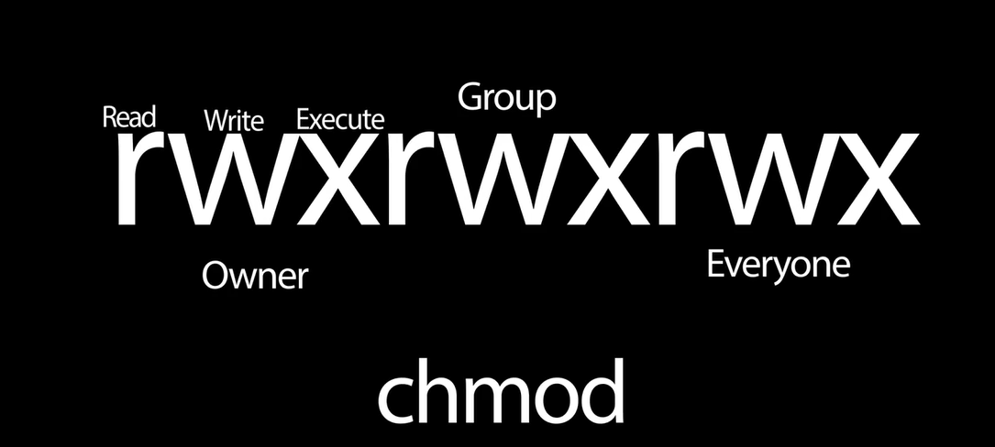

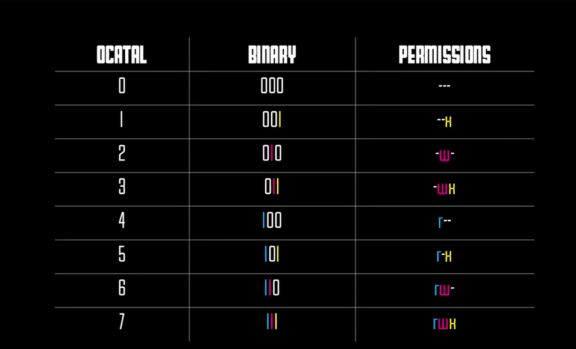

 =4

=2

=1

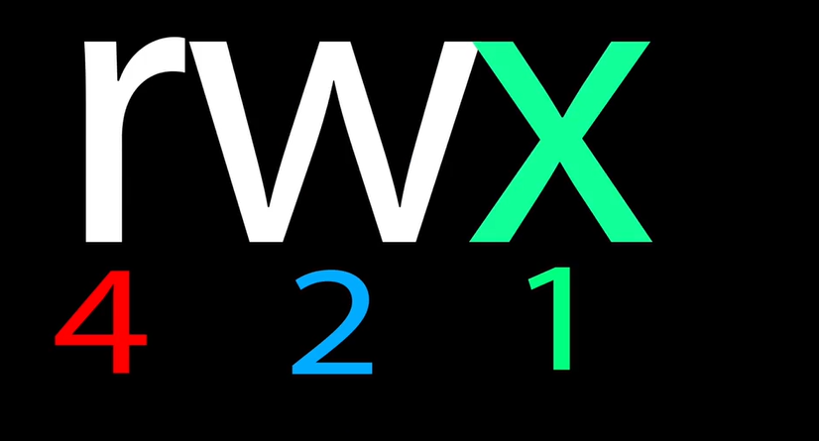

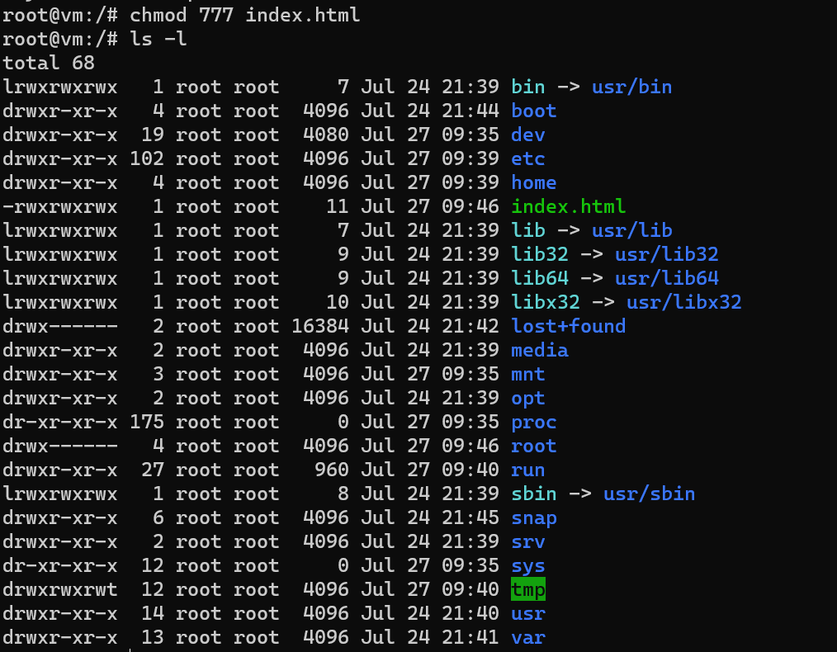

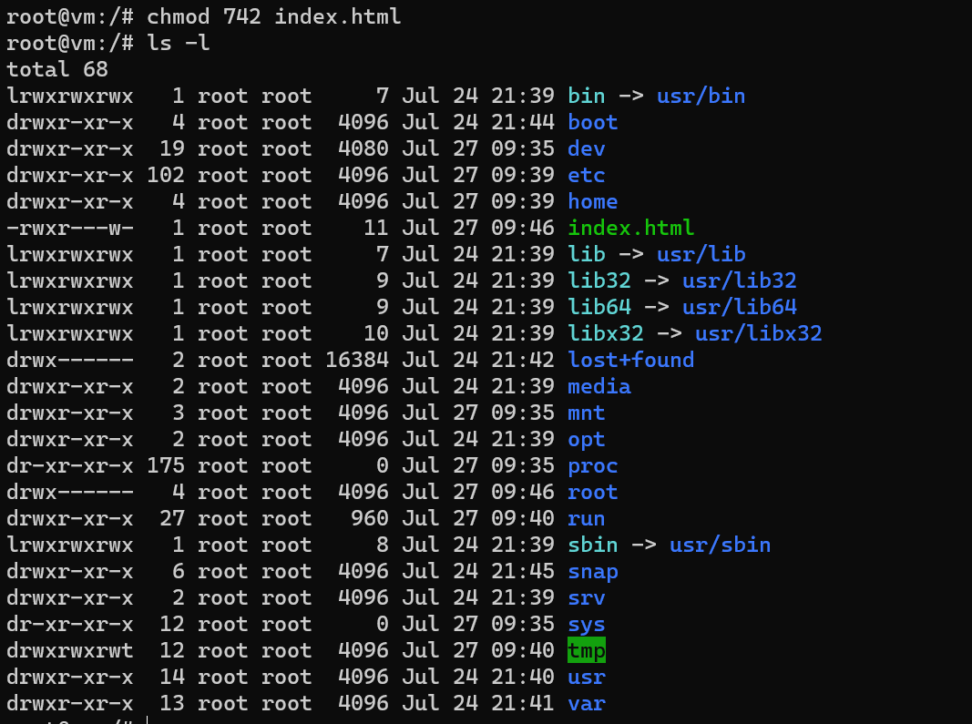

To change the owner of a file ….and this command requires sudo

Sudo chown newownername filename

Now see the result:

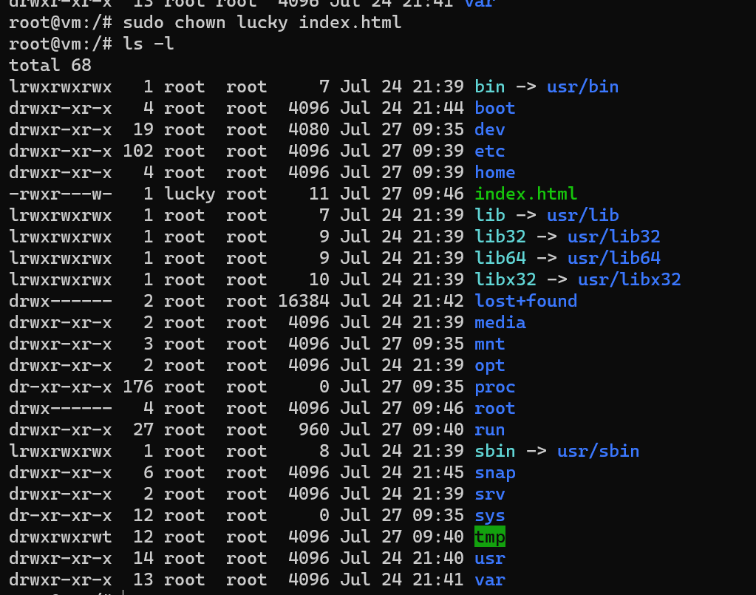

passwd changes user passwords

