# Appendices

# Appendix A: Tests for prior season catch as covariate

Table A1. Model selection tests of time-dependency the log catch during spawning months using F-tests of nested linear models. $S_{t}$ is the catch during the spawning period (Jul-Sep). $N_{t}$ is the catch during the non-spawning period (Oct-Jun). $S_{t-1}$ and $N_{t-1}$ are the catch during the prior season during and after the spawning period respectively. $S_{t-2}$ and $N_{t-2}$ are the same for two seasons prior. Test A uses catch during the spawning period as the explanatory variable. Test B uses catch during the non-spawning period as the explanatory variable. Test C uses both. For Test C, the nestedness is lines 1-3 and lines 1-2 and 4.

|  |  |  |  |  |  |
| --- | --- | --- | --- | --- | --- |
| Model | Residual df | Residual deviance | F | p value | AIC |
| Time dependency test A 1983-2015 data |  |  |  |  |  |
| $ln(S_{t})$ = $α$ + $ϵ$ | 32 | 65.09 |  |  | 120.07 |
| (Var($ϵ$) = 2.03) |  |  |  |  |  |
| $ln(S_{t})$ = $α$ + $βln(S_{t-1})$ + $ϵ$ | 31 | 56.91 | 4.61 | 0.04 | 117.63 |
| ( $R^{2}adj$ = 10%, Var($ϵ$) = 1.84) |  |  |  |  |  |
| $ln(S_{t})$ = $α$ + $β_{1}ln(S_{t-1})$ + $β_{2}ln(S_{t-2})$ + $ϵ$ | 30 | 53.27 | 2.05 | 0.163 | 117.45 |
| ( $R^{2}adj$ = 13%, Var($ϵ$) = 1.78) |  |  |  |  |  |
|  |  |  |  |  |  |
| Time dependency test B 1983-2015 data |  |  |  |  |  |
| $ln(S_{t})$ = $α$ + $ϵ$ | 32 | 65.09 |  |  | 120.07 |
| (Var($ϵ$) = 2.03) |  |  |  |  |  |
| $ln(S_{t})$ = $α$ + $βln(N_{t-1})$ + $ϵ$ | 31 | 48.33 | 10.45 | 0.003 | 112.24 |
| ( $R^{2}adj$ = 23%, Var($ϵ$) = 1.56) |  |  |  |  |  |
| $ln(S_{t})$ = $α$ + $β_{1}ln(N_{t-1})$ + $β_{2}ln(N_{t-2})$ + $ϵ$ | 30 | 48.11 | 0.14 | 0.714 | 114.09 |
| ( $R^{2}adj$ = 21%, Var($ϵ$) = 1.6) |  |  |  |  |  |
|  |  |  |  |  |  |
| Time dependency test C 1983-2015 data |  |  |  |  |  |
| $ln(S_{t})$ = $α$ + $βln(N_{t-1})$ + $ϵ$ | 31 | 48.33 |  |  | 112.24 |
| ( $R^{2}adj$ = 23%, Var($ϵ$) = 1.56) |  |  |  |  |  |
| $ln(S_{t})$ = $α$ + $β_{1}ln(N_{t-1})$ + $β_{2}ln(S_{t-1})$ + $ϵ$ | 30 | 47.65 | 0.43 | 0.517 | 113.77 |
| ( $R^{2}adj$ = 22%, Var($ϵ$) = 1.59) |  |  |  |  |  |
| $ln(S_{t})$ = $α$ + $β_{1}ln(N_{t-1})$ + $β_{2}ln(S_{t-2})$ + $ϵ$ | 30 | 47.89 | 0.28 | 0.601 | 113.94 |
| ( $R^{2}adj$ = 22%, Var($ϵ$) = 1.6) |  |  |  |  |  |

Table A2. Model selection tests of time-dependency the catch during spawning months using non-linear responses instead of linear responses as in Table A1 See Table A1 for an explanation of the parameters and model set-up.

|  |  |  |  |  |  |
| --- | --- | --- | --- | --- | --- |
| Model | Residual df | Residual deviance | F | p value | AIC |
| Time dependency test A 1983-2015 data |  |  |  |  |  |
| $ln(S_{t})$ = $α$ + $βln(S_{t-1})$ + $ϵ$ | 31 | 56.91 |  |  | 117.63 |
| ( $R^{2}adj$ = 10%, Var($ϵ$) = 1.84) |  |  |  |  |  |
| $ln(S_{t})$ = $α$ + $s(ln(S_{t-1}))$ + $ϵ$ | 29 | 48.2 | 2.73 | 0.085 | 115.01 |
| ( $R^{2}adj$ = 20%, Var($ϵ$) = 1.63) |  |  |  |  |  |
| $ln(S_{t})$ = $α$ + $s_{1}(ln(S_{t-1}))$ + $s_{2}(ln(S_{t-2}))$ + $ϵ$ | 26.2 | 44.27 | 0.86 | 0.466 | 116.82 |
| ( $R^{2}adj$ = 20%, Var($ϵ$) = 1.62) |  |  |  |  |  |
|  |  |  |  |  |  |
| Time dependency test B 1983-2015 data |  |  |  |  |  |
| $ln(S_{t})$ = $α$ + $βln(N_{t-1})$ + $ϵ$ | 31 | 48.33 |  |  | 112.24 |
| ( $R^{2}adj$ = 23%, Var($ϵ$) = 1.56) |  |  |  |  |  |
| $ln(S_{t})$ = $α$ + $s(ln(N_{t-1}))$ + $ϵ$ | 29.6 | 44.66 | 1.71 | 0.203 | 111.57 |
| ( $R^{2}adj$ = 27%, Var($ϵ$) = 1.49) |  |  |  |  |  |
| $ln(S_{t})$ = $α$ + $s_{1}(ln(N_{t-1}))$ + $s_{2}(ln(N_{t-2}))$ + $ϵ$ | 27.3 | 42.64 | 0.57 | 0.594 | 113.79 |
| ( $R^{2}adj$ = 26%, Var($ϵ$) = 1.51) |  |  |  |  |  |
|  |  |  |  |  |  |
| Time dependency test C 1983-2015 data |  |  |  |  |  |
| $ln(S_{t})$ = $α$ + $s(ln(N_{t-1}))$ + $ϵ$ | 29.6 | 44.66 |  |  | 111.57 |
| ( $R^{2}adj$ = 27%, Var($ϵ$) = 1.49) |  |  |  |  |  |
| $ln(S_{t})$ = $α$ + $s_{1}(ln(N_{t-1}))$ + $s_{2}(ln(S_{t-1}))$ + $ϵ$ | 26.9 | 38.53 | 1.66 | 0.202 | 111.12 |
| ( $R^{2}adj$ = 32%, Var($ϵ$) = 1.39) |  |  |  |  |  |
| $ln(S_{t})$ = $α$ + $s_{1}(ln(N_{t-1}))$ + $s_{2}(ln(S_{t-2}))$ + $ϵ$ | 26.8 | 40.64 | 0.98 | 0.414 | 113.05 |
| ( $R^{2}adj$ = 28%, Var($ϵ$) = 1.47) |  |  |  |  |  |

Table A3. Model selection tests of time-dependency for the catch during spawning months using 1956-2015 data. See Table A1 for definitions.

|  |  |  |  |  |  |
| --- | --- | --- | --- | --- | --- |
| Model | Residual df | Residual deviance | F | p value | AIC |
| Time dependency test B linear 1956-2015 data |  |  |  |  |  |
| $ln(S_{t})$ = $α$ + $ϵ$ | 57 | 80.84 |  |  | 187.85 |
| ( $R^{2}adj$ = 0%, Var($ϵ$) = 1.42) |  |  |  |  |  |
| $ln(S_{t})$ = $α$ + $βln(N_{t-1})$ + $ϵ$ | 56 | 67.58 | 10.79 | 0.002 | 179.46 |
| ( $R^{2}adj$ = 15%, Var($ϵ$) = 1.21) |  |  |  |  |  |
| $ln(S_{t})$ = $α$ + $β_{1}ln(N_{t-1})$ + $β_{2}ln(N_{t-2})$ + $ϵ$ | 55 | 67.58 | 0 | 0.97 | 181.46 |
| ( $R^{2}adj$ = 13%, Var($ϵ$) = 1.23) |  |  |  |  |  |
|  |  |  |  |  |  |
| Linearity test 1956-2015 data |  |  |  |  |  |
| $ln(S_{t})$ = $α$ + $βln(N_{t-1})$ + $ϵ$ | 56 | 67.58 |  |  | 179.46 |
| ( $R^{2}adj$ = 15%, Var($ϵ$) = 1.21) |  |  |  |  |  |
| $ln(S_{t})$ = $α$ + $s(ln(N_{t-1}))$ + $ϵ$ | 54.6 | 65.7 | 1.13 | 0.312 | 179.64 |
| ( $R^{2}adj$ = 16%, Var($ϵ$) = 1.19) |  |  |  |  |  |
| $ln(S_{t})$ = $α$ + $s_{1}(ln(N_{t-1}))$ + $s_{2}(ln(N_{t-2}))$ + $ϵ$ | 52.3 | 65 | 0.25 | 0.811 | 182.78 |
| ( $R^{2}adj$ = 14%, Var($ϵ$) = 1.22) |  |  |  |  |  |

# 

Table A4. Model selection tests of time-dependency the $N_{t}$ model using F-tests of nested models fit to 1983 to 2014 log landings data. The years are determined by the covariate data availability. $N_{t}$ is the catch during the non-spawning period (Qtrs 4, 1 and 2: Oct-Jun) of season $t$ (Jul-Jun). $S_{t-1}$ and $N_{t-1}$ are the catch during the prior sardine season during and after the spawning period respectively. $S_{t-2}$ and $N_{t-2}$ are the same for two seasons prior. Test A uses catch during the spawning period as the explanatory variable. Test B uses catch during the non-spawning period as the explanatory variable. Test C uses both. For Test C, the nestedness is lines 1-3 and lines 1-2 and 4.

|  |  |  |  |  |  |
| --- | --- | --- | --- | --- | --- |
| Model | Residual df | Residual deviance | F | p value | AIC |
| Time dependency test A 1983-2014 data |  |  |  |  |  |
| $ln(N_{t})$ = $α$ + $ϵ$ | 31 | 46.19 |  |  | 106.56 |
| (Var($ϵ$) = 1.49) |  |  |  |  |  |
| $ln(N_{t})$ = $α$ + $βln(S_{t-1})$ + $ϵ$ | 30 | 32.39 | 12.77 | 0.001 | 97.2 |
| ( $R^{2}adj$ = 28%, Var($ϵ$) = 1.08) |  |  |  |  |  |
| $ln(N_{t})$ = $α$ + $β_{1}ln(S_{t-1})$ + $β_{2}ln(S_{t-2})$ + $ϵ$ | 29 | 31.31 | 1 | 0.325 | 98.12 |
| ( $R^{2}adj$ = 28%, Var($ϵ$) = 1.08) |  |  |  |  |  |
|  |  |  |  |  |  |
| Time dependency test B 1983-2014 data |  |  |  |  |  |
| $ln(N_{t})$ = $α$ + $ϵ$ | 31 | 46.19 |  |  | 106.56 |
| (Var($ϵ$) = 1.49) |  |  |  |  |  |
| $ln(N_{t})$ = $α$ + $βln(N_{t-1})$ + $ϵ$ | 30 | 27.41 | 20.17 | 0 | 91.85 |
| ( $R^{2}adj$ = 39%, Var($ϵ$) = 0.91) |  |  |  |  |  |
| $ln(N_{t})$ = $α$ + $β_{1}ln(N_{t-1})$ + $β_{2}ln(N_{t-2})$ + $ϵ$ | 29 | 27 | 0.43 | 0.517 | 93.38 |
| ( $R^{2}adj$ = 38%, Var($ϵ$) = 0.93) |  |  |  |  |  |
|  |  |  |  |  |  |
| Time dependency test C 1983-2014 data |  |  |  |  |  |
| $ln(N_{t})$ = $α$ + $βln(N_{t-1})$ + $ϵ$ | 30 | 27.41 |  |  | 91.85 |
| ( $R^{2}adj$ = 39%, Var($ϵ$) = 0.91) |  |  |  |  |  |
| $ln(N_{t})$ = $α$ + $β_{1}ln(N_{t-1})$ + $β_{2}ln(S_{t-1})$ + $ϵ$ | 29 | 27.32 | 0.1 | 0.759 | 93.75 |
| ( $R^{2}adj$ = 37%, Var($ϵ$) = 0.94) |  |  |  |  |  |
| $ln(N_{t})$ = $α$ + $β_{1}ln(N_{t-1})$ + $β_{2}ln(S_{t-2})$ + $ϵ$ | 29 | 27.4 | 0.01 | 0.93 | 93.84 |
| ( $R^{2}adj$ = 37%, Var($ϵ$) = 0.94) |  |  |  |  |  |

Table A5. Model selection tests of time-dependency the $N_{t}$ model using non-linear responses instead of linear responses as in Table A4 See Table A4 for an explanation of the parameters and model set-up.

|  |  |  |  |  |  |
| --- | --- | --- | --- | --- | --- |
| Model | Residual df | Residual deviance | F | p value | AIC |
| Time dependency test A 1983-2014 data |  |  |  |  |  |
| $ln(N_{t})$ = $α$ + $βln(S_{t-1})$ + $ϵ$ | 30 | 32.39 |  |  | 97.2 |
| ( $R^{2}adj$ = 28%, Var($ϵ$) = 1.08) |  |  |  |  |  |
| $ln(N_{t})$ = $α$ + $s(ln(S_{t-1}))$ + $ϵ$ | 28.1 | 29.4 | 1.68 | 0.207 | 96.88 |
| ( $R^{2}adj$ = 31%, Var($ϵ$) = 1.03) |  |  |  |  |  |
| $ln(N_{t})$ = $α$ + $s_{1}(ln(S_{t-1}))$ + $s_{2}(ln(S_{t-2}))$ + $ϵ$ | 25.1 | 24.35 | 1.84 | 0.166 | 95.69 |
| ( $R^{2}adj$ = 38%, Var($ϵ$) = 0.93) |  |  |  |  |  |
|  |  |  |  |  |  |
| Time dependency test B 1983-2014 data |  |  |  |  |  |
| $ln(N_{t})$ = $α$ + $βln(N_{t-1})$ + $ϵ$ | 30 | 27.41 |  |  | 91.85 |
| ( $R^{2}adj$ = 39%, Var($ϵ$) = 0.91) |  |  |  |  |  |
| $ln(N_{t})$ = $α$ + $s(ln(N_{t-1}))$ + $ϵ$ | 28.5 | 22.99 | 4.07 | 0.04 | 88.28 |
| ( $R^{2}adj$ = 47%, Var($ϵ$) = 0.79) |  |  |  |  |  |
| $ln(N_{t})$ = $α$ + $s_{1}(ln(N_{t-1}))$ + $s_{2}(ln(N_{t-2}))$ + $ϵ$ | 26.3 | 19.89 | 1.87 | 0.171 | 87.3 |
| ( $R^{2}adj$ = 51%, Var($ϵ$) = 0.73) |  |  |  |  |  |
|  |  |  |  |  |  |
| Time dependency test C 1983-2014 data |  |  |  |  |  |
| $ln(N_{t})$ = $α$ + $s(ln(N_{t-1}))$ + $ϵ$ | 28.5 | 22.99 |  |  | 88.28 |
| ( $R^{2}adj$ = 47%, Var($ϵ$) = 0.79) |  |  |  |  |  |
| $ln(N_{t})$ = $α$ + $s_{1}(ln(N_{t-1}))$ + $s_{2}(ln(S_{t-1}))$ + $ϵ$ | 25.9 | 21.83 | 0.55 | 0.631 | 90.96 |
| ( $R^{2}adj$ = 45%, Var($ϵ$) = 0.81) |  |  |  |  |  |
| $ln(N_{t})$ = $α$ + $s_{1}(ln(N_{t-1}))$ + $s_{2}(ln(S_{t-2}))$ + $ϵ$ | 25.6 | 15.58 | 4.26 | 0.015 | 80.66 |
| ( $R^{2}adj$ = 61%, Var($ϵ$) = 0.59) |  |  |  |  |  |

Table A6. Table A5 with 1956-2015 data instead of 1983 to 2014 data. See Table A4 for an explanation of the parameters and model set-up.

|  |  |  |  |  |  |
| --- | --- | --- | --- | --- | --- |
| Model | Residual df | Residual deviance | F | p value | AIC |
| Time dependency test A 1956-2015 data |  |  |  |  |  |
| $ln(N_{t})$ = $α$ + $βln(S_{t-1})$ + $ϵ$ | 55 | 43.02 |  |  | 151.71 |
| ( $R^{2}adj$ = 19%, Var($ϵ$) = 0.78) |  |  |  |  |  |
| $ln(N_{t})$ = $α$ + $s(ln(S_{t-1}))$ + $ϵ$ | 53.4 | 41.68 | 1.04 | 0.348 | 152.24 |
| ( $R^{2}adj$ = 20%, Var($ϵ$) = 0.77) |  |  |  |  |  |
| $ln(N_{t})$ = $α$ + $s_{1}(ln(S_{t-1}))$ + $s_{2}(ln(S_{t-2}))$ + $ϵ$ | 50.7 | 40.21 | 0.71 | 0.534 | 154.53 |
| ( $R^{2}adj$ = 20%, Var($ϵ$) = 0.78) |  |  |  |  |  |
|  |  |  |  |  |  |
| Time dependency test B 1956-2015 data |  |  |  |  |  |
| $ln(N_{t})$ = $α$ + $βln(N_{t-1})$ + $ϵ$ | 55 | 36.81 |  |  | 142.84 |
| ( $R^{2}adj$ = 31%, Var($ϵ$) = 0.67) |  |  |  |  |  |
| $ln(N_{t})$ = $α$ + $s(ln(N_{t-1}))$ + $ϵ$ | 53.6 | 35.24 | 1.75 | 0.191 | 142.2 |
| ( $R^{2}adj$ = 33%, Var($ϵ$) = 0.65) |  |  |  |  |  |
| $ln(N_{t})$ = $α$ + $s_{1}(ln(N_{t-1}))$ + $s_{2}(ln(N_{t-2}))$ + $ϵ$ | 51.3 | 33.96 | 0.87 | 0.439 | 143.8 |
| ( $R^{2}adj$ = 33%, Var($ϵ$) = 0.65) |  |  |  |  |  |
|  |  |  |  |  |  |
| Time dependency test C 1956-2015 data |  |  |  |  |  |
| $ln(N_{t})$ = $α$ + $s(ln(N_{t-1}))$ + $ϵ$ | 53.6 | 35.24 |  |  | 142.2 |
| ( $R^{2}adj$ = 33%, Var($ϵ$) = 0.65) |  |  |  |  |  |
| $ln(N_{t})$ = $α$ + $s_{1}(ln(N_{t-1}))$ + $s_{2}(ln(S_{t-1}))$ + $ϵ$ | 51.2 | 33.5 | 1.12 | 0.342 | 143.28 |
| ( $R^{2}adj$ = 34%, Var($ϵ$) = 0.64) |  |  |  |  |  |
| $ln(N_{t})$ = $α$ + $s_{1}(ln(N_{t-1}))$ + $s_{2}(ln(S_{t-2}))$ + $ϵ$ | 51 | 33.97 | 0.75 | 0.513 | 144.43 |
| ( $R^{2}adj$ = 32%, Var($ϵ$) = 0.65) |  |  |  |  |  |

Table A7. Model selection tests for the $N_{t}$ model using AIC for models fit to log landings data with catch during the spawning season $S_{t}$ added as a covariate. Data 1983 to 2014 were used.

|  |  |  |  |
| --- | --- | --- | --- |
| Model | Residual df | Residual deviance | AIC |
| Add current season spawning information |  |  |  |
| $ln(N_{t})$ = $α$ + $βln(S_{t})$ + $ϵ$ | 30 | 15.41 | 73.43 |
| ( $R^{2}adj$ = 66%, Var($ϵ$) = 0.51) |  |  |  |
| $ln(N_{t})$ = $α$ + $s(ln(S_{t}))$ + $ϵ$ | 28.2 | 14.79 | 74.64 |
| ( $R^{2}adj$ = 65%, Var($ϵ$) = 0.51) |  |  |  |
| $ln(N_{t})$ = $α$ + $βln(S_{t})$ + $s(ln(S_{t-1}))$ + $ϵ$ | 27.1 | 11.51 | 68.8 |
| ( $R^{2}adj$ = 72%, Var($ϵ$) = 0.42) |  |  |  |
| $ln(N_{t})$ = $α$ + $βln(S_{t})$ + $s(ln(N_{t-1}))$ + $ϵ$ | 27.5 | 10.93 | 66.45 |
| ( $R^{2}adj$ = 74%, Var($ϵ$) = 0.39) |  |  |  |

# 

# Appendix B: Tests for environmental variables as covariates

Table B1. Model selection tests of GPCP precipitation as an explanatory variable for the catch during spawning months (Jul-Sep) using 1983 to 2015 data. The data range is determined by the years for which SST was available in order to use a consistent dataset across covariate tests. $S_{t}$ is the catch during Jul-Sep of season $t$. $V_{t}$ is the covariate in the current season which spans two calendar years from July to June in the next year. $V_{t-1}$ is the covariate in the prior Jul-Jun season.

|  |  |  |  |  |  |
| --- | --- | --- | --- | --- | --- |
| Model | Residual df | Residual deviance | F | p value | AIC |
| V = Jun-Jul Precipitation |  |  |  |  |  |
| $ln(S_{t})$ = $α$ + $s(ln(N_{t-1}))$ + $ϵ$ | 29.6 | 44.66 |  |  | 111.57 |
| ( $R^{2}adj$ = 27%, Var($ϵ$) = 1.49) |  |  |  |  |  |
| $ln(S_{t})$ = $α$ + $s(ln(N_{t-1}))$ + $βV_{t}$ + $ϵ$ | 28.6 | 43.39 | 0.86 | 0.361 | 112.56 |
| ( $R^{2}adj$ = 27%, Var($ϵ$) = 1.49) |  |  |  |  |  |
| $ln(S_{t})$ = $α$ + $s(ln(N_{t-1}))$ + $s(V_{t})$ + $ϵ$ | 26.8 | 40.45 | 1.08 | 0.348 | 112.74 |
| ( $R^{2}adj$ = 29%, Var($ϵ$) = 1.45) |  |  |  |  |  |
| $ln(S_{t})$ = $α$ + $s(ln(N_{t-1}))$ + $s(V_{t})$ + $βV_{t-1}$ + $ϵ$ | 25.9 | 39.91 | 0.37 | 0.543 | 114.23 |
| ( $R^{2}adj$ = 27%, Var($ϵ$) = 1.49) |  |  |  |  |  |
| $ln(S_{t})$ = $α$ + $s(ln(N_{t-1}))$ + $s(V_{t})$ + $s(V_{t-1})$ + $ϵ$ | 24.2 | 39.13 | 0.3 | 0.707 | 115.94 |
| ( $R^{2}adj$ = 25%, Var($ϵ$) = 1.52) |  |  |  |  |  |
|  |  |  |  |  |  |
| V = Apr-May Precipitation |  |  |  |  |  |
| $ln(S_{t})$ = $α$ + $s(ln(N_{t-1}))$ + $ϵ$ | 29.6 | 44.66 |  |  | 111.57 |
| ( $R^{2}adj$ = 27%, Var($ϵ$) = 1.49) |  |  |  |  |  |
| $ln(S_{t})$ = $α$ + $s(ln(N_{t-1}))$ + $βV_{t}$ + $ϵ$ | 28.6 | 43.46 | 0.78 | 0.386 | 112.65 |
| ( $R^{2}adj$ = 26%, Var($ϵ$) = 1.5) |  |  |  |  |  |
| $ln(S_{t})$ = $α$ + $s(ln(N_{t-1}))$ + $s(V_{t})$ + $ϵ$ | 26.8 | 42.17 | 0.45 | 0.621 | 114.13 |
| ( $R^{2}adj$ = 25%, Var($ϵ$) = 1.52) |  |  |  |  |  |
| $ln(S_{t})$ = $α$ + $s(ln(N_{t-1}))$ + $s(V_{t})$ + $βV_{t-1}$ + $ϵ$ | 25.8 | 42.18 | NA | NA | 116.09 |
| ( $R^{2}adj$ = 23%, Var($ϵ$) = 1.57) |  |  |  |  |  |
| $ln(S_{t})$ = $α$ + $s(ln(N_{t-1}))$ + $s(V_{t})$ + $s(V_{t-1})$ + $ϵ$ | 24.1 | 40.14 | 0.76 | 0.459 | 116.79 |
| ( $R^{2}adj$ = 23%, Var($ϵ$) = 1.56) |  |  |  |  |  |

Table B3. Model selection tests of sea surface temperature off Cochi as the explanatory variable ($V$) for the catch during spawning months (Jul-Sep) using 1983 to 2015 data. See Table B1 for an explanation of the models.

|  |  |  |  |  |  |
| --- | --- | --- | --- | --- | --- |
| Model | Residual df | Residual deviance | F | p value | AIC |
| V = Jul-Sep SST |  |  |  |  |  |
| $ln(S_{t})$ = $α$ + $s(ln(N_{t-1}))$ + $ϵ$ | 29.6 | 44.66 |  |  | 111.57 |
| ( $R^{2}adj$ = 27%, Var($ϵ$) = 1.49) |  |  |  |  |  |
| $ln(S_{t})$ = $α$ + $s(ln(N_{t-1}))$ + $βV_{t}$ + $ϵ$ | 28.6 | 42.38 | 1.86 | 0.184 | 111.77 |
| ( $R^{2}adj$ = 28%, Var($ϵ$) = 1.46) |  |  |  |  |  |
| $ln(S_{t})$ = $α$ + $s(ln(N_{t-1}))$ + $s(V_{t})$ + $ϵ$ | 27 | 35.62 | 3.35 | 0.061 | 108.26 |
| ( $R^{2}adj$ = 37%, Var($ϵ$) = 1.27) |  |  |  |  |  |
| $ln(S_{t})$ = $α$ + $s(ln(N_{t-1}))$ + $s(V_{t})$ + $βV_{t-1}$ + $ϵ$ | 26 | 34.03 | 1.34 | 0.256 | 108.68 |
| ( $R^{2}adj$ = 38%, Var($ϵ$) = 1.26) |  |  |  |  |  |
| $ln(S_{t})$ = $α$ + $s(ln(N_{t-1}))$ + $s(V_{t})$ + $s(V_{t-1})$ + $ϵ$ | 24.7 | 32.65 | 0.79 | 0.422 | 109.19 |
| ( $R^{2}adj$ = 38%, Var($ϵ$) = 1.25) |  |  |  |  |  |
|  |  |  |  |  |  |
| V = Jan-Dec SST |  |  |  |  |  |
| $ln(S_{t})$ = $α$ + $s(ln(N_{t-1}))$ + $ϵ$ | 29.6 | 44.66 |  |  | 111.57 |
| ( $R^{2}adj$ = 27%, Var($ϵ$) = 1.49) |  |  |  |  |  |
| $ln(S_{t})$ = $α$ + $s(ln(N_{t-1}))$ + $βV_{t}$ + $ϵ$ | 28.6 | 41.84 | 1.98 | 0.172 | 111.38 |
| ( $R^{2}adj$ = 29%, Var($ϵ$) = 1.44) |  |  |  |  |  |
| $ln(S_{t})$ = $α$ + $s(ln(N_{t-1}))$ + $s(V_{t})$ + $ϵ$ | 26.7 | 41.56 | 0.1 | 0.9 | 113.89 |
| ( $R^{2}adj$ = 26%, Var($ϵ$) = 1.5) |  |  |  |  |  |
| $ln(S_{t})$ = $α$ + $s(ln(N_{t-1}))$ + $s(V_{t})$ + $βV_{t-1}$ + $ϵ$ | 25.7 | 39.4 | 1.58 | 0.22 | 114.02 |
| ( $R^{2}adj$ = 28%, Var($ϵ$) = 1.47) |  |  |  |  |  |
| $ln(S_{t})$ = $α$ + $s(ln(N_{t-1}))$ + $s(V_{t})$ + $s(V_{t-1})$ + $ϵ$ | 23.9 | 37.02 | 0.91 | 0.406 | 114.58 |
| ( $R^{2}adj$ = 28%, Var($ϵ$) = 1.46) |  |  |  |  |  |

Table B4. Model selection tests of upwelling intensity off Cochi as the explanatory variable. See Table B1 for an explanation of the models.

|  |  |  |  |  |  |
| --- | --- | --- | --- | --- | --- |
| Model | Residual df | Residual deviance | F | p value | AIC |
| V = Jul-Sep Upwelling current and prior seasons |  |  |  |  |  |
| $ln(S_{t})$ = $α$ + $s(ln(N_{t-1}))$ + $ϵ$ | 29.6 | 44.66 |  |  | 111.57 |
| ( $R^{2}adj$ = 27%, Var($ϵ$) = 1.49) |  |  |  |  |  |
| $ln(S_{t})$ = $α$ + $s(ln(N_{t-1}))$ + $βV_{t}$ + $ϵ$ | 28.6 | 40.75 | 2.63 | 0.119 | 110.5 |
| ( $R^{2}adj$ = 31%, Var($ϵ$) = 1.4) |  |  |  |  |  |
| $ln(S_{t})$ = $α$ + $s(ln(N_{t-1}))$ + $s(V_{t})$ + $ϵ$ | 26.6 | 39.74 | 0.34 | 0.712 | 112.5 |
| ( $R^{2}adj$ = 29%, Var($ϵ$) = 1.44) |  |  |  |  |  |
| $ln(S_{t})$ = $α$ + $s(ln(N_{t-1}))$ + $s(V_{t})$ + $βV_{t-1}$ + $ϵ$ | 25.7 | 39.71 | 0.02 | 0.886 | 114.38 |
| ( $R^{2}adj$ = 27%, Var($ϵ$) = 1.49) |  |  |  |  |  |
| $ln(S_{t})$ = $α$ + $s(ln(N_{t-1}))$ + $s(V_{t})$ + $s(V_{t-1})$ + $ϵ$ | 24 | 38.65 | 0.4 | 0.649 | 116.08 |
| ( $R^{2}adj$ = 25%, Var($ϵ$) = 1.52) |  |  |  |  |  |
|  |  |  |  |  |  |
| V = Oct-Dec Upwelling prior season |  |  |  |  |  |
| $ln(S_{t})$ = $α$ + $s(ln(N_{t-1}))$ + $ϵ$ | 29.6 | 44.66 |  |  | 111.57 |
| ( $R^{2}adj$ = 27%, Var($ϵ$) = 1.49) |  |  |  |  |  |
| $ln(S_{t})$ = $α$ + $s(ln(N_{t-1}))$ + $βV_{t-1}$ + $ϵ$ | 28.6 | 44.25 | 0.27 | 0.604 | 113.24 |
| ( $R^{2}adj$ = 25%, Var($ϵ$) = 1.52) |  |  |  |  |  |
| $ln(S_{t})$ = $α$ + $s(ln(N_{t-1}))$ + $s(V_{t-1})$ + $ϵ$ | 27.2 | 43.85 | 0.18 | 0.756 | 114.8 |
| ( $R^{2}adj$ = 23%, Var($ϵ$) = 1.56) |  |  |  |  |  |
|  |  |  |  |  |  |
| V = Jan-Mar Upwelling prior season |  |  |  |  |  |
| $ln(S_{t})$ = $α$ + $s(ln(N_{t-1}))$ + $ϵ$ | 29.6 | 44.66 |  |  | 111.57 |
| ( $R^{2}adj$ = 27%, Var($ϵ$) = 1.49) |  |  |  |  |  |
| $ln(S_{t})$ = $α$ + $s(ln(N_{t-1}))$ + $βV_{t-1}$ + $ϵ$ | 28.6 | 44.08 | 0.38 | 0.54 | 113.13 |
| ( $R^{2}adj$ = 25%, Var($ϵ$) = 1.52) |  |  |  |  |  |
| $ln(S_{t})$ = $α$ + $s(ln(N_{t-1}))$ + $s(V_{t-1})$ + $ϵ$ | 26.9 | 42.45 | 0.62 | 0.525 | 114.3 |
| ( $R^{2}adj$ = 25%, Var($ϵ$) = 1.53) |  |  |  |  |  |

# 

Table B5. Model selection tests of GPCP precipitation as an explanatory variable for the catch during the non-spawning months (Oct-Jun) using 1983 to 2014 data. The data range is determined by the years for which SST was available in order to use a consistent dataset across covariate tests. $N_{t}$ is the catch during Oct-Jun of season $t$. $V_{t}$ is the covariate in the current season which spans two calendar years from July to June in the next year. $V_{t-1}$ is the covariate in the prior Jul-Jun season.

|  |  |  |  |  |  |
| --- | --- | --- | --- | --- | --- |
| Model | Residual df | Residual deviance | F | p value | AIC |
| V = Jun-Jul Precipitation |  |  |  |  |  |
| $ln(N_{t})$ = $α$ + $s(ln(N_{t-1}))$ + $s(ln(S_{t-2}))$ + $ϵ$ | 25.6 | 15.58 |  |  | 80.66 |
| ( $R^{2}adj$ = 61%, Var($ϵ$) = 0.59) |  |  |  |  |  |
| $ln(N_{t})$ = $α$ + $s(ln(N_{t-1}))$ + $s(ln(S_{t-2}))$ + $βV_{t}$ + $ϵ$ | 24.6 | 14.11 | 2.69 | 0.115 | 79.44 |
| ( $R^{2}adj$ = 63%, Var($ϵ$) = 0.55) |  |  |  |  |  |
| $ln(N_{t})$ = $α$ + $s(ln(N_{t-1}))$ + $s(ln(S_{t-2}))$ + $s(V_{t})$ + $ϵ$ | 22.9 | 13.77 | 0.36 | 0.66 | 80.94 |
| ( $R^{2}adj$ = 62%, Var($ϵ$) = 0.56) |  |  |  |  |  |
| $ln(N_{t})$ = $α$ + $s(ln(N_{t-1}))$ + $s(ln(S_{t-2}))$ + $βV_{t-1}$ + $ϵ$ | 24.6 | 15.54 | 0.07 | 0.783 | 82.49 |
| ( $R^{2}adj$ = 59%, Var($ϵ$) = 0.61) |  |  |  |  |  |
| $ln(N_{t})$ = $α$ + $s(ln(N_{t-1}))$ + $s(ln(S_{t-2}))$ + $s(V_{t-1})$ + $ϵ$ | 22.7 | 14.09 | 1.31 | 0.288 | 82.1 |
| ( $R^{2}adj$ = 61%, Var($ϵ$) = 0.58) |  |  |  |  |  |
|  |  |  |  |  |  |
| V = Apr-May Precipitation |  |  |  |  |  |
| $ln(N_{t})$ = $α$ + $s(ln(N_{t-1}))$ + $s(ln(S_{t-2}))$ + $ϵ$ | 25.6 | 15.58 |  |  | 80.66 |
| ( $R^{2}adj$ = 61%, Var($ϵ$) = 0.59) |  |  |  |  |  |
| $ln(N_{t})$ = $α$ + $s(ln(N_{t-1}))$ + $s(ln(S_{t-2}))$ + $βV_{t}$ + $ϵ$ | 24.6 | 15.42 | 0.27 | 0.601 | 82.28 |
| ( $R^{2}adj$ = 60%, Var($ϵ$) = 0.6) |  |  |  |  |  |
| $ln(N_{t})$ = $α$ + $s(ln(N_{t-1}))$ + $s(ln(S_{t-2}))$ + $s(V_{t})$ + $ϵ$ | 22.9 | 14.99 | 0.41 | 0.641 | 83.74 |
| ( $R^{2}adj$ = 59%, Var($ϵ$) = 0.61) |  |  |  |  |  |
| $ln(N_{t})$ = $α$ + $s(ln(N_{t-1}))$ + $s(ln(S_{t-2}))$ + $βV_{t-1}$ + $ϵ$ | 24.6 | 15.55 | 0.05 | 0.83 | 82.58 |
| ( $R^{2}adj$ = 59%, Var($ϵ$) = 0.61) |  |  |  |  |  |
| $ln(N_{t})$ = $α$ + $s(ln(N_{t-1}))$ + $s(ln(S_{t-2}))$ + $s(V_{t-1})$ + $ϵ$ | 22.9 | 15.04 | 0.5 | 0.58 | 83.78 |
| ( $R^{2}adj$ = 59%, Var($ϵ$) = 0.62) |  |  |  |  |  |

Table B6. Model selection tests of sea surface temperature off Cochi as the explanatory variable ($V$) for the catch during the non-spawning months (Oct-Jun) using 1983 to 2014 data. See Table B5 for an explanation of the models.

|  |  |  |  |  |  |
| --- | --- | --- | --- | --- | --- |
| Model | Residual df | Residual deviance | F | p value | AIC |
| V = Jan-Dec SST |  |  |  |  |  |
| $ln(N_{t})$ = $α$ + $s(ln(N_{t-1}))$ + $s(ln(S_{t-2}))$ + $ϵ$ | 25.6 | 15.58 |  |  | 80.66 |
| ( $R^{2}adj$ = 61%, Var($ϵ$) = 0.59) |  |  |  |  |  |
| $ln(N_{t})$ = $α$ + $s(ln(N_{t-1}))$ + $s(ln(S_{t-2}))$ + $βV_{t}$ + $ϵ$ | 24.6 | 12.34 | 6.8 | 0.016 | 75.14 |
| ( $R^{2}adj$ = 68%, Var($ϵ$) = 0.48) |  |  |  |  |  |
| $ln(N_{t})$ = $α$ + $s(ln(N_{t-1}))$ + $s(ln(S_{t-2}))$ + $s(V_{t})$ + $ϵ$ | 22.8 | 11.96 | 0.44 | 0.626 | 76.63 |
| ( $R^{2}adj$ = 67%, Var($ϵ$) = 0.49) |  |  |  |  |  |
| $ln(N_{t})$ = $α$ + $s(ln(N_{t-1}))$ + $s(ln(S_{t-2}))$ + $βV_{t-1}$ + $ϵ$ | 24.6 | 14.91 | 1.31 | 0.263 | 81.2 |
| ( $R^{2}adj$ = 61%, Var($ϵ$) = 0.58) |  |  |  |  |  |
| $ln(N_{t})$ = $α$ + $s(ln(N_{t-1}))$ + $s(ln(S_{t-2}))$ + $s(V_{t-1})$ + $ϵ$ | 22.8 | 12.92 | 2.12 | 0.147 | 79.13 |
| ( $R^{2}adj$ = 64%, Var($ϵ$) = 0.53) |  |  |  |  |  |
|  |  |  |  |  |  |
| V = Jul-Sep SST |  |  |  |  |  |
| $ln(N_{t})$ = $α$ + $s(ln(N_{t-1}))$ + $s(ln(S_{t-2}))$ + $ϵ$ | 25.6 | 15.58 |  |  | 80.66 |
| ( $R^{2}adj$ = 61%, Var($ϵ$) = 0.59) |  |  |  |  |  |
| $ln(N_{t})$ = $α$ + $s(ln(N_{t-1}))$ + $s(ln(S_{t-2}))$ + $βV_{t}$ + $ϵ$ | 24.6 | 12.89 | 7.19 | 0.015 | 76.47 |
| ( $R^{2}adj$ = 66%, Var($ϵ$) = 0.5) |  |  |  |  |  |
| $ln(N_{t})$ = $α$ + $s(ln(N_{t-1}))$ + $s(ln(S_{t-2}))$ + $s(V_{t})$ + $ϵ$ | 23.1 | 9.78 | 5.15 | 0.021 | 69.77 |
| ( $R^{2}adj$ = 73%, Var($ϵ$) = 0.4) |  |  |  |  |  |
| $ln(N_{t})$ = $α$ + $s(ln(N_{t-1}))$ + $s(ln(S_{t-2}))$ + $βV_{t-1}$ + $ϵ$ | 24.6 | 15.54 | 0.07 | 0.78 | 82.47 |
| ( $R^{2}adj$ = 59%, Var($ϵ$) = 0.61) |  |  |  |  |  |
| $ln(N_{t})$ = $α$ + $s(ln(N_{t-1}))$ + $s(ln(S_{t-2}))$ + $s(V_{t-1})$ + $ϵ$ | 23.3 | 14.67 | 1.07 | 0.334 | 82.5 |
| ( $R^{2}adj$ = 60%, Var($ϵ$) = 0.59) |  |  |  |  |  |

# 

Table B7. Model selection tests of upwelling intensity off Cochi as the explanatory variable. See Table B5 for an explanation of the models.

|  |  |  |  |  |  |
| --- | --- | --- | --- | --- | --- |
| Model | Residual df | Residual deviance | F | p value | AIC |
| V = Jul-Sep Upwelling |  |  |  |  |  |
| $ln(N_{t})$ = $α$ + $s(ln(N_{t-1}))$ + $s(ln(S_{t-2}))$ + $ϵ$ | 25.6 | 15.58 |  |  | 80.66 |
| ( $R^{2}adj$ = 61%, Var($ϵ$) = 0.59) |  |  |  |  |  |
| $ln(N_{t})$ = $α$ + $s(ln(N_{t-1}))$ + $s(ln(S_{t-2}))$ + $βV_{t}$ + $ϵ$ | 24.6 | 13.47 | 4.15 | 0.054 | 77.96 |
| ( $R^{2}adj$ = 65%, Var($ϵ$) = 0.53) |  |  |  |  |  |
| $ln(N_{t})$ = $α$ + $s(ln(N_{t-1}))$ + $s(ln(S_{t-2}))$ + $s(V_{t})$ + $ϵ$ | 22.8 | 12.75 | 0.78 | 0.453 | 78.75 |
| ( $R^{2}adj$ = 65%, Var($ϵ$) = 0.52) |  |  |  |  |  |
| $ln(N_{t})$ = $α$ + $s(ln(N_{t-1}))$ + $s(ln(S_{t-2}))$ + $βV_{t-1}$ + $ϵ$ | 24.6 | 14.86 | 1.23 | 0.276 | 81.09 |
| ( $R^{2}adj$ = 61%, Var($ϵ$) = 0.58) |  |  |  |  |  |
| $ln(N_{t})$ = $α$ + $s(ln(N_{t-1}))$ + $s(ln(S_{t-2}))$ + $s(V_{t-1})$ + $ϵ$ | 22.8 | 14.71 | 0.14 | 0.844 | 83.4 |
| ( $R^{2}adj$ = 59%, Var($ϵ$) = 0.61) |  |  |  |  |  |
|  |  |  |  |  |  |
| V = Oct-Dec Upwelling |  |  |  |  |  |
| $ln(N_{t})$ = $α$ + $s(ln(N_{t-1}))$ + $s(ln(S_{t-2}))$ + $ϵ$ | 25.6 | 15.58 |  |  | 80.66 |
| ( $R^{2}adj$ = 61%, Var($ϵ$) = 0.59) |  |  |  |  |  |
| $ln(N_{t})$ = $α$ + $s(ln(N_{t-1}))$ + $s(ln(S_{t-2}))$ + $βV_{t}$ + $ϵ$ | 24.6 | 15.36 | 0.37 | 0.538 | 82.15 |
| ( $R^{2}adj$ = 60%, Var($ϵ$) = 0.6) |  |  |  |  |  |
| $ln(N_{t})$ = $α$ + $s(ln(N_{t-1}))$ + $s(ln(S_{t-2}))$ + $s(V_{t})$ + $ϵ$ | 23.2 | 14.95 | 0.5 | 0.54 | 83.1 |
| ( $R^{2}adj$ = 59%, Var($ϵ$) = 0.61) |  |  |  |  |  |
| $ln(N_{t})$ = $α$ + $s(ln(N_{t-1}))$ + $s(ln(S_{t-2}))$ + $βV_{t-1}$ + $ϵ$ | 24.6 | 15.03 | 0.94 | 0.339 | 81.47 |
| ( $R^{2}adj$ = 61%, Var($ϵ$) = 0.59) |  |  |  |  |  |
| $ln(N_{t})$ = $α$ + $s(ln(N_{t-1}))$ + $s(ln(S_{t-2}))$ + $s(V_{t-1})$ + $ϵ$ | 23.3 | 14.94 | 0.12 | 0.794 | 82.97 |
| ( $R^{2}adj$ = 59%, Var($ϵ$) = 0.6) |  |  |  |  |  |
|  |  |  |  |  |  |
| V = Jan-Mar Upwelling |  |  |  |  |  |
| $ln(N_{t})$ = $α$ + $s(ln(N_{t-1}))$ + $s(ln(S_{t-2}))$ + $ϵ$ | 25.6 | 15.58 |  |  | 80.66 |
| ( $R^{2}adj$ = 61%, Var($ϵ$) = 0.59) |  |  |  |  |  |
| $ln(N_{t})$ = $α$ + $s(ln(N_{t-1}))$ + $s(ln(S_{t-2}))$ + $βV_{t}$ + $ϵ$ | 24.6 | 15.42 | 0.28 | 0.588 | 82.24 |
| ( $R^{2}adj$ = 60%, Var($ϵ$) = 0.6) |  |  |  |  |  |
| $ln(N_{t})$ = $α$ + $s(ln(N_{t-1}))$ + $s(ln(S_{t-2}))$ + $s(V_{t})$ + $ϵ$ | 23 | 14.59 | 0.87 | 0.412 | 82.72 |
| ( $R^{2}adj$ = 60%, Var($ϵ$) = 0.6) |  |  |  |  |  |
| $ln(N_{t})$ = $α$ + $s(ln(N_{t-1}))$ + $s(ln(S_{t-2}))$ + $βV_{t-1}$ + $ϵ$ | 24.6 | 15.57 | 0.02 | 0.887 | 82.61 |
| ( $R^{2}adj$ = 59%, Var($ϵ$) = 0.61) |  |  |  |  |  |
| $ln(N_{t})$ = $α$ + $s(ln(N_{t-1}))$ + $s(ln(S_{t-2}))$ + $s(V_{t-1})$ + $ϵ$ | 22.9 | 15.3 | 0.27 | 0.725 | 84.35 |
| ( $R^{2}adj$ = 58%, Var($ϵ$) = 0.63) |  |  |  |  |  |

# 

# Appendix C: Tests for Chlorophyll-a as a covariate

Table C2. Model selection tests of Chlorophyll-a as an explanatory variable for the catch during spawning months (Jul-Sep) using 1998 to 2014 data. The data range is determined by the years for which CHL was available. $S_{t}$ is the catch during Jul-Sep of season $t$. $V_{t}$ is the covariate in the current season which spans two calendar years from July to June in the next year. $V_{t-1}$ is the covariate in the prior Jul-Jun season. For Oct-Dec and Jan-Mar only Chlorophyll-a in the prior season is used since these months are after spawning in the current season. Non-linearity is modeled as a 2nd-order polynomial due to data constraints and appears as $p()$ in the model equations. The non-spawner catch is modeled as a function of non-spawner catch in the prior year only, without spawner catch 2-years prior as in the other covariate analyses (Appendix B). This is done due to data constraints. The models are nested; the roman numeral indicates the level of nestedness. Models at levels II and higher are shown with the component that is added to the base level model (M1) at top.

|  |  |  |  |  |  |
| --- | --- | --- | --- | --- | --- |
| Model | Residual df | Residual deviance | F | p value | AIC |
| I-M1: $ln(S_{t})=α+p(ln(N_{t-1}))+ϵ$ | 14 | 1.97 |  |  | 19.6 |
| ( $R^{2}adj$ = 14%, Var($ϵ$) = 0.14) |  |  |  |  |  |
| V = Jul-Sep Chlorophyll |  |  |  |  |  |
| II: $ln(S_{t})=M1+βV_{t}$ | 13 | 1.68 | 0.74 | 0.41 | 18.93 |
| ( $R^{2}adj$ = 26%, Var($ϵ$) = 0.13) |  |  |  |  |  |
| III: $ln(S_{t})=M1+p(V_{t})$ | 12 | 1.68 | 0.02 | 0.878 | 20.89 |
| ( $R^{2}adj$ = 20%, Var($ϵ$) = 0.14) |  |  |  |  |  |
| IV: $ln(S_{t})=M1+p(V_{t})+βV_{t-1}$ | 11 | 1.67 | 0.08 | 0.781 | 22.76 |
| ( $R^{2}adj$ = 13%, Var($ϵ$) = 0.15) |  |  |  |  |  |
| V: $ln(S_{t})=M1+p(V_{t})+p(V_{t-1})$ | 10 | 1.64 | 0.16 | 0.694 | 24.48 |
| ( $R^{2}adj$ = 6%, Var($ϵ$) = 0.16) |  |  |  |  |  |
|  |  |  |  |  |  |
| V = Oct-Dec Chlorophyll |  |  |  |  |  |
| II: $ln(S_{t})=M1+βV_{t-1}$ | 13 | 1.79 | 0.12 | 0.733 | 19.95 |
| ( $R^{2}adj$ = 21%, Var($ϵ$) = 0.14) |  |  |  |  |  |
| III: $ln(S_{t})=M1+p(V_{t-1})$ | 12 | 1.68 | 0.73 | 0.408 | 20.94 |
| ( $R^{2}adj$ = 20%, Var($ϵ$) = 0.14) |  |  |  |  |  |
|  |  |  |  |  |  |
| V = Jan-Mar Chlorophyll |  |  |  |  |  |
| II: $ln(S_{t})=M1+βV_{t-1}$ | 13 | 1.79 | 0.07 | 0.798 | 20.02 |
| ( $R^{2}adj$ = 21%, Var($ϵ$) = 0.14) |  |  |  |  |  |
| III: $ln(S_{t})=M1+p(V_{t-1})$ | 12 | 1.77 | 0.13 | 0.721 | 21.83 |
| ( $R^{2}adj$ = 15%, Var($ϵ$) = 0.15) |  |  |  |  |  |

Table C1. Model selection tests of Chlorophyll-a as an explanatory variable for the catch during the non-spawning months (Oct-Jun) using 1998 to 2014 data. The data range is determined by the years for which CHL was available. $N_{t}$ is the catch during Oct-Jun of season $t$. $V_{t}$ is the covariate in the current season which spans two calendar years from July to June in the next year. $V_{t-1}$ is the covariate in the prior Jul-Jun season. Non-linearity is modeled as a 2nd-order polynomial due to data constraints and appears as $p()$ in the model equations. The non-spawner catch is modeled as a function of non-spawner catch in the prior year only, without spawner catch 2-years prior as in the other covariate analyses (Appendix B). This is done due to data constraints. The models are nested; the roman numeral indicates the level of nestedness. Models at levels II and higher are shown with the component that is added to the base level model (M1) at top.

|  |  |  |  |  |  |
| --- | --- | --- | --- | --- | --- |
| Model | Residual df | Residual deviance | F | p value | AIC |
| I-M1: $ln(N_{t})=α+p(ln(N_{t-1}))+ϵ$ | 14 | 1.97 |  |  | 19.6 |
| ( $R^{2}adj$ = 14%, Var($ϵ$) = 0.14) |  |  |  |  |  |
|  |  |  |  |  |  |
| V = Jul-Sep Chlorophyll |  |  |  |  |  |
| II: $ln(N_{t})=M1+βV_{t}$ | 13 | 1.96 | 0.06 | 0.815 | 21.52 |
| ( $R^{2}adj$ = 8%, Var($ϵ$) = 0.15) |  |  |  |  |  |
| III: $ln(N_{t})=M1+p(V_{t})$ | 12 | 1.87 | 0.54 | 0.478 | 22.69 |
| ( $R^{2}adj$ = 5%, Var($ϵ$) = 0.16) |  |  |  |  |  |
| II: $ln(N_{t})=M1+βV_{t-1}$ | 13 | 1.92 | 0.32 | 0.582 | 21.17 |
| ( $R^{2}adj$ = 10%, Var($ϵ$) = 0.15) |  |  |  |  |  |
| III: $ln(N_{t})=M1+p(V_{t-1})$ | 11.6 | 1.87 | 0.22 | 0.731 | 22.75 |
| ( $R^{2}adj$ = 4%, Var($ϵ$) = 0.16) |  |  |  |  |  |
|  |  |  |  |  |  |
| V = Oct-Dec Chlorophyll |  |  |  |  |  |
| II: $ln(N_{t})=M1+βV_{t}$ | 13 | 1.88 | 0.77 | 0.402 | 20.84 |
| ( $R^{2}adj$ = 11%, Var($ϵ$) = 0.14) |  |  |  |  |  |
| III: $ln(N_{t})=M1+p(V_{t})$ | 12 | 1.71 | 1.55 | 0.241 | 21.17 |
| ( $R^{2}adj$ = 13%, Var($ϵ$) = 0.14) |  |  |  |  |  |
| IV: $ln(N_{t})=M1+p(V_{t})+βV_{t-1}$ | 11 | 1.14 | 4.99 | 0.05 | 16.37 |
| ( $R^{2}adj$ = 36%, Var($ϵ$) = 0.1) |  |  |  |  |  |
| V: $ln(N_{t})=M1+p(V_{t})+p(V_{t-1})$ | 10 | 1.13 | 0.12 | 0.733 | 18.16 |
| ( $R^{2}adj$ = 31%, Var($ϵ$) = 0.11) |  |  |  |  |  |
| II: $ln(N_{t})=M1+βV_{t-1}$ | 13 | 1.5 | 4.32 | 0.063 | 16.96 |
| ( $R^{2}adj$ = 29%, Var($ϵ$) = 0.12) |  |  |  |  |  |
| III: $ln(N_{t})=M1+p(V_{t-1})$ | 10.3 | 1.2 | 1.03 | 0.409 | 17.14 |
| ( $R^{2}adj$ = 33%, Var($ϵ$) = 0.11) |  |  |  |  |  |
|  |  |  |  |  |  |
| V = Jan-Mar Chlorophyll |  |  |  |  |  |
| II: $ln(N_{t})=M1+βV_{t}$ | 13 | 1.97 | 0 | 0.972 | 21.6 |
| ( $R^{2}adj$ = 7%, Var($ϵ$) = 0.15) |  |  |  |  |  |
| III: $ln(N_{t})=M1+p(V_{t})$ | 12 | 1.82 | 0.93 | 0.358 | 22.23 |
| ( $R^{2}adj$ = 7%, Var($ϵ$) = 0.15) |  |  |  |  |  |
| II: $ln(N_{t})=M1+βV_{t-1}$ | 13 | 1.67 | 2.14 | 0.171 | 18.78 |
| ( $R^{2}adj$ = 21%, Var($ϵ$) = 0.13) |  |  |  |  |  |
| III: $ln(N_{t})=M1+p(V_{t-1})$ | 11 | 1.63 | 0.12 | 0.884 | 21.25 |
| ( $R^{2}adj$ = 14%, Var($ϵ$) = 0.14) |  |  |  |  |  |

Table C3. Model selection tests of Chlorophyll-a as an explanatory variable for the catch during the non-spawning months (Oct-Jun) using box 5.

|  |  |  |  |  |  |
| --- | --- | --- | --- | --- | --- |
| Model | Residual df | Residual deviance | F | p value | AIC |
| I-M1: $ln(N_{t})=α+p(ln(N_{t-1}))+ϵ$ | 14 | 1.97 |  |  | 19.6 |
| ( $R^{2}adj$ = 14%, Var($ϵ$) = 0.14) |  |  |  |  |  |
|  |  |  |  |  |  |
| V = Jul-Sep Chlorophyll |  |  |  |  |  |
| II: $ln(N_{t})=M1+βV_{t}$ | 13 | 1.67 | 2.01 | 0.187 | 18.76 |
| ( $R^{2}adj$ = 21%, Var($ϵ$) = 0.13) |  |  |  |  |  |
| III: $ln(N_{t})=M1+p(V_{t})$ | 12 | 1.66 | 0.05 | 0.836 | 20.69 |
| ( $R^{2}adj$ = 15%, Var($ϵ$) = 0.14) |  |  |  |  |  |
| II: $ln(N_{t})=M1+βV_{t-1}$ | 13 | 1.91 | 0.46 | 0.512 | 21.04 |
| ( $R^{2}adj$ = 10%, Var($ϵ$) = 0.15) |  |  |  |  |  |
| III: $ln(N_{t})=M1+p(V_{t-1})$ | 10.5 | 1.53 | 1.09 | 0.383 | 21.19 |
| ( $R^{2}adj$ = 15%, Var($ϵ$) = 0.14) |  |  |  |  |  |
|  |  |  |  |  |  |
| V = Oct-Dec Chlorophyll |  |  |  |  |  |
| II: $ln(N_{t})=M1+βV_{t}$ | 13 | 1.55 | 4.22 | 0.067 | 17.57 |
| ( $R^{2}adj$ = 27%, Var($ϵ$) = 0.12) |  |  |  |  |  |
| III: $ln(N_{t})=M1+p(V_{t})$ | 12 | 1.35 | 2.11 | 0.177 | 17.13 |
| ( $R^{2}adj$ = 31%, Var($ϵ$) = 0.11) |  |  |  |  |  |
| IV: $ln(N_{t})=M1+p(V_{t})+βV_{t-1}$ | 11 | 1 | 3.51 | 0.091 | 14.1 |
| ( $R^{2}adj$ = 44%, Var($ϵ$) = 0.09) |  |  |  |  |  |
| V: $ln(N_{t})=M1+p(V_{t})+p(V_{t-1})$ | 10 | 0.98 | 0.18 | 0.684 | 15.8 |
| ( $R^{2}adj$ = 40%, Var($ϵ$) = 0.1) |  |  |  |  |  |
| II: $ln(N_{t})=M1+βV_{t-1}$ | 13 | 1.37 | 5.15 | 0.044 | 15.47 |
| ( $R^{2}adj$ = 35%, Var($ϵ$) = 0.11) |  |  |  |  |  |
| III: $ln(N_{t})=M1+p(V_{t-1})$ | 11 | 1.35 | 0.11 | 0.895 | 17.89 |
| ( $R^{2}adj$ = 29%, Var($ϵ$) = 0.12) |  |  |  |  |  |
|  |  |  |  |  |  |
| V = Jan-Mar Chlorophyll |  |  |  |  |  |
| II: $ln(N_{t})=M1+βV_{t}$ | 13 | 1.59 | 3.35 | 0.097 | 17.92 |
| ( $R^{2}adj$ = 25%, Var($ϵ$) = 0.12) |  |  |  |  |  |
| III: $ln(N_{t})=M1+p(V_{t})$ | 12 | 1.57 | 0.17 | 0.692 | 19.72 |
| ( $R^{2}adj$ = 20%, Var($ϵ$) = 0.13) |  |  |  |  |  |
| II: $ln(N_{t})=M1+βV_{t-1}$ | 13 | 1.72 | 2.78 | 0.125 | 19.33 |
| ( $R^{2}adj$ = 19%, Var($ϵ$) = 0.13) |  |  |  |  |  |
| III: $ln(N_{t})=M1+p(V_{t-1})$ | 10.4 | 0.98 | 3.25 | 0.071 | 13.58 |
| ( $R^{2}adj$ = 46%, Var($ϵ$) = 0.09) |  |  |  |  |  |

# Appendix D: Correlation of covariates across the boxes

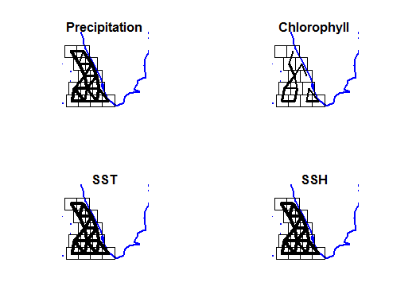

Figure C1. Correlation of the covariates across boxes. Correlation is shown by the width of the lines between neighboring boxes.

# Appendix E: Covariates along the SE India coast

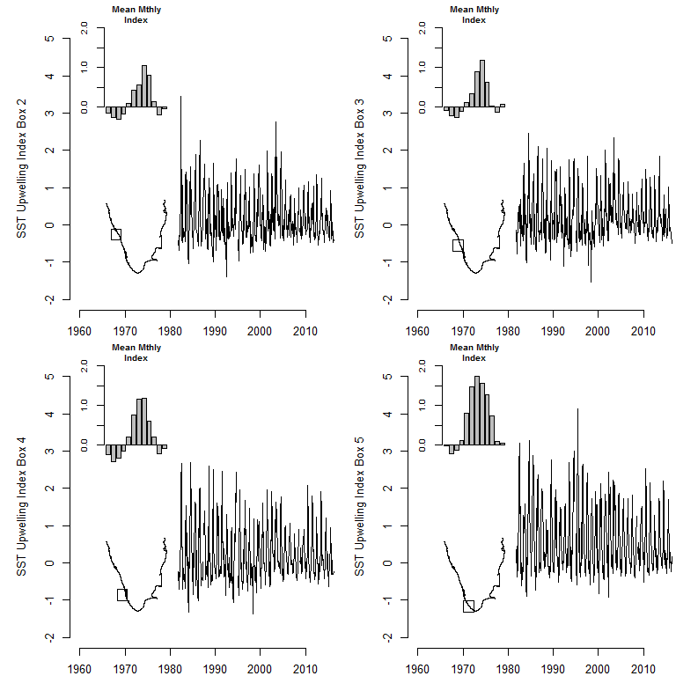

Figure E1. Upwelling index.

# 

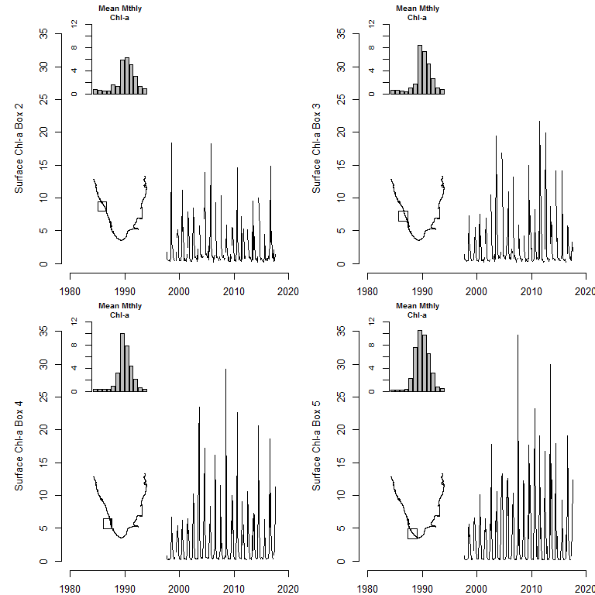

Figure E2. Chlorophyll-a.

# 

# Appendix F: Comparison of land and oceanic rainfall measurements

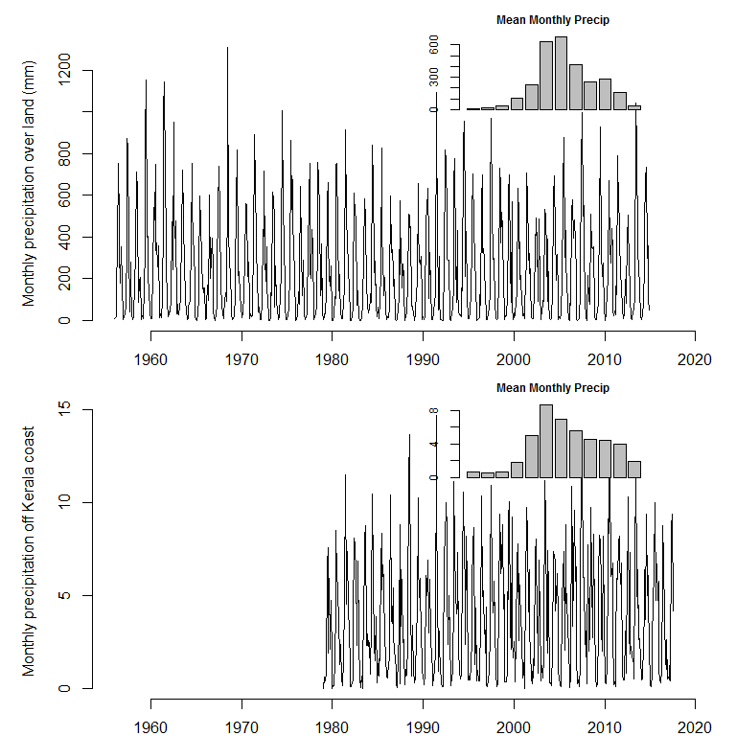

Figure F1

# 

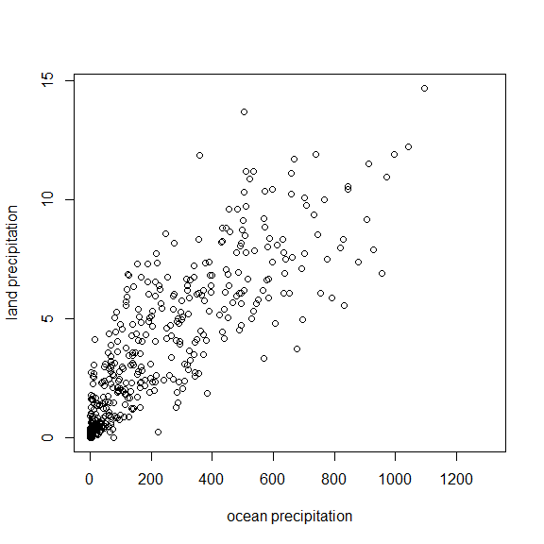

Figure F2. Monthly precipitation measured over land via land gauges versus the precipitation measured via remote sensing over the ocean.

# Appendix G: Chlorophyll-a images in 2016

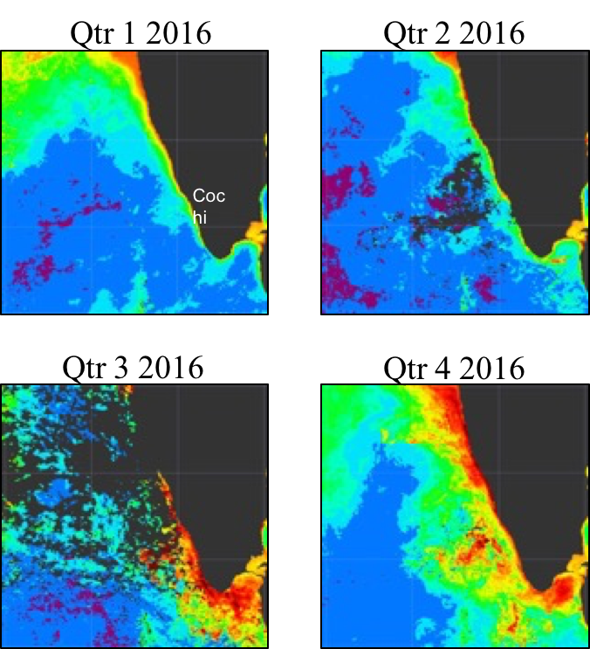

Figure 9

# 