Influence of temperature and upwelling intensity on oil sardine (*Sardinella longiceps*) landings along the southwest coast of India

15 May, 2018

# Introduction

The Indian oil sardine (*Sardinella longiceps* Valenciennes, 1847) is one of the most commercially important fish resources along the southwest coast of India (Figure 1) and comprises ca 25% of the catch biomass (Vivekanandan et al. 2003). Landings of the Indian oil sardine are highly seasonal and peak during and after the summer monsoon period (June through September), in conjunction with the onset and early relaxation of coastal upwelling. However, the landings of this small pelagic finfish are also highly variable from year to year. Small pelagics often exhibit high variability due to the effects of environmental conditions on survival and recruitment (Checkley Jr. et al. 2009). In addition, the Indian oil sardine fishery is largely coastal and artisanal thus migration of fish schools in and out of the coastal zone greatly affects exposure to the fishery.

Researchers have examined a variety of environmental variables for their correlation with landings of the Indian oil sardine. Precipitation during the southwest monsoon (Murty and Edelman 1966, Antony Raja 1969, 1972, Jayaprakash 2002) and the day of the monsoon arrival (Jayaprakash 2002) is thought to act as either a direct or indirect cue for spawning. Many studies have looked for correlations between precipitation, however the reported effects are positive in some studies and negative in others. Researchers have also found correlations with various metrics of upwelling intensity during the post-monsoon period (Longhurst and Wooster 1990, Madhupratap et al. 1994, Jayaprakash 2002, Krishnakumar et al. 2008, Thara 2011) and with direct measures of productivity, such as nearshore zooplankton and phytoplankton abundance (Hornell 1910, Nair 1952, Nair and Subrahmanyan 1955, Madhupratap et al. 1994, George et al. 2012). Researchers have also found correlations with sea surface temperature (SST); SST can affect both somatic growth rates and juvenile survival but also can cause fish to move off-shore and away from the shore-based fishery (Annigeri 1969, Prabhu and Dhulkhed 1970, Pillai 1991). In this paper, we revisit the analysis of environmental covariates that correlate with oil sardine catch using environmental covariates measured via remote-sensing. Remote-sensing data give us a longer time-series of environmental data and over a wide spatial extent at a daily and monthly resolution. A better understanding of how and whether remote sensing data explains variation in seasonal catch will help us understand both how the environment affects population dynamics and how remote sensing can be used to help predict favorable and unfavorable years for landings.

Our analysis focuses on the Kerala coast (Figure 1) region of India, where the majority of the Indian oil sardines are landed and where oil sardines comprise ca. 40% of the marine fish catch (Srinath 1998, Vivekanandan et al. 2003). This area is in the Southeast Arabian Sea (SEAS), one of world’s major upwelling zones, with seasonal peaks in primary productivity driven by upwelling caused by winds during the Indian summer monsoon (Madhupratap et al. 2001, Habeebrehman et al. 2008) between June and September. Within the SEAS, the coastal zone off Kerala between 9N to 13N has especially intense upwelling due to the combined effects of wind stress and remote forcing (Smitha et al. 2008, Smitha 2010). The result is a strong temperature differential between the near-shore and off-shore and high primary productivity and chlorophyll in this region (Madhupratap et al. 2001, Habeebrehman et al. 2008, Jayaram et al. 2010, Raghavan et al. 2010, Smitha 2010, Chauhan et al. 2011). The primary productivity peaks subside after September while mesozooplankton abundances increase and remain high in the inter-monsoon period (Madhupratap et al. 2001).

The Indian oil sardine fishery is restricted along the narrow strip of the western India continental shelf, within 20 km from the shore. The yearly cycle of the fishery begins start of spawning during June – July, corresponding with the onset of the southwest monsoon (Chidambaram 1950, Antony Raja 1969). The mature fish migrate from offshore to coastal waters coinciding with the prevailing wind conditions (Hornell 1910). A gradual increase in temperature ranging from 26 to 28°C is favorable for their inshore migration (Chidambaram 1950), and the spawning begins during the southwest monsoon period when temperature, salinity and suitable food availability are conducive for larval survival (Murty and Edelman 1966, Jayaprakash and Pillai 2000, Krishnakumar et al. 2008, Nair et al. 2016). Although peak spawning occurs in June to July, spawning continues into September (Hornell 1910, Hornell and Nayudu 1923, Antony Raja 1969, Prabhu and Dhulkhed 1970) and early- and late-spawning cohorts are evident in the length distributions of the 0-year fish. Spawning occurs in shallow waters outside of the traditional range of the fishery (Antony Raja 1964), and after spawning the adults migrate closer to the coast and the spent fish become exposed to the fishery.

After eggs are spawned, they develop rapidly into larvae within 24 hrs (Nair 1959). The phytoplankton bloom that provide sardine larvae food is dependent upon nutrient influx from coastal upwelling and runoff from rivers during the monsoon and early fall. The blooms start in the south near the southern tip of India in June, increase in intensity and spread northward up the coast (Smitha 2010). Variation in the bloom initiation time and intensity leads to changes in the food supply and to corresponding changes in the growth and survival of larvae and in the later recruitment of 0-year sardines into the fishery (George et al. 2012). Oil sardines grow rapidly during their first few months, and 0-year fish from 40mm to 100mm appear in the catch in August and September in most years (Antony Raja 1970, Nair et al. 2016). As the phytoplankton bloom spreads northward, the oil sardines follow thus the oil sardine fishery builds from south to north during the post-monsoon period. Oil sardines remain inshore feeding throughout the winter months, until March to May when the inshore waters warm considerably and sardines move off-shore to deeper waters (Chidambaram 1950). Catches of sardines are correspondingly low during this time for all size classes. The age at first maturity occurs at approximately 150 mm size (Nair et al. 2016), which is reached within one year. When the monsoon returns, the oil sardine cycle begins anew.

Overall, catches along the Kerala coast are fairly high throughout the year except during March-May (Figure 2). The age-distribution caught by the fishery varies through the year. The fishery is closed during June to mid-July during the monsoon and peak spawning, and when it resumes in mid-July, it is first dominated by 1-2.5 year old mature fish (Bensam 1964, Antony Raja 1969, Nair et al. 2016). In August or September a spike of 0-year (40mm) juveniles from the June spawning typically appears in the catch (Antony Raja 1969, Nair et al. 2016) and another spike of 0-year fish is sometimes seen in February from the last fall spawning (Prabhu and Dhulkhed 1967, 1970). From October through July, the catch is dominated by fish from 120mm-180mm (Antony Raja 1970, Prabhu and Dhulkhed 1970, Nair et al. 2016) which is a mix of 0-yr, 1-yr and 2-yr fish (Nair et al. 2016).

# Materials and Methods

## Sardine landing data

Quarterly fish landing data have been collected by the Central Marine Fisheries Research Institute (CMFRI) in Kochi, India, since the early 1950s using a stratified multi-stage sample design that takes into account landing centers, number of fishing days, and boat net combinations in fishing operations (Srinath et al. 2005). The quarterly landings for oil sardine landed from all gears in Kerala were obtained from CMFRI reports (1956-1984) and online database (1985-2015). (CMFRI 1969, 1995, Pillai 1982, Jacob et al. 1987, 2016). The quarterly landing data were log-transformed to stabilize the seasonal variance.

## Remote-sensing data

We analysed monthly composites of the following environmental data derived from satellites: Sea Surface Temperature (SST), chlorophyll-a (CHL), upwelling (UPW) and precipitation. Sea surface temperature: For 1981 to 2002, we used Pathfinder Version 5.2 product on a 4km grid, and for 2003 to 2016, we used Advanced Very-High Resolution Radiometer (AVHRR) data at a 0.1 degree spatial scale. Chlorophyll-a, we used SeaWiFS data on a 0.1 degree spatial scale for 1981 to 2002 and MODIS data from 2003 to 2017 at 0.05° spatial scale. The SST and CHL data were averaged across thirteen 1 degree by 1 degree boxes which roughly parallel the bathymetry (Figure 1). The SST and CHL satellite data were retrieved from the NOAA ERDDAP server.

For an index of coastal upwelling, we used the sea-surface temperature differential between near shore and 3 degrees offshore as described by Naidu et al. (1999) and Smitha et al. (2008). The index is computed as the average SST in boxes 3 degrees offshore of boxes 1-5 in Figure 1 minus the average SST in boxes 1-5. For SST, we used the remote-sensing sea-surface temperature data sets described above. This SST-based upwelling index has been validated as a more reliable metric of upwelling off the coast of Kerala compared to wind-based upwelling indices (Smitha et al. 2008).

Precipitation data were obtained from two different sources. The first was an estimate of the monthly precipitation (mm) over Kerala from land-based rain gauges (Kothawale and Rajeevan 2017). This time series is available from the start of our landing data (1956). The second was a remote-sensing precipitation product from the NOAA Global Precipitation Climatology Project (Adler et al. 2016). This provides estimate of precipitation over the ocean using a global 2.5 degree grid. We used the 2.5 by 2.5 degree box defined by latitude 8.75 to 11.25 and longitude 73.25 to 75.75 for the precipitation off the coast of Kerala. These data are available from 1979 forward (2017).

## Hypotheses

Environmental variability is known to be a key driver of population variability in small forage fish (Bakun 1996, Cury et al. (2000), Checkley Jr. et al. (2017)). Based on biological information concerning how environmental conditions affect sardine survival and recruitment and affect exposure of sardines to the coastal fishery, we developed a set of hypotheses (Table 1 concerning which remote-sensing covariates in which months should correlate with landings in specific quarters. The quarter 3 (Jul-Sep) catch overlaps the monsoon and the main spawning months. This is also the quarter where small 0-year fish from early spawning (June) often appear in the catch, sometimes in large numbers. Variables that are affect or are correlated with movement of sardines inshore should be correlated with quarter 3 landings. In addition, pre-spawning (Jan-May) conditions should be correlated with the spawning strength as adult oil sardines experience an acceleration of growth during this period along with egg development [. Some researchers have also hypothesized that conditions in The post-monsoon catch (Oct-May) is primarily fish greater than 120mm and a mix of 0-yr fish (less than 12 months old) and mature fish (greater than 12 months old). Variables that are correlated with larval and juvenile survival should correlate with the post-monsoon catch both in the current year and in futures years one to two years after.

Our hypotheses (Table 1 focus mainly on two drivers: upwelling and ocean temperature. We also test hypotheses concerning precipitation as this has historically been an environmental covariate considered to influence the timing of oil sardine landings. Salinity has been proposed as responsible for spawning initiation; however we do not have long-term salinity data.

## Explanatory models

We investigated correlations between environmental variables and sardine catch during different times of the year using generalized additive models (GAMs, Wood 2017). GAMs allow one to model the effect of a covariate as a flexible non-linear function and it was known that the effects of the environmental covariates were likely to be non-linear, albeit in an unknown way. Our approach is analogous to that taken by Jacobson and MacCall (1995) in a study of the effects of SST on Pacific sardine recruitment. We modeled the catches during the late-spawning season (quarter 3) separately from the post-summer monsoon season (October to June). The quarter 3 catch has a different size-distribution as it often is extremely bi-modal with a peak of small sardines from the current spawning. The covariates that affect the timing of spawning and the early egg and larval survival may be different and the fishing closure from July to mid-August may also affect the correlations.

The objective of our analysis was to determine if environmental covariates can explain variation in catch that cannot be explained solely by the prior catch, i.e. can environmental variables explain catch anomalies. The use of time series models, such as ARIMA models, has been used for forecasting oil sardine catch from past catch (Srinath 1998) and has a long tradition in fisheries for forecasting catch from catch time series for other species (Stergiou and Christou 1996). We used generalized additive models instead of auto-regressive (ARIMA) models to allow the effect of past catch to be non-linear and because there was little support for including auto-regressive errors based on diagnostic tests of the residuals. This lack of strong autocorrelation in residuals has been found in other studies on forecasting catch from past catches (Stergiou and Christou 1996).

The first step in our analysis was to determine the catch model: the model for current catch as a function of the past catch. Once a sufficient model for the catch was determined, the covariates were studied individually and then jointly. F-tests and AIC on nested sets of GAM models (Wood et al. 2016) were used to evaluate the support for the catch models and later the covariate models. One feature of GAMs is that they allow the ‘flexibility’ or smoothing parameter of the response curve to be estimated. However we fixed the degree of flexibility so that reasonably smooth responses were achieved and to limit the flexibility of the models being fit. Multi-modal or overly flexible response curves would not realistic for our application. We used GAMs with smooth terms represented by penalized regression splines (Wood 2011, using the mgcv package in R) and fixed the smoothing term at an intermediate value (sp=0.6).

Our catch models took the form

where is the log catch in the current year and was defined as either 3rd quarter catch (Jul-Aug) or post-summer monsoon catch (Oct-Jun) depending on which period we were studying. The catches were logged to stabilize and normalize the variance. The model is primarily statistical, meaning it should not be thought of as being a population growth model. We tested models with prior year catch () defined as post-summer monsoon (Oct-Jun) catch () or late-summer monsoon (Jul-Sep) catch () as the explanatory catch variable. The catch models were fit to 1982 to 2015 catch data, corresponding to the years where the SST, upwelling and precipitation data were available. The catch model was selected via F-tests and AIC on nested sets of GAM models. After selection the best model with the 1982-2015 data, the fitting was repeated with the 1955 to 1981 catch data to confirm the form of the catch models.

Once the catch models were determined, the covariates were studied individually and then jointly using catch anomalies as the response variable. The catch anomaly is defined as the difference between the observed catch and the predicted catch from a model using catch in prior years with no environmental covariates. As with the catch models, F-tests and AIC on nested sets of GAM models (Wood et al. 2016) were used to evaluate the support for models. The smoothing term was fixed at an intermediate value (sp=0.6) instead of treated as an estimated variable.

Our models for catch in late-spawning season (June to September or quarter 3) took the form

The left-hand side is the catch anomaly where the and functions define the catch model selected in the first part of our analysis. Catch in the 3rd quarter (July-Aug) captures a mix of spawning age fish as it overlaps with the tail end of the spawning season—the fishery is closed July to mid-August during the height of the summer monsoon and spawning season—and small 0-year fish from early June spawning. The model seeks to explain the 3rd quarter catch anomalies via a non-linear function of the covariates, and . The covariates tested are those discussed in the section on covariates that have been hypothesized to drive the size of the spawning biomass exposed to the fishery. The relevant covariate may be in the concurrent with the catch or in a prior year. The model for catch in the post-summer monsoon quarters (October to June) took a similar form:

where the left-hand side is the catch anomaly for the total catch in the post-summer monsoon October to June (a nine-month period that spans two calendar years). The covariates tested are those discussed in the section on covariates that have been hypothesized to drive both survival and growth of juvenile fish and the factors that lead to feeding of fish inshore and thus exposed to the coastal fishery.

# Results

## Catches in prior seasons as explanatory variables

There was support for including the post-summer monsoon catch in the previous year as an explanatory variable for the quarter 3 catch (June to August). Models with were strongly supported over an intercept only model (Table 2, time-dependency test). However the addition of the catch two years prior, , lead to either no decrease in the residual deviance (i.e. increase in the explained variance) and in fact, increased the residual deviance for the model with non-linearity (Table 2, Linearity test). We also tested the support for non-linearity in the effect of the prior year catch on the catch in the 3rd quarter. This was done by comparing models with included as a linear term or as a non-linear function (Table 2, Linearity test). The residual deviance decreased using a non-linear response however the cost was 1.4 degrees of freedom. The result was only weak (non-significant) support for allowing a non-linear response. The full set of models tested, including tests using catch during the spawning months in previous seasons as a covariate are shown in Tables A1 and A2. The results were the same if we used the full landings data set from 1956 to 2015 (Table A3). Overall, the landings in prior seasons was only weakly explanatory for the catch in the 3rd quarter, and the maximum was less than 30% (Table 2).

The results were similar for models of the landings () during the post-summer monsoon months (Table 3). The most supported model for used a non-linear response to landings during the post-monsoon months of the previous season: with a non-linear response to landings during the spawning season (3rd quarter) two years prior (Table 3). There was low support for including landings outside of the spawning months two seasons prior or for using the landings during the spawning months in the immediately prior season (Tables A4, A5, and A6). We did not test models using the catch during quarter 3 in the current fishing season as these data would not be available; the data requires 12 months to process.

## Environmental covariates as explanatory variables

There was no support for using precipitation during the summer monsoon (Jun-Jul) or pre-monsoon period (Apr-May) as an explanatory variable for the catch during the spawning months (Table B1) nor the non-spawning months (Table B2). This was the case whether precipitation in the current or previous season was used, if precipitation was included as non-linear or non-linear effect, or if the smoothing term (degree of non-linearity allowed) was estimated and thus not constrained, and if either precipitation during monsoon (Jun-Jul) or pre-monsoon (Apr-May) were used as the covariate.

However, we found significant correlation between average sea surface temperature during the early post-spawning period (Jul-Dec) and catch during the spawning season (Table 3, Table B3). Sea surface temperature has been found to be correlated with sardine biomass in a number of other studies [Jacobson and MacCall (1995); add the others]. The residual deviance was lowest in a model with SST in both the prior year and two years prior included and with a non-linear response for both. This a similar result to Jacobson and MacCall (1995) who found that SST in multiple prior years was supported as explanatory variables for sardine recruitment and productivity. However the reduction in degrees of freedom was high for this model and it was not supported, despite having the lowest residual degrees of freedom, given the cost (loss of degrees of freedom). The model with the lowest AIC was a model with only the current year and a non-linear response. The response shows a step-response with a negative effect at low temperatures and then an increased effect a higher temperatures (Figure 3). This type of step-response has been found in studies of the effect of SST on recruitment in Pacific sardines (Jacobson and MacCall 1995). The for this model was 0.40 (Table 4).

The strongest predictor of the catch during the spawning season however was the upwelling strength during Jan-Mar (4-6 months prior) in the previous season (Tables 4 and B4). Jan-Mar is a period when the young of the year and age-1 fish would be found feeding in large shoals in the coastal region. This is also the time of year with the second highest catches and catches that are dominated by small-sized fish (*citation*). The best supported model included only the upwelling strength in the prior year, without SST included as a covariate (Table 4). The for this model was 0.60 and the fitted versus observed catches for this model are shown in Figure 4.

For catch in the post-summer monsoon months (Oct-Jun), sea surface temperature during July to September in the current season was a significant predictor similar to what was found for catches in the spawning months (quarter 3). Upwelling in the prior season was also a significant predictor, but the important months were Oct-Dec. This is period is important for larval and early juvenile survival and growth, and other studies have also found this to be a critical period for future stock size in sardines (*citation*). The model with the lowest residual variance and lowest AIC was the model which included both the SST and upwelling covariates (Table 4). The for this model was 0.73 and the fitted versus observed catches for this model are shown in Figure 4.

Chlorophyll-a density is speculated to be an important predictor of larval sardine survival and growth. In addition, sardines shoal in response to coastal chlorophyll blooms, which brings them in contact with the coastal fisheries. Thus chlorophyll-a density is assumed to be an important driver of future or current sardine catches. We had chlorophyll-a remote-sensing data only from 1998 onward. Our simplest covariate model required 5 degrees of freedom, thus we were limited in the analyses we could conduct. In addition, the years, 1998-2014, have relatively low variability in catch sizes; the logged catch sizes during this period range from 10-11 during quarter 3 and 11-12 during the other three quarters. Second degree polynomial models were fit (Appendix C) to the average log chlorophyll-a density in the current and prior season from quarter 3 (Jul-Sep), 4 (Oct-Dec), and 1 (Jan-Mar). Chlorophyll-a density was not a significant predictor for the spawning catch for any of the tested combinations of current or prior season and quarter. The only significant effect was seen for post-summer monsoon catches using chlorophyll-a density in Oct-Dec of the current and prior season (Table C1). This matches results which found that the upwelling index in Oct-Dec of the prior season was a predictor for the post-summer monsoon catch. The upwelling index and chlorophyll-a density are both indices of low-trophic level productivity.

# Discussion

Sardines in all the world’s ecosystems exhibit large fluctuations in abundance (Baumgartner et al. 1992, Schwartzlose et al. 2010). These small forage fish are strongly influenced by natural variability in upwelling driven by both large-scale forces, i.e. El Nino patterns, and by changes in winds and currents and in addition local conditions of temperature, salinity, and oxygen levels have both direct and indirect on sardine recruitment and survival.

Many studies on Pacific sardines have looked at the correlation between sea surface temperature (SST) and recruitment. Temperature can have direct effect, an indirect effect on food availability or affect survival (Houde 1987). Studies in the California Current System, have found that SST explains year-to-year variability in Pacific sardine recruitment (Jacobson and MacCall 1995, Checkley Jr. et al. 2009, 2017, Lindegren and Checkley Jr. 2012). Consistent with these studies, we also found that SST was the covariate that explained variability in catch anomalies (difference between the landing prediction from prior years’ catches).

McClatchie et al. (2010) found no SST relationship with SST and Pacific sardine recruitment, however their analysis used a linear relationship while both other studies that found a relationship (Jacobson and MacCall 1995, Checkley Jr. et al. 2017) allowed a non-linear relationship. Both Jacobson and MacCall (1995) and Checkley et al (2017) found a step-like response function for temperature, where lower temperatures were poor and had negative effects and then at a threshold value the effect became positive. Our analysis found a similar step-like effect function (Figure ).

There were three outlier years when catch were much lower than expected based on prior catches. For these years, sea surface temperature improved the model fit greatly (Figure 5).

Implications. In California Current system, SST is used as an indicator for recruitment and is used in management of harvest.

# References

Adler, R., J.-J. Wang, M. Sapiano, G. Huffman, L. Chiu, P. P. Xie, R. Ferraro, U. Schneider, A. Becker, D. Bolvin, E. Nelkin, G. Gu, and N. C. Program. 2016. Global precipitation climatology project (gpcp) climate data record (cdr), version 2.3 (monthly). Report, National Centers for Environmental Information.

Annigeri, G. G. 1969. Fishery and biology of the oil sardine at karwar. Indian Journal of Fisheries 16:35–50.

Antony Raja, B. T. 1964. Some aspects of spawning biology of indian oil sardine sardinella longiceps valenciennes. Indian Journal of Fisheries 11:45–120.

Antony Raja, B. T. 1969. Indian oil sardine. CMFRI Bulletin 16:1–142.

Antony Raja, B. T. 1970. Estimation of age and growth of the indian oil sardine, sardinella longiceps val. Indian Journal of Fisheries 17:26–42.

Bakun, A. 1996. Patterns in the ocean: Ocean processes and marine population dynamics. Book, California Sea Grant, in cooperation with Centro de Investigaciones Biologicas del Noroeste, La Paz, Mexico.

Baumgartner, T. R., A. Soutar, and V. Ferreira-Bartrina. 1992. Reconstruction of the history of the pacific sardine and northern anchovy populations over the past two millennia from sediments of the santa barbara basin, california. CalCOFI Report 33:24–40.

Bensam, P. 1964. Growth variations in the indian oil sardine, sardinella longiceps valenciennes. Indian Journal of Fisheries 11 A:699–708.

Chauhan, O. S., B. R. Raghavan, K. Singh, A. S. Rajawat, U. Kader, and S. Nayak. 2011. Influence of orographically enhanced sw monsoon flux on coastal processes along the se arabian sea. Journal of Geophysical Research. Oceans 116:C12037.

Checkley Jr., D. M., J. Alheit, Y. Oozeki, and C. Roy. 2009. Climate change and small pelagic fish. Edited Book, Cambridge University Press, Cambridge.

Checkley Jr., D. M., R. G. Asch, and R. R. Rykaczewski. 2017. Climate, anchovy, and sardine. Annual Review of Marine Science 9:469–493.

Chidambaram, K. 1950. Studies on the length frequency of oil sardine, sardinella longiceps cuv. & val. and on certain factors influencing their appearance on the calicut coast of the madras presidency. Proceedings of Indian Academy of Sciences 31:352–286.

CMFRI. 1969. Marine fish production in india 1950-1968. Report, Central Marine Fisheries Research Institute.

CMFRI. 1995. Marine fish landings in india during 1985-93. Report.

Cury, P., A. Bakun, R. J. Crawford, A. Jarre, R. A. Quinones, L. J. Shannon, and H. M. Verheye. 2000. Small pelagics in upwelling systems: Patterns of interaction and structural changes in “wasp-waist” ecosystems. ICES Journal of Marine Science 57:603–618.

George, G., B. Meenakumari, M. Raman, S. Kumar, P. Vethamony, M. T. Babu, and X. Verlecar. 2012. Remotely sensed chlorophyll: A putative trophic link for explaining variability in indian oil sardine stocks. Journal of Coastal Research 28:105–113.

Habeebrehman, H., M. P. Prabhakaran, J. Jacob, P. Sabu, K. J. Jayalakshmi, C. T. Achuthankutty, and C. Revichandran. 2008. Variability in biological responses influenced by upwelling events in the eastern arabian sea. Journal of Marine Systems 74:545–560.

Hornell, J. 1910. Report on the results of a fishery cruise along the malabar coast and to the laccadive islands in 1908. Madras Fishery Bulletin 4:76–126.

Hornell, J., and M. R. Nayudu. 1923. A contribution to the life history of the indian sardine with note, on the plankton of the malabar coast. Madras Fishery Bulletin 17:129.

Houde, E. D. 1987. Fish early life dynamics and recruitment variability. American Fisheries Society Symposium 2:17–29.

Jacob, T., V. Rajendran, P. K. M. Pillai, J. Andrews, and U. K. Satyavan. 1987. An appraisal of the marine fisheries in kerala. Report, Central Marine Fisheries Research Institute.

Jacobson, L. D., and A. D. MacCall. 1995. Stock-recruitment models for pacific sardine (sardinops sagax). Canadian Journal of Fisheries and Aquatic Sciences 52:566–577.

Jayaprakash, A. A. 2002. Long term trends in rainfall, sea level and solar periodicity: A case study for forecast of malabar sole and oil sardine fishery. Journal of the Marine Biological Association of India 44:163–175.

Jayaprakash, A. A., and N. G. K. Pillai. 2000. The indian oil sardine. Pages 259–281 *in* V. N. Pillai and N. G. Menon, editors. Marine fisheries research and management. Book Section, Central Marine Fisheries Research Institute, Kerala, India.

Jayaram, C., N. Chacko, K. A. Joseph, and A. N. Balchand. 2010. Interannual variability of upwelling indices in the southeastern arabian sea: A satellite based study. Ocean Science Journal 45:27–40.

Kothawale, D. R., and M. Rajeevan. 2017. Monthly, seasonal and annual rainfall time series for all-india, homogeneous regions and meteorological subdivisions: 1871-2016. Report, Indian Institute of Tropical Meteorology.

Krishnakumar, P. K., K. S. Mohamed, P. K. Asokan, T. V. Sathianandan, P. U. Zacharia, K. P. Abdurahiman, V. Shettigar, and N. R. Durgekar. 2008. How environmental parameters influenced fluctuations in oil sardine and mackerel fishery during 1926-2005 along the south-west coast of india? Marine Fisheries Information Service T&E Series 198:1–5.

Lindegren, M., and D. M. Checkley Jr. 2012. Temperature dependence of pacific sardine (sardinops sagax) recruitment in the california current ecosystem revisited and revised. Canadian Journal of Fisheries and Aquatic Sciences 70:245–252.

Longhurst, A. R., and W. S. Wooster. 1990. Abundance of oil sardine (sardinella longiceps) and upwelling on the southwest coast of india. Canadian Journal of Fisheries and Aquatic Sciences 47:2407–2419.

Madhupratap, M., T. C. Gopalakrishnan, P. Haridas, and K. K. C. Nair. 2001. Mesozooplankton biomass, composition and distribution in the arabian sea during the fall intermonsoon: Implications of oxygen gradients. Deep Sea Research Part II: Topical Studies in Oceanography 48:1345–1368.

Madhupratap, M., S. R. Shetye, K. N. V. Nair, and S. R. S. Nair. 1994. Oil sardine and indian mackerel: Their fishery, problems and coastal oceanography. Current Science 66:340–348.

McClatchie, S., R. Goericke, G. Auad, and K. Hill. 2010. Re-assessment of the stock–recruit and temperature–recruit relationships for pacific sardine (sardinops sagax). Canadian Journal of Fisheries and Aquatic Sciences 67:1782–1790.

Murty, A. V. S., and M. S. Edelman. 1966. On the relation between the intensity of the south-west monsoon and the oil-sardine fishery of india. Indian Journal of Fisheries 13:142–149.

Naidu, P. D., M. R. R. Kumar, and V. R. Babu. 1999. Time and space variations of monsoonal upwelling along the west and east coasts of india. Continental Shelf Research 19:559–572.

Nair, P. G., S. Joseph, V. Kripa, R. Remya, and V. N. Pillai. 2016. Growth and maturity of indian oil sardine sardinella longiceps (valenciennes, 1847) along southwest coast of india. Journal of Marine Biological Association of India 58:64–68.

Nair, R. V. 1952. Studies on the revival of the indian oil sardine fishery. Proceedings of Indo-Pacific Fisheries Council 2:1–15.

Nair, R. V. 1959. Notes on the spawning habits and early life-history of the oil sardine, sardinella longiceps cuv. & val. Indian Journal of Fisheries 6:342–359.

Nair, R. V., and R. Subrahmanyan. 1955. The diatom, fragilaria oceanica cleve, an indicator of abundance of the indian oil sardine, sardinella longiceps cuv. and val. Current Science 24:41–42.

Pillai, V. N. 1982. Physical characteristics of the coastal waters off the south-west coast of india with an attempt to study the possible relationship with sardine, mackerel and anchovy fisheries. Thesis.

Pillai, V. N. 1991. Salinity and thermal characteristics of the coastal waters off southwest coast of india and their relation to major pelagic fisheries of the region. Journal of the Marine Biological Association of India 33:115–133.

Prabhu, M. S., and M. H. Dhulkhed. 1967. On the occurrence of small-sized oil sardine sardinella longiceps val. Current Science 35:410–411.

Prabhu, M. S., and M. H. Dhulkhed. 1970. The oil sardine fishery in the mangalore zone during the seasons 1963-64 and 1967-68. Indian Journal of Fisheries 17:57–75.

Raghavan, B. R., T. Deepthi, S. Ashwini, S. K. Shylini, M. Kumarswami, S. Kumar, and A. A. Lotliker. 2010. Spring inter monsoon algal blooms in the eastern arabian sea: Shallow marine encounter off karwar and kumbla coast using a hyperspectral radiometer. International Journal of Earth Sciences and Engineering 3:827–832.

Schwartzlose, R. A., J. Alheit, A. Bakun, T. R. Baumgartner, R. Cloete, R. J. M. Crawford, W. J. Fletcher, Y. Green-Ruiz, E. Hagen, T. Kawasaki, D. Lluch-Belda, S. E. Lluch-Cota, A. D. MacCall, Y. Matsuura, M. O. Nevárez-Martínez, R. H. Parrish, C. Roy, R. Serra, K. V. Shust, M. N. Ward, and J. Z. Zuzunaga. 2010. Worldwide large-scale fluctuations of sardine and anchovy populations. South African Journal of Marine Science 21:289–347.

Smitha, B. R. 2010. Coastal upwelling of the south eastern arabian sea — an integrated approach. Thesis.

Smitha, B. R., V. N. Sanjeevan, K. G. Vimalkumar, and C. Revichandran. 2008. On the upwelling of the southern tip and along the west coast of india. Journal of Coastal Research 24:95–102.

Srinath, M. 1998. Exploratory analysis on the predictability of oil sardine landings in kerala. Indian Journal of Fisheries 45:363–374.

Srinath, M., S. Kuriakose, and K. G. Mini. 2005. Methodology for estimation of marine fish landings in india. Report, Central Marine Fisheries Research Institute.

Stergiou, K. I., and E. D. Christou. 1996. Modeling and forecasting annual fisheries catches: Comparison of regression, univariate and mulivariate time series methods. Fisheries Research 25:105–138.

Thara, K. J. 2011. Response of eastern arabian sea to extreme climatic events with special reference to selected pelagic fishes. Thesis.

Vivekanandan, E., M. Srinath, V. N. Pillai, S. Immanuel, and K. N. Kurup. 2003. Marine fisheries along the southwest coast of india. Pages 759–792 *in* G. Silvestre, L. Garces, I. Stobutzki, C. Luna, M. Ahmad, R. A. Valmonte-Santos, L. Lachia-Alino, P. Munro, V. Christensen, and D. Pauly, editors. Assessment, management, and future directions for coastal fisheries in asian countries. Book Section, WorldFish Center Conference Proceedings 67, WorldFish Center, Penang.

Wood, S. N. 2011. Fast stable restricted maximum likelihood and marginal likelihood estimation of semiparametric generalized linear models. Journal of the Royal Statistical Society B 73:3–36.

Wood, S. N. 2017. Generalized additive models: An introduction with r. 2nd editions. Book, Chapman; Hall/CRC.

Wood, S. N., N. Pya, and B. Safken. 2016. Smoothing parameter and model selection for general smooth models (with discussion). Journal of the American Statistical Association 111:1548–1575.

1972.. Chart or Table.

2016.. Personal Communication.

2017, 11-03-2017.. Online Database.

# Figure Legends

Figure 1. Close up of Kerala State with the latitude/longitude boxes used for the satellite data. Kerala State is marked in grey and the oil sardine catch from this region is being modeled.

Figure 2. Quarterly catch data 1956-2014 from Kerala. The catches have a strong seasonal pattern with the highest catches in quarter 4 Note that quarter 3 is July-Sept and that the fishery is closed July 1 to Aug 15, thus the fishery is only open 1.5 months in quarter 3. The mean catch (metric tonnes) in quarters 1 to 4 are 38, 19.2, 30.9, and 59.9 metric tonnes respectively.

Figure 6. Cartoon of the sardine life-cycle in the SE Indian Ocean and how it interacts with the fishery.

Figure 7. Remote sensing covariates used in the analysis. All data are monthly averages over Box 4 in Figure 1 on the Kerala coast off of Kochi. Panel A) Upwelling Index. The upwelling index is the difference between the near-shore sea surface temperature (SST) and the off-shore SST defined as 3 degrees longitude offshore. Panel B) Surface chlorophyll-a (Chl-a). The Chl-a data are only available from 1997 onward. Panel C) Sea surface temperature constructed from Advanced Very High Resolution Radiometer (AVHRR). Panel D) Average daily rainfall (mm/day) off the Kerala coast.

Figure 8. Key oil sardine life-history events overlaid on the monthly SST in the near-shore and off-shore and the near-shore Chl-a.

Figure 3. Effects of covariates estimated from the GAM models. Panel A) Effect of SST during the spawning months (Jul-Sep) on catch during the spawning months. Low SST is associated with lower that expected catch during the spawning months. Panel B) Effect of upwelling (inshore/off-shore SST differential) during Jan-Mar of the prior season on catch during the next spawning months (Jul-Sep). The index is the difference between offshore and inshore SST, thus a negative value indicates warmer coastal surface water than off-shore. Warm coastal water during Jan-Mar when sardines are foraging along the coast, is associated with lower catch during the next spawning season. Panel C) Effect of SST during the spawning months (Jul-Sep) on catch during the subsequent non-spawning months (Oct-Jun). Low SST is associated with lower that expected catch during the following non-spawning months. Panel D) Effect of upwelling (inshore/off-shore SST differential) during Oct-Dec of the prior season on catch during the non-spawning months (Oct-Jun) the next season. Strong upwelling (positive upwelling index) in the early larval and juvenile period (Oct-Dec) is associated with higher than expected catch in the next season.

Figure 5. Fitted versus observed catch with models with and without environmental covariates. Panel A) Fitted versus observed log catch in the spawning months with only non-spawning catch in the previous season as the covariate: . Panel B) Fitted versus observed log catch in the spawning months with Jan-Mar upwelling in the prior season added as a covariate to the model: . Panel C) Fitted versus observed log catch in the non-spawning months with only non-spawning catch in the previous season and spawning catch two season prior as the covariates: . Panel D) Fitted versus observed log catch in the non-spawning months with current season SST in Jul-Sep () and Oct-Dec upwelling in the prior season () added as covariates: . was added linearly since the data were insufficient to estimate four non-linear effects.

Table 1. Hypotheses for covariates affecting landings. See text for details.

|  |  |  |  |  |
| --- | --- | --- | --- | --- |
| Life-history stage | Time period | Hypothesis | Responses | Explanatory variables |
| Age 2+ | Jun-Sep | HDD1. Q3 catch is dominated by mature age 2+ fish, thus abundance of the 1-yr and 2-yr ages in the prior season should be correlated with the abundance of spawners this year. | Catch Q3 year t | Catch Q4 year t-1 and Q1-2 year t |
| Age 1-2 | Oct-May | HDD2. Abundance of 1-year and 2-year fish should be correlated with strength of the cohorts from the previous two seasons. We do not have have direct measures of recruitment or spawners. However the catch in Q3 is dominated by mature fish, thus catch in Q3 in the previous two calendar years is expected to be correlated with the current season’s post-monsoon catch. | Catch Q4 year t and Q1-2 year t+1 | Catch Q3 year t-1 and year t-2 |
| Age 2+ | Oct-May | HDD3. Because age 2 fish also appear in the post-monsoon catch, we also expect the post-monsoon catch in the previous season to be correlated with the post-monsoon catch in the current season. | Catch Q4 year t and Q1-2 year t+1 | Catch Q4 year t-1 and Q1-2 year t |
| Spawning | Jun-Sep | HS1. The onset of monsoon with heavy precipitation triggers movement of adults from offshore to more inshore spawn regions either due to changes in salinity, turbulence or noise. After spawning, spent adult migrate inshore and are exposed to the fishery. | Catch Q3 year t | Seasonal precipitation anomaly during Jun-Jul in year t |
|  |  | HS2. The level of precipitation in pre-monsoon predicts spawning strength. | Catch Q3 year t | Seasonal precipitation anomaly during Apr-May in year t |
|  |  | HS3. Low sea surface temperature is associated with delayed and limited spawning (Jacobson and MacCall 1995) as a behavioral response by adults to avoid exposing larvae to low temperatures associated with poor survival. | Catch Q3 year t | Average SST during Jun-Sep in year t |
|  |  | HS4. Extremely high upwelling brings poorly oxygenated water to the surface causing sardines to move offshore (**???**). | Catch Q3 year t | Average upwelling index Jun-Sep, Max upwelling index Jun-Sep in year t |
|  |  | HS5. Salinity changes due to precipitation or river run-off trigger spawning. | Catch Q3 year t | Average Salinity during Jun-Sep in year t |
| Larvae | July-Oct | HL1. Larval mortality is higher in colder water due to low motility causing increased predation and slower somatic growth. Low SST is also associated with strong upwelling which advects larvae into offshore waters and brings poorly oxygenated water to the surface. | Catch Q4 year t and Q1-2 year t+1 | Average SST during Jun-Sep, Cum DD Jun-Sep in year t-1 |
| Larvae |  | HL2. Extremely strong upwelling brings poorly oxygenated water to the surface causing larval mortality and advects larvae offshore. | Catch Q4 year t and Q1-2 year t+1 | Average upwelling index Jun-Sep, max upwelling index Jun-Sep in year t-1 |
| Juvenile |  | HJ1. Upwelling is associated with higher productivity and higher density of zooplankton, which leads to better larval and juvenile growth and survival. Thus the strength of upwelling during the monsoon should be associated with higher biomass in subsequent years. | Catch Q4 year t and Q1-2 year t+1 | Average upwelling index Jun-Sep, max upwelling index Jun-Sep in year t-1 and t-2 |
| Juvenile |  | HJ2. Chlorophyll blooms are signatures of high productivity from nutrient influx either due to upwelling or coastal inputs. Chlorophyll bloom intensity in prior years should be associated with future sardine biomass. | Catch Q4 year t and Q1-2 year t+1 | Average Chl-a density Jun-Dec, Chl-a density Jun-Dec in year t-1 and t-2 |
| All ages | Mar-Apr | HA1. During the Mar-Apr, the sea temperatures are high and sardines migrate offshore to avoid high temperatures. | Catch Q2 year t | Average SST Q2 year t, max SST Q2 year t |

# 

Table 2. Model selection tests of time-dependency and linearity for the model using F-tests of nested models fit to log landings data. is the catch during the spawning period (Qtr 3 = July-Sep) of season (Jul-Jun). is the catch during the prior sardine season after the spawning period (the 9-months following Qtr 3, Oct-Jun, of the previous sardine season). is the same for two seasons prior. is a non-linear function of the response variable.

|  |  |  |  |  |  |
| --- | --- | --- | --- | --- | --- |
| Model | Residual df | Residual deviance | F | p value | AIC |
| Time dependency test 1982-2015 data |  |  |  |  |  |
| = + | 33 | 65.13 |  |  | 122.59 |
| (Var() = 1.97) |  |  |  |  |  |
| = + + | 32 | 48.37 | 10.85 | 0.002 | 114.47 |
| ( = 23%, Var() = 1.51) |  |  |  |  |  |
| = + + + | 31 | 48.18 | 0.12 | 0.729 | 116.34 |
| ( = 21%, Var() = 1.55) |  |  |  |  |  |
|  |  |  |  |  |  |
| Linearity test 1982-2015 data |  |  |  |  |  |
| = + + | 32 | 48.37 |  |  | 114.47 |
| ( = 23%, Var() = 1.51) |  |  |  |  |  |
| = + + | 30.6 | 44.8 | 1.74 | 0.199 | 113.76 |
| ( = 27%, Var() = 1.44) |  |  |  |  |  |
| = + + + | 28.2 | 42.91 | 0.54 | 0.618 | 116.14 |
| ( = 25%, Var() = 1.47) |  |  |  |  |  |
| = + + + | 27.7 | 40.87 | 0.97 | 0.419 | 115.33 |
| ( = 28%, Var() = 1.42) |  |  |  |  |  |

# 

Table 3. Model selection tests for the model using AIC for models fit to log landings data. is the catch during the spawning season. is the catch during the non-spawning period (Qtrs 4, 1 and 2: Oct-Jun) of season (Jul-Jun). and are the catch during the prior sardine season during and after the spawning period respectively. and are the same for two seasons prior.

|  |  |  |  |  |  |
| --- | --- | --- | --- | --- | --- |
| Model | Residual df | Residual deviance | F | p value | AIC |
| = + + | 31 | 27.42 |  |  | 93.54 |
| ( = 39%, Var() = 0.88) |  |  |  |  |  |
| = + + | 29.5 | 23.04 | 5.2 | 0.02 | 89.79 |
| ( = 47%, Var() = 0.77) |  |  |  |  |  |
| = + + + | 27.2 | 19.95 | 2.28 | 0.115 | 88.81 |
| ( = 51%, Var() = 0.71) |  |  |  |  |  |
| = + + + | 26.5 | 15.97 | 10 | 0.008 | 82.62 |
| ( = 60%, Var() = 0.58) |  |  |  |  |  |

# 

Table 4. Top covariates for the spawner () and non-spawner () models. The models are nested; the roman numeral indicates the level of nestedness. Models at levels II and higher are shown with the component that is added to the base level model (M0 or M1) at top. The full set of covariate models tested are given in Appendix B. The fitted versus observed catches from the covariate models are shown in Figure 5.

|  |  |  |  |  |  |
| --- | --- | --- | --- | --- | --- |
| Model | Residual df | Residual deviance | F | p value | AIC |
| Spawner catch models with covariates |  |  |  |  |  |
| = Jul-Sep SST current season |  |  |  |  |  |
| = Jan-Mar upwelling prior season |  |  |  |  |  |
| I-M0: | 29.6 | 44.66 |  |  | 111.57 |
| ( = 27%, Var() = 1.49) |  |  |  |  |  |
| II: | 27 | 35.62 | 2.73 | 0.073 | 108.26 |
| ( = 37%, Var() = 1.27) |  |  |  |  |  |
| III: | 24.4 | 33.06 | 0.76 | 0.514 | 110.1 |
| ( = 37%, Var() = 1.28) |  |  |  |  |  |
| II: | 26.9 | 42.45 | 0.53 | 0.648 | 114.3 |
| ( = 25%, Var() = 1.53) |  |  |  |  |  |
|  |  |  |  |  |  |
| Spawner catch models with covariates |  |  |  |  |  |
| = Jul-Sep SST current season |  |  |  |  |  |
| = Oct-Dec upwelling prior season |  |  |  |  |  |
| I-M1: | 25.6 | 15.58 |  |  | 80.66 |
| ( = 61%, Var() = 0.59) |  |  |  |  |  |
| II: | 23.1 | 9.78 | 5.8 | 0.007 | 69.77 |
| ( = 73%, Var() = 0.4) |  |  |  |  |  |
| III: | 22.1 | 9.61 | 0.44 | 0.505 | 71.14 |
| ( = 73%, Var() = 0.41) |  |  |  |  |  |
| II: | 23.3 | 14.94 | 0.48 | 0.649 | 82.97 |
| ( = 59%, Var() = 0.6) |  |  |  |  |  |



Figure 1

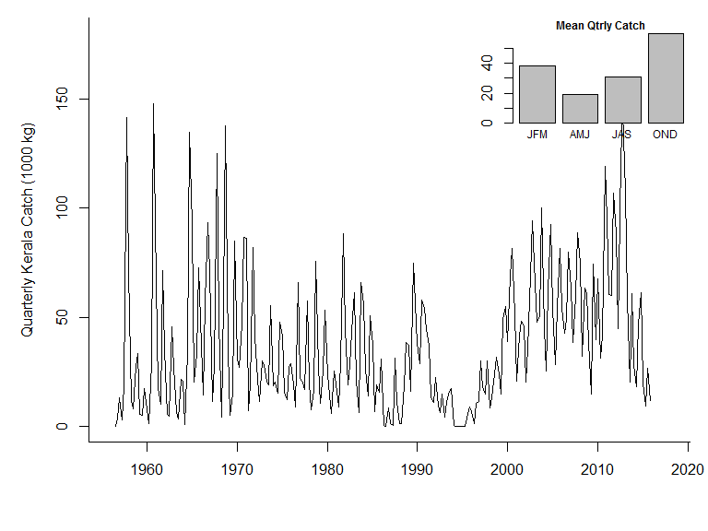

Figure 2

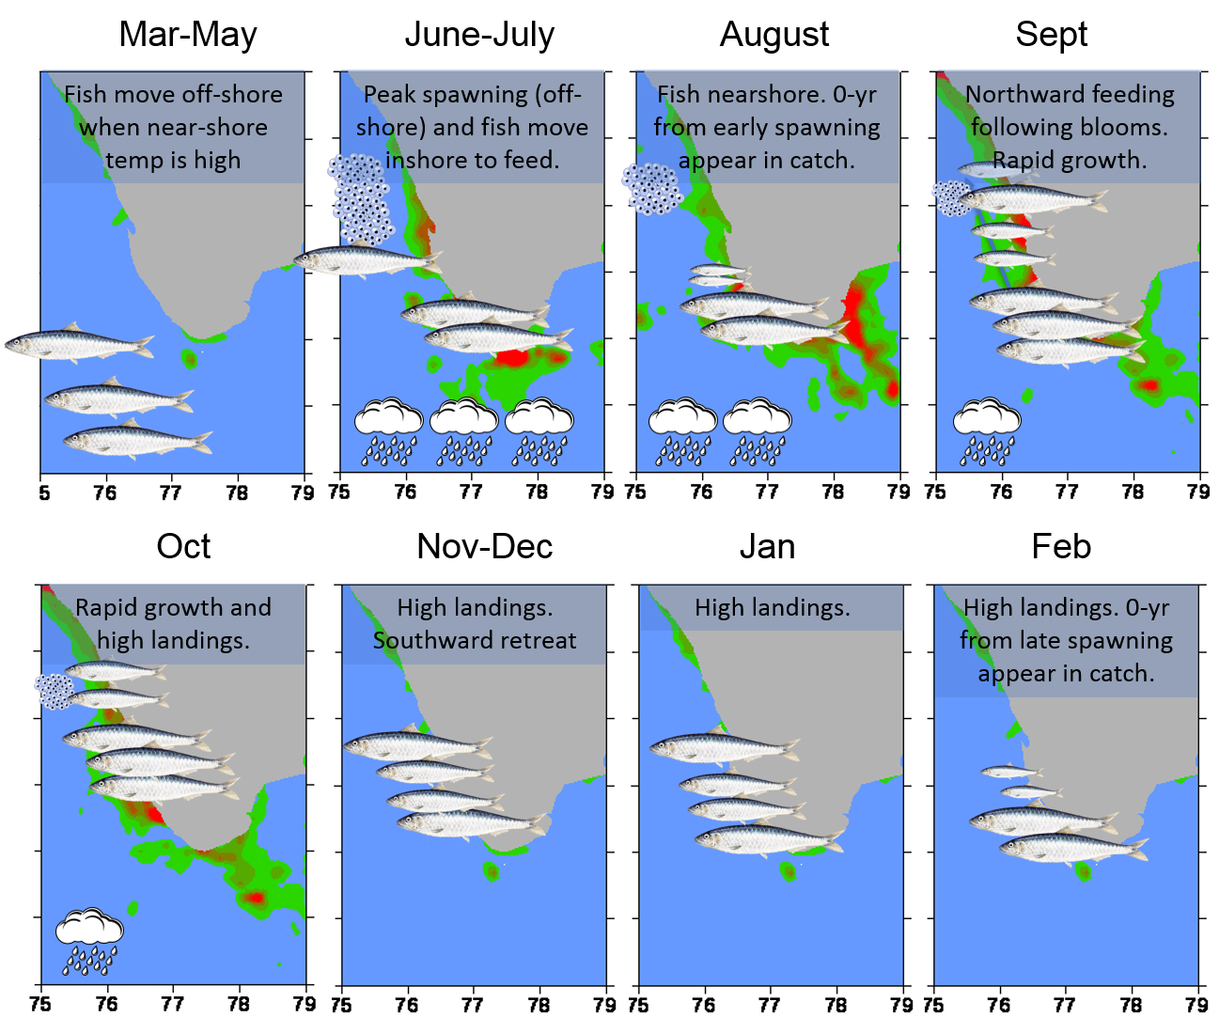

Figure 6

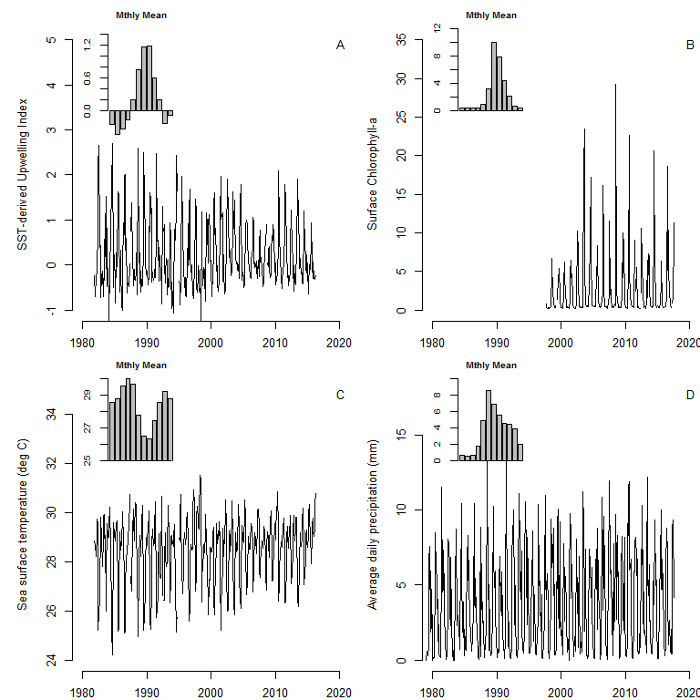

Figure 7

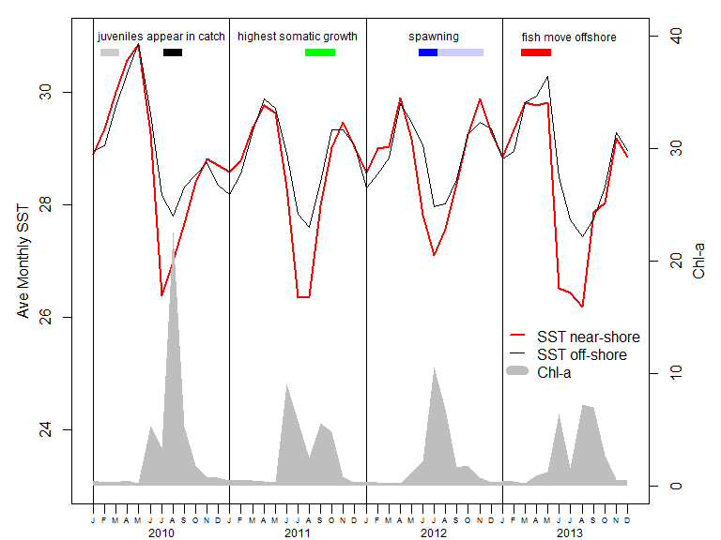

Figure 8

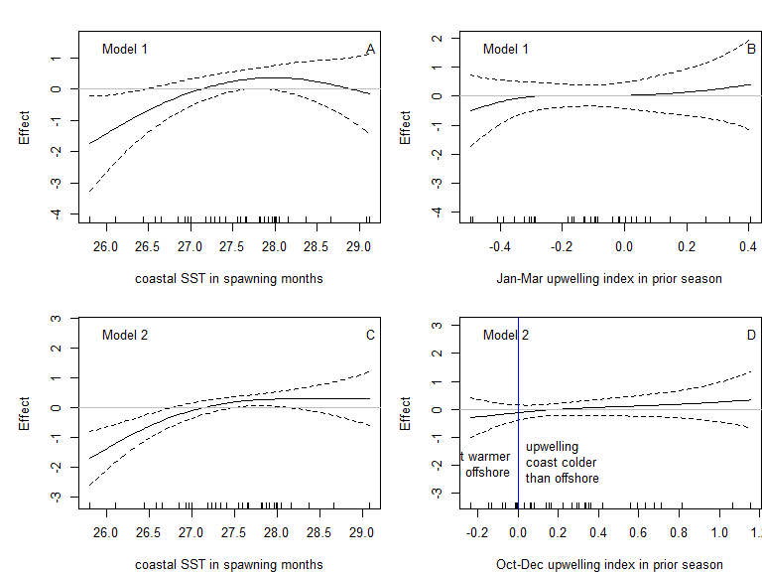

Figure 3

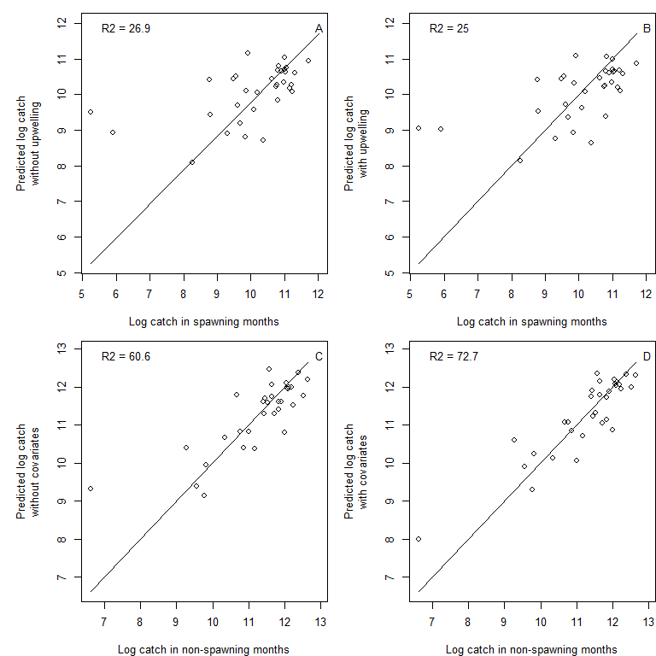

Figure 5

# Appendices

# Appendix A: Tests for prior season catch as covariate

Table A1. Model selection tests of time-dependency the log catch during spawning months using F-tests of nested linear models. is the catch during the spawning period (Jul-Sep). is the catch during the non-spawning period (Oct-Jun). and are the catch during the prior season during and after the spawning period respectively. and are the same for two seasons prior. Test A uses catch during the spawning period as the explanatory variable. Test B uses catch during the non-spawning period as the explanatory variable. Test C uses both. For Test C, the nestedness is lines 1-3 and lines 1-2 and 4.

|  |  |  |  |  |  |
| --- | --- | --- | --- | --- | --- |
| Model | Residual df | Residual deviance | F | p value | AIC |
| Time dependency test A 1983-2015 data |  |  |  |  |  |
| = + | 32 | 65.09 |  |  | 120.07 |
| (Var() = 2.03) |  |  |  |  |  |
| = + + | 31 | 56.91 | 4.61 | 0.04 | 117.63 |
| ( = 10%, Var() = 1.84) |  |  |  |  |  |
| = + + + | 30 | 53.27 | 2.05 | 0.163 | 117.45 |
| ( = 13%, Var() = 1.78) |  |  |  |  |  |
|  |  |  |  |  |  |
| Time dependency test B 1983-2015 data |  |  |  |  |  |
| = + | 32 | 65.09 |  |  | 120.07 |
| (Var() = 2.03) |  |  |  |  |  |
| = + + | 31 | 48.33 | 10.45 | 0.003 | 112.24 |
| ( = 23%, Var() = 1.56) |  |  |  |  |  |
| = + + + | 30 | 48.11 | 0.14 | 0.714 | 114.09 |
| ( = 21%, Var() = 1.6) |  |  |  |  |  |
|  |  |  |  |  |  |
| Time dependency test C 1983-2015 data |  |  |  |  |  |
| = + + | 31 | 48.33 |  |  | 112.24 |
| ( = 23%, Var() = 1.56) |  |  |  |  |  |
| = + + + | 30 | 47.65 | 0.43 | 0.517 | 113.77 |
| ( = 22%, Var() = 1.59) |  |  |  |  |  |
| = + + + | 30 | 47.89 | 0.28 | 0.601 | 113.94 |
| ( = 22%, Var() = 1.6) |  |  |  |  |  |

Table A2. Model selection tests of time-dependency the catch during spawning months using non-linear responses instead of linear responses as in Table A1 See Table A1 for an explanation of the parameters and model set-up.

|  |  |  |  |  |  |
| --- | --- | --- | --- | --- | --- |
| Model | Residual df | Residual deviance | F | p value | AIC |
| Time dependency test A 1983-2015 data |  |  |  |  |  |
| = + + | 31 | 56.91 |  |  | 117.63 |
| ( = 10%, Var() = 1.84) |  |  |  |  |  |
| = + + | 29 | 48.2 | 2.73 | 0.085 | 115.01 |
| ( = 20%, Var() = 1.63) |  |  |  |  |  |
| = + + + | 26.2 | 44.27 | 0.86 | 0.466 | 116.82 |
| ( = 20%, Var() = 1.62) |  |  |  |  |  |
|  |  |  |  |  |  |
| Time dependency test B 1983-2015 data |  |  |  |  |  |
| = + + | 31 | 48.33 |  |  | 112.24 |
| ( = 23%, Var() = 1.56) |  |  |  |  |  |
| = + + | 29.6 | 44.66 | 1.71 | 0.203 | 111.57 |
| ( = 27%, Var() = 1.49) |  |  |  |  |  |
| = + + + | 27.3 | 42.64 | 0.57 | 0.594 | 113.79 |
| ( = 26%, Var() = 1.51) |  |  |  |  |  |
|  |  |  |  |  |  |
| Time dependency test C 1983-2015 data |  |  |  |  |  |
| = + + | 29.6 | 44.66 |  |  | 111.57 |
| ( = 27%, Var() = 1.49) |  |  |  |  |  |
| = + + + | 26.9 | 38.53 | 1.66 | 0.202 | 111.12 |
| ( = 32%, Var() = 1.39) |  |  |  |  |  |
| = + + + | 26.8 | 40.64 | 0.98 | 0.414 | 113.05 |
| ( = 28%, Var() = 1.47) |  |  |  |  |  |

Table A3. Model selection tests of time-dependency for the catch during spawning months using 1956-2015 data. See Table A1 for definitions.

|  |  |  |  |  |  |
| --- | --- | --- | --- | --- | --- |
| Model | Residual df | Residual deviance | F | p value | AIC |
| Time dependency test B linear 1956-2015 data |  |  |  |  |  |
| = + | 57 | 80.84 |  |  | 187.85 |
| ( = 0%, Var() = 1.42) |  |  |  |  |  |
| = + + | 56 | 67.58 | 10.79 | 0.002 | 179.46 |
| ( = 15%, Var() = 1.21) |  |  |  |  |  |
| = + + + | 55 | 67.58 | 0 | 0.97 | 181.46 |
| ( = 13%, Var() = 1.23) |  |  |  |  |  |
|  |  |  |  |  |  |
| Linearity test 1956-2015 data |  |  |  |  |  |
| = + + | 56 | 67.58 |  |  | 179.46 |
| ( = 15%, Var() = 1.21) |  |  |  |  |  |
| = + + | 54.6 | 65.7 | 1.13 | 0.312 | 179.64 |
| ( = 16%, Var() = 1.19) |  |  |  |  |  |
| = + + + | 52.3 | 65 | 0.25 | 0.811 | 182.78 |
| ( = 14%, Var() = 1.22) |  |  |  |  |  |

# 

Table A4. Model selection tests of time-dependency the model using F-tests of nested models fit to 1983 to 2014 log landings data. The years are determined by the covariate data availability. is the catch during the non-spawning period (Qtrs 4, 1 and 2: Oct-Jun) of season (Jul-Jun). and are the catch during the prior sardine season during and after the spawning period respectively. and are the same for two seasons prior. Test A uses catch during the spawning period as the explanatory variable. Test B uses catch during the non-spawning period as the explanatory variable. Test C uses both. For Test C, the nestedness is lines 1-3 and lines 1-2 and 4.

|  |  |  |  |  |  |
| --- | --- | --- | --- | --- | --- |
| Model | Residual df | Residual deviance | F | p value | AIC |
| Time dependency test A 1983-2014 data |  |  |  |  |  |
| = + | 31 | 46.19 |  |  | 106.56 |
| (Var() = 1.49) |  |  |  |  |  |
| = + + | 30 | 32.39 | 12.77 | 0.001 | 97.2 |
| ( = 28%, Var() = 1.08) |  |  |  |  |  |
| = + + + | 29 | 31.31 | 1 | 0.325 | 98.12 |
| ( = 28%, Var() = 1.08) |  |  |  |  |  |
|  |  |  |  |  |  |
| Time dependency test B 1983-2014 data |  |  |  |  |  |
| = + | 31 | 46.19 |  |  | 106.56 |
| (Var() = 1.49) |  |  |  |  |  |
| = + + | 30 | 27.41 | 20.17 | 0 | 91.85 |
| ( = 39%, Var() = 0.91) |  |  |  |  |  |
| = + + + | 29 | 27 | 0.43 | 0.517 | 93.38 |
| ( = 38%, Var() = 0.93) |  |  |  |  |  |
|  |  |  |  |  |  |
| Time dependency test C 1983-2014 data |  |  |  |  |  |
| = + + | 30 | 27.41 |  |  | 91.85 |
| ( = 39%, Var() = 0.91) |  |  |  |  |  |
| = + + + | 29 | 27.32 | 0.1 | 0.759 | 93.75 |
| ( = 37%, Var() = 0.94) |  |  |  |  |  |
| = + + + | 29 | 27.4 | 0.01 | 0.93 | 93.84 |
| ( = 37%, Var() = 0.94) |  |  |  |  |  |

Table A5. Model selection tests of time-dependency the model using non-linear responses instead of linear responses as in Table A4 See Table A4 for an explanation of the parameters and model set-up.

|  |  |  |  |  |  |
| --- | --- | --- | --- | --- | --- |
| Model | Residual df | Residual deviance | F | p value | AIC |
| Time dependency test A 1983-2014 data |  |  |  |  |  |
| = + + | 30 | 32.39 |  |  | 97.2 |
| ( = 28%, Var() = 1.08) |  |  |  |  |  |
| = + + | 28.1 | 29.4 | 1.68 | 0.207 | 96.88 |
| ( = 31%, Var() = 1.03) |  |  |  |  |  |
| = + + + | 25.1 | 24.35 | 1.84 | 0.166 | 95.69 |
| ( = 38%, Var() = 0.93) |  |  |  |  |  |
|  |  |  |  |  |  |
| Time dependency test B 1983-2014 data |  |  |  |  |  |
| = + + | 30 | 27.41 |  |  | 91.85 |
| ( = 39%, Var() = 0.91) |  |  |  |  |  |
| = + + | 28.5 | 22.99 | 4.07 | 0.04 | 88.28 |
| ( = 47%, Var() = 0.79) |  |  |  |  |  |
| = + + + | 26.3 | 19.89 | 1.87 | 0.171 | 87.3 |
| ( = 51%, Var() = 0.73) |  |  |  |  |  |
|  |  |  |  |  |  |
| Time dependency test C 1983-2014 data |  |  |  |  |  |
| = + + | 28.5 | 22.99 |  |  | 88.28 |
| ( = 47%, Var() = 0.79) |  |  |  |  |  |
| = + + + | 25.9 | 21.83 | 0.55 | 0.631 | 90.96 |
| ( = 45%, Var() = 0.81) |  |  |  |  |  |
| = + + + | 25.6 | 15.58 | 4.26 | 0.015 | 80.66 |
| ( = 61%, Var() = 0.59) |  |  |  |  |  |

Table A6. Table A5 with 1956-2015 data instead of 1983 to 2014 data. See Table A4 for an explanation of the parameters and model set-up.

|  |  |  |  |  |  |
| --- | --- | --- | --- | --- | --- |
| Model | Residual df | Residual deviance | F | p value | AIC |
| Time dependency test A 1956-2015 data |  |  |  |  |  |
| = + + | 55 | 43.02 |  |  | 151.71 |
| ( = 19%, Var() = 0.78) |  |  |  |  |  |
| = + + | 53.4 | 41.68 | 1.04 | 0.348 | 152.24 |
| ( = 20%, Var() = 0.77) |  |  |  |  |  |
| = + + + | 50.7 | 40.21 | 0.71 | 0.534 | 154.53 |
| ( = 20%, Var() = 0.78) |  |  |  |  |  |
|  |  |  |  |  |  |
| Time dependency test B 1956-2015 data |  |  |  |  |  |
| = + + | 55 | 36.81 |  |  | 142.84 |
| ( = 31%, Var() = 0.67) |  |  |  |  |  |
| = + + | 53.6 | 35.24 | 1.75 | 0.191 | 142.2 |
| ( = 33%, Var() = 0.65) |  |  |  |  |  |
| = + + + | 51.3 | 33.96 | 0.87 | 0.439 | 143.8 |
| ( = 33%, Var() = 0.65) |  |  |  |  |  |
|  |  |  |  |  |  |
| Time dependency test C 1956-2015 data |  |  |  |  |  |
| = + + | 53.6 | 35.24 |  |  | 142.2 |
| ( = 33%, Var() = 0.65) |  |  |  |  |  |
| = + + + | 51.2 | 33.5 | 1.12 | 0.342 | 143.28 |
| ( = 34%, Var() = 0.64) |  |  |  |  |  |
| = + + + | 51 | 33.97 | 0.75 | 0.513 | 144.43 |
| ( = 32%, Var() = 0.65) |  |  |  |  |  |

Table A7. Model selection tests for the model using AIC for models fit to log landings data with catch during the spawning season added as a covariate. Data 1983 to 2014 were used.

|  |  |  |  |
| --- | --- | --- | --- |
| Model | Residual df | Residual deviance | AIC |
| Add current season spawning information |  |  |  |
| = + + | 30 | 15.41 | 73.43 |
| ( = 66%, Var() = 0.51) |  |  |  |
| = + + | 28.2 | 14.79 | 74.64 |
| ( = 65%, Var() = 0.51) |  |  |  |
| = + + + | 27.1 | 11.51 | 68.8 |
| ( = 72%, Var() = 0.42) |  |  |  |
| = + + + | 27.5 | 10.93 | 66.45 |
| ( = 74%, Var() = 0.39) |  |  |  |

# 

# Appendix B: Tests for environmental variables as covariates

Table B1. Model selection tests of GPCP precipitation as an explanatory variable for the catch during spawning months (Jul-Sep) using 1983 to 2015 data. The data range is determined by the years for which SST was available in order to use a consistent dataset across covariate tests. is the catch during Jul-Sep of season . is the covariate in the current season which spans two calendar years from July to June in the next year. is the covariate in the prior Jul-Jun season.

|  |  |  |  |  |  |
| --- | --- | --- | --- | --- | --- |
| Model | Residual df | Residual deviance | F | p value | AIC |
| V = Jun-Jul Precipitation |  |  |  |  |  |
| = + + | 29.6 | 44.66 |  |  | 111.57 |
| ( = 27%, Var() = 1.49) |  |  |  |  |  |
| = + + + | 28.6 | 43.39 | 0.86 | 0.361 | 112.56 |
| ( = 27%, Var() = 1.49) |  |  |  |  |  |
| = + + + | 26.8 | 40.45 | 1.08 | 0.348 | 112.74 |
| ( = 29%, Var() = 1.45) |  |  |  |  |  |
| = + + + + | 25.9 | 39.91 | 0.37 | 0.543 | 114.23 |
| ( = 27%, Var() = 1.49) |  |  |  |  |  |
| = + + + + | 24.2 | 39.13 | 0.3 | 0.707 | 115.94 |
| ( = 25%, Var() = 1.52) |  |  |  |  |  |
|  |  |  |  |  |  |
| V = Apr-May Precipitation |  |  |  |  |  |
| = + + | 29.6 | 44.66 |  |  | 111.57 |
| ( = 27%, Var() = 1.49) |  |  |  |  |  |
| = + + + | 28.6 | 43.46 | 0.78 | 0.386 | 112.65 |
| ( = 26%, Var() = 1.5) |  |  |  |  |  |
| = + + + | 26.8 | 42.17 | 0.45 | 0.621 | 114.13 |
| ( = 25%, Var() = 1.52) |  |  |  |  |  |
| = + + + + | 25.8 | 42.18 | NA | NA | 116.09 |
| ( = 23%, Var() = 1.57) |  |  |  |  |  |
| = + + + + | 24.1 | 40.14 | 0.76 | 0.459 | 116.79 |
| ( = 23%, Var() = 1.56) |  |  |  |  |  |

Table B3. Model selection tests of sea surface temperature off Cochi as the explanatory variable () for the catch during spawning months (Jul-Sep) using 1983 to 2015 data. See Table B1 for an explanation of the models.

|  |  |  |  |  |  |
| --- | --- | --- | --- | --- | --- |
| Model | Residual df | Residual deviance | F | p value | AIC |
| V = Jul-Sep SST |  |  |  |  |  |
| = + + | 29.6 | 44.66 |  |  | 111.57 |
| ( = 27%, Var() = 1.49) |  |  |  |  |  |
| = + + + | 28.6 | 42.38 | 1.86 | 0.184 | 111.77 |
| ( = 28%, Var() = 1.46) |  |  |  |  |  |
| = + + + | 27 | 35.62 | 3.35 | 0.061 | 108.26 |
| ( = 37%, Var() = 1.27) |  |  |  |  |  |
| = + + + + | 26 | 34.03 | 1.34 | 0.256 | 108.68 |
| ( = 38%, Var() = 1.26) |  |  |  |  |  |
| = + + + + | 24.7 | 32.65 | 0.79 | 0.422 | 109.19 |
| ( = 38%, Var() = 1.25) |  |  |  |  |  |
|  |  |  |  |  |  |
| V = Jan-Dec SST |  |  |  |  |  |
| = + + | 29.6 | 44.66 |  |  | 111.57 |
| ( = 27%, Var() = 1.49) |  |  |  |  |  |
| = + + + | 28.6 | 41.84 | 1.98 | 0.172 | 111.38 |
| ( = 29%, Var() = 1.44) |  |  |  |  |  |
| = + + + | 26.7 | 41.56 | 0.1 | 0.9 | 113.89 |
| ( = 26%, Var() = 1.5) |  |  |  |  |  |
| = + + + + | 25.7 | 39.4 | 1.58 | 0.22 | 114.02 |
| ( = 28%, Var() = 1.47) |  |  |  |  |  |
| = + + + + | 23.9 | 37.02 | 0.91 | 0.406 | 114.58 |
| ( = 28%, Var() = 1.46) |  |  |  |  |  |

Table B4. Model selection tests of upwelling intensity off Cochi as the explanatory variable. See Table B1 for an explanation of the models.

|  |  |  |  |  |  |
| --- | --- | --- | --- | --- | --- |
| Model | Residual df | Residual deviance | F | p value | AIC |
| V = Jul-Sep Upwelling current and prior seasons |  |  |  |  |  |
| = + + | 29.6 | 44.66 |  |  | 111.57 |
| ( = 27%, Var() = 1.49) |  |  |  |  |  |
| = + + + | 28.6 | 40.75 | 2.63 | 0.119 | 110.5 |
| ( = 31%, Var() = 1.4) |  |  |  |  |  |
| = + + + | 26.6 | 39.74 | 0.34 | 0.712 | 112.5 |
| ( = 29%, Var() = 1.44) |  |  |  |  |  |
| = + + + + | 25.7 | 39.71 | 0.02 | 0.886 | 114.38 |
| ( = 27%, Var() = 1.49) |  |  |  |  |  |
| = + + + + | 24 | 38.65 | 0.4 | 0.649 | 116.08 |
| ( = 25%, Var() = 1.52) |  |  |  |  |  |
|  |  |  |  |  |  |
| V = Oct-Dec Upwelling prior season |  |  |  |  |  |
| = + + | 29.6 | 44.66 |  |  | 111.57 |
| ( = 27%, Var() = 1.49) |  |  |  |  |  |
| = + + + | 28.6 | 44.25 | 0.27 | 0.604 | 113.24 |
| ( = 25%, Var() = 1.52) |  |  |  |  |  |
| = + + + | 27.2 | 43.85 | 0.18 | 0.756 | 114.8 |
| ( = 23%, Var() = 1.56) |  |  |  |  |  |
|  |  |  |  |  |  |
| V = Jan-Mar Upwelling prior season |  |  |  |  |  |
| = + + | 29.6 | 44.66 |  |  | 111.57 |
| ( = 27%, Var() = 1.49) |  |  |  |  |  |
| = + + + | 28.6 | 44.08 | 0.38 | 0.54 | 113.13 |
| ( = 25%, Var() = 1.52) |  |  |  |  |  |
| = + + + | 26.9 | 42.45 | 0.62 | 0.525 | 114.3 |
| ( = 25%, Var() = 1.53) |  |  |  |  |  |

# 

Table B5. Model selection tests of GPCP precipitation as an explanatory variable for the catch during the non-spawning months (Oct-Jun) using 1983 to 2014 data. The data range is determined by the years for which SST was available in order to use a consistent dataset across covariate tests. is the catch during Oct-Jun of season . is the covariate in the current season which spans two calendar years from July to June in the next year. is the covariate in the prior Jul-Jun season.

|  |  |  |  |  |  |
| --- | --- | --- | --- | --- | --- |
| Model | Residual df | Residual deviance | F | p value | AIC |
| V = Jun-Jul Precipitation |  |  |  |  |  |
| = + + + | 25.6 | 15.58 |  |  | 80.66 |
| ( = 61%, Var() = 0.59) |  |  |  |  |  |
| = + + + + | 24.6 | 14.11 | 2.69 | 0.115 | 79.44 |
| ( = 63%, Var() = 0.55) |  |  |  |  |  |
| = + + + + | 22.9 | 13.77 | 0.36 | 0.66 | 80.94 |
| ( = 62%, Var() = 0.56) |  |  |  |  |  |
| = + + + + | 24.6 | 15.54 | 0.07 | 0.783 | 82.49 |
| ( = 59%, Var() = 0.61) |  |  |  |  |  |
| = + + + + | 22.7 | 14.09 | 1.31 | 0.288 | 82.1 |
| ( = 61%, Var() = 0.58) |  |  |  |  |  |
|  |  |  |  |  |  |
| V = Apr-May Precipitation |  |  |  |  |  |
| = + + + | 25.6 | 15.58 |  |  | 80.66 |
| ( = 61%, Var() = 0.59) |  |  |  |  |  |
| = + + + + | 24.6 | 15.42 | 0.27 | 0.601 | 82.28 |
| ( = 60%, Var() = 0.6) |  |  |  |  |  |
| = + + + + | 22.9 | 14.99 | 0.41 | 0.641 | 83.74 |
| ( = 59%, Var() = 0.61) |  |  |  |  |  |
| = + + + + | 24.6 | 15.55 | 0.05 | 0.83 | 82.58 |
| ( = 59%, Var() = 0.61) |  |  |  |  |  |
| = + + + + | 22.9 | 15.04 | 0.5 | 0.58 | 83.78 |
| ( = 59%, Var() = 0.62) |  |  |  |  |  |

Table B6. Model selection tests of sea surface temperature off Cochi as the explanatory variable () for the catch during the non-spawning months (Oct-Jun) using 1983 to 2014 data. See Table B5 for an explanation of the models.

|  |  |  |  |  |  |
| --- | --- | --- | --- | --- | --- |
| Model | Residual df | Residual deviance | F | p value | AIC |
| V = Jan-Dec SST |  |  |  |  |  |
| = + + + | 25.6 | 15.58 |  |  | 80.66 |
| ( = 61%, Var() = 0.59) |  |  |  |  |  |
| = + + + + | 24.6 | 12.34 | 6.8 | 0.016 | 75.14 |
| ( = 68%, Var() = 0.48) |  |  |  |  |  |
| = + + + + | 22.8 | 11.96 | 0.44 | 0.626 | 76.63 |
| ( = 67%, Var() = 0.49) |  |  |  |  |  |
| = + + + + | 24.6 | 14.91 | 1.31 | 0.263 | 81.2 |
| ( = 61%, Var() = 0.58) |  |  |  |  |  |
| = + + + + | 22.8 | 12.92 | 2.12 | 0.147 | 79.13 |
| ( = 64%, Var() = 0.53) |  |  |  |  |  |
|  |  |  |  |  |  |
| V = Jul-Sep SST |  |  |  |  |  |
| = + + + | 25.6 | 15.58 |  |  | 80.66 |
| ( = 61%, Var() = 0.59) |  |  |  |  |  |
| = + + + + | 24.6 | 12.89 | 7.19 | 0.015 | 76.47 |
| ( = 66%, Var() = 0.5) |  |  |  |  |  |
| = + + + + | 23.1 | 9.78 | 5.15 | 0.021 | 69.77 |
| ( = 73%, Var() = 0.4) |  |  |  |  |  |
| = + + + + | 24.6 | 15.54 | 0.07 | 0.78 | 82.47 |
| ( = 59%, Var() = 0.61) |  |  |  |  |  |
| = + + + + | 23.3 | 14.67 | 1.07 | 0.334 | 82.5 |
| ( = 60%, Var() = 0.59) |  |  |  |  |  |

# 

Table B7. Model selection tests of upwelling intensity off Cochi as the explanatory variable. See Table B5 for an explanation of the models.

|  |  |  |  |  |  |
| --- | --- | --- | --- | --- | --- |
| Model | Residual df | Residual deviance | F | p value | AIC |
| V = Jul-Sep Upwelling |  |  |  |  |  |
| = + + + | 25.6 | 15.58 |  |  | 80.66 |
| ( = 61%, Var() = 0.59) |  |  |  |  |  |
| = + + + + | 24.6 | 13.47 | 4.15 | 0.054 | 77.96 |
| ( = 65%, Var() = 0.53) |  |  |  |  |  |
| = + + + + | 22.8 | 12.75 | 0.78 | 0.453 | 78.75 |
| ( = 65%, Var() = 0.52) |  |  |  |  |  |
| = + + + + | 24.6 | 14.86 | 1.23 | 0.276 | 81.09 |
| ( = 61%, Var() = 0.58) |  |  |  |  |  |
| = + + + + | 22.8 | 14.71 | 0.14 | 0.844 | 83.4 |
| ( = 59%, Var() = 0.61) |  |  |  |  |  |
|  |  |  |  |  |  |
| V = Oct-Dec Upwelling |  |  |  |  |  |
| = + + + | 25.6 | 15.58 |  |  | 80.66 |
| ( = 61%, Var() = 0.59) |  |  |  |  |  |
| = + + + + | 24.6 | 15.36 | 0.37 | 0.538 | 82.15 |
| ( = 60%, Var() = 0.6) |  |  |  |  |  |
| = + + + + | 23.2 | 14.95 | 0.5 | 0.54 | 83.1 |
| ( = 59%, Var() = 0.61) |  |  |  |  |  |
| = + + + + | 24.6 | 15.03 | 0.94 | 0.339 | 81.47 |
| ( = 61%, Var() = 0.59) |  |  |  |  |  |
| = + + + + | 23.3 | 14.94 | 0.12 | 0.794 | 82.97 |
| ( = 59%, Var() = 0.6) |  |  |  |  |  |
|  |  |  |  |  |  |
| V = Jan-Mar Upwelling |  |  |  |  |  |
| = + + + | 25.6 | 15.58 |  |  | 80.66 |
| ( = 61%, Var() = 0.59) |  |  |  |  |  |
| = + + + + | 24.6 | 15.42 | 0.28 | 0.588 | 82.24 |
| ( = 60%, Var() = 0.6) |  |  |  |  |  |
| = + + + + | 23 | 14.59 | 0.87 | 0.412 | 82.72 |
| ( = 60%, Var() = 0.6) |  |  |  |  |  |
| = + + + + | 24.6 | 15.57 | 0.02 | 0.887 | 82.61 |
| ( = 59%, Var() = 0.61) |  |  |  |  |  |
| = + + + + | 22.9 | 15.3 | 0.27 | 0.725 | 84.35 |
| ( = 58%, Var() = 0.63) |  |  |  |  |  |

# 

# Appendix C: Tests for Chlorophyll-a as a covariate

Table C2. Model selection tests of Chlorophyll-a as an explanatory variable for the catch during spawning months (Jul-Sep) using 1998 to 2014 data. The data range is determined by the years for which CHL was available. is the catch during Jul-Sep of season . is the covariate in the current season which spans two calendar years from July to June in the next year. is the covariate in the prior Jul-Jun season. For Oct-Dec and Jan-Mar only Chlorophyll-a in the prior season is used since these months are after spawning in the current season. Non-linearity is modeled as a 2nd-order polynomial due to data constraints and appears as in the model equations. The non-spawner catch is modeled as a function of non-spawner catch in the prior year only, without spawner catch 2-years prior as in the other covariate analyses (Appendix B). This is done due to data constraints. The models are nested; the roman numeral indicates the level of nestedness. Models at levels II and higher are shown with the component that is added to the base level model (M1) at top.

|  |  |  |  |  |  |
| --- | --- | --- | --- | --- | --- |
| Model | Residual df | Residual deviance | F | p value | AIC |
| I-M1: | 14 | 1.97 |  |  | 19.6 |
| ( = 14%, Var() = 0.14) |  |  |  |  |  |
| V = Jul-Sep Chlorophyll |  |  |  |  |  |
| II: | 13 | 1.68 | 0.74 | 0.41 | 18.93 |
| ( = 26%, Var() = 0.13) |  |  |  |  |  |
| III: | 12 | 1.68 | 0.02 | 0.878 | 20.89 |
| ( = 20%, Var() = 0.14) |  |  |  |  |  |
| IV: | 11 | 1.67 | 0.08 | 0.781 | 22.76 |
| ( = 13%, Var() = 0.15) |  |  |  |  |  |
| V: | 10 | 1.64 | 0.16 | 0.694 | 24.48 |
| ( = 6%, Var() = 0.16) |  |  |  |  |  |
|  |  |  |  |  |  |
| V = Oct-Dec Chlorophyll |  |  |  |  |  |
| II: | 13 | 1.79 | 0.12 | 0.733 | 19.95 |
| ( = 21%, Var() = 0.14) |  |  |  |  |  |
| III: | 12 | 1.68 | 0.73 | 0.408 | 20.94 |
| ( = 20%, Var() = 0.14) |  |  |  |  |  |
|  |  |  |  |  |  |
| V = Jan-Mar Chlorophyll |  |  |  |  |  |
| II: | 13 | 1.79 | 0.07 | 0.798 | 20.02 |
| ( = 21%, Var() = 0.14) |  |  |  |  |  |
| III: | 12 | 1.77 | 0.13 | 0.721 | 21.83 |
| ( = 15%, Var() = 0.15) |  |  |  |  |  |

Table C1. Model selection tests of Chlorophyll-a as an explanatory variable for the catch during the non-spawning months (Oct-Jun) using 1998 to 2014 data. The data range is determined by the years for which CHL was available. is the catch during Oct-Jun of season . is the covariate in the current season which spans two calendar years from July to June in the next year. is the covariate in the prior Jul-Jun season. Non-linearity is modeled as a 2nd-order polynomial due to data constraints and appears as in the model equations. The non-spawner catch is modeled as a function of non-spawner catch in the prior year only, without spawner catch 2-years prior as in the other covariate analyses (Appendix B). This is done due to data constraints. The models are nested; the roman numeral indicates the level of nestedness. Models at levels II and higher are shown with the component that is added to the base level model (M1) at top.

|  |  |  |  |  |  |
| --- | --- | --- | --- | --- | --- |
| Model | Residual df | Residual deviance | F | p value | AIC |
| I-M1: | 14 | 1.97 |  |  | 19.6 |
| ( = 14%, Var() = 0.14) |  |  |  |  |  |
|  |  |  |  |  |  |
| V = Jul-Sep Chlorophyll |  |  |  |  |  |
| II: | 13 | 1.96 | 0.06 | 0.815 | 21.52 |
| ( = 8%, Var() = 0.15) |  |  |  |  |  |
| III: | 12 | 1.87 | 0.54 | 0.478 | 22.69 |
| ( = 5%, Var() = 0.16) |  |  |  |  |  |
| II: | 13 | 1.92 | 0.32 | 0.582 | 21.17 |
| ( = 10%, Var() = 0.15) |  |  |  |  |  |
| III: | 11.6 | 1.87 | 0.22 | 0.731 | 22.75 |
| ( = 4%, Var() = 0.16) |  |  |  |  |  |
|  |  |  |  |  |  |
| V = Oct-Dec Chlorophyll |  |  |  |  |  |
| II: | 13 | 1.88 | 0.77 | 0.402 | 20.84 |
| ( = 11%, Var() = 0.14) |  |  |  |  |  |
| III: | 12 | 1.71 | 1.55 | 0.241 | 21.17 |
| ( = 13%, Var() = 0.14) |  |  |  |  |  |
| IV: | 11 | 1.14 | 4.99 | 0.05 | 16.37 |
| ( = 36%, Var() = 0.1) |  |  |  |  |  |
| V: | 10 | 1.13 | 0.12 | 0.733 | 18.16 |
| ( = 31%, Var() = 0.11) |  |  |  |  |  |
| II: | 13 | 1.5 | 4.32 | 0.063 | 16.96 |
| ( = 29%, Var() = 0.12) |  |  |  |  |  |
| III: | 10.3 | 1.2 | 1.03 | 0.409 | 17.14 |
| ( = 33%, Var() = 0.11) |  |  |  |  |  |
|  |  |  |  |  |  |
| V = Jan-Mar Chlorophyll |  |  |  |  |  |
| II: | 13 | 1.97 | 0 | 0.972 | 21.6 |
| ( = 7%, Var() = 0.15) |  |  |  |  |  |
| III: | 12 | 1.82 | 0.93 | 0.358 | 22.23 |
| ( = 7%, Var() = 0.15) |  |  |  |  |  |
| II: | 13 | 1.67 | 2.14 | 0.171 | 18.78 |
| ( = 21%, Var() = 0.13) |  |  |  |  |  |
| III: | 11 | 1.63 | 0.12 | 0.884 | 21.25 |
| ( = 14%, Var() = 0.14) |  |  |  |  |  |

Table C3. Model selection tests of Chlorophyll-a as an explanatory variable for the catch during the non-spawning months (Oct-Jun) using box 5.

|  |  |  |  |  |  |
| --- | --- | --- | --- | --- | --- |
| Model | Residual df | Residual deviance | F | p value | AIC |
| I-M1: | 14 | 1.97 |  |  | 19.6 |
| ( = 14%, Var() = 0.14) |  |  |  |  |  |
|  |  |  |  |  |  |
| V = Jul-Sep Chlorophyll |  |  |  |  |  |
| II: | 13 | 1.67 | 2.01 | 0.187 | 18.76 |
| ( = 21%, Var() = 0.13) |  |  |  |  |  |
| III: | 12 | 1.66 | 0.05 | 0.836 | 20.69 |
| ( = 15%, Var() = 0.14) |  |  |  |  |  |
| II: | 13 | 1.91 | 0.46 | 0.512 | 21.04 |
| ( = 10%, Var() = 0.15) |  |  |  |  |  |
| III: | 10.5 | 1.53 | 1.09 | 0.383 | 21.19 |
| ( = 15%, Var() = 0.14) |  |  |  |  |  |
|  |  |  |  |  |  |
| V = Oct-Dec Chlorophyll |  |  |  |  |  |
| II: | 13 | 1.55 | 4.22 | 0.067 | 17.57 |
| ( = 27%, Var() = 0.12) |  |  |  |  |  |
| III: | 12 | 1.35 | 2.11 | 0.177 | 17.13 |
| ( = 31%, Var() = 0.11) |  |  |  |  |  |
| IV: | 11 | 1 | 3.51 | 0.091 | 14.1 |
| ( = 44%, Var() = 0.09) |  |  |  |  |  |
| V: | 10 | 0.98 | 0.18 | 0.684 | 15.8 |
| ( = 40%, Var() = 0.1) |  |  |  |  |  |
| II: | 13 | 1.37 | 5.15 | 0.044 | 15.47 |
| ( = 35%, Var() = 0.11) |  |  |  |  |  |
| III: | 11 | 1.35 | 0.11 | 0.895 | 17.89 |
| ( = 29%, Var() = 0.12) |  |  |  |  |  |
|  |  |  |  |  |  |
| V = Jan-Mar Chlorophyll |  |  |  |  |  |
| II: | 13 | 1.59 | 3.35 | 0.097 | 17.92 |
| ( = 25%, Var() = 0.12) |  |  |  |  |  |
| III: | 12 | 1.57 | 0.17 | 0.692 | 19.72 |
| ( = 20%, Var() = 0.13) |  |  |  |  |  |
| II: | 13 | 1.72 | 2.78 | 0.125 | 19.33 |
| ( = 19%, Var() = 0.13) |  |  |  |  |  |
| III: | 10.4 | 0.98 | 3.25 | 0.071 | 13.58 |
| ( = 46%, Var() = 0.09) |  |  |  |  |  |

# Appendix D: Correlation of covariates across the boxes

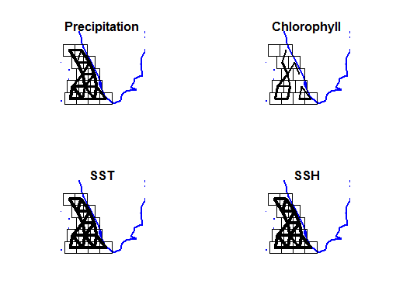

Figure C1. Correlation of the covariates across boxes. Correlation is shown by the width of the lines between neighboring boxes.

# Appendix E: Covariates along the SE India coast

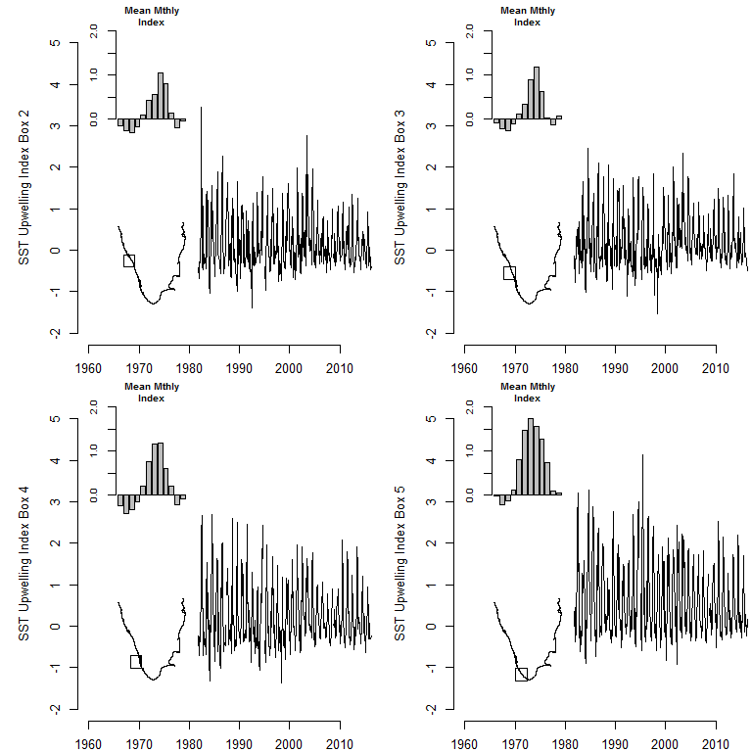

Figure E1. Upwelling index.

# 

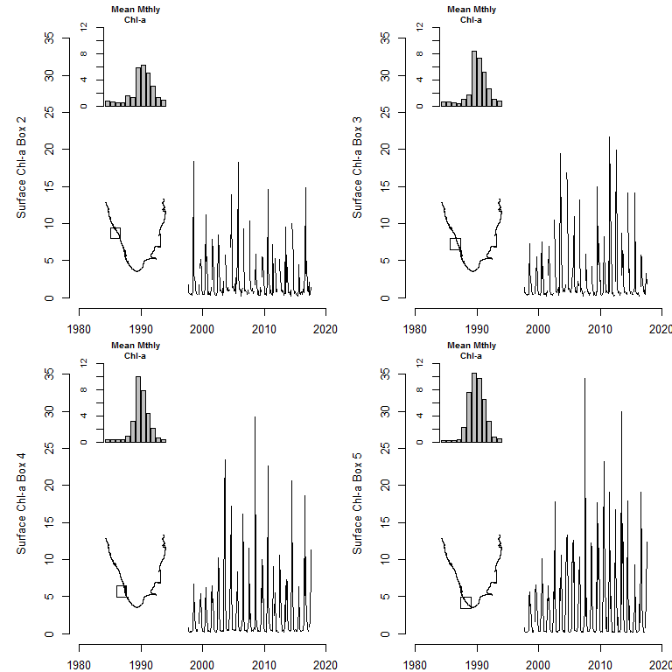

Figure E2. Chlorophyll-a.

# 

# Appendix F: Comparison of land and oceanic rainfall measurements

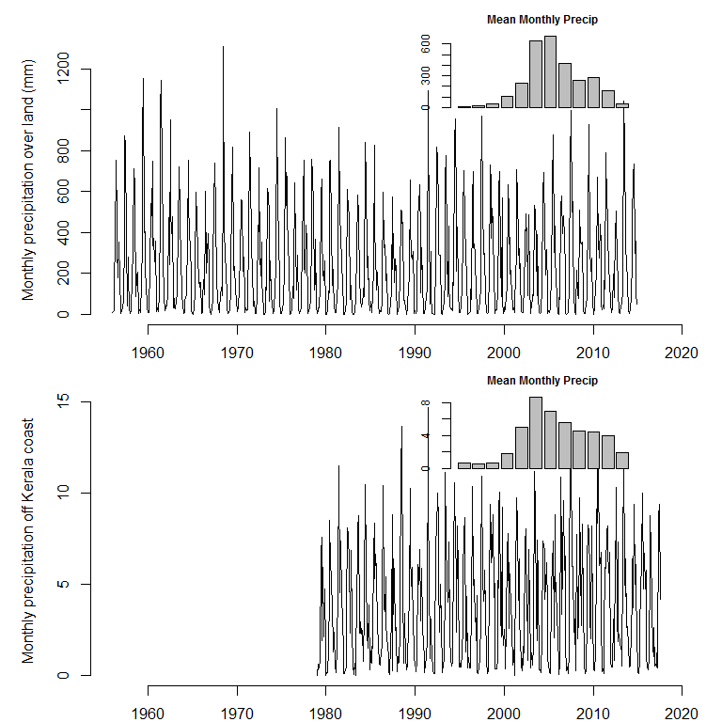

Figure F1

# 

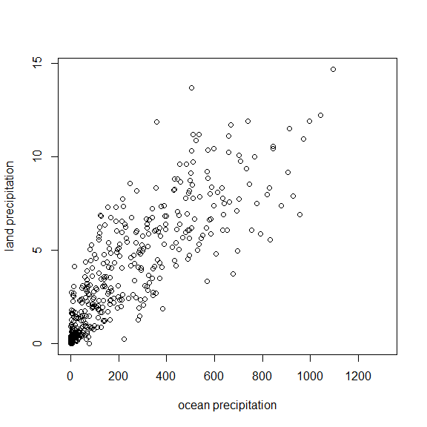

Figure F2. Monthly precipitation measured over land via land gauges versus the precipitation measured via remote sensing over the ocean.

# Appendix G: Chlorophyll-a images in 2016

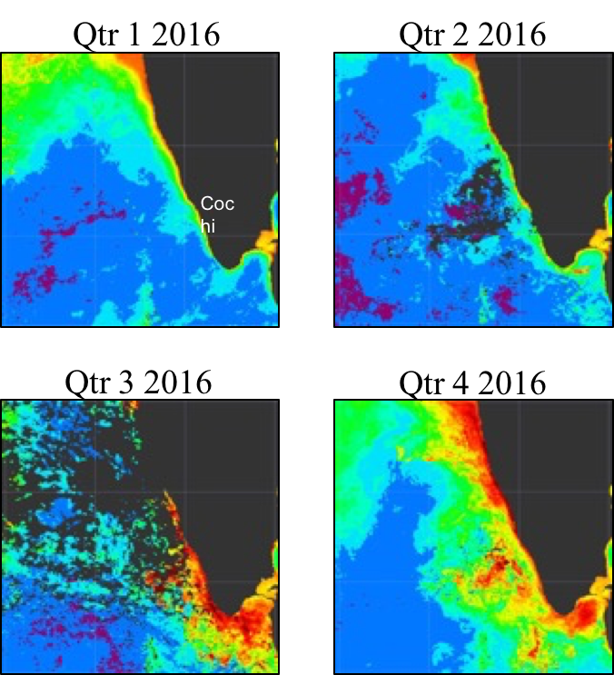

Figure 9

# 